Scenario 1: Bob wants to message his group and tell them that he won’t be able to make it to their event today. Bob logs into the app, sees his profile, selects see all groups, and then goes to the chat group. He selects not going on the event in the group, and an auto message with red coloring indicates he cannot go. He can then type a message and hits send, allowing all members of the group to receive a push notification for this message (unless they opted to mute the chat). The chat also shows that he will not attend the event and is listed as not going.

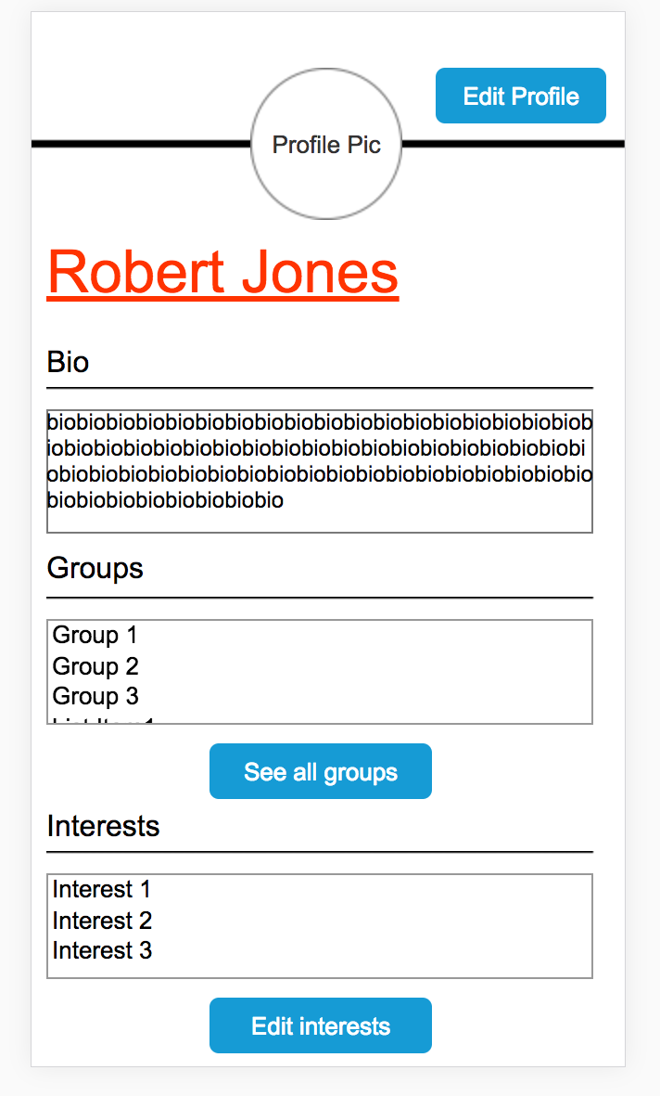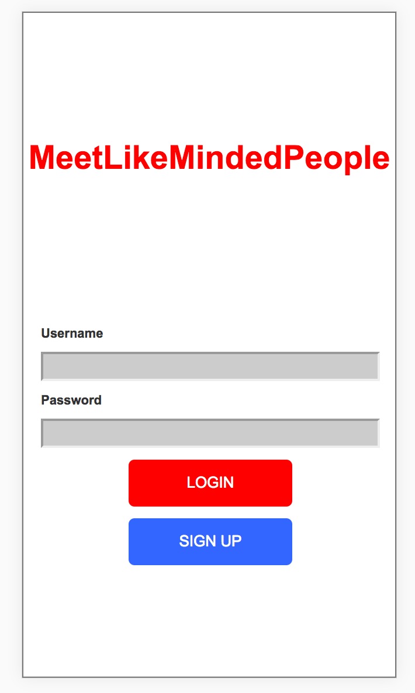

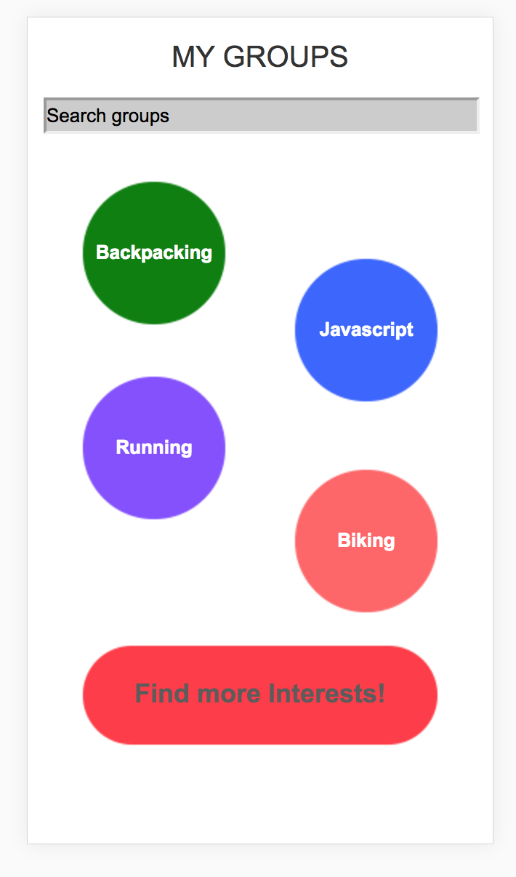

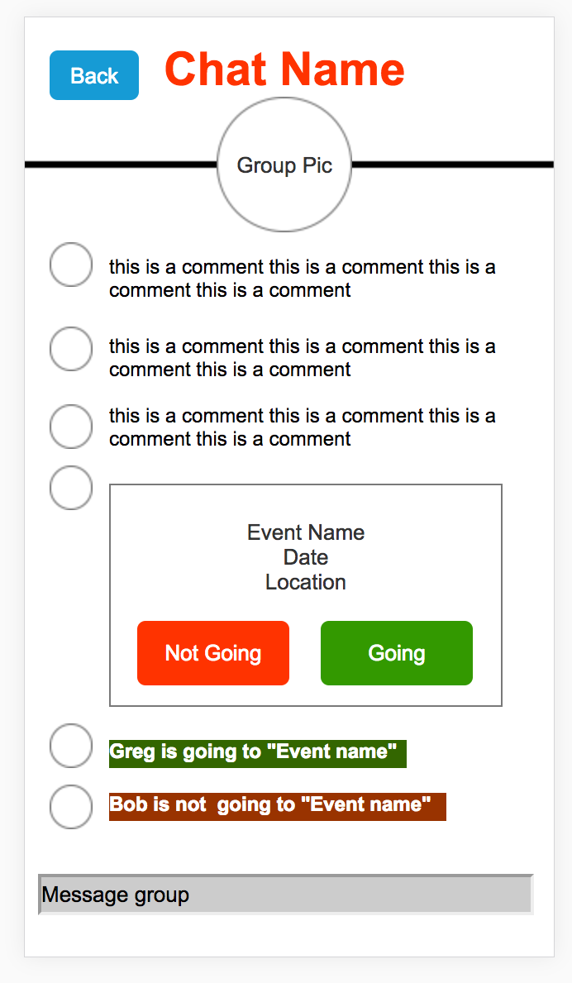

Scenario 2: Sarah wants to leave one of the groups she has joined, since she no longer is interested in that category. She opens the app, selects see all groups from her profile picture, selects the desired group, goes to the menu button on the top right, selects additional settings, and selects leave group. This group is no longer listed on her group list and she is redirected to the groups page.







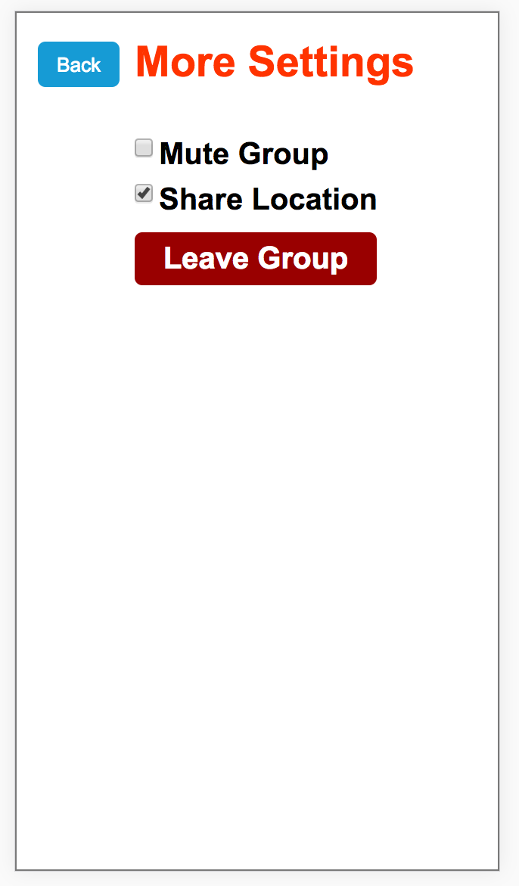

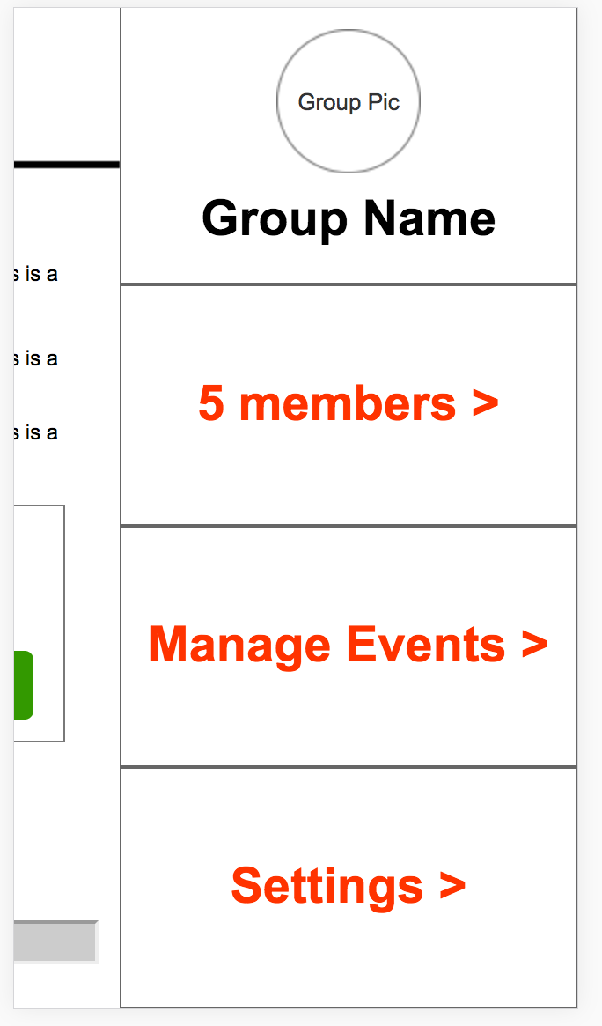

Scenario 3: David is new to the application; he opens the app, sets up a username and password and then is prompted to select some interests to join. He goes through selecting activities or searching for them, and then can join any thing that interests him. After setting up his interest and profile through the profile setup page, he is paired with new groups he can now talk to.

