46.

**package** assessment;

**import** java.util.*;

**public** **class** Anagram {

**public** **static** List<List<String>> groupAnagram(String[] string){

HashMap<String,List<String>> map=**new** HashMap<>();

List<List<String>> res=**new** ArrayList<>();

**for**(String str:string) {

**char**[] ch=str.toCharArray();

Arrays.*sort*(ch);

String key=**new** String(ch);

**if**(map.containsKey(key)) {

map.get(key).add(str);

}

**else** {

List<String> stringList=**new** ArrayList<>();

stringList.add(str);

map.put(key, stringList);

}

}

res.addAll(map.values());

**return** res;

}

**public** **static** **void** main(String[] args) {

String[] string= {"eat","tea","tan","ate","nat","bat"};

List<List<String>> result=*groupAnagram*(string);

result.forEach(res->System.***out***.println(res+""));

}

}

OUTPUT:  
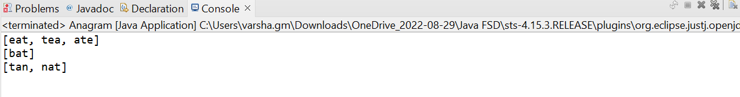

47.

OUTPUT:

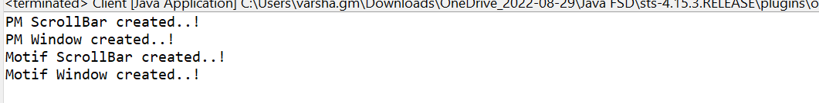

48.

App.js

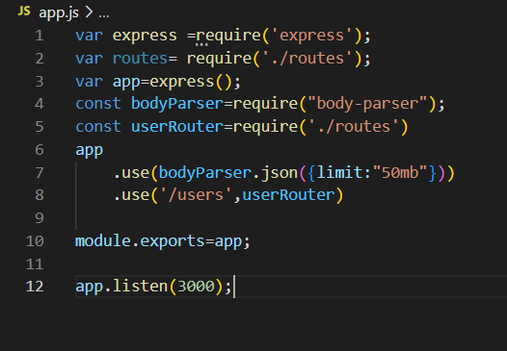

Foo.service.js

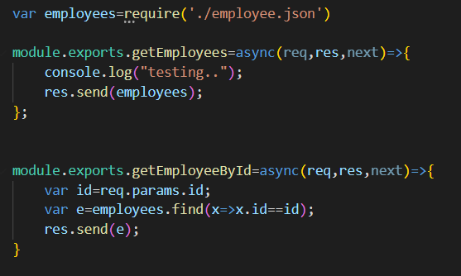

Employee.json

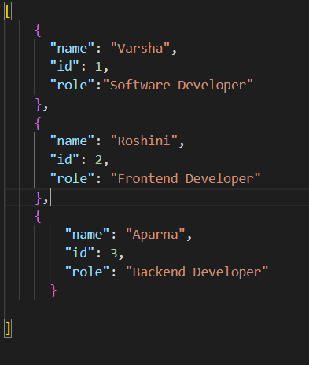

Foo.route.js

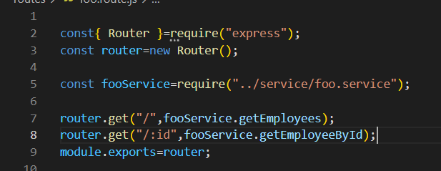

Index.js

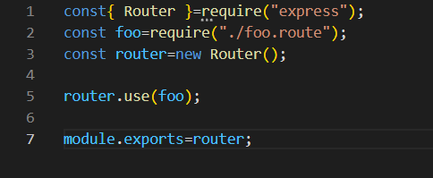

OUTPUT:

Return the list of employees:

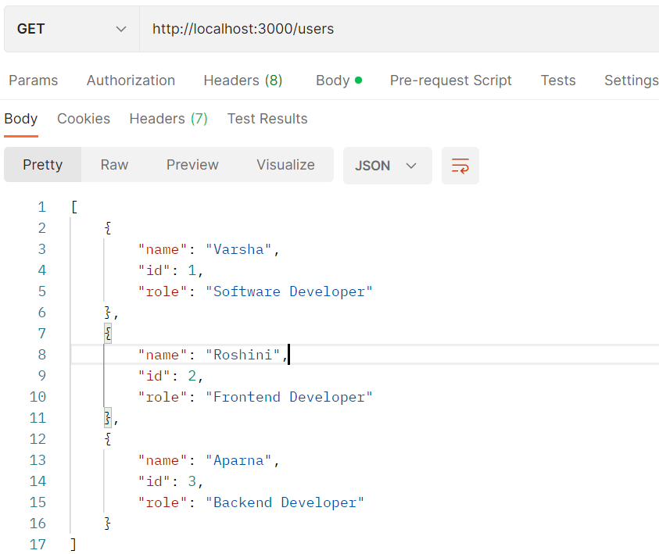

Search by id:

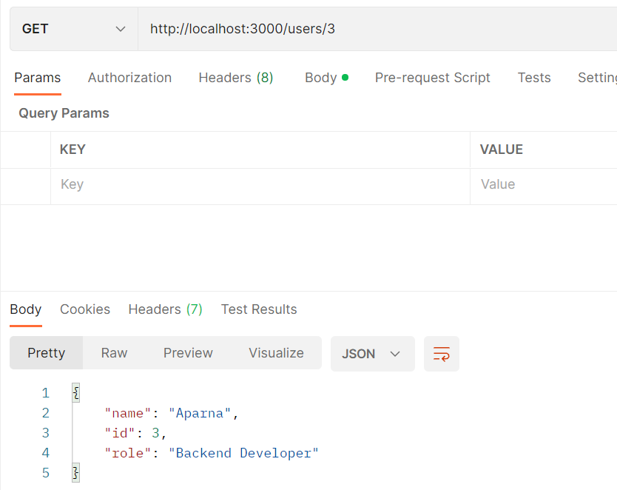

50.

App.js

import {useState} from 'react';

const randomNo = () => {

  const [number, setNumber] = useState(0);

  function randomNumberInRange(min, max) {

    return Math.floor(Math.random() * (max - min + 1)) + min;

  }

  const handleClick = () => {

    setNumber(randomNumberInRange(100, 500));

  };

  return (

  <div>

  <h2 >Random Number is: {number}</h2>

  <button onClick={handleClick}>Generate random number</button>

  </div>

  );

};

export default randomNo;

Output:

