The current through the five coils is a little complicated.  Here is an example configuration (with naming convention): HV89TA74TB81AV46IV76

The helical and vertical coils are tied together, and the vertical coil is split into 3 segments. I haven't been able to open the file so I am not sure how it is arranged.  It looks like there are three filaments for the vertical coils (which might correspond to the three segments).

Coil currents in Amperes   (columns are the upper and lower sets of vertical coils)

 8.5440E+05,                            # Helical coil current [A],         (1) = 0.89* Imain

-4.2720E+05, -4.2720E+05,   # Main vertical coil segment 1 (2) = -(1)/2, -(1)/2   (upper, lower)

-2.1360E+05, -2.1360E+05,   # Main vertical coil segment 2 (3) = +(2)/2, +(2)/2

-1.0680E+05, -1.0680E+05,   # Main vertical coil segment 3 (4) = +(3)/2, +(3)/2

 6.6240E+04,  6.6240E+04,   # Aux. vertical coil [A],              (5) = 0.46*Imain

 3.6480E+05,  3.6480E+05,    # Inner vertical coil [A],             (6) = 0.76*Imain

The Toroidal A and Toroidal B coils go like ~ A coil, B coil, B coil, A coil ... or:

 4.4400E+05, 1.7658E+05, 1.7658E+05, 4.4400E+05,

TA,TB,TB,TA [A], (7) = 0.74*Imain, 0.81*Imain, 0.74*Imain, 0.81*Imain

So HV stands for Helical/Vertical coil current.

….

Since we probably need a multi-filament model. I went through the documentation that I have and pulled out the size of the coils. The helical coil is a bit complicated, and the internal distribution of the copper packs is poloidally assymmetric on the TA / TB coils, but I can build a multi-filament model out of the information I have.

The helical coil filaments that we have hold 3 x 8 filaments. Each one of these represents one of the water cooled copper windings. 1 winding of a copper pack is 17mm x 28 mm. Water cooled with a circular channel cut through the center.

Here are the notes that I took while going through the documentation. They might not mean much, but they can hang around as background information for now.

# =================== #

Helical Coil [3x8 turn copper pack] (3 parallel circuits of 8 turn windings, 40 kA max per winding -> 120 kA max)

166mm wide (quasi-poloidal direction) x 120 mm thick (minor radial direction)

designed: 164 mm width x 120 mm thick [ 4x8 copper pack ]

actual: 164 mm width x 86 mm height. R0=1.2m, AC=0.22m, pitch mod. alpha=-0.40

Vertical Coils [ ]

V: 264 mm width x 348 mm height box. R=3.546m, Z=1.2m,

OV1 seg (upper, lower): R=3.316, Z= 1.2m+( 0.010, 0.000)m ( 77 Width x 140mm Height)

OV2 seg (upper, lower): R=3.454, Z= 1.272m+( 0.010, 0.000)m (175 W x 135 mm H)

OV3 seg (upper, lower): R=3.546, Z= 1.128m+( 0.010, 0.000)m (348 W x 140 mm H)

All outer vertical coils: From Heliotron E!

AV: 154.4mm width x 213.4 mm height. R=1.7m, Z=0.78m + (0.010, 0.000)m

Main vertical coil: From Heliotron E!

IV: 134mm width x 209 mm height. R=0.425m, Z=0.17m + (0.000, 0.000)m

Two separate 990 mm diameter coils: [1 x 80 turn]

TA Coils [2x10 turn copper pack, 30 kA max/conductor ] - 4 parallel circuits–>120 kA max

147 mm wide (toroidal direction) x 126 mm thick (minor radial direction)

116.8 mm W, 87mm H, a=0.651m

TB Coils [ 1 x 20 turn copper pack, 10.9 kA max/conductor]

67 mm wide (toroidal direction) x 192 mm thick (minor radial direction)

39.6 mm W, 154.5 mm H, a=0.60775m

# =================== #

Number of turn and maximum current of each coil are,

- Helical: 8 turns, 120kA each (=960kAT)

- Main Vertical (can be divided into three):

OV1: 4 turns, 120kA (=480kAT)

OV2: 2 turns, 120kA (=240kAT)

OV3: 1 turn, 120kA (=120kAT)

TA: 5 turns, 120kA (=600kAT)

TB: 20 turns, 10.9kA (=218kAT)

AV: 24 turns, 6kAT (=144kAT)

IV: 80 turns, 6 kAT (=480kAT)

# =================== #

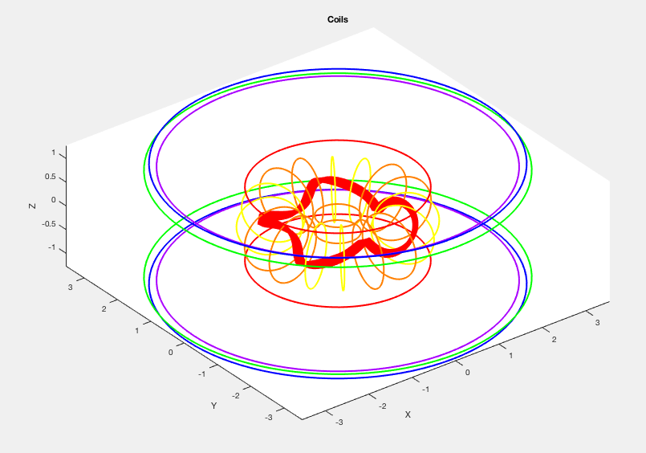

Number of turn and maximum current of each coil are,

- Helical: 8 turns, 120kA each (= 960kAT) (3 parallel circuits of 8 turn windings, 40 kA/winding)

- Main Vertical (can be divided into three):

       OV1: 4 turns, 120kA (=480kAT)

       OV2: 2 turns, 120kA (=240kAT)

       OV3: 1 turn, 120kA (=120kAT)

TA: 5 turns, 120kA (=600kAT)  (4 parallel circuits from 2x10 conductor pack: 30 kA/winding)

TB: 20 turns, 10.9kA (=218kAT)  (1x20 conductor pack:  1 filament, 20 turns)

AV: 24 turns, 6kAT (=144kAT)     (1 filamant, 24 turns)

IV: 80 turns, 6 kAT (=480kAT)     (1 filament, 80 turns)

**.... so now fitting it into the model we have:**

24 filaments for the Helical coil

Example configuration (with naming convention): **HV89 TA74 TB81 AV46 IV76**

Current per turn for each coil in our filament model for this configuration:

   Helical coil:                  0.89*Imain / 24

   OV1:                     0.5*0.89*Imain / 4

   OV2:                   0.25*0.89*Imain / 2

   OV3:                 0.125*0.89*Imain / 1

   TA:                    0.74*Imain / 20

   TB:                    0.81*Imain / 20

   AV:                    0.46*Imain / 24

   IV:                     0.76*Imain / 80

Current per turn for each coil (generally in this filament model):

   Helical coil:                 HV / 24

   OV1:                     0.5*HV / 4

   OV2:                   0.25*HV / 2

   OV3:                 0.125*HV / 1

   TA:                    TA / 20

   TB:                    TB / 20

   AV:                    AV / 24

   IV:                     IV / 80

Output from filament model line-following:

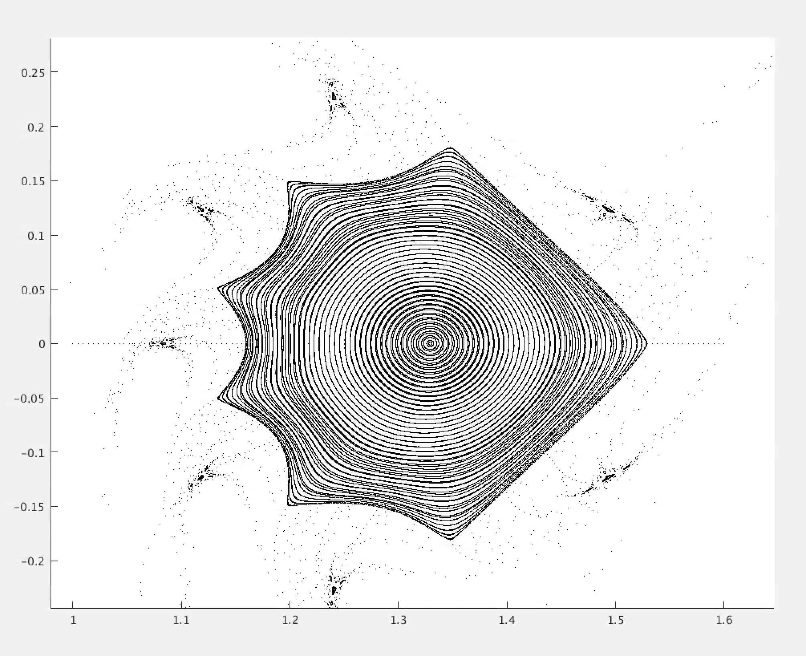

Output from KMAG code (line-following with method of moments over real coils):

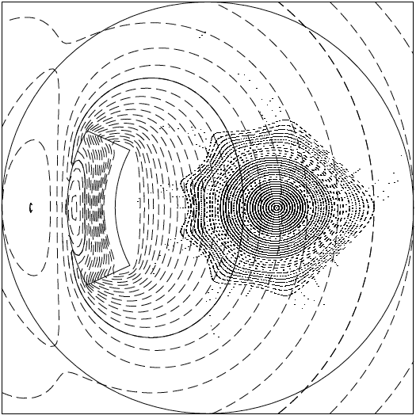

0,0,525,529

Comparison: