Man Tik Li

CS 360 - 002

Krzysztof Nowak

August 27, 2020

**Test 2**

**Completed question: #1, #2, #4, #5, #6**

1. 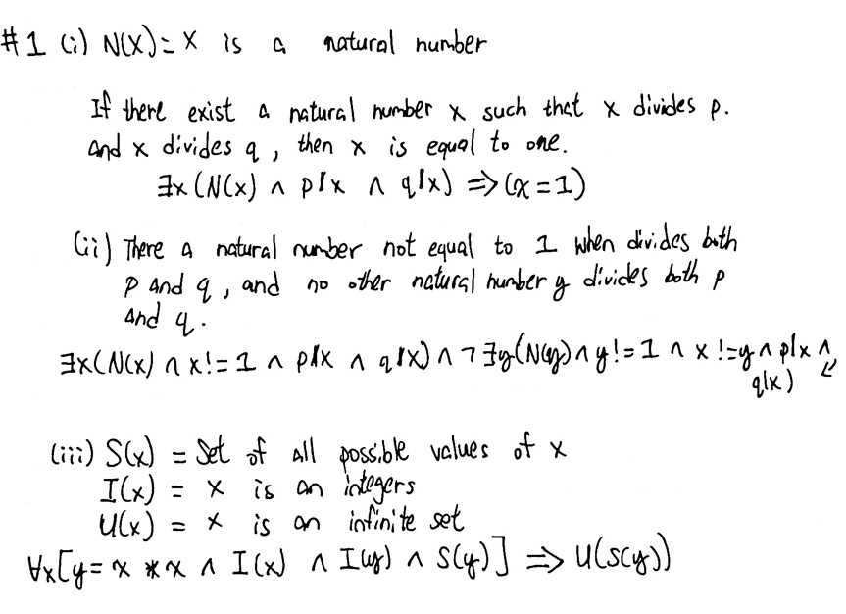
2. Scheme and Haskell both use lists and have subroutines through the process. Scheme has one more subroutine (the split function) than Haskell. The Scheme mainly calling tail recursion to process. Haskell implement with loops and recursion. The time complexity for both merge sort is $(θn log n)$. And the space complexity for the merge sort for both is n.
   1. The merge function takes two lists. It checks both lists are not empty before retrieve the first values of both lists. Then assigning the values to the value of x and y, which compare the value. A new list is constructed with the cons with x as the first value merge with rest of the elements in second list, when x is less than y. Otherwise, a list created with the y value as the first value and rest of elements in second list. The merge function compares the value and the given lists. The split function takes a list and split it into two empty lists. If the list is null and a new list given, when the rest of the list is empty. Otherwise, three variables a, b, and c pass the values to the lists and a new list is formulated. The msort function takes a list as the values to be stored. It used by the merge and split functions.
   2. The Haskell is similar to the scheme. The msort return a null list if it is null. It returns only one value is present. Then call the merge ls1 and lis2 if a list is given. The function returns the second list, if the first list is empty. It returns the first list, if the second list is empty. When (x:xs) and (y:ys) are given two lists, the function compares the first value of the second list. Otherwise, y is first value and merge(x:xs) is the rest. The msort split list into two.
   3. Apply takes two arguments, a procedure, and a list of arguments to apply the procedure. Apply creates a new environment with a list of arguments. The purpose is to extend an environment and let the procedure's parameters bound to the arguments in which the procedure is applied.
   4. Compound procedures are constructed from parameters, procedure bodies, and environments using the constructor make-procedure. It applies a set of arguments, evaluate the body of the procedure in a new environment. The environment extends the environment part of the procedure object by a frame in which the parameters of the procedure bound to the arguments with the procedure is applied.
3. A close up of a piece of paper

   Description automatically generated
4. A close up of a piece of paper

   Description automatically generated