One Touch Application is a new tool to assist customers / partners for configuring several Headsets with a desired configuration. This Application is planned for the roll out a Bluetooth Push To Talk solution using BlueParrott B450-XT and C400-XT headsets. The Application will support other Headsets as well.

The Applications will also support providing visibility into the 4-digit pairing ID for the headsets, to have the units labeled according to its friendly name to ensure their users connect to their intended device.

**Instruction details**

*Attention: Operators should use gloves under rework. Gloves should be changed every shift or a new working day.*

Preconditions

* Install 'one-click' app on your android device.

1. Bluetooth pair headset to android device
2. Run a specific 'one-click' app (bponebutton-debug.apk file ) that makes the necessary configuration changes to a BlueParrott headset to make it suitable for enterprise Frontline Worker use.
3. Within the ‘one click’ app – press the “Warehouse Mode” Button. This step will also set the Headset in the SDK Mode

1. Nice to have steps –
2. Read and note the 4-digit number (not “:”) displayed at the top of the app screen (shown in red frame on below picture – 0CA7). This can be used as a unique identifier for the Headset

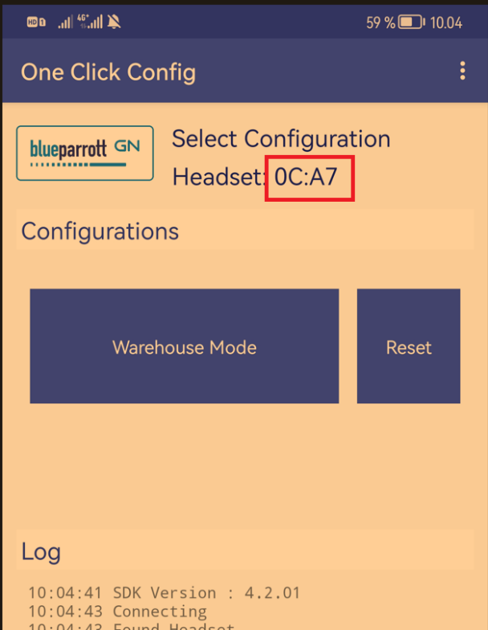

1. Create label -referencing 4-digit number - print on label. (Black color label, white color digits – label size suitable to fit C300-XT hanger space
2. Apply label to headset - affixed on C300-XT hanger 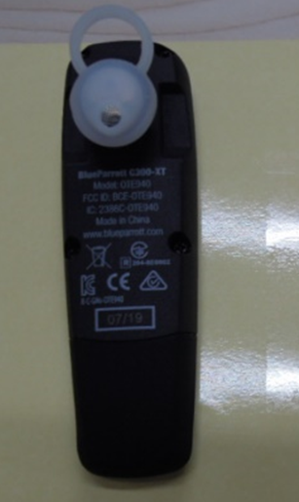

**0CA7**

1. Reset headset. (Hold the headset near your ear and press and hold the Volume Up and the Volume Down buttons together for approximately 6-10 seconds until two low tones sound)

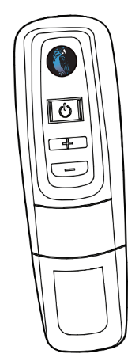

1. Turn Headset Off (conserves battery power): Hold down the MFB for approximately 4–5 seconds until you hear a voice prompt “power off.” A red light will flash 4 times and the headset will turn off

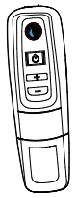

MFB