Interactive Coptic Tune (ICT) App

Operation Manual

Contents

Step 1: What is needed ? 2

Step 2: Download ICT app 2

Step 3: ICT app structure 2

Step 4: Add your tune files and modify the tune data file 2

Step 5: Create the tune places and animation 3

# Step 1: What is needed ?

1. The tune name.
2. The tune text as an image (png or jpg - a format that an internet browser can display).
3. The tune sound as mp3.

# Step 2: Download ICT app

1. The ICT app located on <http://gnairooze.info/subs/ict2/index.html>.
2. Click on the Download link.

# Step 3: ICT app structure

The ICT app contains many folders. The following are the ones containing the tune data:

1. **img** folder: this folder contains the tune text as an image (eg. toteron.png)
2. **snd** folder: this folder contains the tune sound as mp3 (eg. tote_eron.mp3)
3. **js** folder: this folder contains the tune data file tune_data.js. This file name should not be changed.

# Step 4: Add your tune files and modify the tune data file

1. Add your tune image in the **img** folder
2. Add your tune sound in the **snd** folder
3. Open **js/tune_data.js** file in any text editor that can edit text without formatting (microsoft word is not suitable fo this task).
4. Replace all the data in **tune_data.js** file with the following data:

|  |
| --- |
| var tune_data = {  "tune_name": "***tune_name_value***",  "tune_text": "img/***tune_text_value***",  "tune_mp3": "snd/***tune_mp3_value***",  "places": []  }; |

1. Replace ***tune_name_value*** with your tune name.
2. Replace ***tune_text_value*** with your tune image file name.
3. Replace ***tune_mp3_value*** with your tune sound filename.

# Step 5: Create the tune places and animation

1. 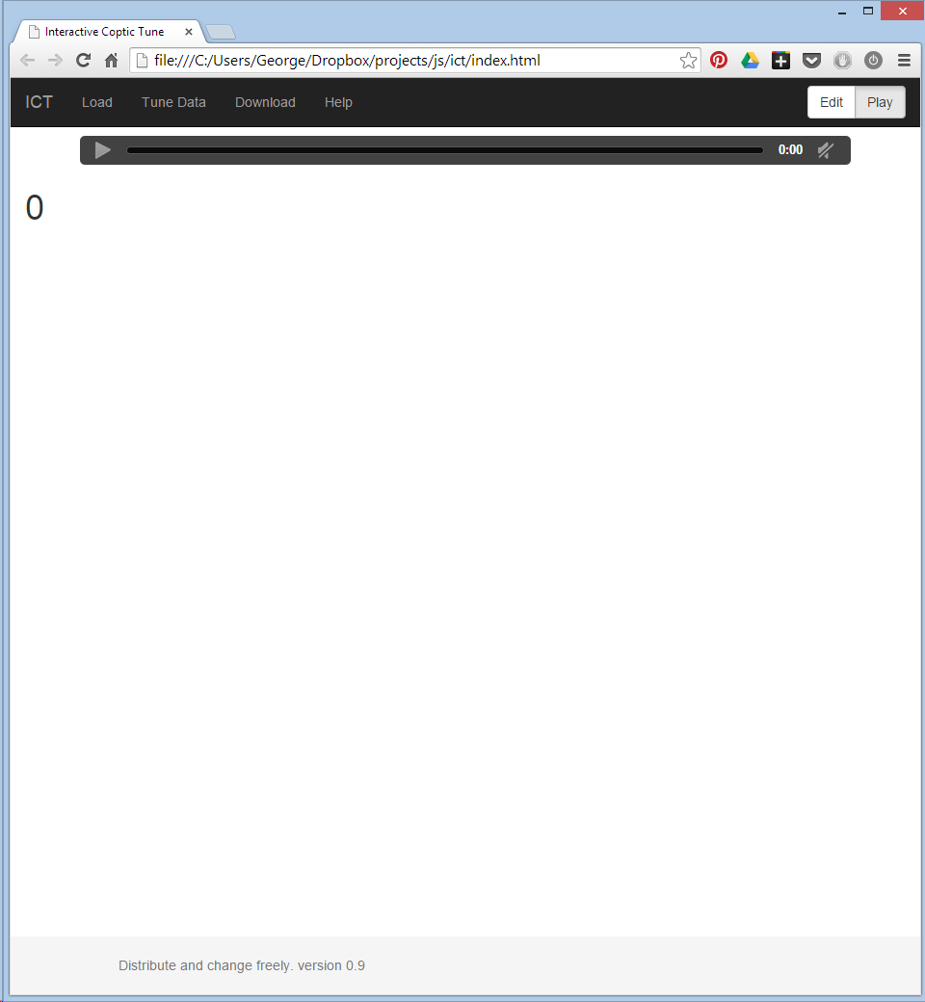Open **index.html** file in your browser (Google Chrome preferably) by double clicking on it.
2. 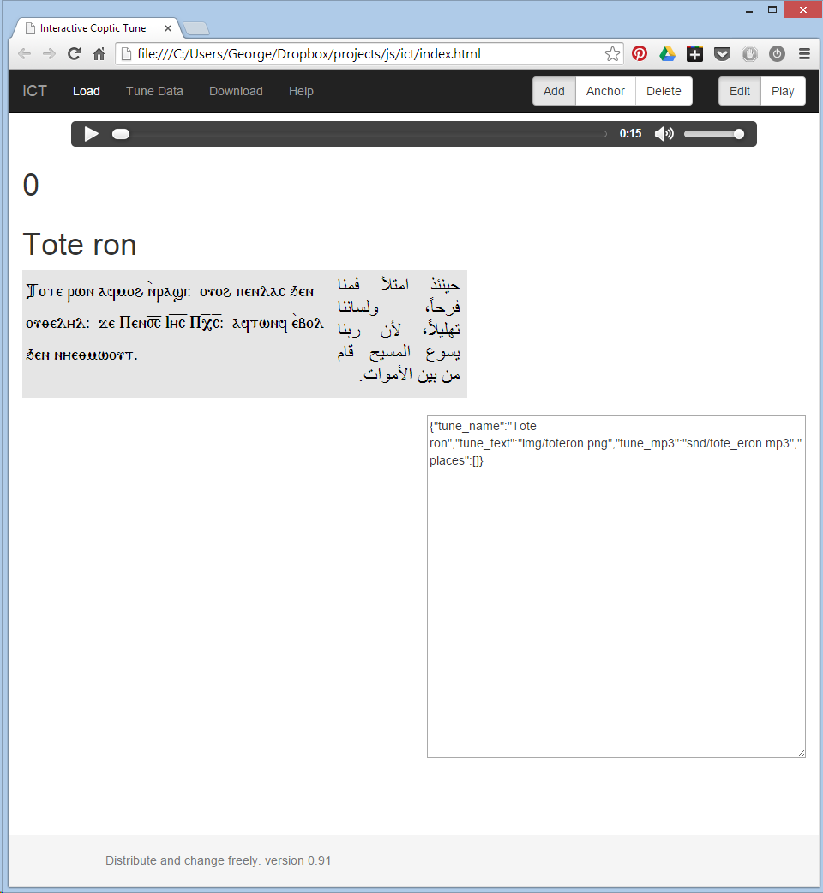Click on the **Edit** button on the top right corner, and then click on **Load** button on the top left corner after **ICT** link. The tune image and sound will be loaded.
3. First, an anchor point should be created. It the first point in the tune. The one that will start the animation. Click on the **Anchor** button at the top right.
4. 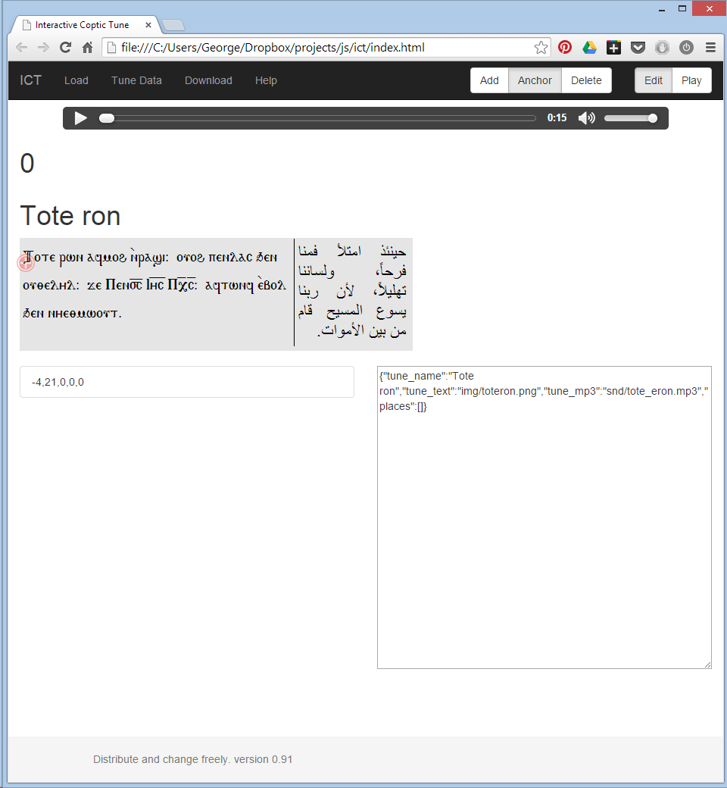Click on the tune image in the position where the tune should be started at time zero. A point marked with white cross in a red circle will be created.
5. If the previous click has been on wrong position, click on the **Delete** button at the top right, then click on the point. The point will be delete. This action can be taken in case of any mistakes or modifications are needed.
6. Click on the **Add** button on the top right.
7. Play the tune in the audio player either play clicking the play button or pressing **p** on te keyboard.
8. 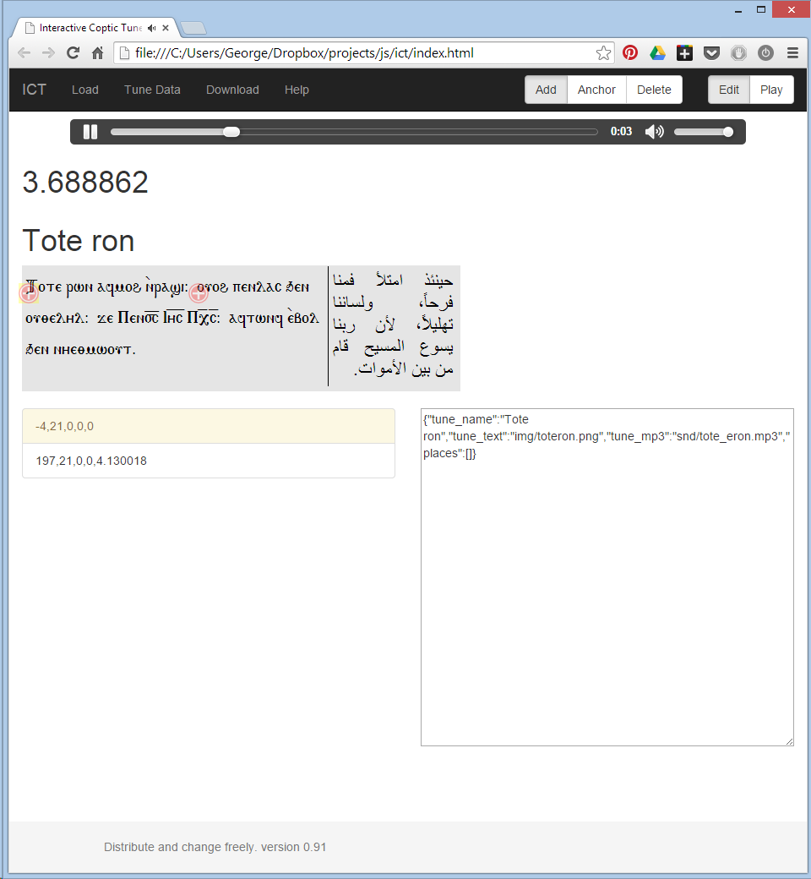When you hear the place you like in the tune, click on the tune image position that this related to this place.
9. 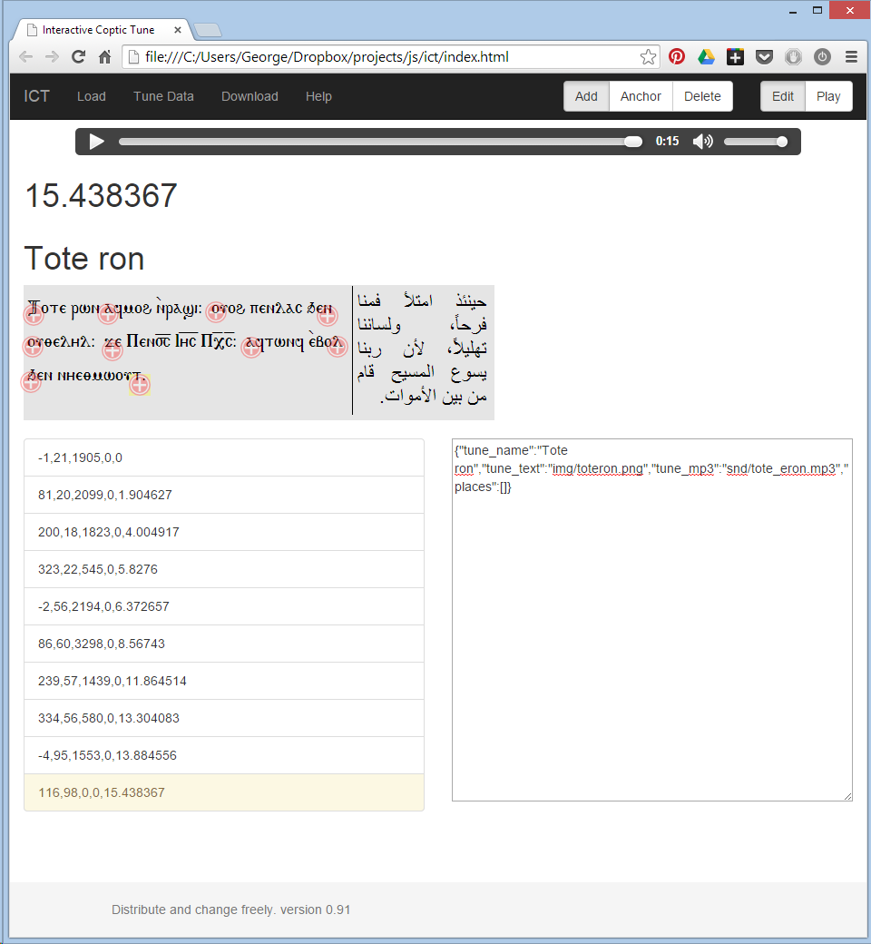Repeat the previous step as much as you needed. You can repeat the tune using the audio player controls and repeat the previous step many times.
10. 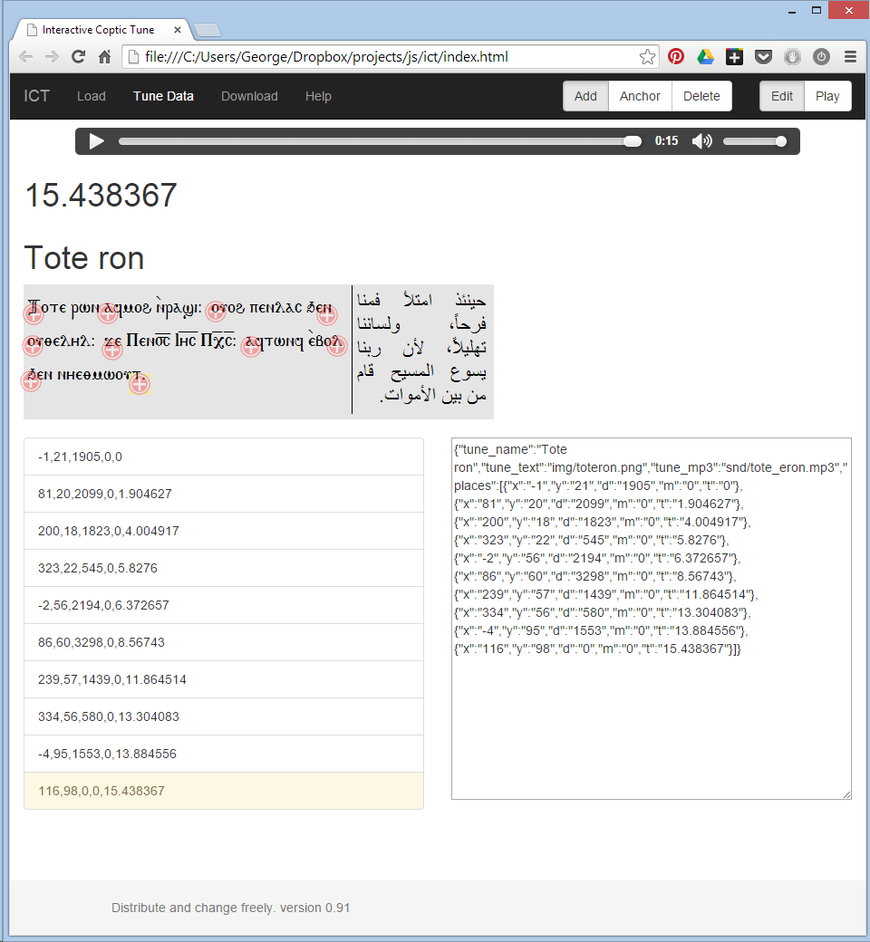At the end, click on the **Tune Data** button at the top left. This will display the points’ data you just created in the text area in the bottom right. Copy this data.
11. Paste the tune data and replace the old data in **js/tune_data.js** file.
12. Enjoy. Pray for me.