College Event Calendar Using HTML5 and CSS Grid

Abstract
In modern educational institutions, managing and tracking events efficiently is essential for both students and faculty. This paper presents the design and development of a College Event Calendar using HTML5 and CSS Grid. The system provides a user-friendly interface to display academic schedules, cultural events, and important announcements in a structured calendar format. By leveraging modern web technologies, the proposed solution ensures responsiveness, accessibility, and ease of use across different devices. The application simplifies event management and improves communication within the institution.
Keywords: HTML5, CSS Grid, Web Development, Event Management, Calendar UI
1. Introduction
Colleges conduct various events such as seminars, exams, workshops, and cultural programs. Managing these events manually or through scattered platforms can lead to confusion and missed information. A centralized digital calendar helps in organizing and presenting event data effectively.
The aim of this project is to develop a web-based College Event Calendar that visually represents events in a structured format. Using HTML5 and CSS Grid, the application ensures a modern layout and better user experience. The system allows users to view events by date and provides clear categorization of activities.
2. Literature Survey
Existing event management systems often rely on complex frameworks or require backend integration. While tools like Google Calendar provide similar functionality, they are not customized for institutional needs.
Previous studies suggest that lightweight front-end solutions using HTML and CSS can effectively deliver calendar interfaces without heavy dependencies. CSS Grid, in particular, offers flexible layout control, making it suitable for designing calendar-based applications.
3. System Design and Methodology
The proposed system is developed using basic web technologies:
HTML5: Used to structure the calendar layout and event elements.
CSS Grid: Used to design a responsive and visually appealing calendar interface.
JavaScript (optional): Can be used for dynamic event handling.
Working Principle:
The calendar is divided into rows and columns representing weeks and days.
Events are mapped to specific dates using structured HTML elements.
CSS Grid aligns the calendar into a clean, organized format.
Responsive design ensures compatibility across devices.
Features:
Monthly calendar view
Event highlighting
Simple and clean UI
Responsive design

4. Implementation
The system is implemented using a grid-based layout where each cell represents a day of the month. Events are displayed within these cells. CSS styling enhances readability and usability.
Basic steps involved:
Creating calendar structure using HTML
Applying grid layout using CSS
Styling events with colors and fonts
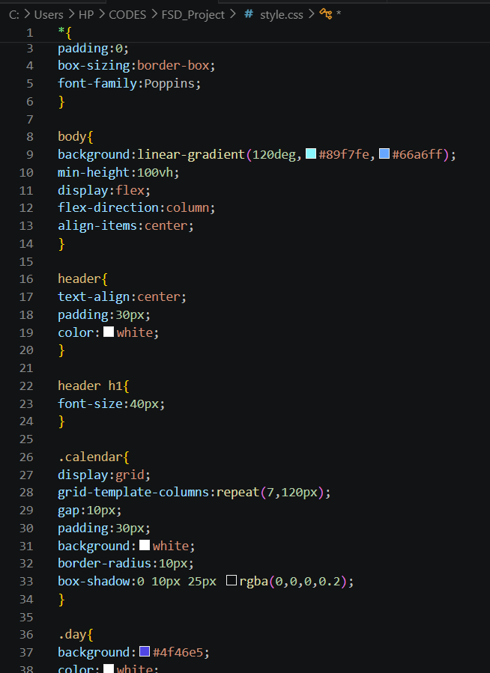
Testing responsiveness on different screen sizes

5. Results and Discussion
The developed calendar successfully displays events in an organized manner. Users can easily identify event dates and details. The use of CSS Grid ensures proper alignment and responsiveness.
Advantages:
Easy to develop and maintain
No heavy backend required
Fast loading and lightweight
Limitations:
Limited dynamic functionality without JavaScript
No database integration in basic version

6. Conclusion
The College Event Calendar provides an efficient way to manage and display institutional events. By using HTML5 and CSS Grid, the system achieves a balance between simplicity and functionality. It enhances user experience and ensures better communication of event schedules.

7. Future Scope
The project can be further improved by:
Adding a backend database for event storage
Implementing user login and admin controls
Integrating notifications and reminders
Making it a full-stack web application
