Tour Guide Application Using Web Technologies

Abstract
Tourism plays a significant role in economic and cultural development. However, travelers often face difficulties in finding reliable information about destinations, routes, and nearby services. This paper presents the design and development of a Tour Guide Application that provides users with essential travel information in a simple and accessible manner. The application is developed using modern web technologies and aims to enhance the travel experience by offering location details, attractions, and navigation assistance. The system is designed to be user-friendly, responsive, and efficient.
Keywords: Tour Guide App, Web Development, Travel Assistance, Navigation, User Interface

1. Introduction
With the rapid growth of tourism, there is an increasing need for digital solutions that help travelers explore new places efficiently. Traditional tour guides may not always be available or affordable, making mobile and web-based applications a better alternative.
The Tour Guide Application aims to provide tourists with all necessary information such as popular destinations, routes, and nearby facilities. This project focuses on building a simple and effective system using web technologies that can be accessed anytime and anywhere.

2. Literature Survey
Existing travel applications like Google Maps and TripAdvisor provide extensive features but can be complex and data-heavy. Research indicates that lightweight applications tailored to specific user needs can improve usability and performance.
Previous systems have focused on GPS-based tracking, recommendation systems, and user reviews. However, many lack simplicity and offline accessibility. This project addresses these issues by designing a basic yet effective tour guide interface.

3. System Design and Methodology
The application is developed using the following technologies:
HTML5: For structuring web pages
CSS: For styling and responsive design
JavaScript: For interactive features
(Optional APIs): Maps or location services
Working Principle:
Users open the application and select a location.
The system displays information about tourist attractions.
Navigation details and nearby services are shown.
Users can explore different locations easily through the interface.
Features:
Location-based information
Tourist attractions listing
Simple navigation guidance
Responsive and user-friendly UI
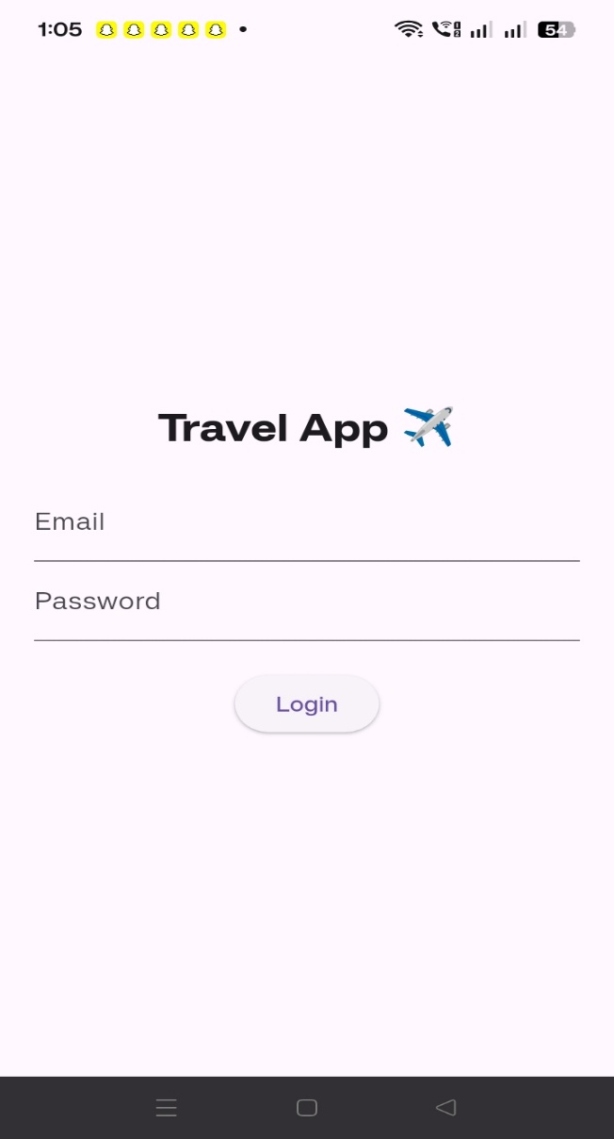

4. Implementation
The application interface is designed with a focus on simplicity. Pages are created using HTML, styled using CSS, and enhanced with JavaScript for dynamic behavior.
Steps involved:
Designing homepage and navigation structure
Creating destination pages
Adding interactive elements using JavaScript
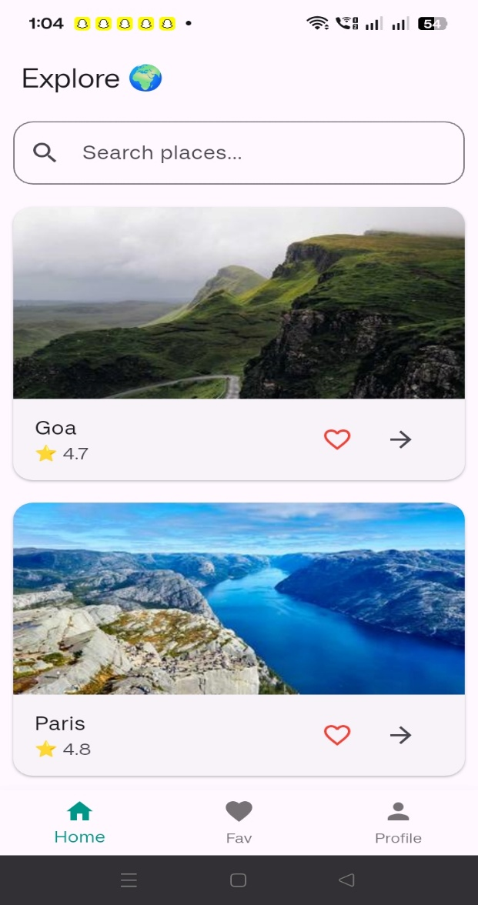
Testing across devices for responsiveness

5. Results and Discussion
The developed application successfully provides basic tour guidance features. Users can easily access information about different locations and navigate through the system.
Advantages:
Easy to use
Lightweight and fast
Accessible on multiple devices
Limitations:
Limited real-time data without APIs
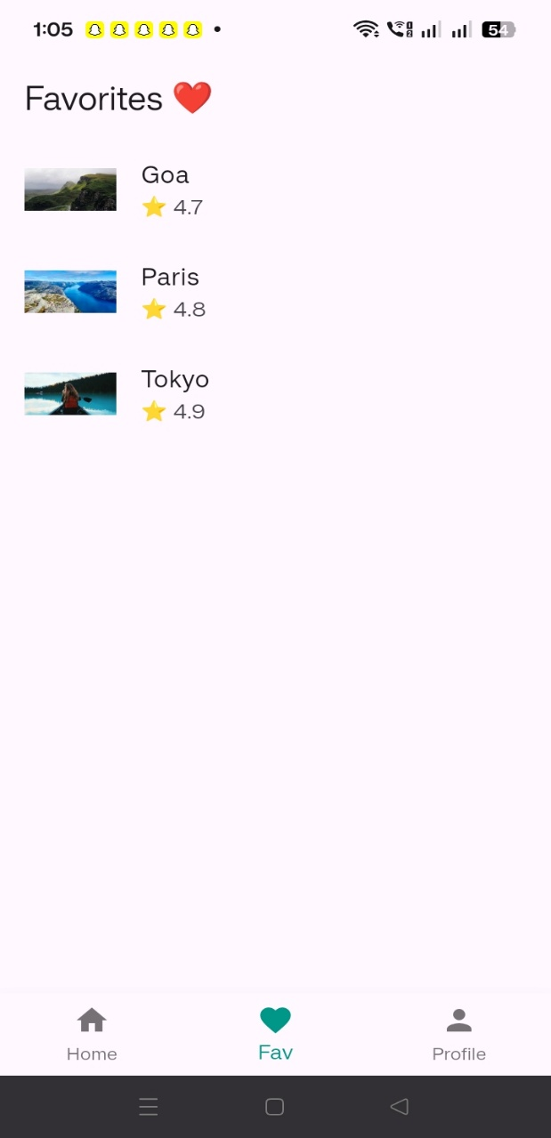
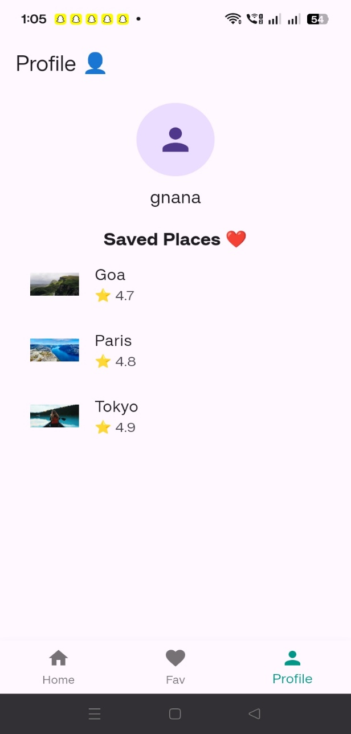
No advanced recommendation system

6. Conclusion
The Tour Guide Application serves as a useful tool for travelers by providing essential information in a simple format. It demonstrates how basic web technologies can be used to build effective real-world applications.

7. Future Scope
The project can be enhanced by:
Integrating GPS and live maps
Adding user reviews and ratings
Supporting offline access
Developing a mobile app version
Implementing AI-based recommendations

