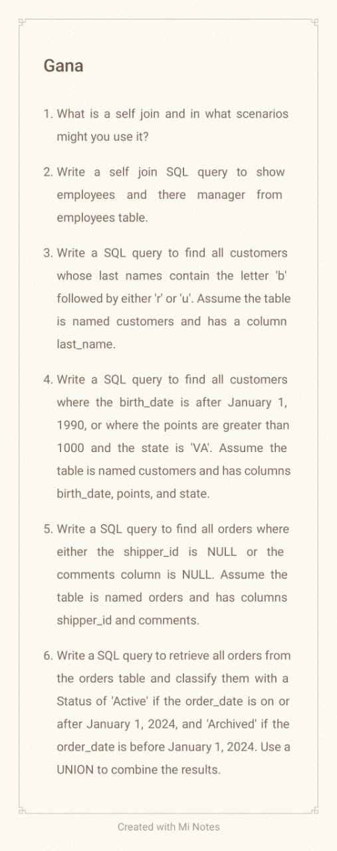

1.what is self join and the scenario?

ANS. self join is nothing but joining the single table by comparing

the data of that table columns.---Here i'm using sql_hr table by

comparing the column date,And the scenario is to state that who (employees)

is reporting to whom(manager).

2.QUESTION

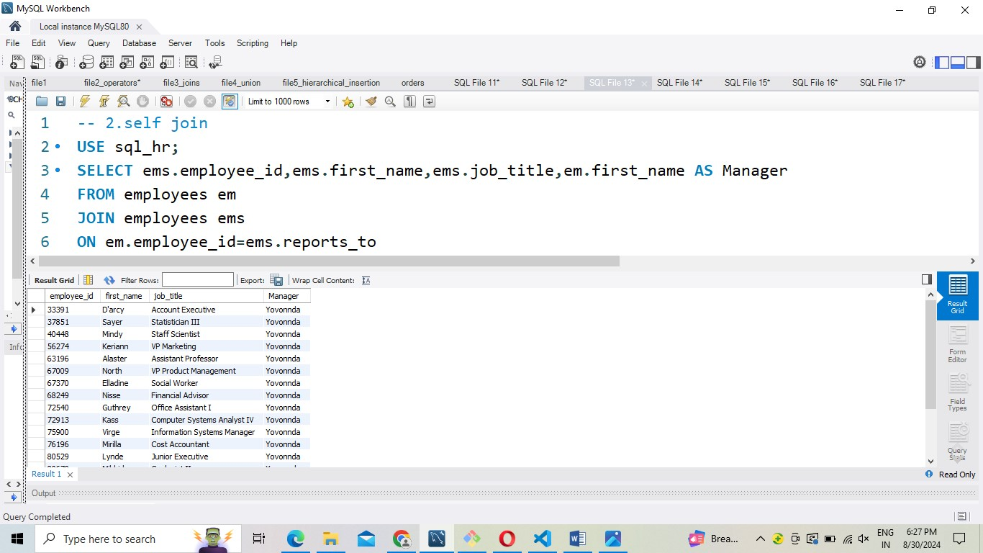

3.QUESTION

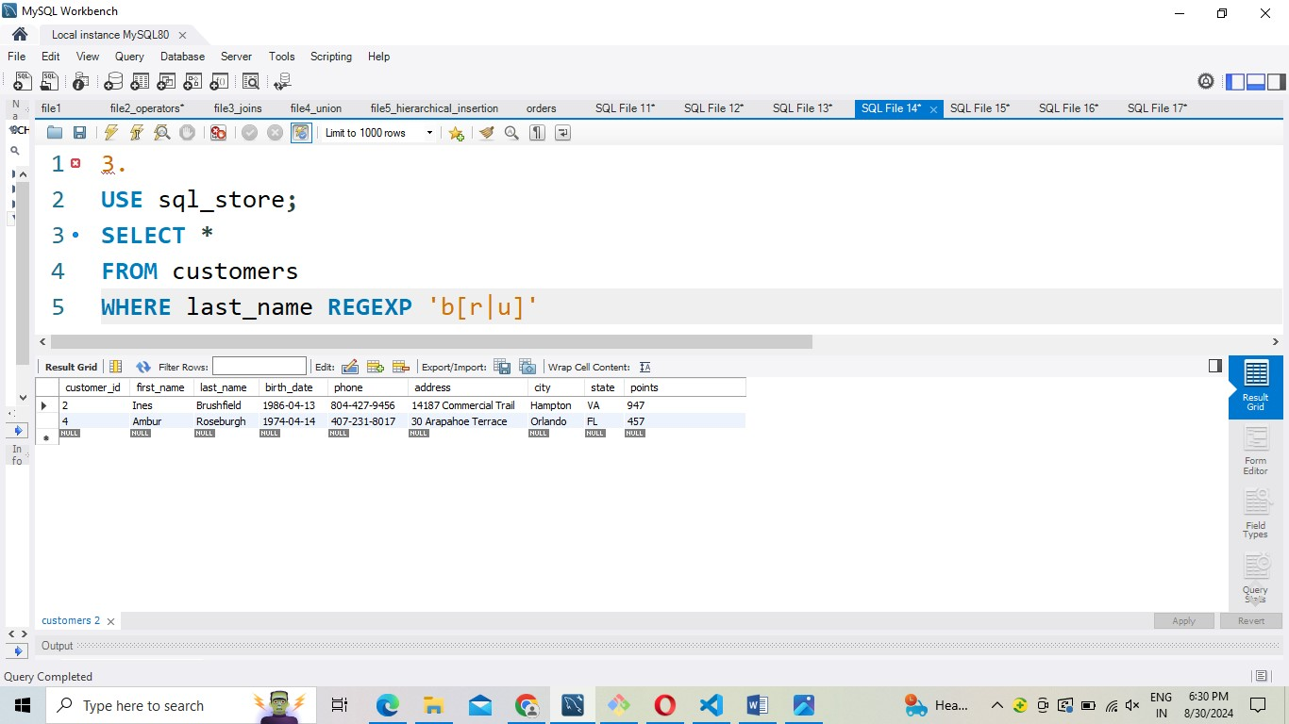

4.QUESTION

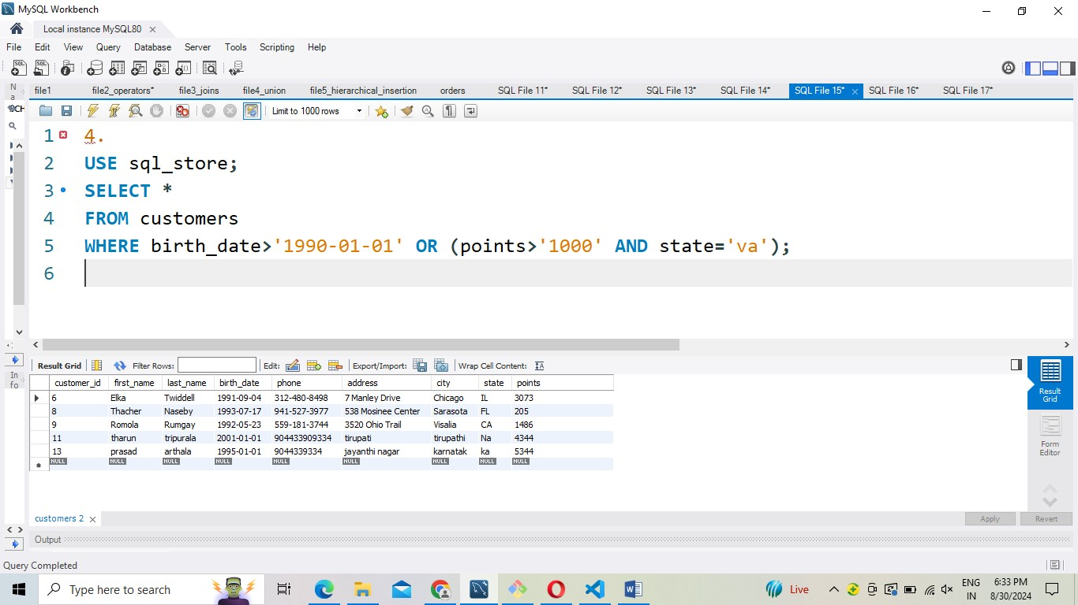

5.QUESTION

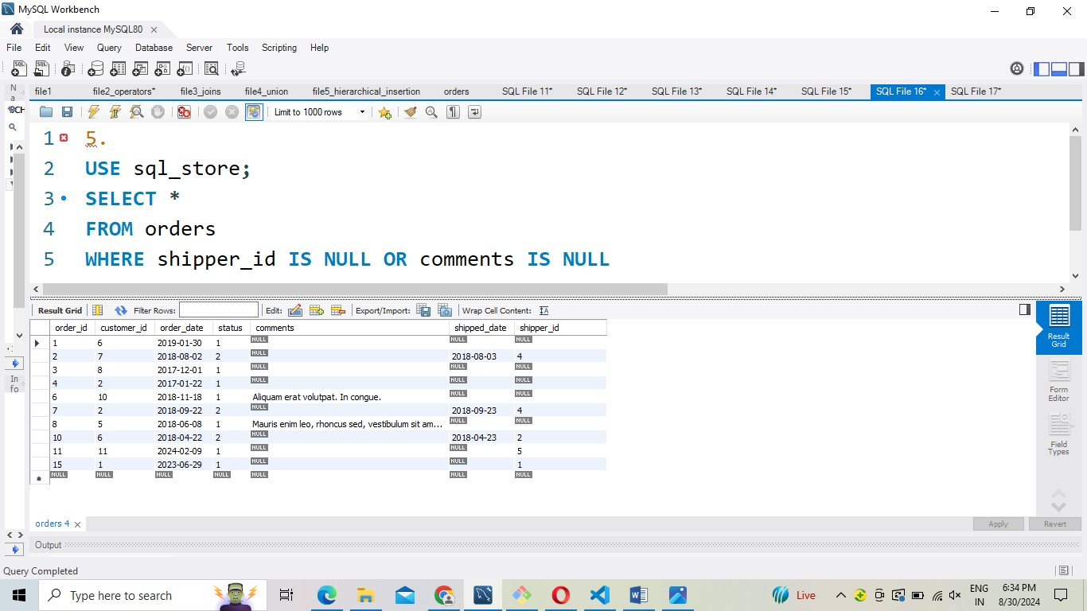

6.QUESTION

