33333333SIMATS ENGINEERING
ASSESSMENT TOOL 1

COURSE NAME: Database Management Systems
COURSE CODE: CSA0501

COURSE OUTCOME COVERED

CO1: Analyze DBMS architecture, different data models, schema types, and design ER/EER diagrams, relational schemas for case-based scenarios by identifying entities and relationships. (BL1, BL2)

Activity Tool : Short Answer Text(High)
Assessment Tool Weightage: 30%

Dr

QUESTIONS Total Marks: 50
Q.No | Question | Bloom's Level | Marks
1 | UPS Product Tracking Information System  UPS prides itself on having up-to-date information on the processing and current location of each shipped item. To do this, UPS relies on a company-wide information system. Shipped items are the heart of the UPS product tracking information system. Shipped items can be characterized by item number (unique), weight, dimensions, insurance amount, destination, and final delivery date. Shipped items are received into the UPS system at a single retail center. Retail centers are characterized by their type, uniqueID, and address. Shipped items make their way to their destination via one or more standard UPS transportation events (i.e., flights, truck deliveries). These transportation events are characterized by a unique scheduleNumber, a type (e.g, flight, truck), and a deliveryRoute. Create an Entity Relationship diagram that captures this information about the UPS system. | BL1 – Remember | 5
2 | Course Management System  Consider a university database for the scheduling of classrooms for final exams. This database could be modeled as the single entity set exam, with attributes course-name, section-number, room-number, and time. Alternatively, one or more additional entity sets could be defined, along with relationship sets to replace some of the attributes of the exam entity set, as  • course with attributes name, department, and c-number  • section with attributes s-number and enrollment, and dependent as a weak entity set on course  • room with attributes r-number, capacity, and building  Show an E-R diagram illustrating the use of all three additional entity sets listed. | BL2 – Understand | 5
3 | University Registrar’s Office Management System  A university registrar’s office maintains data about the following entities:  - courses, including number, title, credits, syllabus, and prerequisites;  - course offerings, including course number, year, semester, section number, instructor(s), timings, and classroom;  - students, including student-id, name, and program;  - instructors, including identification number, name, department, and title.  - Further, the enrollment of students in courses and grades awarded to students in each course they are enrolled for must be appropriately modeled.  Construct an E-R diagram for the registrar’s office. | BL2 – Understand | 5
4 | Hospital Management System  Construct an E-R diagram for a hospital with a set of patients and a set of medical doctors.  Associate with each patient a log of the various tests and examinations conducted. Construct appropriate tables for the above ER Diagram :  Patient(SS#, name, insurance)  Physician ( name, specialization)  Test-log( SS#, test-name, date, time)  Doctor-patient (physician-name, SS#)  Patient-history(SS#, test-name, date) | BL2 – Understand | 5
5 | Company Project Management System  Construct an ER Diagram for Company having following details :  Company organized into DEPARTMENT. Each department has unique name and a particular employee who manages the department. Start date for the manager is recorded. Department may have several locations.  • A department controls a number of PROJECT. Projects have a unique name, number and a single location.  • Company’s EMPLOYEE name, ssno, address, salary, sex and birth date are recorded. An employee is assigned to one department, but may work for several projects (not necessarily controlled by dept). Number of hours/week an employee works on each project is recorded; The immediate supervisor for the employee.  • Employee’s DEPENDENT are tracked for health insurance purposes (dependentname, birthdate, relationship to employee). | BL2 – Understand | 5
6 | Explain schema and instance with examples. Distinguish between logical schema, physical schema, and view schema. | BL1 – Remember | 5
7 | Identify the entities, attributes, and relationships for a Bank Management System and construct its ER diagram. | BL2 – Understand | 5
8 | Explain the Extended ER (EER) model. Describe the concepts of generalization, specialization, and aggregation. | BL2 – Understand | 5
9 | Design an EER diagram for a Hospital Management System incorporating inheritance and weak entities. | BL2 – Understand | 5
10 | Explain the role of a DBA (Database Administrator) and the responsibilities associated with the position. | BL1 – Remember | 5

Code of Conduct:

I D. Gnanadeepthi (192411123)(Name / Reg No) certify that this submission is my original work and that I have adhered to the guidelines specified for this assessment.
I understand that any violation of academic integrity rules will result in disciplinary action.

Signature of the student: D. Gnanadeepthi

1. Ans:
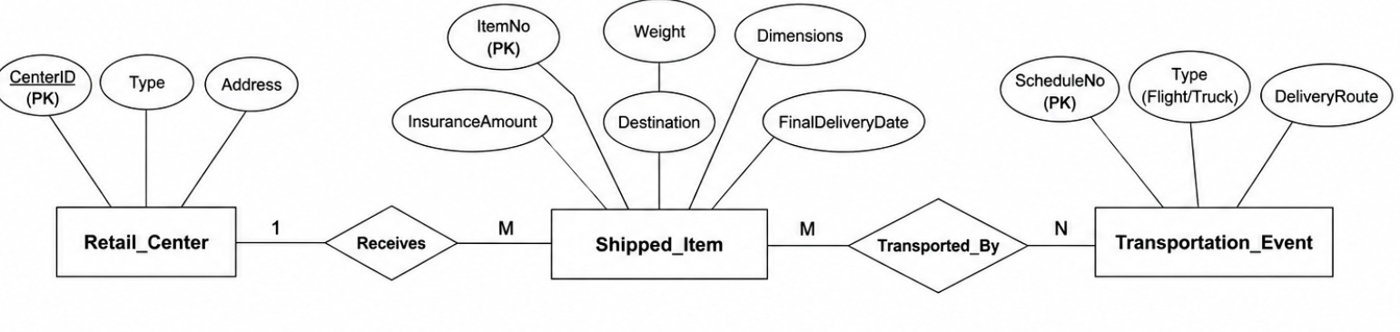

2 Ans:
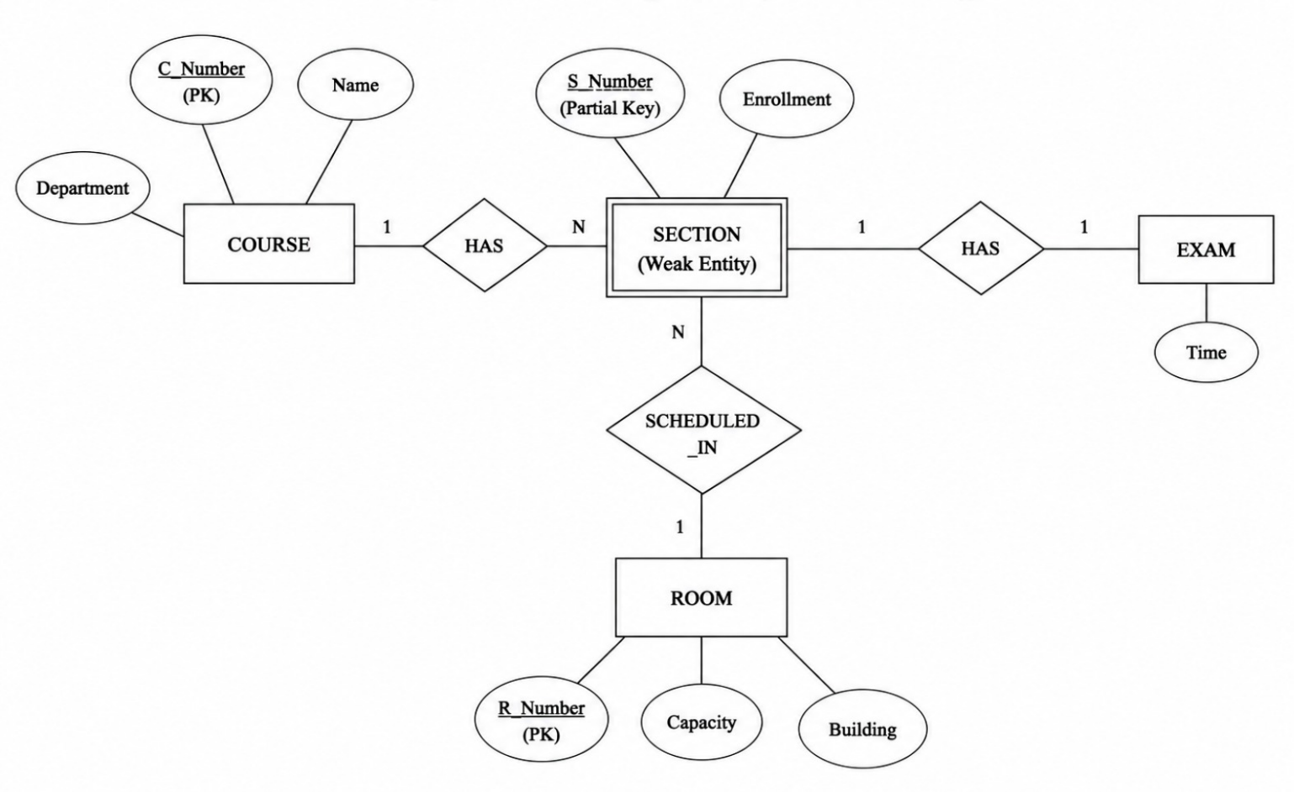

3. Ans:
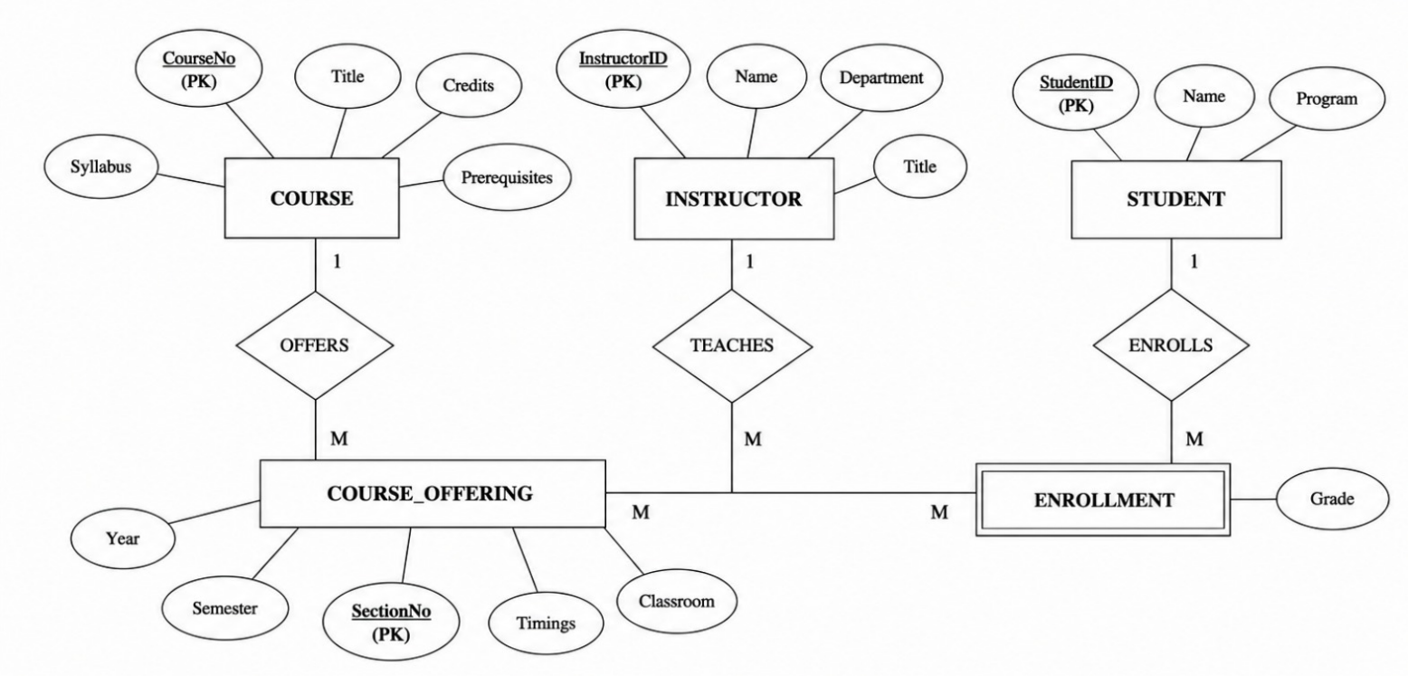

4. Ans:
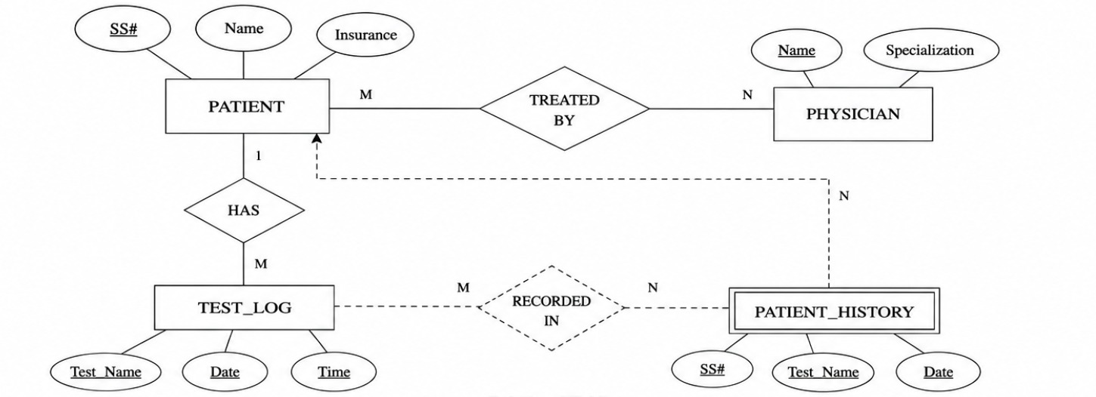
5. Ans:
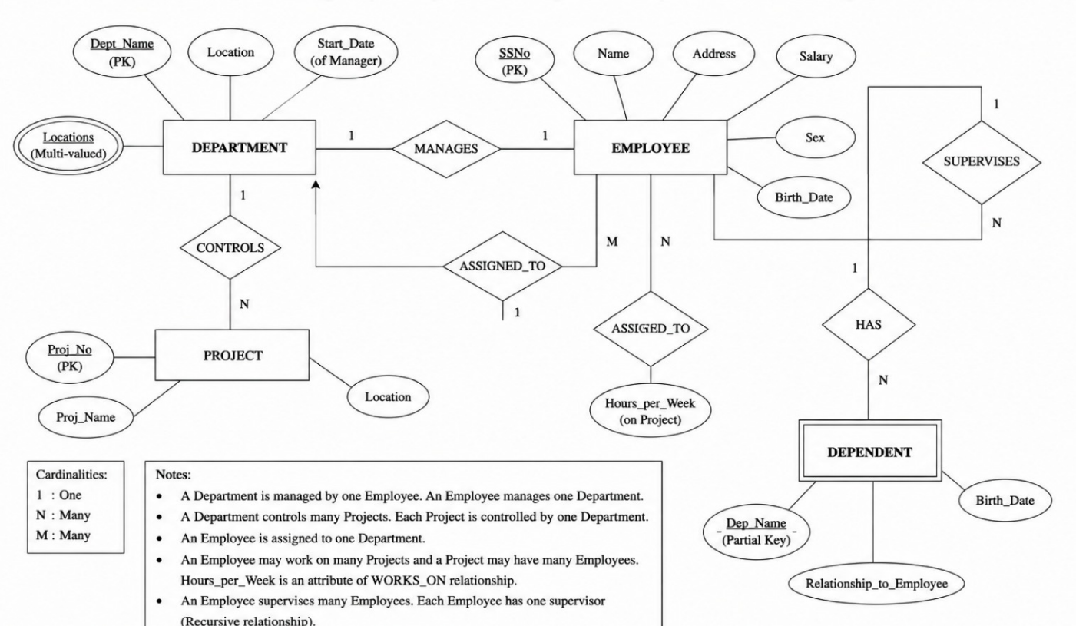

6. Ans:
Schema
A schema is the blueprint or structure of a database. It defines tables, columns, and relationships.
Example:
Student(Student_ID, Name, Department, Age)
Instance
An instance is the actual data stored in the database at a particular time.
Example:
Student_ID | Name | Department | Age
101 | Rahul | CSE | 20

Schema vs Instance
Schema | Instance
Database structure | Actual data
Changes rarely | Changes frequently

Types of Schema
- Logical Schema: Defines tables, attributes, and relationships.
Example: Student(Student_ID, Name, Age)
- Physical Schema: Defines how data is stored on disk (files, indexes).
- View Schema: Defines what a user can see.
Example: Student view shows only Student_ID, Name, and Department (Age hidden).

7. Ans
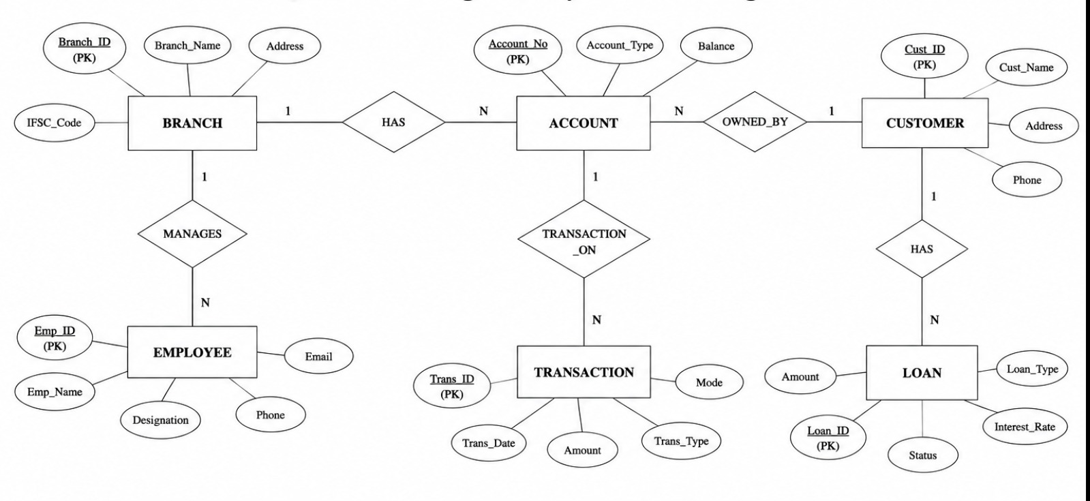

8. Ans
Extended ER (EER) Model
The Extended Entity-Relationship (EER) model is an extension of the ER model. It includes advanced concepts like generalization, specialization, and aggregation to represent complex database relationships.
1. Generalization
- Generalization combines similar lower-level entities into a higher-level entity.
- It is a bottom-up approach.
Example:
Car and Bike → Vehicle
2. Specialization
- Specialization divides a higher-level entity into lower-level entities based on specific characteristics.
- It is a top-down approach.
Example:
Employee → Manager, Engineer, Clerk
3. Aggregation
- Aggregation treats a relationship between entities as a higher-level entity so it can participate in another relationship.
Example:
An Employee works on a Project. This Works_On relationship is aggregated to relate with a Manager who supervises it.

Concept | Description | Example
Generalization | Combines entities into one higher-level entity | Car, Bike → Vehicle
Specialization | Divides an entity into sub-entities | Employee → Manager, Engineer
Aggregation | Treats a relationship as an entity | Manager supervises Employee–Project relationship

9. Ans:
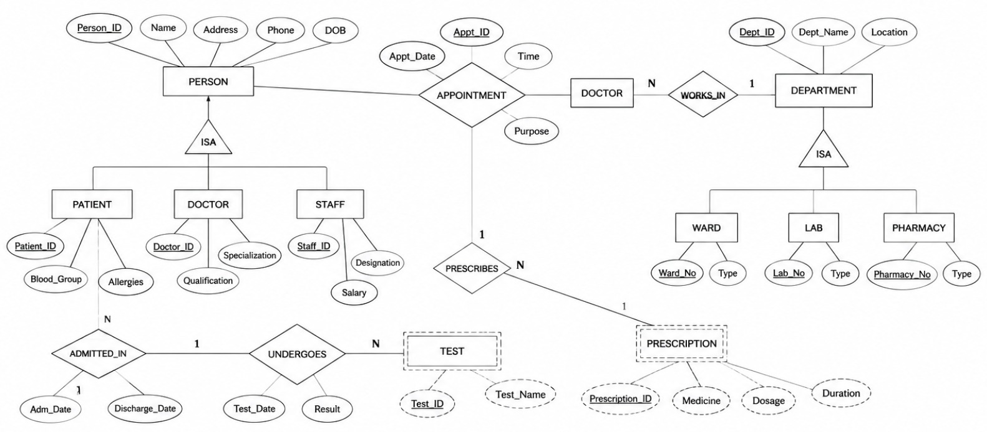

10. Ans:
Role of a Database Administrator (DBA)
A Database Administrator (DBA) is responsible for managing, maintaining, and securing a database to ensure it operates efficiently and reliably.
Responsibilities of a DBA
- Database Installation and Configuration: Install and set up the DBMS.
- Database Security: Create user accounts and control access to data.
- Backup and Recovery: Perform regular backups and restore data when needed.
- Performance Monitoring: Optimize database performance and resolve issues.
- Data Integrity: Ensure data is accurate, consistent, and reliable.
- Database Maintenance: Update, monitor, and maintain the database regularly.
RUBRICS FOR CALCULATION:

Criteria | Weightage | Level 4 (Exemplary) | Level 3 (Proficient) | Level 2 (Developing) | Level 1 (Beginning)
Concept Identification | 30% | Demonstrates  clear and  complete  understanding of  the concept | Good  understanding  with minor  gaps | Basic  understanding  with some  misconceptions | Poor or  incorrect  understandin  g
Linkages | 25% | Completely  correct answer  with no errors | Mostly correct  with minor  errors | Partially correct  with noticeable  errors | Incorrect or  irrelevant  answer
Organization | 20% | Correctly applies  concepts to solve  the  question/problem | Applies  concepts with  minor  mistakes | Limited or  partially correct  application | No or  incorrect  application
Integration of Literature | 15% | Covers all  required parts of  the question | Covers most  parts with  minor  omissions | Covers only  some parts | Incomplete  or missing  response
Clarity | 10% | Clear, concise,  and well-  organized answer | Understandabl  e with minor  issues | Somewhat  unclear or poorly  structured | Difficult to  understand

