Blackstone — daily scrum update US East
Thursday, June 18, 2026 · Report generated 12:45 PM IST
At a glance
Compliance | API requests | Slow req ≥30s | Open incidents
100% | 522  Max 3.76s resp. | 0 | 3  #134003, #131077, #131076

Platform performance — US East (N-2 metric)
Metric | Value
Total accounts | 175
Completed jobs (24h) | 524
Tenants impacted | 0
Pending N-2 accts | 0
Older backlog | 0
Compliance % | 100%

Service metric (COST)
Metric | Value
Total requests (24h) | 522
Max response time | 3.76 sec
Slow requests ≥30s | 0
Users impacted | 0
Health status | Good

Pendo engagement — Blackstone segment · last 3 days (16 Jun – 18 Jun)
Source: Blackstone Pendo segment only. cs.support.blackstone@corestack.io excluded. Grey rows = segment members with no activity in this window.
Visitor | Domain | Events (3d) | Days active | Minutes | Last seen
robert young | bluemantis.com | 152 | 1 | 10 | 16 Jun
adam schutska | bluemantis.com | — | — | — | 15 Jun
bhavana prabhuswamy | bluemantis.com | — | — | — | 15 Jun
rj gravel | bluemantis.com | — | — | — | 19 May
abagchi | corestack.io | — | — | — | 2 Jun
cspbillingapi | bluemantis.com | — | — | — | 26 May

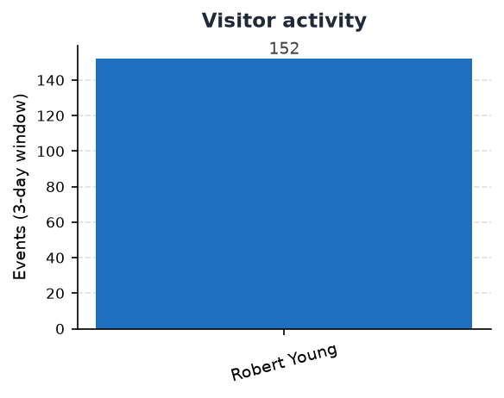 | 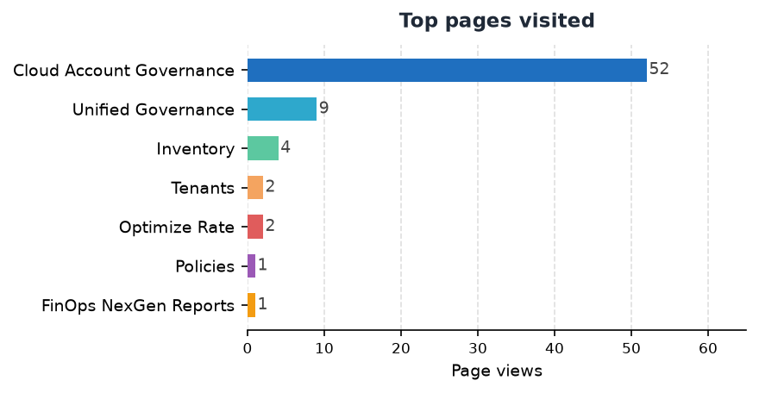

Top pages visited
Page | Views
Cloud Account Governance | 52
Unified Governance | 9
Inventory | 4
Tenants | 2
Optimize Rate | 2
Policies | 1
FinOps NexGen Reports | 1

Blackstone incidents — ADO status
ADO query: https://dev.azure.com/CoreStack-Tech/Product_Mgmt/_workitems?filter=tags+eq+'Blackstone'
ID | Title | Assigned to | Bundle | Pri | State | Type
134003 | Assessment Report UI Error Despite Successful Report Generation | Zubair | Analytics | P2 | In Progress | Bug
131077 | Blackstone - Rover - Forecast data missing | Aadhithya Shanmugapriyan | FinOps | P2 | New | Bug
131076 | Blackstone - RBAC permission issue on tenant view | Aadhithya Shanmugapriyan | Core | P3 | Awaiting Deployment | Bug

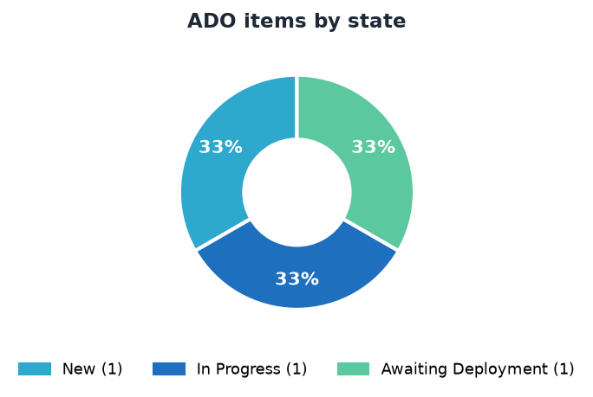 | 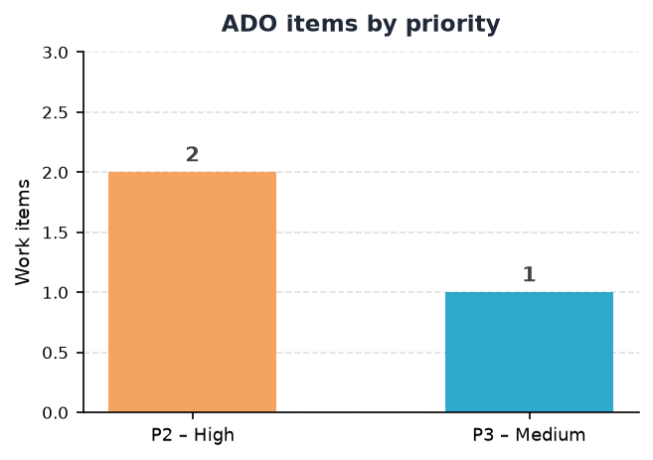

Blackstone — daily scrum update EU
Thursday, June 18, 2026 · Report generated 12:45 PM IST
At a glance
Compliance | API requests | Slow req ≥30s | Open incidents
100% | 522  Max 3.76s resp. | 0 | 3  #134003, #131077, #131076

Platform performance — EU (N-2 metric)
Metric | Value
Total accounts | 175
Completed jobs (24h) | 524
Tenants impacted | 0
Pending N-2 accts | 0
Older backlog | 0
Compliance % | 100%

Service metric (COST)
Metric | Value
Total requests (24h) | 522
Max response time | 3.76 sec
Slow requests ≥30s | 0
Users impacted | 0
Health status | Good

Pendo engagement — Blackstone segment · last 3 days (16 Jun – 18 Jun)
Source: Blackstone Pendo segment only. cs.support.blackstone@corestack.io excluded. Grey rows = segment members with no activity in this window.
Visitor | Domain | Events (3d) | Days active | Minutes | Last seen
timo pantsari | blackstone.com | — | — | — | 15 Jun
alex | aliando.com | — | — | — | 1 Jun
dipali koche | bluemantis.com | — | — | — | 1 Jun
chris | aliando.com | — | — | — | 4 Jun
dene donovan | ingrammicro.com | — | — | — | 9 Jun

 | 

Top pages visited
Page | Views
Cloud Account Governance | 52
Unified Governance | 9
Inventory | 4
Tenants | 2
Optimize Rate | 2
Policies | 1
FinOps NexGen Reports | 1

Blackstone incidents — ADO status
ADO query: https://dev.azure.com/CoreStack-Tech/Product_Mgmt/_workitems?filter=tags+eq+'Blackstone'
ID | Title | Assigned to | Bundle | Pri | State | Type
134003 | Assessment Report UI Error Despite Successful Report Generation | Zubair | Analytics | P2 | In Progress | Bug
131077 | Blackstone - Rover - Forecast data missing | Aadhithya Shanmugapriyan | FinOps | P2 | New | Bug
131076 | Blackstone - RBAC permission issue on tenant view | Aadhithya Shanmugapriyan | Core | P3 | Awaiting Deployment | Bug

 | 
CoreStack · Cloud Operations Intelligence · Daily scrum report N-2 = jobs created 24h–48h ago · Slow = request ≥30s

