TITLE: Hospital Management System
TABLE NAMES:
*Patient
*Doctor
*Appointment
*Billing

SCHEMA DIAGRAM:
Patient:
p_id  Int PRIMARY KEY | p_name varchar(20)  Not null | p_age  Int | p_Gender  varchar(1)  CHECK | p_phno  mno

DOCTOR:
d_id  Int PRIMARY KEY | d_name  varchar(20)  Not null | d_spec  varchar(30)  Not null | d_phno  varchar(10) | d_email  Varchar(20)

APPOINTMENT:
a_id  INT PRIMARY KEY | Patient_ID INT  Fk | Doctor_ID INT  Fk | Date  DATE | Time  TIME

BILLING:
b_id  INT  PRIMARY KEY | Patient_ID  INT  Fk | Amount  Decimal (10,2) | Payment_Method VARCHAR(20) | Date  DATE

QUERY:

Drop table patient;
CREATE domain mno as varchar(10) check(value~ ‘^/d{10}$’);
CREATE TABLE Patient (
p_id INT PRIMARY KEY,
p_name VARCHAR(20) NOT null,
p_age INT,
p_Gender VARCHAR(1) check(p_Gender IN(‘F’,’M’)),
p_phno mno
);

INSERT INTO Patient VALUES
(1, ‘John ’, 30, ‘M’, ‘9876543210’),
(2, ‘Alice’, 25, ‘F’, ‘9876501084’),
(3, ‘Ravir’, 40, ‘M’, ‘7894561630’);

CREATE TABLE Doctor (
d_id INT PRIMARY KEY,
d_name VARCHAR(20) Not null,
d_Spec VARCHAR(30) Not null,
Phone mno ,
d_email VARCHAR(20)
);

INSERT INTO Doctor VALUES
(101, ‘Dr. Mehta’, ‘Cardiology’, ‘7891238560’, ‘mehta@hospital.com’),
(102, ‘Dr. Priya’, ‘Neurology’, ‘7810394071’, ‘priya@hospital.com’),
(103, ‘Dr. Sharma’, ‘Orthopedics’, ‘7908735562’, ‘sharma@hospital.com’);

CREATE TABLE Appointment (
a_id INT PRIMARY KEY,
Patient_ID INT REFERENCES Patient(p_id),
Doctor_ID INT REFERENCES Doctor(d_id),
Date DATE,
Time TIME
);

INSERT INTO Appointment VALUES
(201, 1, 101, ‘2025-07-21’, ’10:00:00’),
(202, 2, 103, ‘2025-07-21’, ’11:30:00’),
(203, 3, 102, ‘2025-07-22’, ’09:45:00’);

CREATE TABLE Billing (
b_id INT PRIMARY KEY,
Patient_ID INT REFERENCES Patient(p_id),
Amount DECIMAL(10,2),
Payment_Method VARCHAR(20),
Date DATE
);

INSERT INTO Billing VALUES
(301, 1, 1500.00, ‘Cash’, ‘2025-07-21’),
(302, 2, 2000.00, ‘Credit Card’, ‘2025-07-21’),
(303, 3, 1800.00, ‘UPI’, ‘2025-07-22’);
SELECT *FROM Patient;
SELECT*FROM Doctor;
SELECT*FROM Appointment;
SELECT*FROM Billing;
Alter table Patient rename to P_detail;
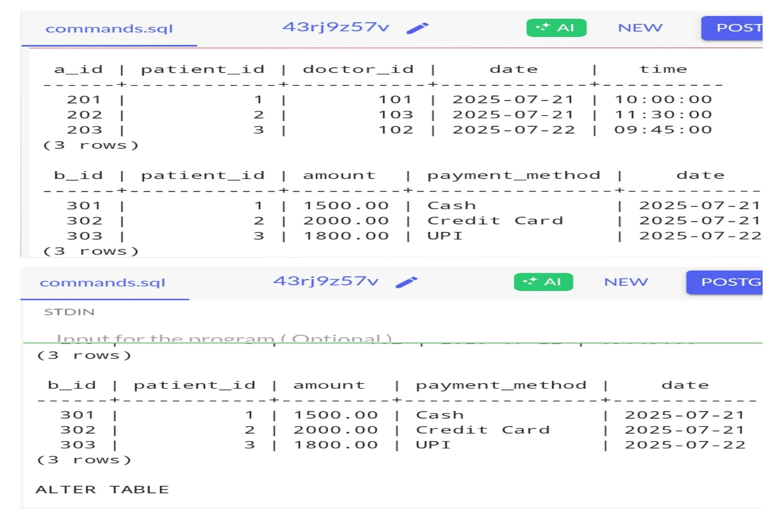
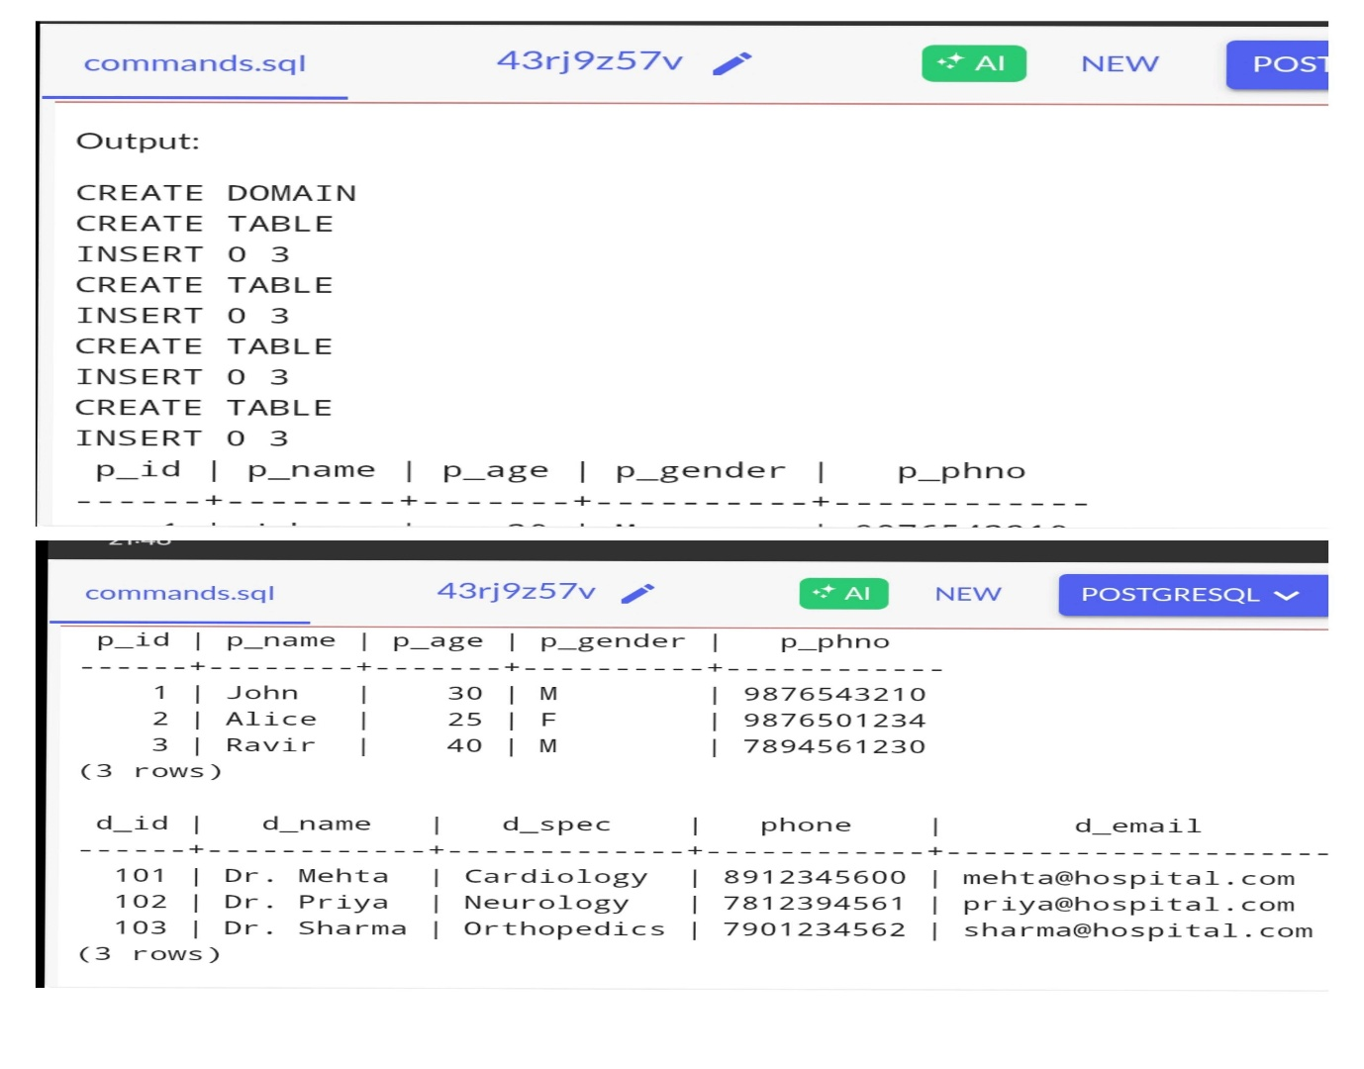
OUTPUT:

