Steps to Run the Application

1. Start the Database
Start the Postgres container:
docker compose up -d db

2. Set Up the Backend
cd backend && npm install && npm run migrate && npm run seed && npm start

3. Set Up the Frontend
Install dependencies and start the dev server:
cd frontend && npm install && npm run dev
The app will be available at http://localhost:5173.

4. Login Information
Email: hr.manager@acme.com
Password: Password123!

5. Screenshots

Login Page
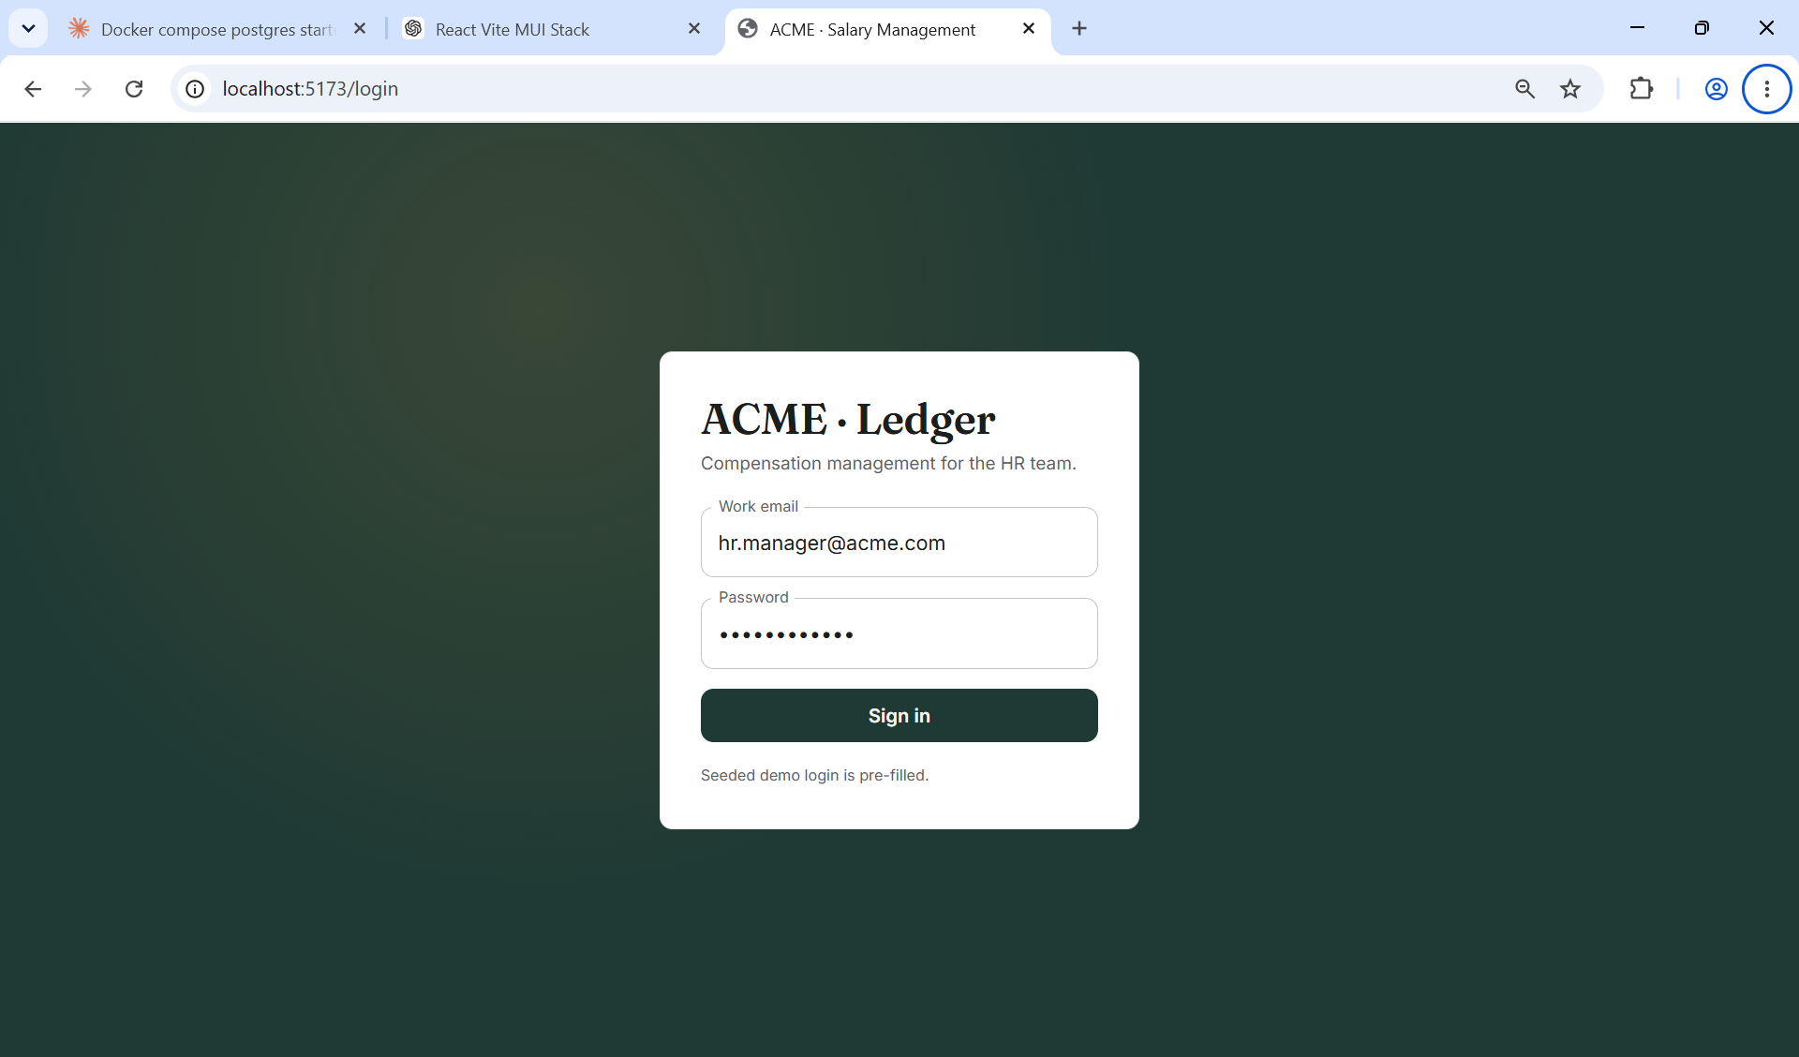

Dashboard
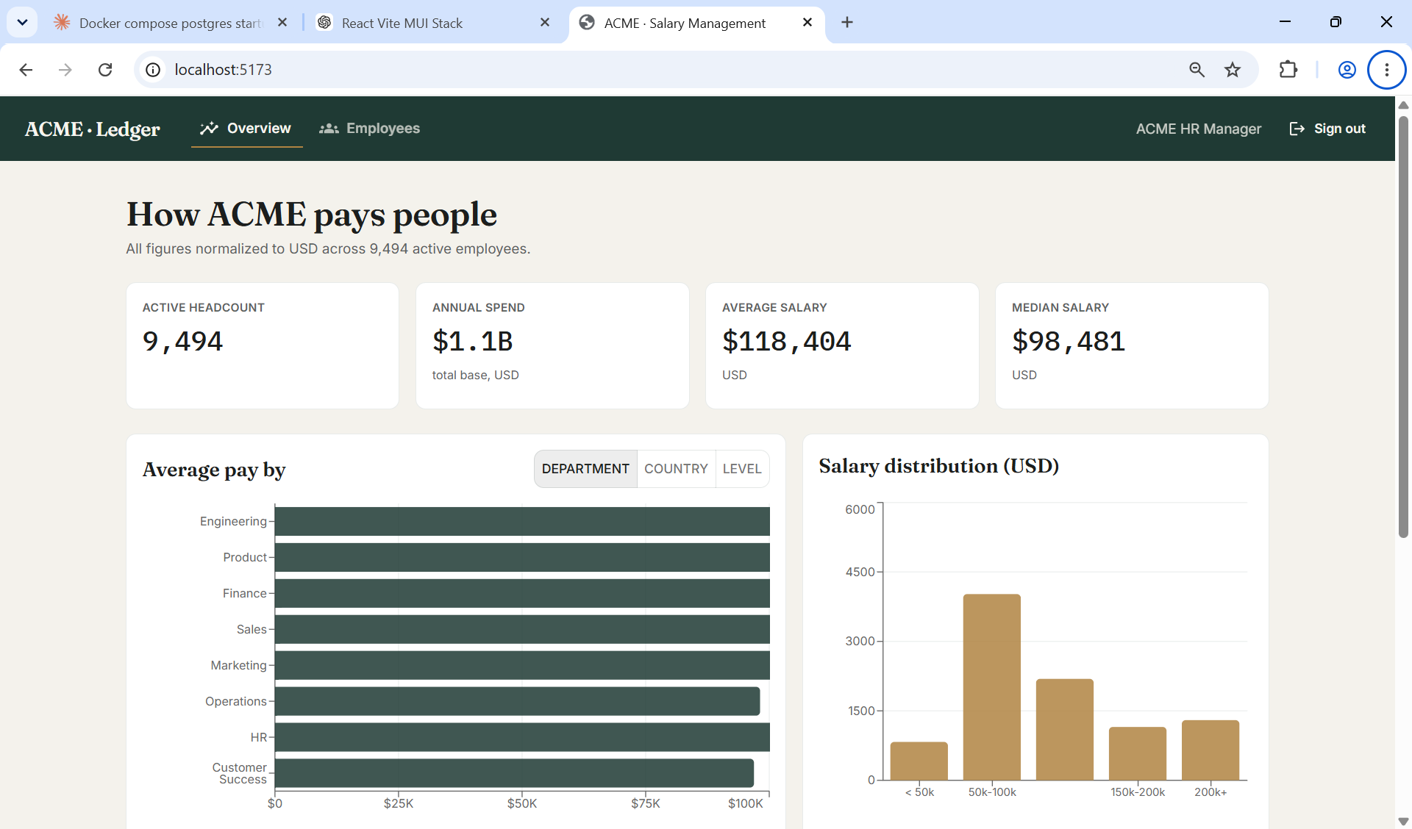

Employees
