CVR GNANA SAI  Chittoor, Andhra Pradesh, India | +91 7702137930 | gnanasaicvr@gmail.com | LeetCode: CVR_sai | 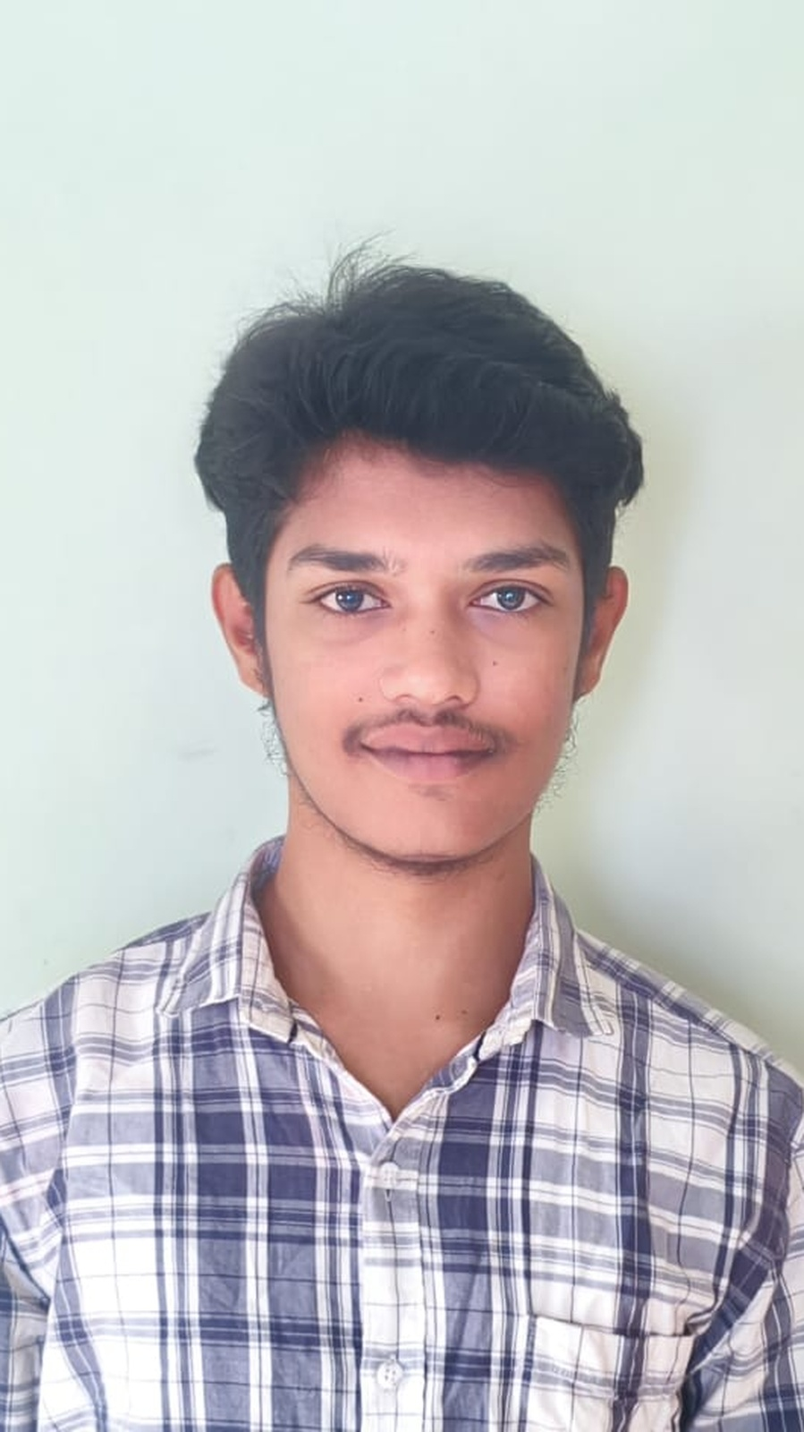
PROFESSIONAL SUMMARY
Computer Science Engineering student graduating in 2027 with a strong foundation in Java, Python, SQL, and DBMS. Experienced in developing academic and personal projects using programming and database concepts. A quick learner with strong problem-solving, teamwork, adaptability, and time-management skills, eager to apply technical knowledge to real-world challenges.
EDUCATION
Bachelor of Technology (B.Tech), Computer Science Engineering 2027 (Expected)
SASTRA University | CGPA: 8.20
Intermediate (MPC) 2023
Sri Vivekanandha Junior College | Percentage: 98.1%
Secondary School Certificate (SSC) 2021
LittleFlower English Medium High School | Percentage: 99.5%
SKILLS
- Programming Languages: Java, Python (Basic)
- Databases: MySQL
- Java Technologies: JDBC
- Core Concepts: Object-Oriented Programming (OOP), Database Management Systems (DBMS)
- Soft Skills: Adaptability, Quick Learner, Time Management
PROJECTS
Flood Prediction System – Personal Project
- Developed a machine learning model to predict floods using historical rainfall and water-level data.
- Preprocessed data by handling missing values, normalizing features, and performing feature selection to improve model accuracy.
- Trained and compared multiple machine learning models using Scikit-learn and selected the best-performing model based on accuracy metrics.
- Tools and Technologies: Python, Pandas, Scikit-learn
AI Placement Assistant using RAG and Local LLMs – Personal Project
- Built an AI-powered Placement Assistant using Flowise, Ollama, and Llama 3 with Retrieval-Augmented Generation (RAG) to analyze resumes, perform semantic search, and generate context-aware responses from uploaded PDF documents.
- Implemented Resume Analysis, Skill Gap Detection, Placement Readiness Scoring, and Personalized Interview Question Generation using vector embeddings and locally hosted LLMs.
EXTRACURRICULAR ACTIVITIES
- Cricket, SASTRA University: Represented the SASTRA University Cricket Team in inter-collegiate cricket competitions, demonstrating teamwork, discipline, and the ability to perform under pressure.
LANGUAGES
English, Telugu, Tamil

