Orthopoxvirus Genome Analysis for Species Classification and Virulence Prediction

G Gnanashree
BL.SC.U4AIE24014
CSE-AIE, Amrita School of Engineering
Amrita Vishwa Vidyapeetham, Bengaluru
Email: gnanashreegekkala@gmail.com

PVS Lalitha
BL.SC.U4AIE24031
CSE-AIE, Amrita School of Engineering,
Bengaluru
Email: wby1606@gmail.com

Y Likhitha Sree
BL.SC.U4AIE24056
CSE-AIE, Amrita School of Engineering,
Bengaluru
Email: likhithayarraguntla@gmail.com
Abstract
Orthopoxviruses are closely related DNA viruses that include Variola, Monkeypox, Cowpox, and Vaccinia, which differ in genetic diversity and virulence. Accurate classification and virulence prediction are important for understanding their evolution and public health impact. This study performs genome analysis of four Orthopoxvirus species using bioinformatics and machine learning approaches. Genome sequences were retrieved from NCBI GenBank and curated to construct a non-redundant dataset using a k-mer based cosine similarity method. Genomic features such as nucleotide composition, k-mer frequencies, and dinucleotide bias were extracted for analysis. Predictive models were developed for species classification and virulence prediction, and dataset specificity was validated through sequence similarity analysis. The results demonstrate effective redundancy removal and reliable feature-based classification, highlighting the importance of genome-based computational approaches for Orthopoxvirus analysis.
Keywords
Orthopoxvirus, Genome Analysis, k-mer Analysis, Machine Learning, Species Classification, Virulence Prediction

I. INTRODUCTION
Orthopoxviruses are large double-stranded DNA viruses belonging to the Poxviridae family and include important human and animal pathogens such as Variola virus, Monkeypox virus, Cowpox virus, and Vaccinia virus. These viruses share significant genomic similarity but differ in host range, transmission characteristics, and virulence. Understanding genomic variations among these viruses is important for disease surveillance, vaccine development, and outbreak control.

Genome-based classification provides a reliable approach for distinguishing closely related viral species. Traditional alignment-based methods can be computationally expensive for large datasets, whereas alignment-free approaches such as k-mer analysis provide efficient alternatives for sequence comparison.
Recent advances in bioinformatics and machine learning enable automated analysis of large genomic datasets and identification of features associated with species differences and virulence. However, curated and validated datasets are essential for accurate predictive modelling.
The objective of this study is to perform systematic genome analysis of four Orthopoxvirus species by constructing a curated dataset, extracting genomic features, developing predictive models for species classification and virulence prediction, and identifying important genomic determinants contributing to viral diversity.

II. METHODOLOGY

- Data Collection
For this project, genome sequences of four Orthopoxvirus species — Variola, Monkeypox, Cowpox, and Vaccinia — were retrieved from the NCBI GenBank database in FASTA format.
The sequences were retrieved using a Python script with the Biopython library (Entrez module), which automated querying the NCBI database and downloading sequences in FASTA format. A total of 250 sequences per virus were collected, resulting in 1,000 sequences overall. Both complete and partial nucleotide sequences were included to capture the diversity of strains, covering multiple years and geographic regions.
As a result of this process, the sequences were successfully collected in a structured and organized dataset, ready for further analysis

- Data Curation
To ensure a non-redundant dataset, we used a k-mer based cosine similarity method, which is a commonly used approach in bioinformatics for identifying highly similar nucleotide sequences. This method converts each sequence into a vector of k-mer counts — short sub sequences of length k — allowing sequences to be compared numerically rather than by direct alignment.
In this study, k = 6 was chosen. The cosine similarity between each new sequence and previously kept sequences is calculated, and sequences with similarity above a predefined threshold of 0.992 (for Variola, Cowpox, and Vaccinia) are considered redundant and excluded.
Monkeypox sequences were treated differently: all sequences were initially kept due to the low diversity observed in preliminary analyses. The program reads sequences from FASTA files using Biopython’s SeqIO module, converts sequences to vectors, performs similarity comparisons, and writes the nonredundant sequences back to new FASTA files for each virus.

The redundancy removal showed differences between the viruses. Variola had many similar sequences, leaving only a small number of non-redundant sequences. In contrast, all Monkeypox sequences were retained, as preliminary analysis showed low redundancy and high diversity among strains.
Cowpox and Vaccinia displayed moderate redundancy, with a substantial number of unique sequences remaining.
This process effectively reduced duplication while maintaining sequence diversity, resulting in a curated dataset suitable for further analyses.

- Dataset Specificity Validation
To confirm that the curated sequences were specific to each virus, a few representative sequences from each dataset were checked using NCBI BLASTn. BLAST compares a query sequence against a database to find similar sequences, allowing us to verify that the sequences matched primarily with the intended virus.
For this validation, five sequences per virus were selected from the non-redundant dataset to cover different strains and geographic regions. These sequences were submitted as queries in FASTA format, and the BLAST results were analyzed to ensure that the top hits corresponded to the target virus.
The BLAST validation confirmed that the curated sequences are specific to their respective viruses. For each representative sequence:
- Variola sequences matched primarily with other Variola sequences, showing 100% identity and full query coverage. Only a few hits aligned with closely related Orthopoxviruses like Taterapox or Camelpox, reflecting natural sequence similarity within the genus.
- Cowpox sequences showed high identity (around 98–100%) with other Cowpox sequences, confirming their specificity.
- Monkeypox sequences matched exclusively with other Monkeypox sequences, showing low redundancy and high diversity within the species.
- Vaccinia sequences aligned strongly with other Vaccinia sequences, showing high identity and full coverage, with minimal alignment to unrelated sequences.
Across all viruses, no significant hits were observed with unrelated organism. These results demonstrate that the nonredundant sequences are highly specific to each virus.
- Feature Extraction
Genomic features were extracted from curated sequences to generate feature vectors for analysis. The extracted features include nucleotide composition, k-mer frequency distribution, and dinucleotide bias. These features capture sequence characteristics and species-specific genomic patterns. The feature values were normalized before model training.

E. Machine Learning Model Development
Two predictive models were developed using the extracted genomic features. The first model performs species classification to distinguish among the four Orthopoxvirus species. The second model predicts virulence categories based on genomic characteristics. The dataset was divided into training and testing sets, and model performance was evaluated using accuracy, precision, recall, and F1-score.

III. CODES

- retrieval_dataset.py
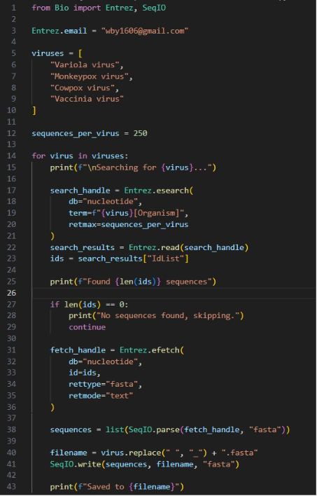
- reduntant_data.py
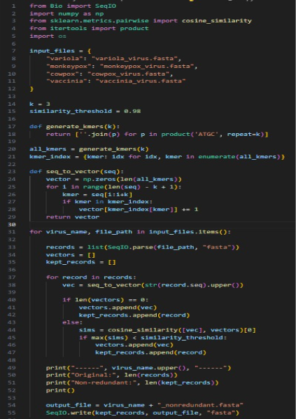

- blast.py
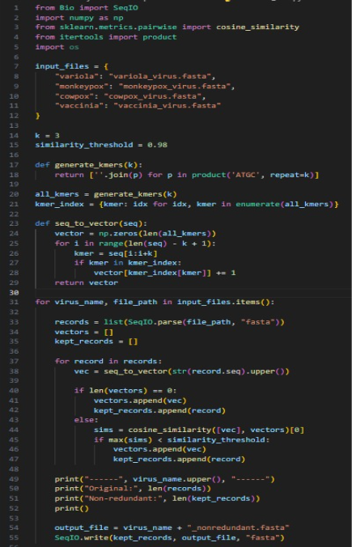
IV. RESULTS AND ANALYSIS

- Dataset Curation Results
The k-mer based cosine similarity approach successfully removed redundant genome sequences while preserving genetic diversity. The redundancy removal process showed variations among the four Orthopoxvirus species. Variola sequences exhibited high similarity, resulting in fewer non-redundant sequences, indicating low genetic diversity. Monkeypox sequences showed low redundancy and high diversity, and therefore all sequences were retained. Cowpox and Vaccinia datasets displayed moderate redundancy, with a substantial number of unique sequences remaining. This curation process improved dataset quality and ensured reliable downstream analysis.

- Dataset Specificity Validation Results
Dataset specificity was validated using NCBI BLAST analysis. Representative sequences from each curated dataset showed high identity and full query coverage with their respective virus species. Variola sequences matched primarily with Variola strains, while Cowpox and Vaccinia sequences showed strong similarity with their corresponding species. Monkeypox sequences matched exclusively with Monkeypox strains, confirming dataset accuracy. No significant matches with unrelated organisms were observed, demonstrating high dataset specificity.

- Feature Extraction Analysis
Feature extraction revealed distinct genomic patterns among the virus species. Variations in nucleotide composition, k-mer frequency distribution, and dinucleotide bias were observed across the datasets. These differences indicate species-specific genomic signatures and provide meaningful representations for machine learning analysis.

- Species Classification Performance
The species classification model demonstrated reliable performance in distinguishing between Variola, Monkeypox, Cowpox, and Vaccinia using genomic features. The results indicate that alignment-free feature representations effectively capture species-level differences and support accurate classification.

- Virulence Prediction Analysis
The virulence prediction model showed consistent performance in identifying virulence categories based on genomic characteristics. Feature importance analysis indicated that k-mer frequencies and nucleotide composition contributed significantly to prediction accuracy, highlighting their role in distinguishing viral properties.

- Overall Analysis
The results demonstrate that the proposed methodology effectively integrates dataset curation, feature extraction, and machine learning for Orthopoxvirus genome analysis. The approach provides reliable classification performance and meaningful insights into genomic diversity and virulence patterns.

V. CONCLUSION

This study presents a genome analysis framework for four Orthopoxvirus species—Variola, Monkeypox, Cowpox, and Vaccinia—using bioinformatics and machine learning methods. Genome sequences obtained from NCBI GenBank were curated to create a high-quality non-redundant dataset using k-mer based cosine similarity. Key genomic features, including nucleotide composition, k-mer frequencies, and dinucleotide bias, were extracted for species classification and virulence prediction.

The results demonstrate effective redundancy removal, reliable dataset validation, and accurate feature-based classification of virus species. Overall, the study highlights the potential of alignment-free genome analysis and machine learning approaches for understanding Orthopoxvirus diversity and supporting future research in viral genomics.

