CODE GENIE AI EXPLAINER AND CODE GENERATOR
Submitted by Kummara Gnanasree

- Abstract:

Code Genie is an AI-powered web application that enables users to generate syntactically correct code in five programming languages - Python, Java, C, C++, and JavaScript - by simply entering a natural language description. The system uses the Meta LLaMA 3.1 8B Instruct large language model accessed through the Hugging Face Inference API for accurate code generation and step-by-step code explanation. Syntax highlighting is implemented using the Highlight.js library for better code readability. The application is built using Flask for the backend, HTML, CSS, and JavaScript for the frontend, and SQLite for data storage. It includes a user profile page, a feedback system, and a comprehensive admin dashboard with Chart.js visualizations for monitoring platform usage.

- Introduction:

The rapid advancement of artificial intelligence has opened new possibilities in software development and education. AI-powered tools that understand natural language and generate executable code are transforming the way people learn programming. However, most existing tools are either too complex for beginners, support only one programming language, or do not explain the generated code. This creates a significant gap for students and learners who need both code generation and understanding.
Code Genie addresses these challenges by providing a simple, intelligent platform where users can generate working code in five languages and receive clear step-by-step explanations - all through plain English descriptions. The application was developed as part of the Infosys Springboard Virtual Internship Program in Generative AI, using Flask, SQLite, the Hugging Face Inference API, and the Meta LLaMA 3.1 8B Instruct pretrained language model.

- Problem statement:

Learning to code is a significant challenge for students and beginners, particularly when multiple programming languages are involved. Each language has its own unique syntax and rules, making it difficult for learners to write correct code without extensive practice.
- Most existing tools support only a single programming language, forcing users to switch between different platforms.
- Even when code is generated, these tools do not explain the logic behind it, leaving users without proper understanding.
- Beginners find it difficult to translate their ideas into syntactically correct code without prior technical knowledge.
- There is no single platform that combines code generation, explanation, user management, and admin monitoring.
- Objectives:

The primary objectives of the Code Genie project are:
- To develop a secure web application with user registration, login, and session management using Flask and SQLite.
- To integrate the Hugging Face Inference API with the Meta LLaMA 3.1 8B Instruct model for code generation and explanation.
- To support five programming languages - Python, Java, C, C++, and JavaScript.
- To implement syntax highlighting using the Highlight.js library for improved code readability.
- To build an admin dashboard with Chart.js visualizations for monitoring platform usage.
- To develop a user profile page with code history, language statistics, and submitted feedback.
- To implement a feedback system with star ratings and written reviews.
- To build an activity logging system that records all user actions with timestamps.

- System Requirements:

Hardware Requirements:
- Processor: Intel Core i3 or higher
- RAM: Minimum 4 GB (8 GB recommended)
- Storage: Minimum 500 MB free disk space
- Internet Connection: Required for Hugging Face API calls
Software Requirements:
- Operating System: Windows 10/11, macOS, or Linux
- Python: Version 3.8 or higher
- Flask: Version 2.0 or higher
- Web Browser: Google Chrome, Mozilla Firefox, or Microsoft Edge
Frontend Libraries:
- HTML5, CSS3, JavaScript - for building the user interface
- Highlight.js v11.9.0 - for syntax highlighting of generated code
- Chart.js v4.4.0 - for rendering interactive charts in the admin dashboard
Backend Libraries:
- Flask - web framework for handling routes, sessions, and requests
- Requests - Python library for making HTTP API calls to Hugging Face
- SQLite3 - built-in Python library for database operations
- Re - Python library for regular expression-based code cleaning
AI Model and API:
- Meta LLaMA 3.1 8B Instruct - pretrained large language model for code generation and explanation
- Hugging Face Inference API - used to access the LLaMA model through the router endpoint

- System Architecture

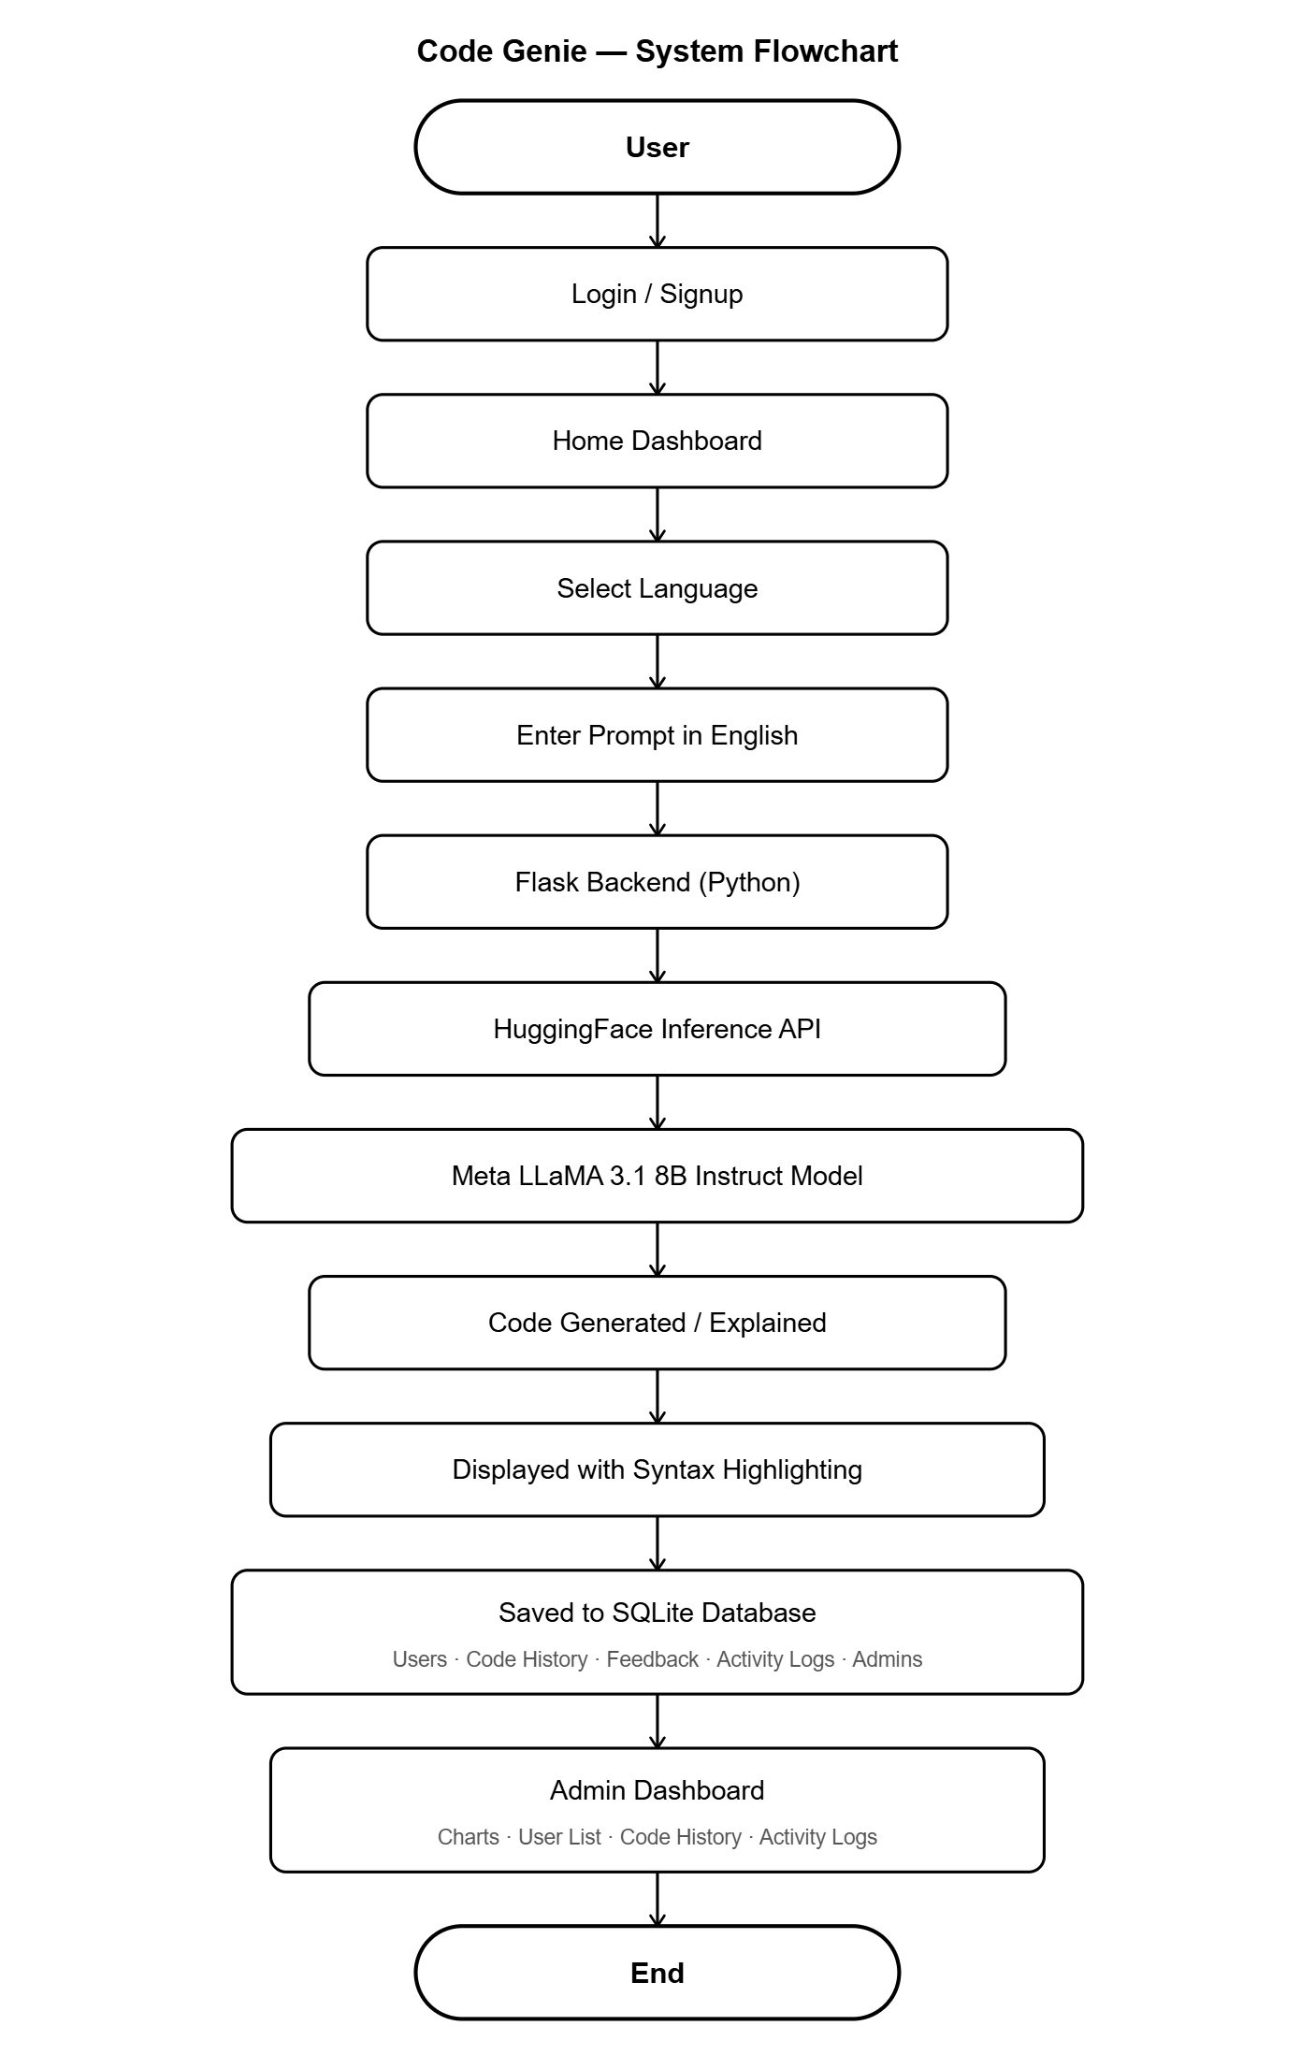

- Methodology:

- Planning and Design: The problem was analysed and objectives were defined. The Meta LLaMA 3.1 8B Instruct model was selected for its strong performance in code generation and explanation. The database schema was designed with five tables - Users, Code History, Feedback, Activity Logs, and Admins.
- Algorithm Design: The code generation algorithm constructs a language-specific system prompt instructing the LLaMA model to output only raw code without markdown or explanations. The user's natural language prompt is sent along with this instruction to the Hugging Face Inference API. The code explanation algorithm uses the same model with a different prompt instructing it to return a clear, numbered, step-by-step plain English explanation. The Re library is used to clean the model's output and remove unwanted characters.
- Frontend Development: The user interface was developed using HTML, CSS, and JavaScript. The Highlight.js library was integrated for syntax highlighting and the Chart.js library was integrated for admin dashboard visualizations.
- Backend Development: Flask routes were built for all pages. Session management was implemented separately for users and administrators. A centralized SQLite3 database helper function and an automatic activity logging function were developed.
- API Integration: The Hugging Face Inference API was integrated using the Requests library. The Flask backend sends structured POST requests with the model name, system prompt, and user message to the API endpoint and processes the returned response.
- Testing and Deployment: All features were tested for correctness and accuracy. The complete project was pushed to a GitHub repository as part of the Infosys Springboard Virtual Internship requirements.

- Implementation:

- User Authentication: Login and signup were implemented using Flask POST routes. User credentials are stored in the SQLite database. Flask sessions manage user login state. Admin authentication uses separate routes and session variables to maintain security.
- Code Generation: The Flask backend sends a structured request to the Hugging Face Inference API with the Meta LLaMA 3.1 8B Instruct model. A language-specific system prompt instructs the model to return only raw code. The Requests library handles the API call and the Re library cleans the response before displaying it to the user.
- Code Explanation: The same Meta LLaMA 3.1 8B Instruct model is used with a different prompt instructing it to explain the code in simple numbered steps without any markdown. JavaScript on the frontend formats the explanation into individual numbered steps in a styled panel.
- Syntax Highlighting: The Highlight.js v11.9.0 library is initialized using JavaScript after page load. It automatically applies color-coded highlighting to keywords, strings, and operators in the generated code for all five supported languages.
- Admin Dashboard: A single Flask route queries all five SQLite database tables and passes the aggregated data to the template. Three Chart.js visualizations are rendered - a doughnut chart for language usage, a bar chart for daily code generation activity, and a bar chart for feedback rating distribution. A tabbed interface with JavaScript search handles navigation between data sections.
- Activity Logging: A centralized Flask helper function records every user action — login, logout, signup, code generation, explanation, and feedback — into the activity logs table in SQLite with the current timestamp.

- Results:

Login Page
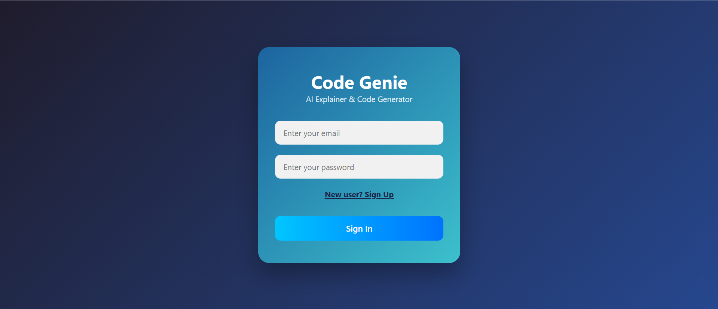

Sign Up Page
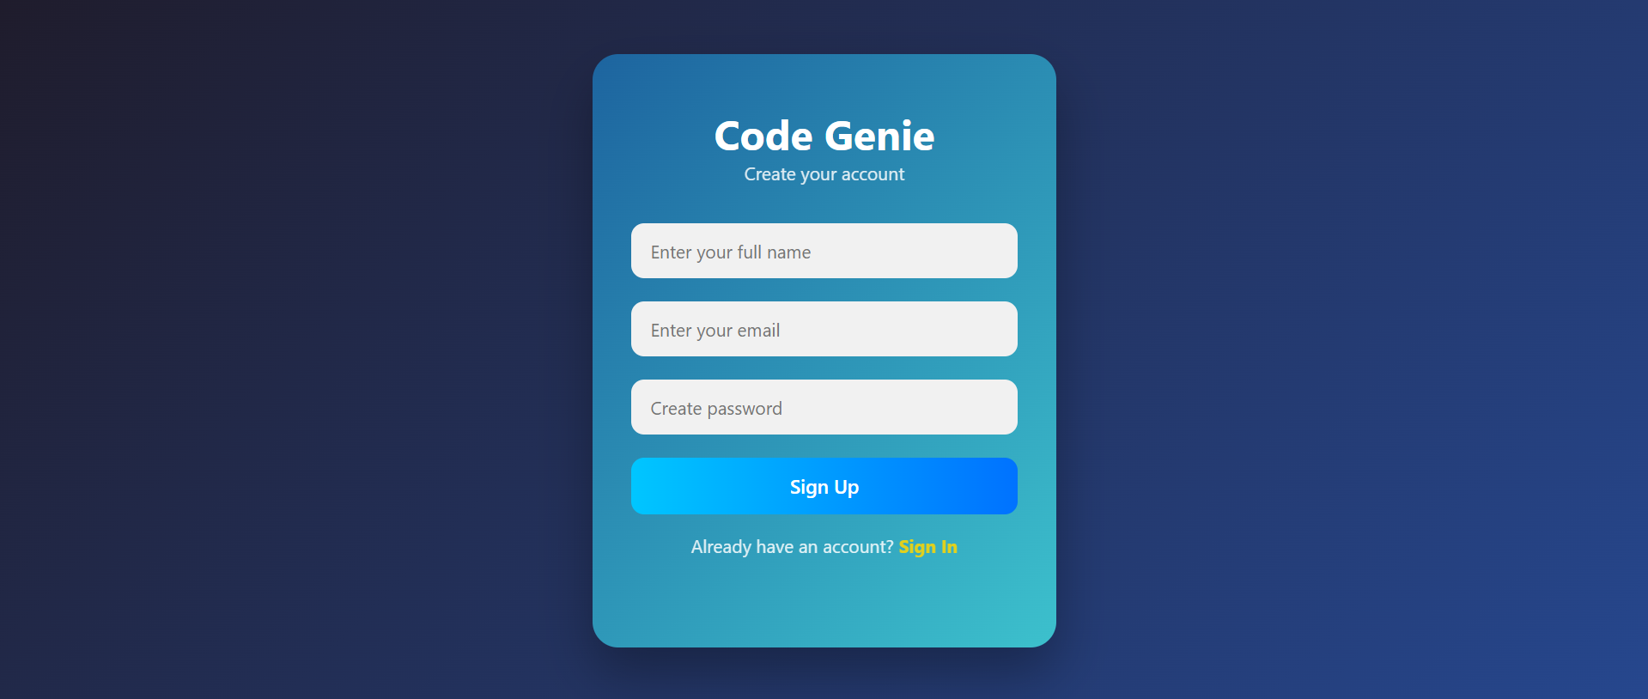

Home Page
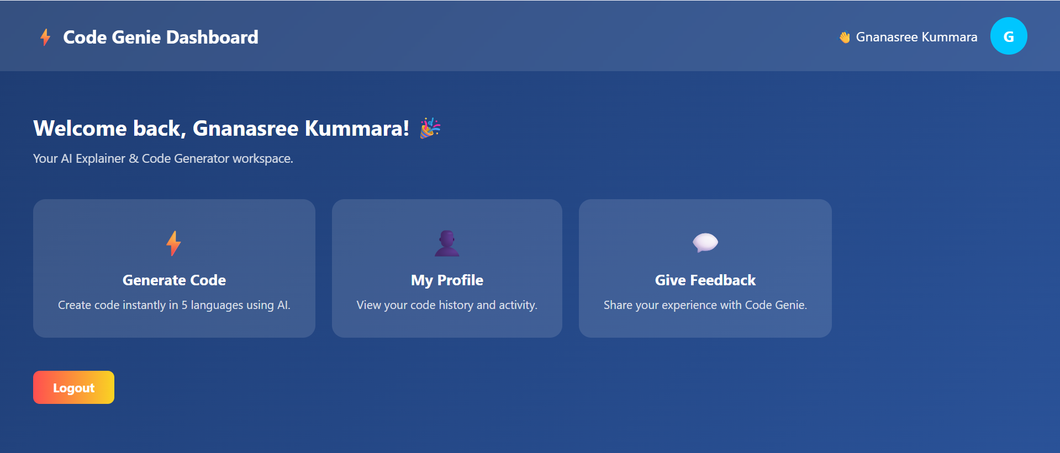

Code Generation page
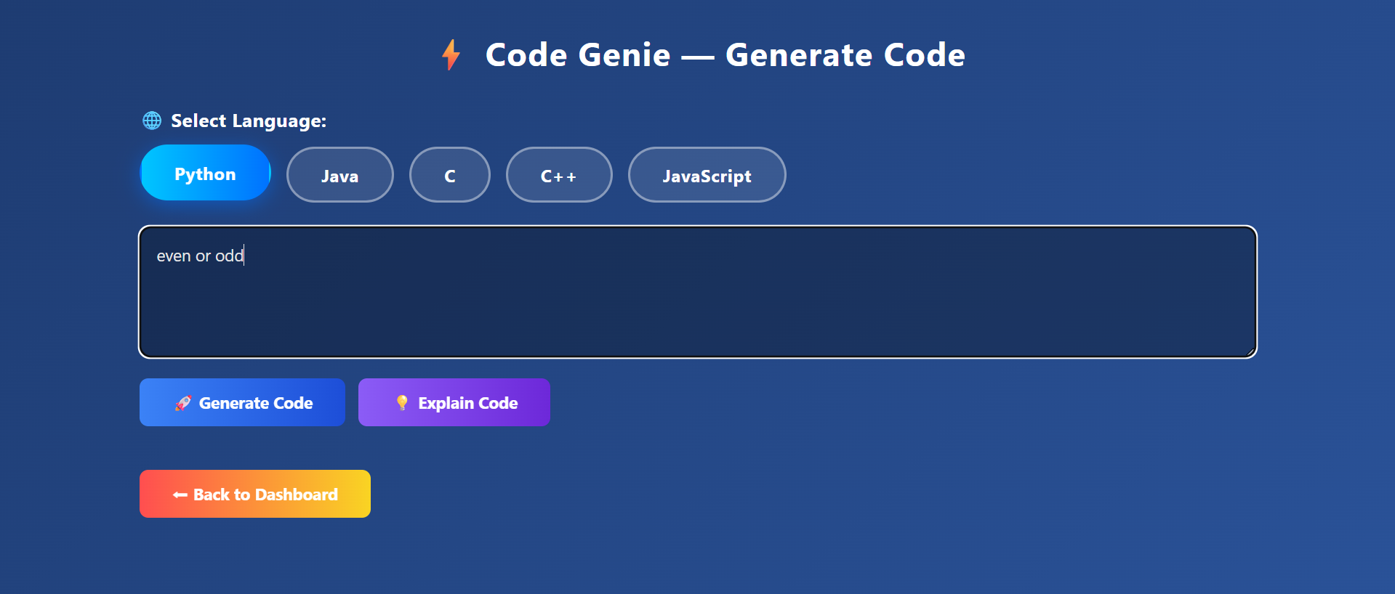

Generated Code with Syntax Highlighting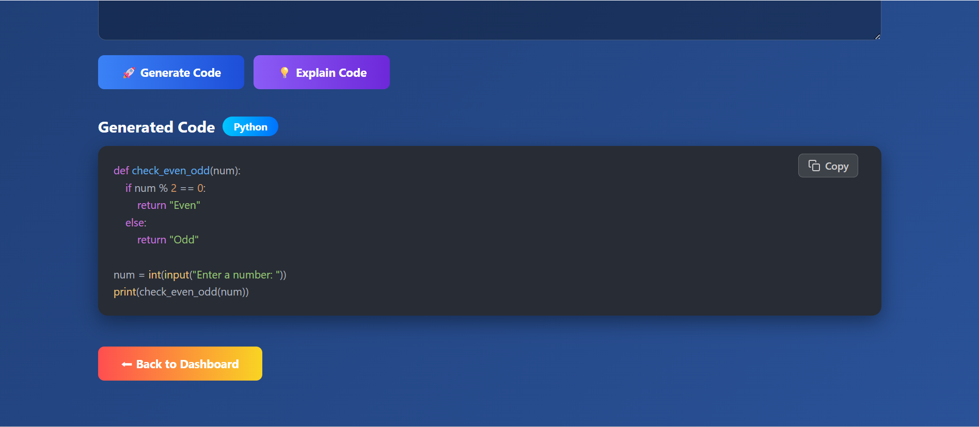

Code Explanation
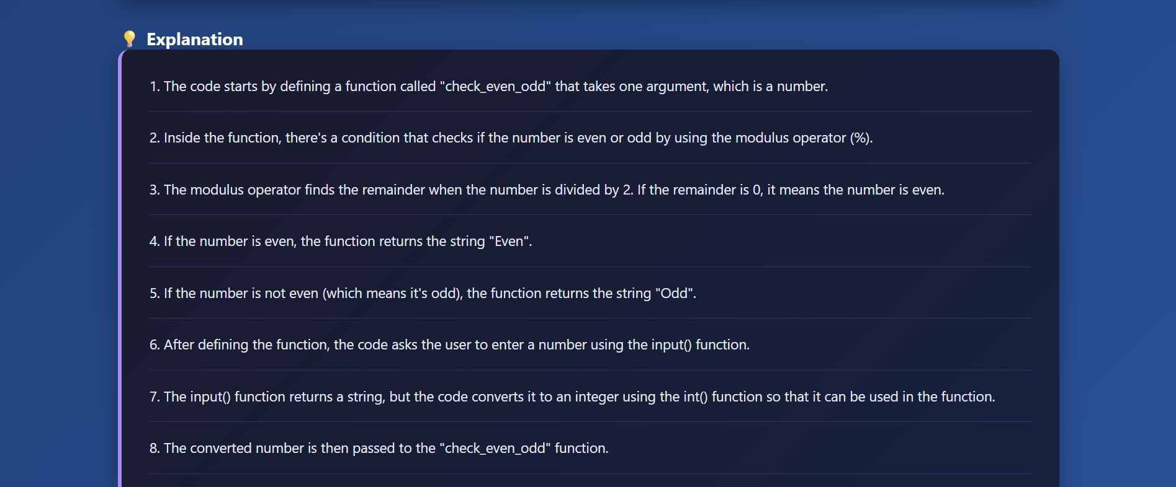

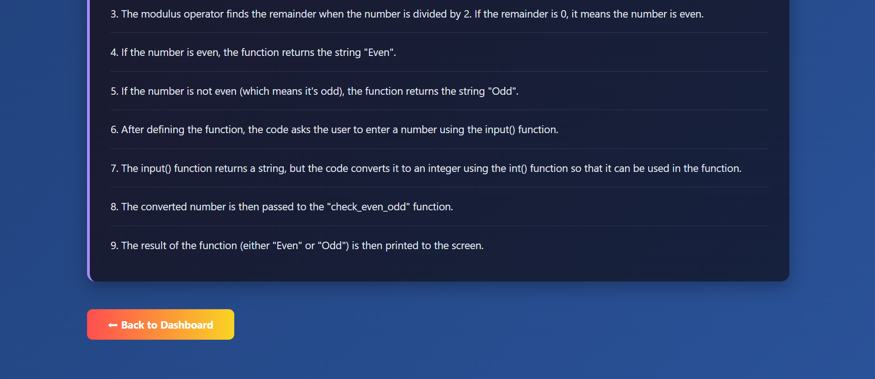

User profile Page
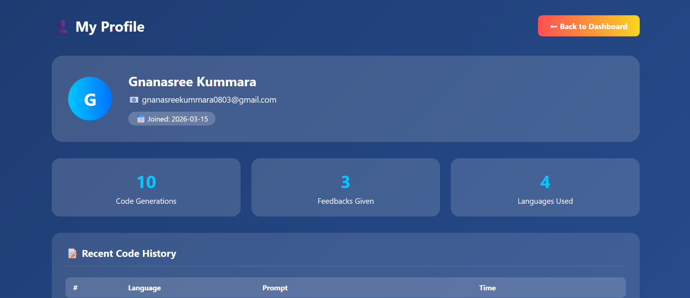

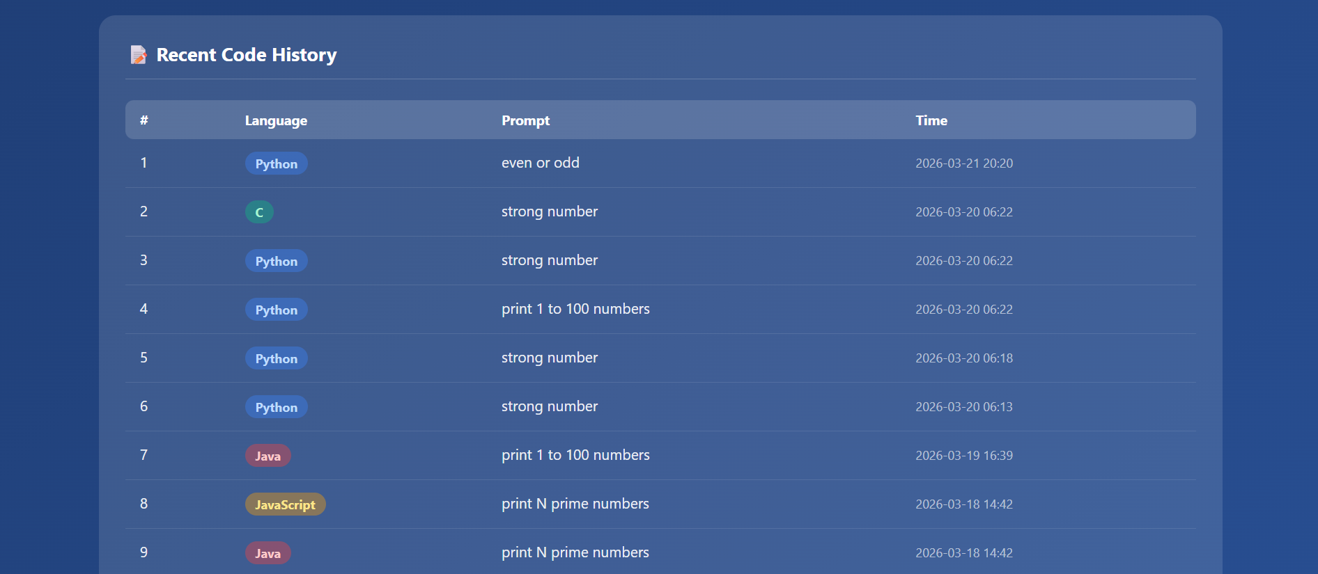

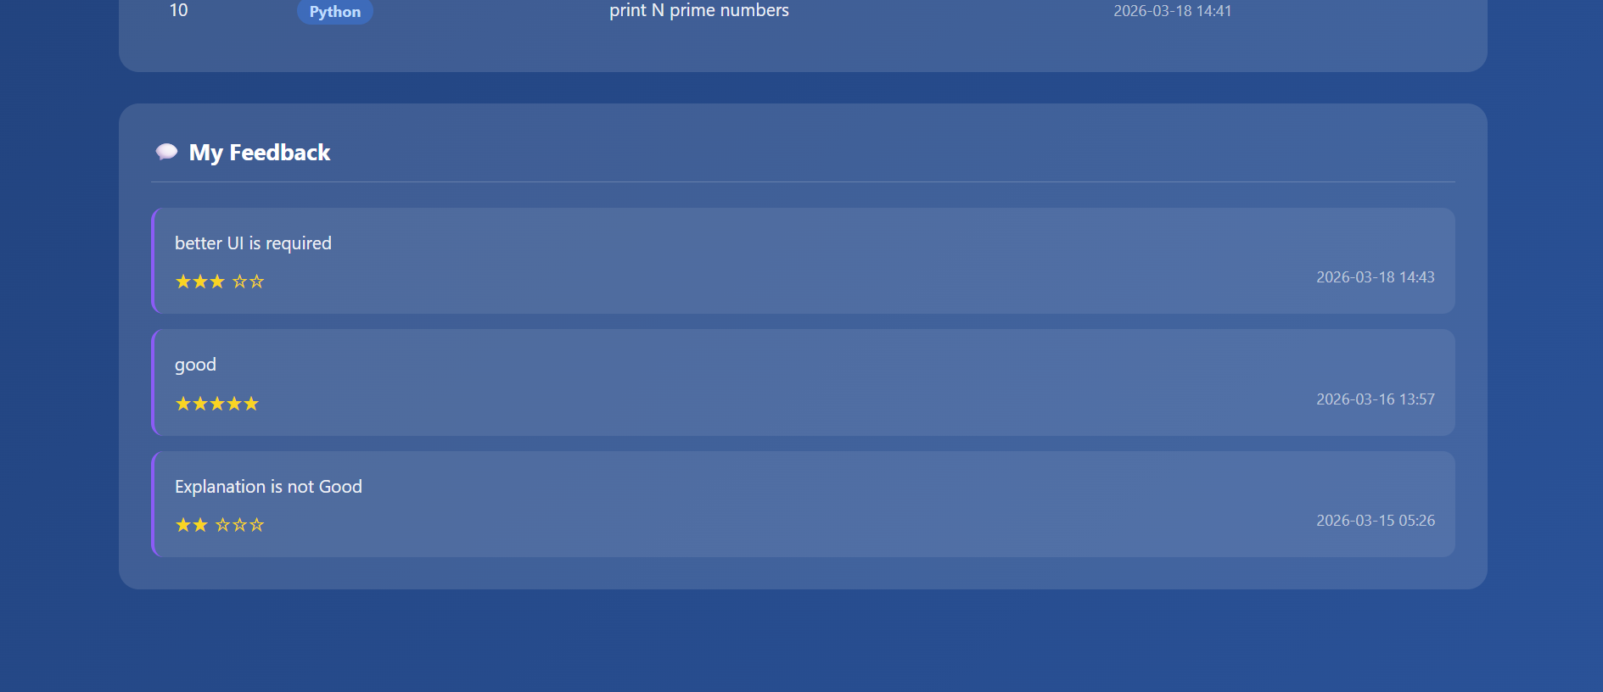

Feedback Page
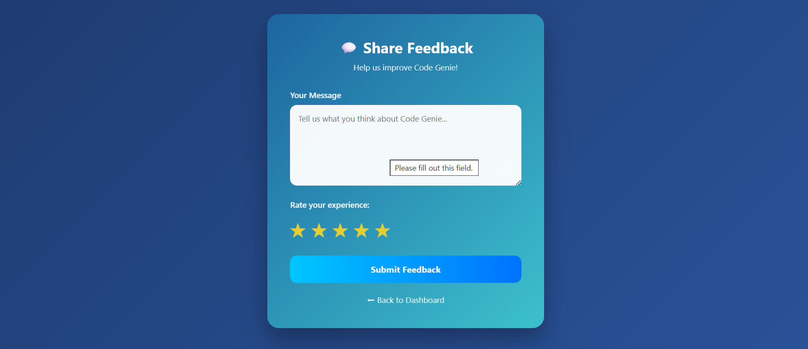

Admin Login Page
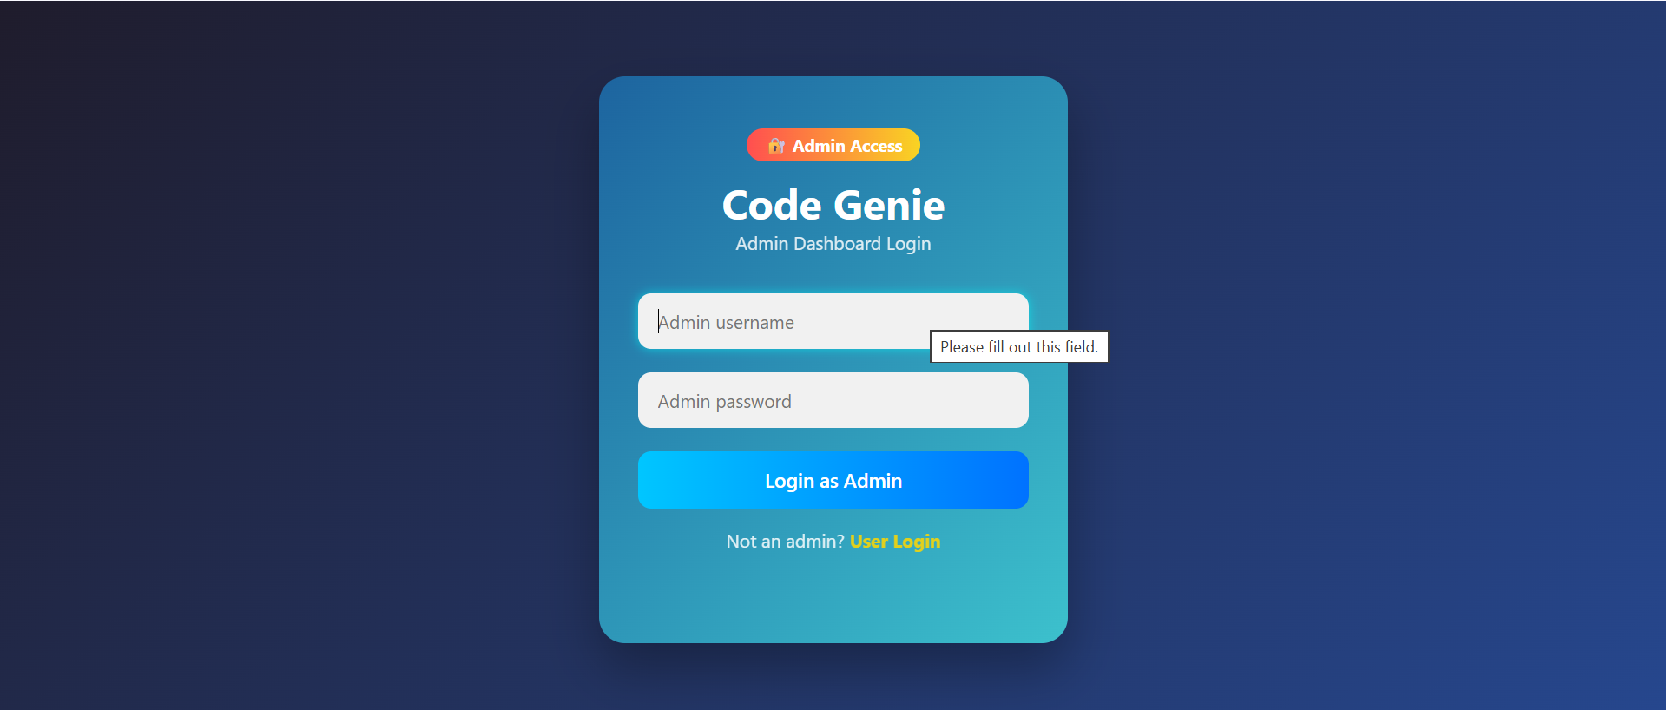

Admin Dashboard - Overview and Charts
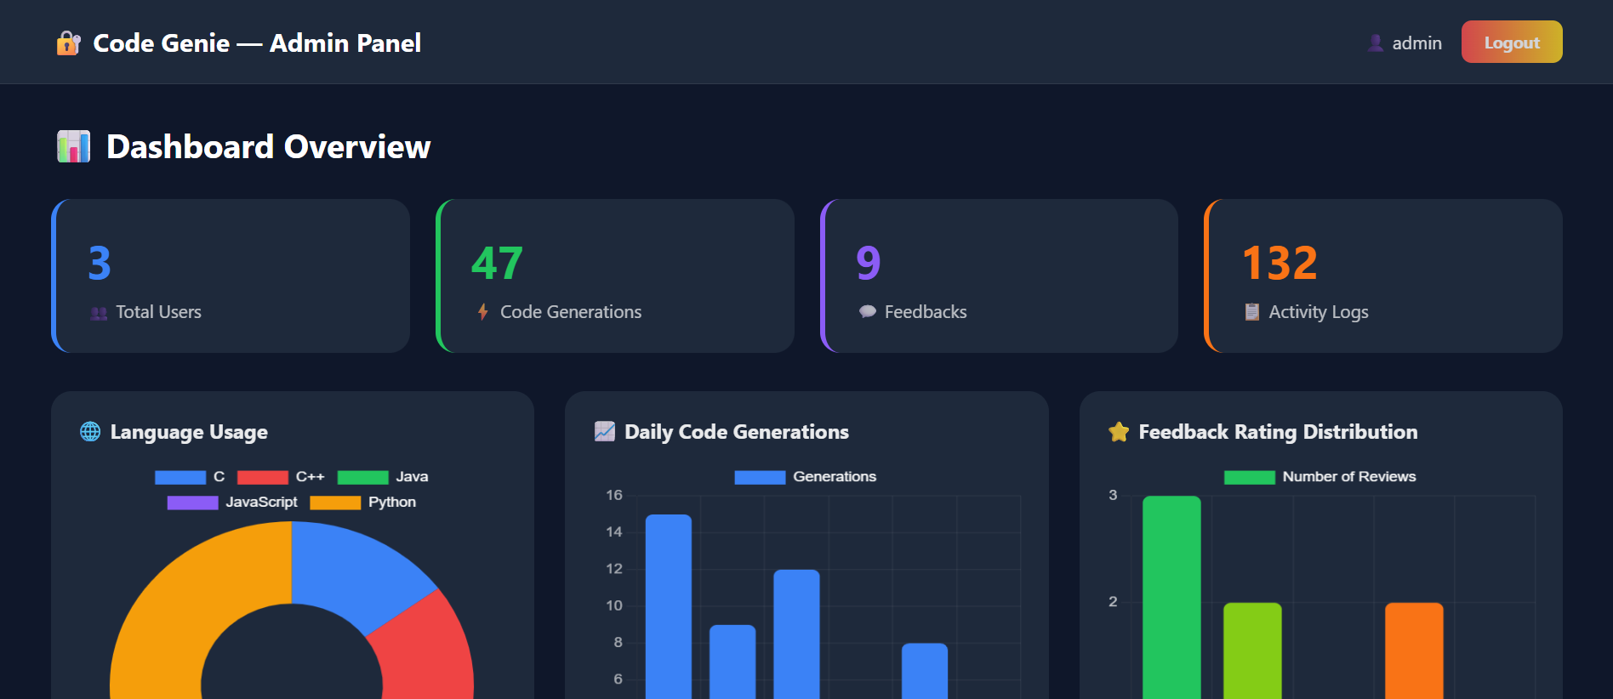

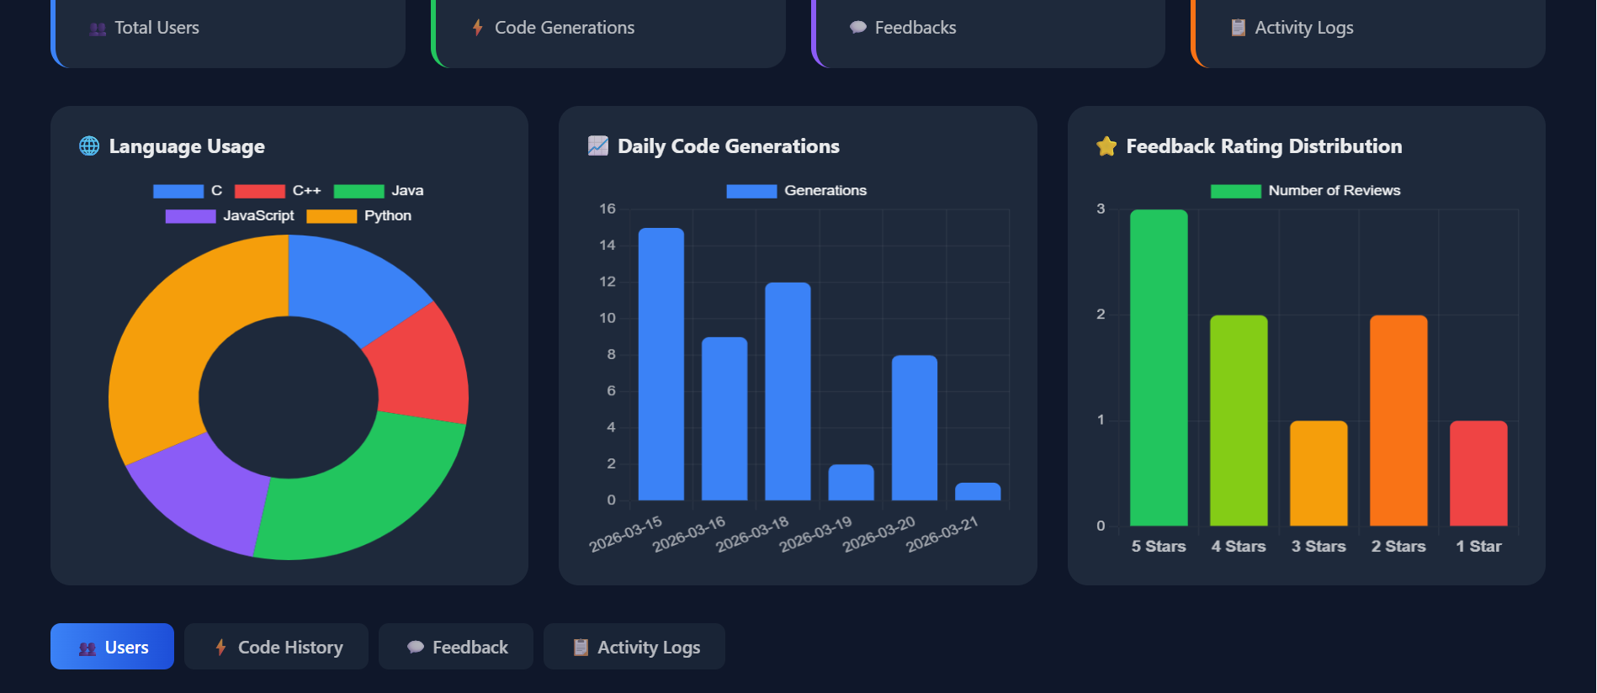

Admin Dashboard - Users
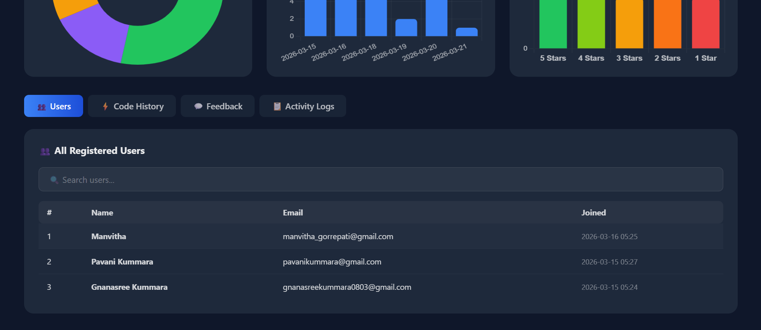

Admin Dashboard - Code History
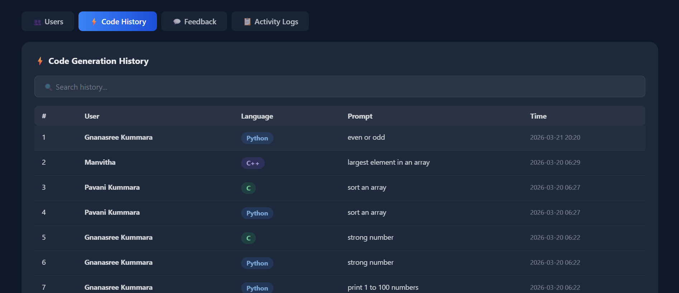

Admin Dashboard - Feedback
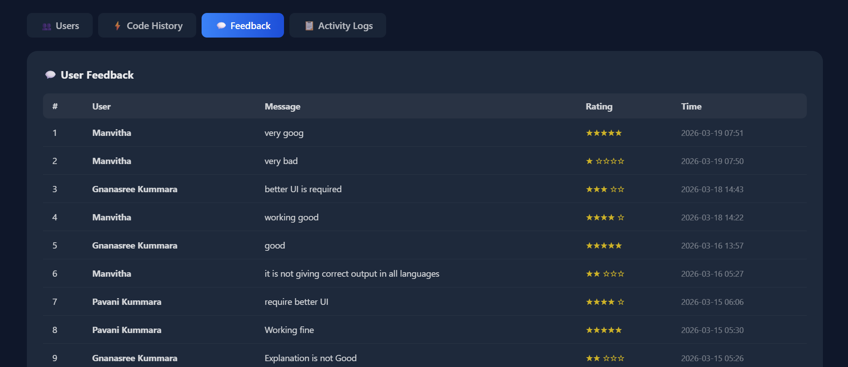
Admin Dashboard – Activity Logs
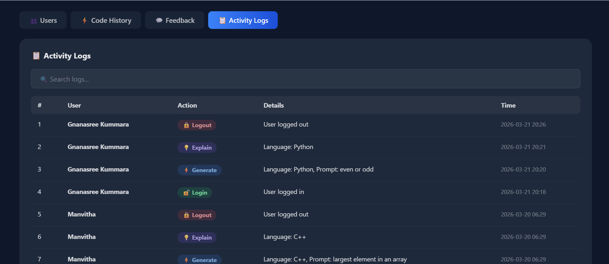

- Features:

User Features:
- Natural language to code conversion in five programming languages
- Step-by-step plain English code explanation
- Syntax highlighting using Highlight.js for better readability
- Inline copy button with visual feedback
- User profile with code history, language statistics, and timestamps
- Star rating feedback system with written reviews
Admin Features:
- Separate secure admin login page
- Statistical summary cards for total users, generations, feedbacks, and logs
- Language usage doughnut chart using Chart.js
- Daily code generation activity bar chart using Chart.js
- Feedback rating distribution bar chart using Chart.js
- Searchable registered users table with join timestamps
- Searchable code generation history with language tags
- Activity logs with color-coded action badges and timestamps

- Advantages:

- Users can generate working code in five languages without knowing their syntax, simply by typing a plain English description.
- The step-by-step explanation feature powered by the Meta LLaMA 3.1 8B Instruct model helps students understand the logic of generated code, making it a valuable educational tool.
- Syntax highlighting using Highlight.js makes code easier to read by visually differentiating keywords, strings, and operators in different colours.
- The admin dashboard built with Chart.js provides visual insights into language usage, daily activity, and feedback rating distribution.
- The automatic activity logging system gives administrators a complete record of every user action with exact timestamps.
- Using the Hugging Face Inference API eliminates the need for local GPU infrastructure, making the application cost-effective and easy to deploy.
- The feedback system allows users to submit star ratings and written reviews, enabling continuous improvement of the platform.

- Conclusion:

Code Genie is a complete AI-powered web application that successfully bridges the gap between natural language and programming. Users can generate working code in five languages and understand it through step-by-step explanations, all through simple plain English descriptions. The application was built using Flask, SQLite, Highlight.js, Chart.js, and the Meta LLaMA 3.1 8B Instruct model accessed through the Hugging Face Inference API. Features including multi-language code generation, syntax highlighting, user profile management, feedback collection, and a comprehensive admin dashboard make Code Genie a complete and production-ready platform.
In terms of future enhancements, the platform can be improved by implementing password hashing for stronger security, adding support for more programming languages such as TypeScript and Swift, integrating a code execution feature directly in the browser, enabling GitHub integration for pushing generated code to repositories, and improving mobile responsiveness for better usability on smartphones and tablets.

- References:

- Hugging Face Inc. (2024). Hugging Face Inference API documentation. Retrieved from https://huggingface.co/docs/api-inference
- Hugging Face Inc. (2024). Meta LLaMA 3.1 8B Instruct model card. Retrieved from https://huggingface.co/meta-llama/Meta-Llama-3.1-8B-Instruct
- SQLite Consortium. (2024). SQLite documentation: A self-contained, serverless, zero-configuration SQL database engine. Retrieved from https://www.sqlite.org/docs.html
- Highlight.js Contributors. (2024). Highlight.js: Syntax highlighting for the web. Retrieved from https://highlightjs.org/
- Chart.js Contributors. (2024). Chart.js: Simple yet flexible JavaScript charting library. Retrieved from https://www.chartjs.org/docs/latest/

