ONLINE BOOKSTORE DATABASE

1. INTRODUCTION:
The Online Bookstore Database is a relational database project developed using Oracle Database and Oracle SQL Developer. The system manages books, authors, genres, customers, orders, and order details. SQL queries, views, indexes, joins, and query optimization techniques were implemented to retrieve and manage the data efficiently.
2. OBJECTIVE:
The objective of this project is to design and implement a structured database for an online bookstore and demonstrate database concepts such as primary keys, foreign keys, joins, views, indexes, and query optimization.
3. TOOLS USED:
Database: Oracle Database
Tool: Oracle SQL Developer
Language: SQL
4. TABLE INFORMATION:
TABLE | PURPOSE
Authors | Stores author information
Geners | Stores book genres
Books | Stores book details
Customers | Stores customer information
Orders | Stores customer orders
Orders_details | Stores books and quantities in each order

5. RELATIONSHIPS:
The database uses primary keys and foreign keys to establish relationships between the tables.
Then:
Authors → Books
Genres → Books
Customers → Orders
Orders → Order_Details
Books → Order_Details

6. VIEWS:

View 1 — Books by Author
BOOKS_BY_AUTHOR

Purpose:
Displays books along with their respective authors.

View 2 — Total Sales by Book
BOOK_TOTAL_SALES

Purpose:
Calculates the total quantity sold and total sales for each book.

View 3 — Customer Order History
CUSTOMER_ORDER_HISTORY

Purpose:
Displays customers along with their order history.

7. QUERY OPTIMIZATION:
Indexes were created on frequently used columns involved in filtering and JOIN operations. Oracle's EXPLAIN PLAN and DBMS_XPLAN were used to examine the query execution plan.
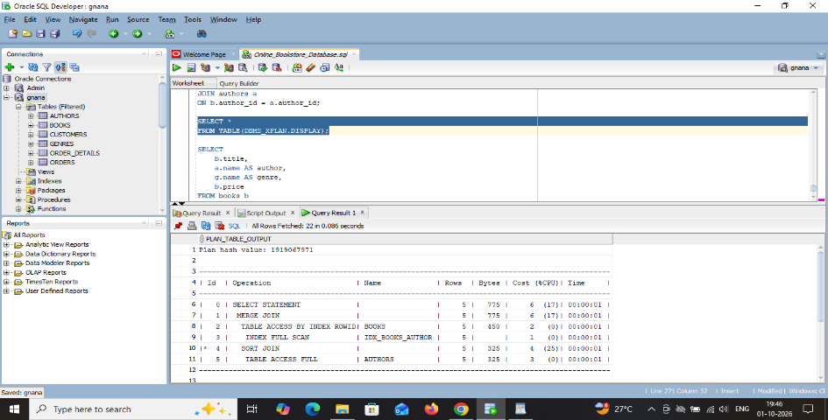

8. CONCLUSION:
The Online Bookstore Database was successfully implemented using Oracle SQL Developer. The project demonstrates relational database design, primary and foreign keys, SQL queries, joins, views, indexes, and query optimization. The database can be extended in the future with additional books, customers, orders, payment information, and inventory management.

