**1. Component Structure in CRXDE**

The **Author Component** is created under the following path:

* **apps/myTraining/components/author**

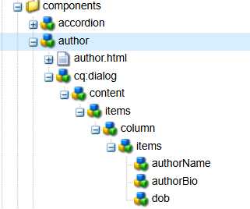

**2. Dialog Configuration in CRXDE**

The dialog consists of three mandatory fields:  
 **Author Name** - Single-line text field  
 **Author Bio** - Multi-line text field  
 **DOB** - Date picker

Path: **/apps/myTraining/components/author/cq:dialog**

***Dialog Structure in CRXDE:***

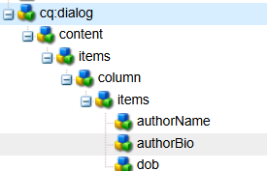

**3. Dialog Fields in AEM Touch UI**

The **dialog** appears in the **AEM Page Editor** when the component is added. The fields capture user input.

<http://localhost:4502/editor.html/content/myTraining/us.html>

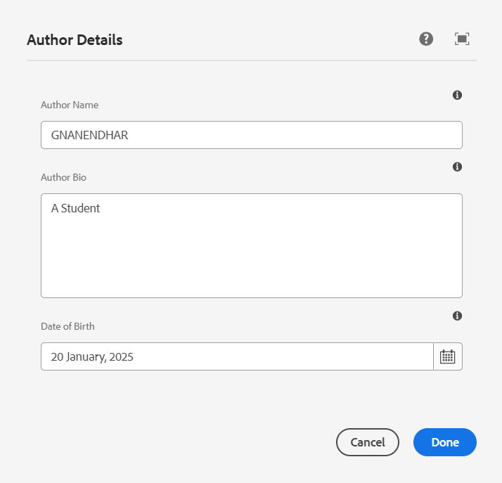

**4. Fetching Values in HTL**

The values are displayed using **HTL properties** in author.html:

<div class="author-container">

<h1>${properties.authorName}</h1>

<p>${properties.authorBio}</p>

<strong>${properties.dob}</strong>

</div>

***Code in author.html***

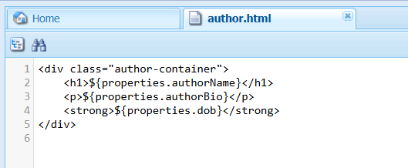

**5. Rendered Component on the AEM Page**

The component should display:  
✔ **Author Name** - <h1>Gnanendhar</h1>  
✔ **Author Bio** - <p>A Student</p>  
✔ **DOB** - <strong>25-05-2004<strong>

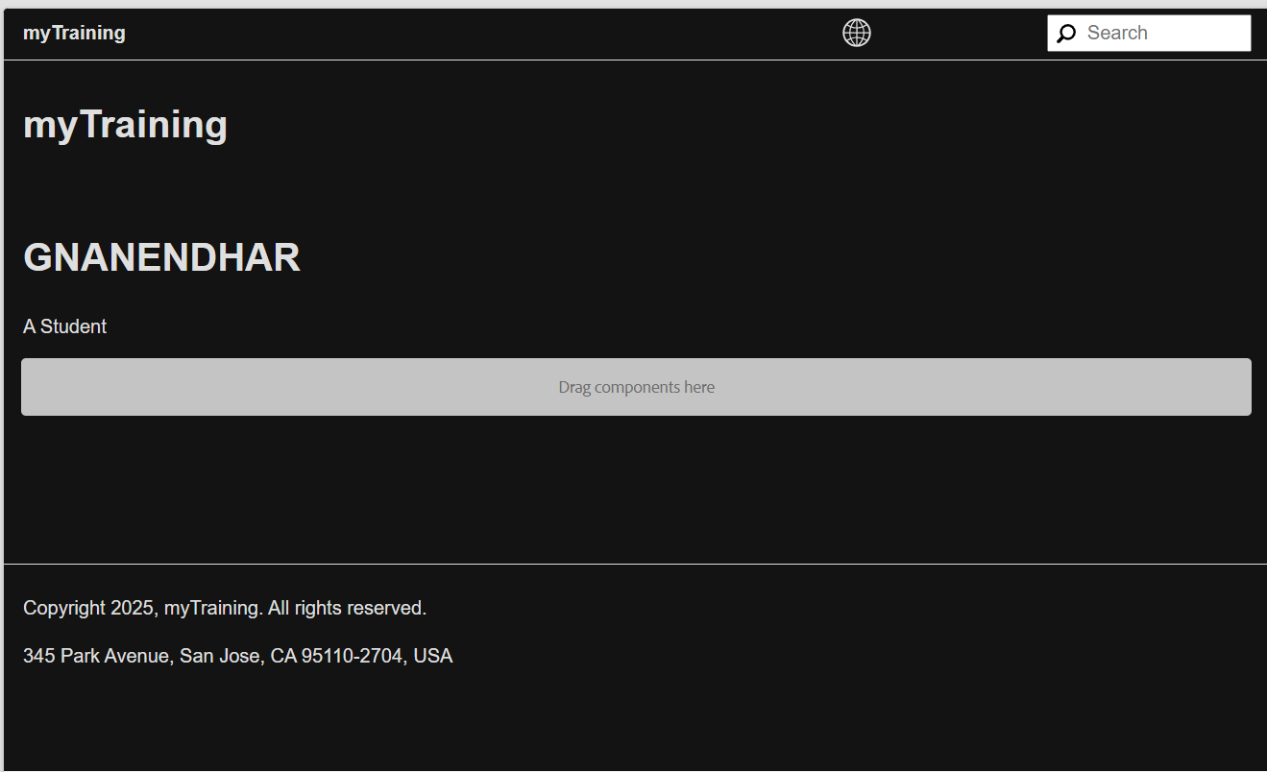

**6. Client Libraries Implementation**

The styles are applied using **Client Libraries** under:  
➡ **/apps/myTraining/clientlibs/author**

**author.css:**

.author-container h1 {

color: blue;

}

.author-container strong {

font-weight: bold;

}

**Content.xml:**

<?xml version="1.0" encoding="UTF-8"?>

<jcr:root

xmlns:jcr="http://www.jcp.org/jcr/1.0"

xmlns:sling="http://sling.apache.org/jcr/sling/1.0"

xmlns:cq="http://www.day.com/jcr/cq/1.0"

jcr:primaryType="cq:ClientLibraryFolder"

categories="myTraining.author"

allowProxy="true"/>

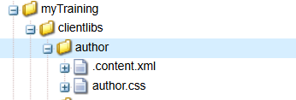

**7. Applying and Verifying Clientlibs**

✔ Author Name appears in **h1 style**  
✔ Author Bio appears as **normal body text**

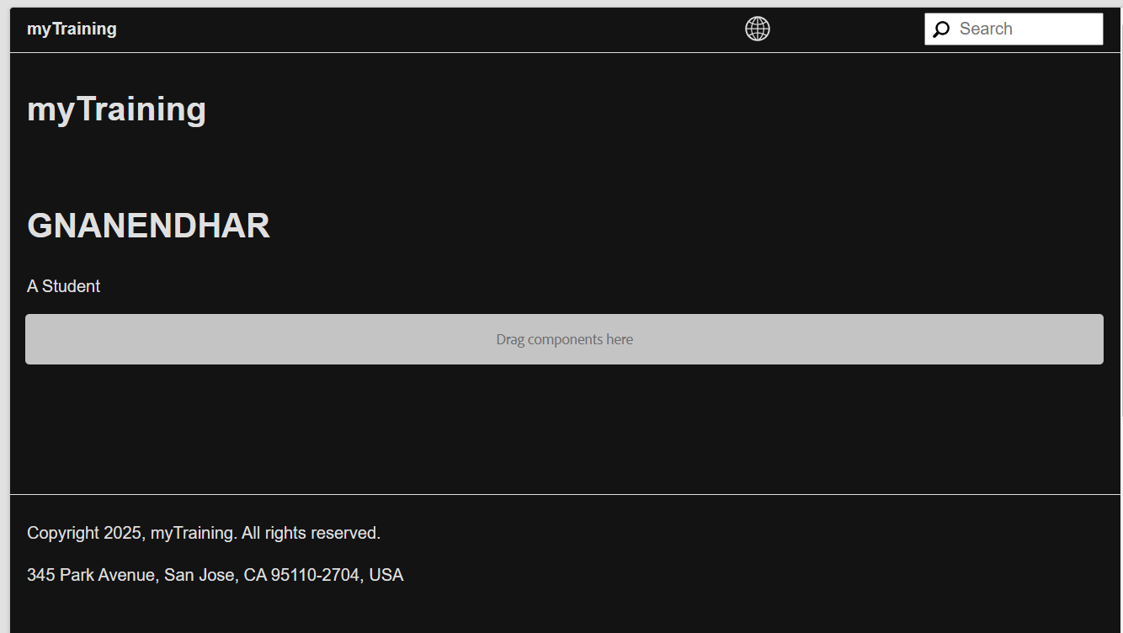

**8. ExtraClientLibs (if implemented)**

**📌 Description**

extraClientLibs allows loading additional styles/scripts for the component.

