1. Maven Version

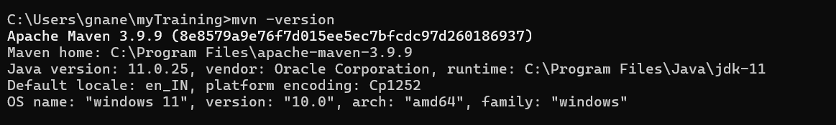

1. AEM Project Structure in File Explorer

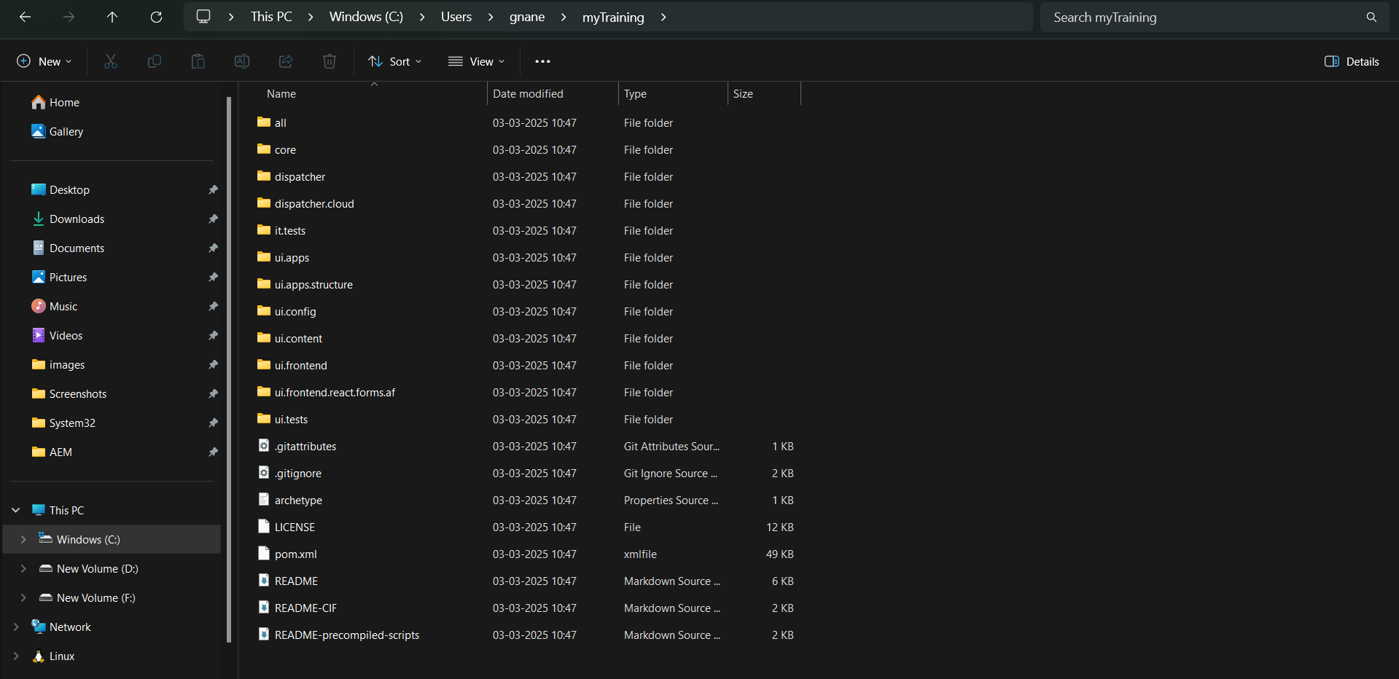

1. **AEM Running on Browser:** <http://localhost:4502>

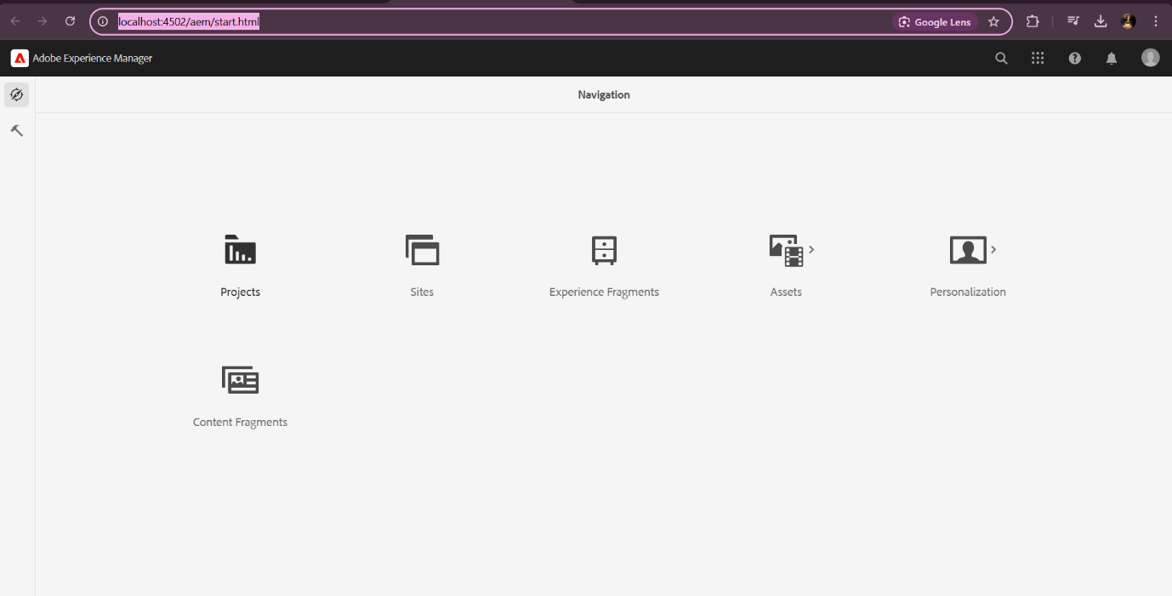

1. Set up of jar:

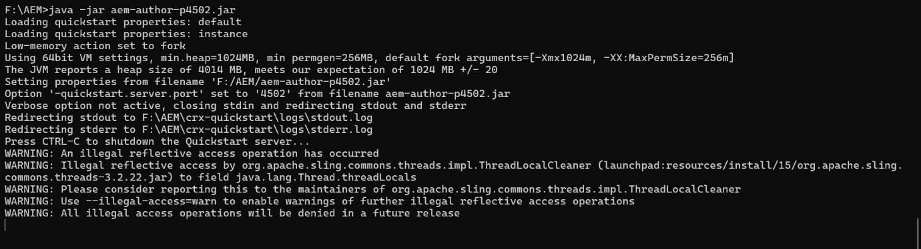

1. Maven Build success:

