Pre-Requisites
Exploratory Analysis Of RainFall Data In India For Agriculture
TEAM ID: LTVIP2026TMIDS66153
1.Anaconda Navigator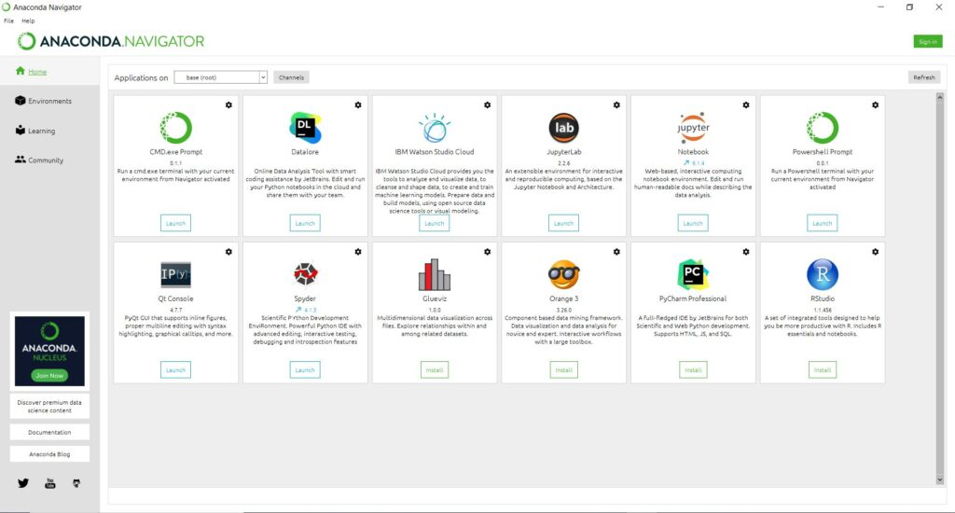
This Photo by Unknown Author is licensed under CC BY-SA
2.Jupyter:
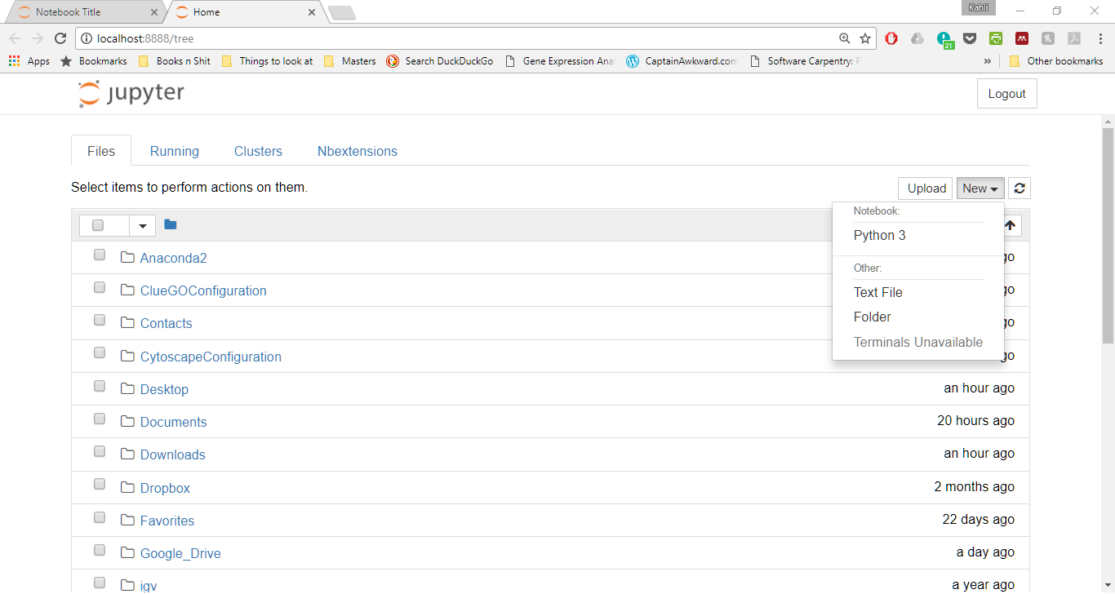

3.Python Pakages:

- Numpy
- Pandas
- Seaborn
- Matplotlib
- Pickle
- Scikit-learn
- Sklearn
- Flask

