# Smart Traffic Light System using IOT

**A S O C I A L L Y R E L E V A N T M I N I PROJECT REPORT**

***Submitted by***

**GNANESHWAR.G [211423104167]**

**HARISHKUMAR.S [211423104209]**

***in partial fulfillment for the award of the degree of***

**BACHELOR OF ENGINEERING**

*in*

**COMPUTER SCIENCE AND ENGINEERING**



**PANIMALAR ENGINEERING COLLEGE**

**(An Autonomous Institution, Affiliated to Anna University, Chennai)**

**OCTOBER 2025**

**PANIMALAR ENGINEERING COLLEGE**

(An Autonomous Institution, Affiliated to Anna University, Chennai)

#### BONAFIDE CERTIFICATE

Certified that this project report “SMART TRAFFIC LIGHT SYSTEM USING IOT” is the Bonafide work of GNANESHWAR.G (211423104167), HARISHKUMAR.S(211423104209) who

carried out the project work under my supervision.

Signature of the HOD with date Signature of the Supervisor with date

Dr L.JABASHEELA M.E.,Ph.D., Mrs.S.LINCY JEMINA M.E.,(Ph.D),

Professor and Head,

Department of Computer Science and Engineering,

Panimalar Engineering College, Chennai- 123

Assistant Professor,

Department of Computer Science and Engineering, Panimalar Engineering College, Chennai- 123

Submitted for the Project Viva– Voce examination held on

INTERNAL EXAMINER EXTERNAL EXAMINER

#### DECLARATION BY THE STUDENT

We **GNANESHWAR.G** [211423104167]**, HARISHKUMAR.S**[211423104209] hereby declare that

this project reporttitled**“SMART TRAFFIC LIGHT SYSTEM USING IOT”**, under theguidance of **Mrs. S.LINCY JEMINA M.E.,(Ph.D.),** is the original work done by us and we have not plagiarized or submitted to any other degree in any university by us.

Gnaneshwar.G [211423104167]

Harish Kumar.S [211423104209]

#### ACKNOWLEDGEMENT

We express our deep gratitude to our respected Secretary and Correspondent **Dr.P.CHINNADURAI, M.A., Ph.D.,** for his kind words and enthusiastic motivation, which inspired us a lot in completing this project.

We would like to extend our heartfelt and sincere thanks to our Directors

##### Tmt.C.VIJAYARAJESWARI,Dr.C.SAKTHIKUMAR,M.E,Ph.D., and Dr.SARANYASREE

**SAKTHIKUMAR B.E.,M.B.A.,Ph.D.,** for providing us with the necessary facilities for completion of this project.

We also express our gratitude to our Principal **Dr.K.MANI, M.E., Ph.D.,** for his timelyconcern and encouragement provided to us throughout the course.

We thank the HOD of CSE Department, **Dr.L.JABASHEELA, M.E., Ph.D.,** for the support extended throughout the project.

We would like to thank our Project Coordinator **DR.DEEPA, M.E., Ph.D., Mrs.S.LINCY JEMINA M.E.,(Ph.D.)** and our Project Guide **Mrs.S**.**LINCY JEMINA, M.E.,(Ph.D.),** and all the faculty members of the Department of CSE for their advice and suggestions for the successful completion of the project.

Gnaneshwar G[211423104167] Harish Kumar S[211423104209]

**ABSTRACT**

Traffic congestion and delays at intersections have become a major problem in rapidly growing cities, leading to time loss, fuel consumption, and difficulty for emergency vehicles like ambulances to pass through. Traditional traffic light systems operate on fixed time intervals, which are inefficient in handling dynamic traffic conditions. To address this issue, a Smart Traffic Light System using IoT is proposed.The system integrates IoT-enabled sensors, cameras, and microcontrollers to monitor real- time traffic density at intersections. Based on the collected data, the traffic signals are dynamically adjusted to optimize flow and minimize congestion. Additionally, an ambulance detection module is incorporated using GPS or RF technology, ensuring automatic green signal clearance for emergency vehicles to move smoothly through intersections. The data collected can also be sent to a cloud server for traffic analysis and future improvements.Unlike conventional systems, this IoT-based solution enables adaptive and intelligent decision-making by analyzing real-time scenarios instead of relying on pre-set timers. The proposed model can be scaled across multiple intersections and integrated with smart city infrastructure, ultimately providing a cost-effective, efficient, and sustainable approach to modern traffic management.

**TABLE OF CONTENTS**

|  |  |  |
| --- | --- | --- |
| **CHAPTER**  **NO** | **TITLE** | **PAGE NO.** |
|  | **ABSTRACT** | v |
|  | **LIST OF FIGURES** | viii |
| **1.** | **INTRODUCTION** | **1** |
|  | 1.1 Overview | 1 |
|  | 1.2 Problem Definition | 1 |
|  | 1.3 Literature Survey | 2 |
| **2.** | **SYSTEM ANALYSIS** | **6** |
|  | 2.1 Existing System | 6 |
|  | 2.2 Proposed System | 6 |
|  | 2.3 Implementation Environment | 7 |
| **3.** | **SYSTEM ARCHITECTURE** | **8** |
|  | 3.1 Architecture Diagram | 8 |
|  | 3.2 Module Design Specification | 9 |
| **4.** | **SYSTEM DESIGN** | **11** |
|  | 4.1 Uml Diagram | 11 |
|  | 4.2 Deployment Diagram | 12 |
| **5.** | **SYSTEM IMPLEMENTATION** | **13** |

|  |  |  |
| --- | --- | --- |
|  | 5.1 Backend Coding | 13 |
| **6.** | **PERFORMANCE ANALYSIS** | **15** |
|  | 6.1 Performance pasrameters | 15 |
|  | 6.2 Performance Metrics | 16 |
|  | 6.3 Result and Discussion | 17 |
| **7.** | **CONCLUSION** | **18** |
|  | 7.1 Conclusion | 18 |
|  | 7.2 Future enhancement | 19 |
| **8.** | **APPENDICES** | **20** |
|  | A1 SDG goals | 20 |
|  | A2 Sample Screenshots | 21 |
|  | A3 Paper Publication | 23 |
|  | A4 Plagiarism report | 35 |
| **9.** | **REFERENCES** | **36** |

**LIST OF FIGURES**

|  |  |  |
| --- | --- | --- |
| **FIG NO.** | **FIGURE DESCRIPTION** | **PAGE NO** |
| 3.1.1 | Activity Diagram for smart traffic light system using IoT | 11 |
| 3.1.2 | Deployment diagram for smart traffic light systemusing IoT | 12 |
| 4.1.1 | Architecture diagram for smart traffic light systemusing IoT | 8 |
| 8.1 | Screenshot of basic page | 21 |
| 8.2. | Screenshot of input Page | 22 |

**CHAPTER 1 INTRODUCTION**

* 1. **OVERVIEW**

Traffic management has become one of the most critical challenges in modern cities due to the rapid increase in population, urbanization, and the number of vehicles on the road. Conventional traffic light systems usually work on predefined time intervals that do not adapt to real-time traffic conditions. This often leads to unnecessary waiting, congestion, fuel wastage, and delays for both commuters and emergency vehicles.

A Smart Traffic Light System using IoT is designed to overcome these limitations by employing intelligent sensors, cameras, microcontrollers, and communication modules to monitor and regulate traffic dynamically. By continuously collecting data on vehicle density, the system can adjust the signal timing automatically to ensure smoother traffic flow. The use of IoT technology allows the system to share data with a central server or cloud, enabling real-time monitoring, analysis, and scalability across multiple intersections.

One of the unique features of this system is its ambulance detection and priority clearance mechanism. Using GPS or RF communication, the traffic light automatically provides a green corridor for emergency vehicles, significantly reducing response times and saving lives. Beyond this, the system contributes to reducing carbon emissions, minimizing human intervention, and supporting the vision of smart and sustainable cities**.**

As the world's population moves from rural to In cities, traffic management has become a serious concern.The number of vehicles in urban areas has grown quickly, putting a lot of pressure on city roads.

Traditional traffic signals, which either rely on manual control or fixed time cycles, are not good enough for handling these changing traffic conditions.These systems can't adjust to real-time changes, leading to problems like traffic jams, Long journey times, more fuel consumption, and increased emissions.Manual control helps during busy or emergency times, but it takes a lot of work and is not always accurate.

* 1. **PROBLEM DEFINITION**

The existing traffic light systems are primarily static and time-based, where signal intervals remain fixed regardless of actual traffic conditions. This results in inefficient traffic management, especially during peak hours or in cases of uneven traffic distribution across different lanes. Vehicles are often forced to wait unnecessarily at red lights even when the road ahead is clear, leading to time wastage, fuel consumption, and environmental pollution.

Another major drawback of conventional systems is the inability to prioritize emergency vehicles such as ambulances, fire trucks, and police vans. Due to traffic congestion and lack of intelligent signal control, emergency vehicles often face delays, which may lead to loss of lives or delayed response during critical situations.

Additionally, manual intervention by traffic police to manage high traffic density is not always effective and may result in human errors or inefficiency. With the growing number of vehicles in urban areas, the limitations of traditional traffic control systems are becoming more evident, demanding a smarter, automated, and adaptive solution.

Therefore, there is a strong need to develop an IoT-based Smart Traffic Light System that can dynamically adapt to real-time traffic flow, ensure the smooth passage of emergency vehicles, reduce fuel wastage, and enhance overall road safety.

* 1. **LITERATURE REVIEW**

Numerous researchers have studied smart traffic management using IoT technologies.[1] Gaikwad, V., Holkar, A., Hande, T., Lokhande, P., and Badade, V. (2023) looked into Intelligent Traffic Controller System with IoTin their paper titled "Data Science and Intelligent Computing Techniques." They used Raspberry Pi and OpenCV for surveillance and automatic traffic signal regulation, noting improvements in traffic flow. They considered real time vehicle detection and congestion limits, but their system wasn't reliable when vehicle colors were similar to the road surface.

[2]Arun Kumar (2022) also introduced a Smart Traffic Light Control System in the IJFANS journal – International Journal of Food and Nutritional Science. Their system used PIC microcontrollers with IR sensors and XBee technology, including an emergencyoverride. Traffic signals were adjusted based on traffic density, with longer green lights during high traffic and priority given to emergency vehicles. However, the system had limitations, such as only working at a single junction, requiring manual override, and not considering pedestrians.

In another study, [3]S.C. Rai, S.P. Nayak, B. Acharya, and V.C. Gerogiannis proposed an Intelligent Traffic Signaling System Based on IoT in the journal Electronics (MDPI). They used inductive loops and IR sensors to detect vehicles and determine prioritization. Their system improved traffic flow and reduced waiting times, but the high cost of the technology and the complexity of maintaining large-

scale sensor networks were major drawbacks.

Other researchers have also explored innovative IoT based solutions. For example, [4]Faisal Al Kalbani, Nada Al Bulushi, and Syed Imran (2023) presented an ICT-Based Smart Traffic Light Controller at the 4th Middle East College Conference. Their system used Arduino UNO with IR sensors and RFID to prioritize emergency vehicles. While it allowed for adaptive traffic control and reliable emergency responses, there were issues with scaling their vehicle detection system and hardware reliability.

[5]Gunashree H.S., Harshitha D.V., Siddesh Prasad B.C., Karthik Kumar J., and Dimple R. proposed an IoT-based Smart Traffic Signal Monitoring System Using Vehicle Density in their paper (IRJMETS). Their system used line-of-sight RF communication but had limited practical use beyond the scope of their study. [6]Dr. Sowmya K.S., Soumya Ranjan Sahoo, Urmila M, and Harshith J. Raj discussed a Smart Traffic Management System Using IoT in the International Journal of Creative Research Thoughts. Their model used YOLOv3 for vehicle detection, IR sensors for density control, and an NFC system for emergency vehicle prioritization. Combining AI and IoT, their system could help reduce emergency vehicle wait times if integrated across a city. However, the initial setup and ongoing maintenance costs and complexity are major considerations.

1. Shailesh Shivajirao Bhise (2025) published an IoT Application in a Smart Traffic Management System in the Journal for Research in Applied Sciences and Biotechnology. The paper reviewed IoT applications in traffic management, focusing on real-time data, AI, and sensor cooperation. It noted that IoT systems improve traffic efficiency with real-time monitoring, adaptive control, and predictive management. However, challenges like large-scale deployment, cybersecurity risks, and interoperability issues still exist.
2. Megha Balmiki, Sahali Dutta, Ankita Majumder, Osmeeta Chauhan, and others (2022) proposed a Smart Traffic Lighting System in JETIR – Journal of Emerging Technologies and Innovative Research. They used IR and ultrasonic sensors with an AT89C51 microcontroller to manage traffic signals in real time and track emergency vehicles. The system improved waiting times and traffic flow, but high implementation costs, complex maintenance, and limited efficiency in emergency services were noted.
3. Rahul Biju, Sakshi Jain, Nehal Hemdev, Teesha P Jain, Preeth T Jain, Dr. Anita Walia, and Dr. Supriya Rai (2023) developed a Smart Traffic Management System Using IoT published in IRE Journals.
4. Pratik Prakash, Aadarsh Singh, Aayush Parasrampuria, and Gargi Sharma (2021) created an IoT- based smart traffic management system described in the International Journal of Electrical, Electronics and Computers. They used IR sensors and Arduino Nano, with simulations on Proteus and a web-based live monitor. Their system reduced waiting times and monitored traffic and emergency vehicles in real time. However, they faced issues with limited range and adjustment requirements for real-world applications.

[11]G. Goutham, T. Maheshwar Reddy, N. Varun Reddy V. Karthik, and K. Sai Sudheer (2020) designed an IoT-based Intelligent Traffic Management System in the International Research Journal of Engineering and Technology (IRJET0).

They used Arduino UNO and IR sensors to detect vehicle density and simulate traffic control. Their system allowed for quicker clearance of emergency vehicles and safe traffic guidance. However, sensor range limitations, hardware costs, and scalability issues in large-scale real-world environments were noted.

**CHAPTER 2 SYSTEM ANALYSIS**

* 1. **EXISTING SYSTEM**

Most of the traffic control and management systems in use today rely on fixed-time or manual control methods, which do not have the ability to sense traffic conditions in real time. Fixed-time signals operate on set time intervals, which means they cannot adjust to changing traffic density or the presence of emergency vehicles. This can result in unnecessary delays. Semi automated systems, even when they include road sensing technology, are not able to adapt quickly to sudden events like accidents or a sudden increase in traffic volume.

Systems that are commonly considered include: fixed-time traffic signals, manually controlled signals, and semi-triggered automated systems. Fixed time signals use a preset timeline to determine how long each lane gets a green light, for example, 30 seconds per lane. The timing is fixed and does not take into account the actual presence of vehicles or emergency vehicles. If vehicles are already on the road during the pre-scheduled green light, this can cause problems and lead to inefficient traffic flow. Manual control requires traffic police or operators to manage traffic during busy periods, special events, VIP movements, or emergencies.

This approach is often time-consuming and not always effective. Semi triggered automated systems use devices like inductive loops or pressure switches to detect vehicle presence. These systems can only identify if a vehicle is in a specific location or among several lanes, giving a general idea of traffic volume. However, they are not equipped to adjust dynamically for changing traffic conditions or to prioritize emergency vehicle paths for safety.

* 1. **PROPOSED SYSTEM**

The proposed system aims to develop an IoT-based Smart Traffic Light System that overcomes the limitations of traditional fixed-time traffic signals. The system utilizes sensors, cameras, microcontrollers, and wireless communication modules to intelligently monitor and control traffic flow in real time. By analyzing traffic density at each intersection, the system dynamically adjusts signal timings to minimize congestion and waiting time.

A key feature of the proposed system is the emergency vehicle detection and priority clearance mechanism. Using technologies such as GPS tracking, RFID tags, or RF transmitters, the system detects approaching ambulances or fire trucks and automatically provides a green corridor, ensuring

faster and safer passage. This significantly reduces delays in emergency response and can help save lives.

The proposed design also enables cloud connectivity for storing and analyzing traffic data. This allows for centralized monitoring, predictive analytics, and integration with smart city infrastructure. The system can be scaled across multiple intersections, enabling city-wide traffic optimization and future expansion without major structural changes.

* 1. **IMPLEMENTATION ENVIROMENT**
     1. **SOFTWARE REQUIREMENT**
        + Windows 10 or 11
        + Visual Studio application
        + Python
        + Arduino IDE
        + Firebase
     2. **HARDWARE REQUIREMENT**
        + Processor: Intel i5 or above
        + Memory (RAM): 16 GB
        + Hard Drive: 32 GB
        + Internet Connection

**CHAPTER 3**

**SYSTEM ARCHITECTURE**

* 1. **ARCHITECTURE OVERVIEW**

The diagram shows the architecture of an IoT-based Smart Traffic Light System designed for real- time traffic management and prioritizing emergency vehicles. Vehicle detection is done using IR and ultrasonic sensors that send data through wires to the junction controller. The ambulance is equipped with GPS and GSM/LoRa modules to share its location over communication networks.

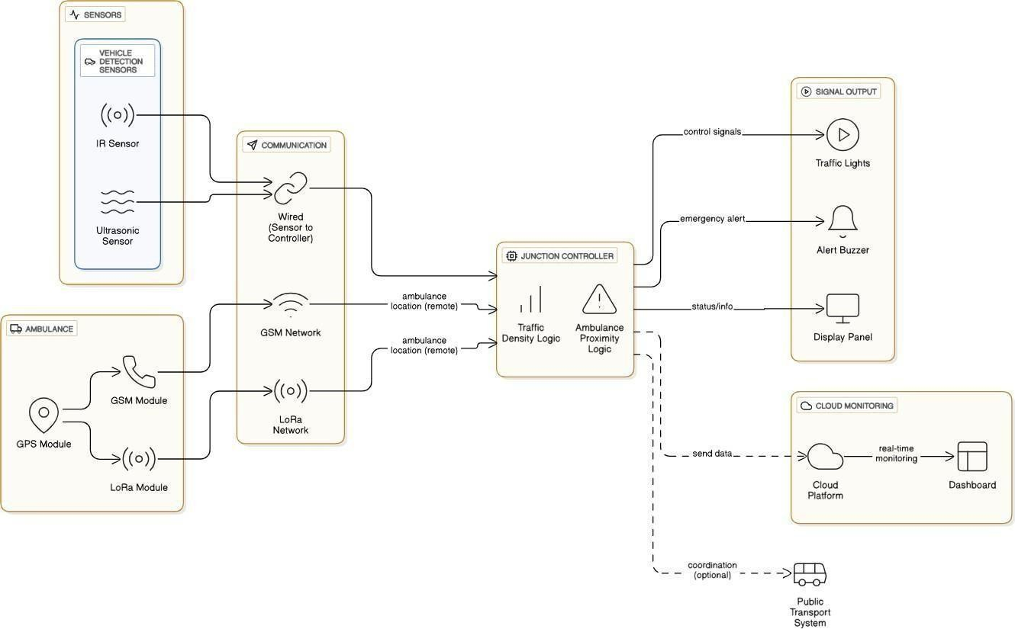

Fig: 3.1.1. Smart traffic light system using Iot

* 1. **MODULE DESIGN SPECIFICATION**

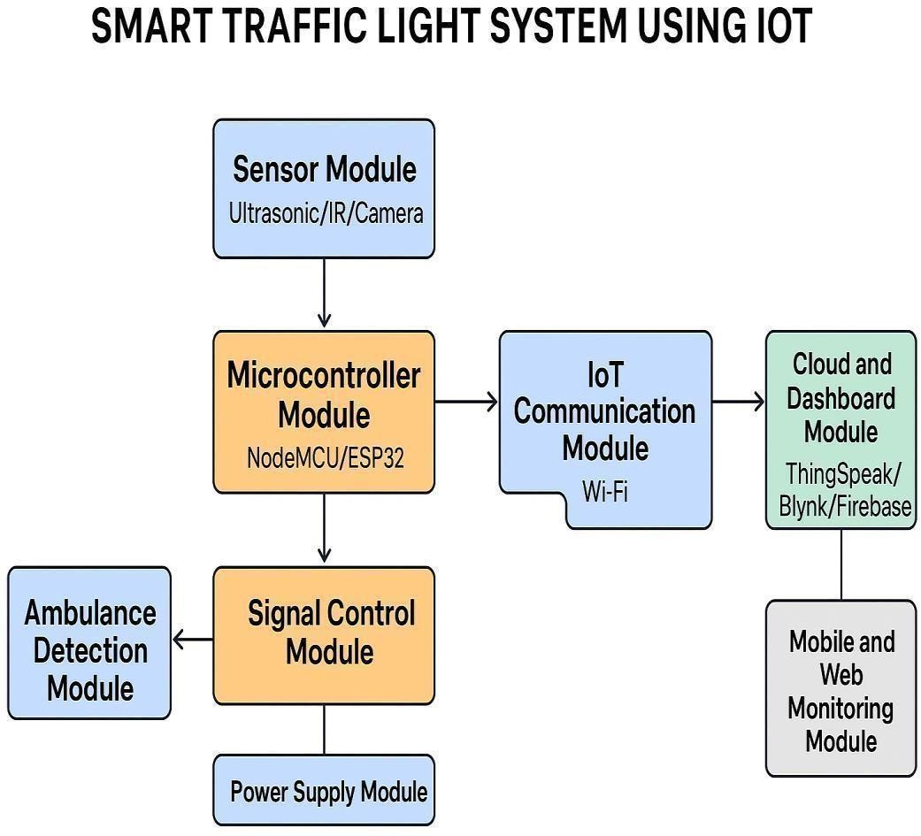

The Smart Traffic Light System using IoT is designed as a collection of interconnected modules, each responsible for a specific function that contributes to the overall performance of the system.

#### Sensing Module:

This module detects real-time traffic conditions using sensors such as infrared detectors, ultrasonic sensors, or cameras. It gathers data related to vehicle density, lane occupancy, and traffic flow, which serves as the input for decision-making.

#### Processing Module:

At the core of the system, this module utilizes a microcontroller or embedded processor to analyze data from the sensing module. Adaptive algorithms are applied to calculate optimal signal durations, ensuring smooth traffic regulation.

#### Traffic Light Control Module:

Based on decisions from the processing unit, this module manages the operation of red, yellow, and green lights at intersections. It ensures proper sequencing and maintains fail-safe functionality in case of errors.

#### IoT Communication Module:

To enable connectivity, this module uses wireless technologies such as Wi-Fi, GSM, or LoRa to transmit traffic data to a cloud platform. It also allows remote commands from traffic authorities to be executed at the local system level.

#### Cloud and Data Management Module:

This module is responsible for storing, processing, and managing real-time as well as historical traffic data. It provides visualization, analytics, and reporting features to assist in traffic monitoring and optimization.

#### User Interface Module:

A web or mobile application is provided for traffic authorities to monitor live conditions, receive alerts, and intervene when necessary. Manual override features are included for emergency situations. **Power Supply Module:**

The entire system is supported by a reliable power supply, consisting of regulated AC input along with optional battery backup or solar panels. This ensures uninterrupted operation during power failures.

**CHAPTER 4**

* 1. **UML DIAGRAMS**

**SYSTEM DESIGN**

**ACTIVITY DIAGRAM**

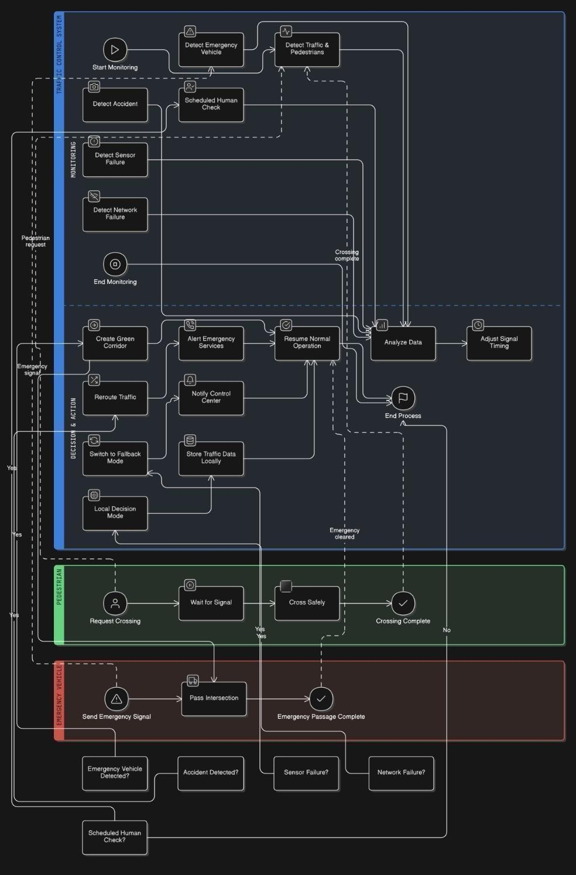

Fig: 4.1.1.Activity diagram for smart traffic light system

* 1. **DEPLOYMENT DIAGRAM**

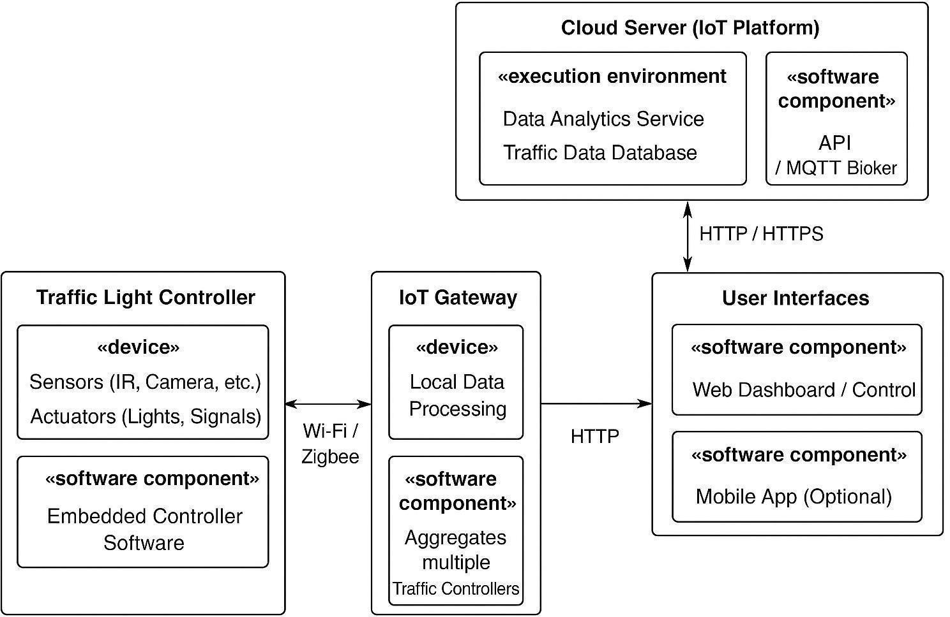

Fig:4.1.2 Deployment diagram for smart traffic light systemusing IoT

The UML deployment diagram for the Smart Traffic Light System using IoT illustrates how different physical and software components interact to manage and optimize traffic flow. At the edge of the system, the Traffic Light Controller consists of sensors such as infrared detectors and cameras, along with actuators like signal lights. It runs embedded controller software that processes sensor data and controls light sequences in real time. These controllers communicate wirelessly via Wi-Fi or Zigbee with an IoT Gateway, which serves as a local hub. The gateway aggregates data from multiple intersections, performs basic edge analytics, and forwards relevant information to the Cloud Server through HTTP or MQTT protocols. The Cloud Server, functioning as the IoT platform, hosts the data analytics service and traffic database, providing large-scale analysis and predictive modeling to optimize traffic flow across the network.

**CHAPTER 5**

**SYSTEM IMPLEMENTATION**

* 1. **BACKEND CODING**

<!doctype html>

<html lang="en">

<head>

<meta charset="utf-8" />

<title>Smart Traffic Light Simulation (4-way) with Ambulance Priority</title>

<style>

body { font-family: Arial, sans-serif; display:flex; gap:20px; padding:20px; } #controls { width:300px; }

canvas { background:#e9e9e9; border:1px solid #ccc; } label { display:block; margin:8px 0 4px; }

input[type="number"]{ width:100%; padding:6px; box-sizing:border-box; } select, button { width:100%; padding:8px; margin-top:8px; }

.legend { margin-top:10px; font-size:14px; }

</style>

</head>

<body>

<div id="controls">

<h3>Simulation controls</h3>

<label>North vehicles</label><input id="nCount" type="number" min="0" value="6">

<label>East vehicles</label><input id="eCount" type="number" min="0" value="3">

<label>South vehicles</label><input id="sCount" type="number" min="0" value="8">

<label>West vehicles</label><input id="wCount" type="number" min="0" value="4">

<label>Ambulance present?</label>

<select id="ambPresence">

<option value="none">No ambulance</option>

<option value="north">North</option>

<option value="east">East</option>

<option value="south">South</option>

<option value="west">West</option>

</select>

<label>Ambulance distance (meters)</label>

<input id="ambDist" type="number" min="0" value="1500">

<button id="startBtn">Start Simulation</button>

<button id="resetBtn">Reset</button>

<div class="legend">

<p><strong>Legend:</strong></p>

<p style="margin:2px">Blue = car, Purple = bike, Yellow = ambulance</p>

<p style="margin:2px">Green light → vehicles on that side move</p>

</div>

</div>

**CHAPTER 6**

**PERFORMANCE EVALUATION**

* 1. **PERFORMANCE PARAMETERS**

The performance of the Smart Traffic Light System is evaluated using the following key parameters:

#### Traffic Flow Efficiency

* + - * Measures the average waiting time of vehicles at intersections.
      * Evaluates improvement in vehicle throughput compared to fixed-time traffic lights.

#### Response Time

* + - * Time taken by the system to detect traffic density or emergency vehicles and adjust signals accordingly.
      * Faster response ensures smoother traffic movement and quicker emergency clearance.

#### Accuracy of Traffic Detection

* + - * Ability of sensors and cameras to correctly detect the number of vehicles and congestion levels.
      * High accuracy ensures optimal signal timing decisions.

#### Emergency Vehicle Priority Handling

* + - * Measures the reduction in delay for ambulances and other emergency vehicles.
      * Ensures the system effectively creates a green corridor when required.

#### System Reliability and Fault Tolerance

* + - * Ability of the system to operate continuously even during sensor failure, network outage, or hardware malfunction.
      * Includes fallback modes and redundancy mechanisms.

#### Energy and Environmental Efficiency

* + - * Reduction in vehicle idle time lowers fuel consumption and emissions.
      * Evaluates the system’s contribution to environmental sustainability.

#### Scalability and Flexibility

* + - * Capability to deploy the system across multiple intersections or integrate with smart city infrastructure.
      * Assesses adaptability for future expansion and integration.
  1. **PERFORMANCE METRICS**

The system often measures vehicle density (D) using IoT sensors such as IR, ultrasonic, or computer vision.

𝑁

𝐷 = 𝐿

𝐷= vehicle density (vehicles per meter)

𝑁= number of vehicles detected in a lane

𝐿= length of the lane being monitored (in meters)

##### Dynamic Green Time Allocation

To adjust signal timing based on real-time density:

𝐷

𝑇𝑔 = 𝑇𝑚𝑖𝑛 + (

𝐷𝑚𝑎𝑥

) × (𝑇𝑚𝑎𝑥 − 𝑇𝑚𝑖𝑛)

𝑇𝑔= green light time for that lane

𝑇𝑚𝑖𝑛= minimum green time

𝑇𝑚𝑎𝑥= maximum green time

𝐷= current vehicle density

𝐷𝑚𝑎𝑥= maximum expected vehicle density

##### Traffic Priority (for Emergency Vehicles)

IoT sensors or RFID detect emergency vehicles:

𝑃 = 𝛼𝐸 + 𝛽𝐷 + 𝛾𝑊

𝑃= priority score of a lane

𝐸= emergency vehicle detection (1 if present, else 0)

𝐷= density

𝑊= waiting time

𝛼, 𝛽, 𝛾= weighting coefficients (decided by system design)

The lane with the highest priority 𝑃gets green first.

##### Average Waiting Time

Used to monitor performance and optimize timing:

∑𝑛 (𝑡𝑒𝑛𝑑,𝑖 − 𝑡𝑠𝑡𝑎𝑟𝑡,𝑖)

𝑊𝑎𝑣𝑔

= 𝑖=1

𝑛

𝑊𝑎𝑣𝑔= average waiting time per vehicle

𝑡𝑠𝑡𝑎𝑟𝑡,𝑖= time vehicle 𝑖arrives at red signal

𝑡𝑒𝑛𝑑,𝑖= time vehicle 𝑖leaves after green

𝑛= number of vehicles

##### Adaptive Signal Optimization (Weighted Function)

For multi-lane intersections with IoT data:

𝑆 = 𝑤1𝐷 + 𝑤2𝑊 + 𝑤3𝑄

𝑆= score for each signal lane

𝐷= density

𝑊= average waiting time

𝑄= queue length

𝑤1, 𝑤2, 𝑤3= weight factors based on priority

The system selects the lane with maximum S for green light.

##### Queue Length Estimation

If sensors measure average spacing 𝑠:

𝐿

𝑄 = 𝑠

𝑄= estimated queue length (number of vehicles)

𝐿= lane length occupied by vehicles

𝑠= average spacing between vehicles

##### IoT Data Fusion (for Decision Making)

Combining multiple sensors (camera, IR, ultrasonic):

∑𝑛 𝑤𝑖𝐷𝑖

𝐷 = 𝑖=1

𝑓𝑢𝑠𝑒𝑑

∑

𝑛

𝑖=1

𝑤𝑖

𝐷𝑖= density measurement from sensor 𝑖

𝑤𝑖= reliability weight of that sensor

𝑛= number of sensors

* 1. **RESULTS AND DISCUSSION**

The smarter traffic light system mentioned earlier combines both hardware and software to better manage traffic flow. IR sensors and cameras help measure how crowded the roads are, while RFID readers, tags, and GPS modules help identify emergency vehicles so they can move through more easily. A Raspberry Pi or ESP32 serves as the main control unit, connected to LED traffic lights and a Wi Fi module to link the system to the cloud. For the software, Python, C++, and the Arduino IDE are used to control the hardware, and OpenCV is used for processing images. Cloud platforms like ThingSpeak, Firebase, or AWS IoT allow real-time monitoring and data storage, while communication protocols similar to MQTT and HTTP ensure reliable data exchange between the controller and the cloud service.

**CHAPTER 7 CONCLUSION AND FUTURE WORK**

* 1. **CONCLUSION**

This Smart Traffic Light System solves the problems of traditional traffic management by being flexible. Unlike traffic lights that follow a fixed schedule or require manual control, this system changes in real time based on how busy or quiet the roads are. It can clear the way for emergency vehicles like ambulances and fire trucks on the go. Using IoT-enabled sensors such as cameras and cloud connections, it helps cut down waiting times, saves fuel, reduces pollution, and makes traveling easier for everyone.

The system also allows for remote monitoring and keeps track of data, so officials can see how traffic moves, where the busiest spots are, and plan for the future. Its ability to grow and be customized makes it useful in smart cities, where smart and flexible solutions are key for building sustainable and efficient urban areas. While the system offers a strong base for managing traffic smartly, there are several improvements that could be added later. For example, using AI and Machine Learning can help predict traffic patterns and adjust signal timings better.

* 1. **FUTURE ENHANCEMENT**

The Smart Traffic Light System using IoT can be further enhanced to increase efficiency, intelligence, and integration with modern urban infrastructure. Future improvements may include:

#### Integration with AI and Machine Learning

* + Implement predictive traffic modeling to anticipate congestion before it occurs.
  + Enable adaptive learning from historical traffic patterns to optimize signal timings dynamically.

#### Vehicle-to-Infrastructure (V2I) Communication

* + Allow vehicles to communicate directly with traffic lights for real-time updates.
  + Improve emergency vehicle detection and dynamic rerouting.

#### Smart City Integration

* + Connect with other IoT-based systems such as parking management, public transport, and environmental monitoring.
  + Enable centralized traffic monitoring and urban planning analytics.

**CHAPTER 8**

**APPENDICES**

**A1. SDG GOALS**

The Smart Traffic Light System using IoT contributes to several Sustainable Development Goals (SDGs). By reducing traffic congestion, vehicle idling, and road accidents.It supports SDG 3 (Good Health and Well-being) through improved urban safety and air quality.

The system promotes SDG 9 (Industry, Innovation, and Infrastructure) by integrating IoT technology and intelligent traffic management into modern urban infrastructure.

It enhances SDG 11 (Sustainable Cities and Communities) by ensuring efficient, safe, and resilient transport networks, while SDG 13 (Climate Action) is addressed through reduced fuel consumption and lower greenhouse gas emissions.

Additionally, by minimizing travel time and improving productivity, it contributes to SDG 8 (Decent Work and Economic Growth). Overall, the system exemplifies how smart, technology-driven solutions can advancemultiple sustainability goals simultaneously.

**A2. SCREENSHOTS**

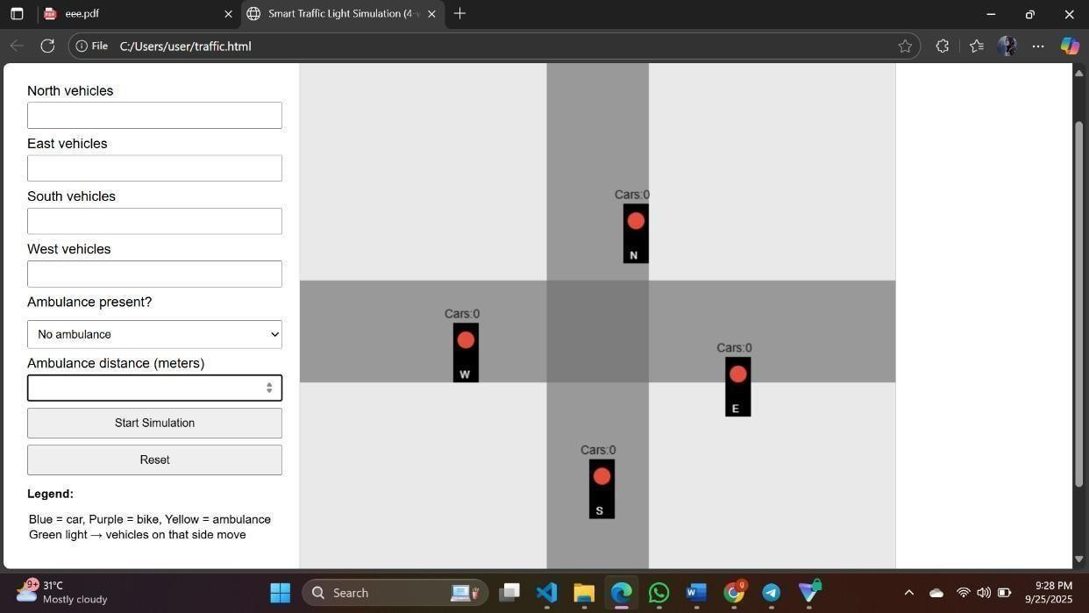

Fig:A.8.1.Screenshot of basic page

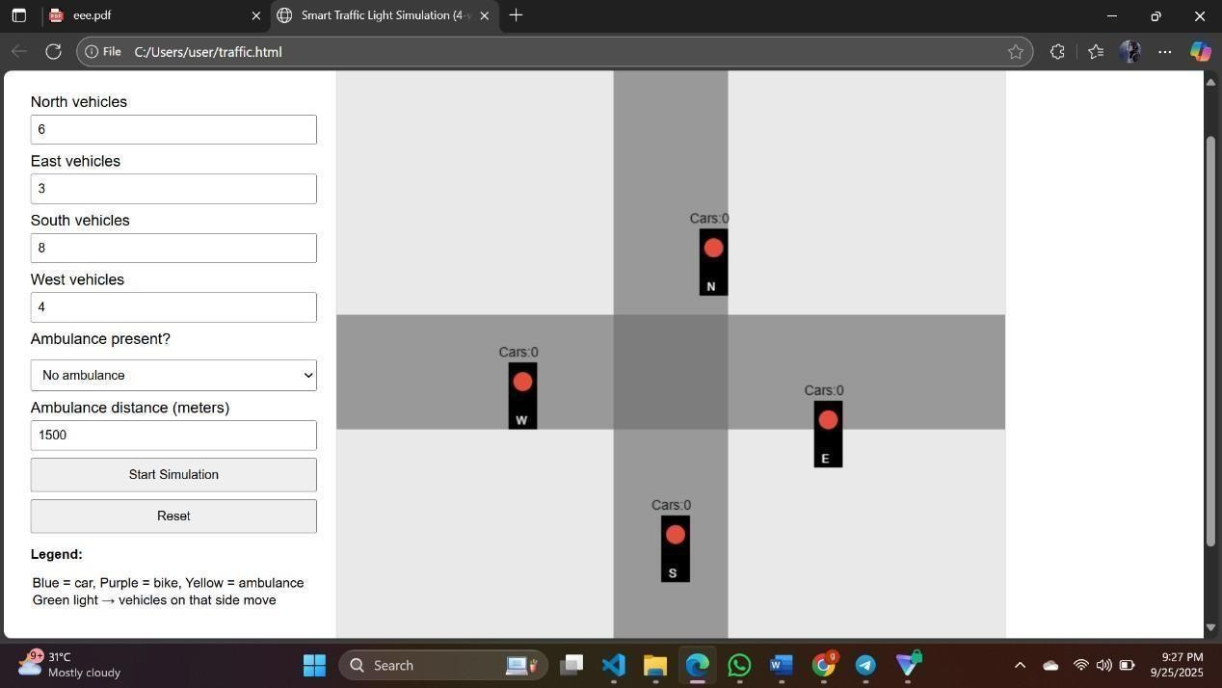

Fig:A.8.2.shot of input Page

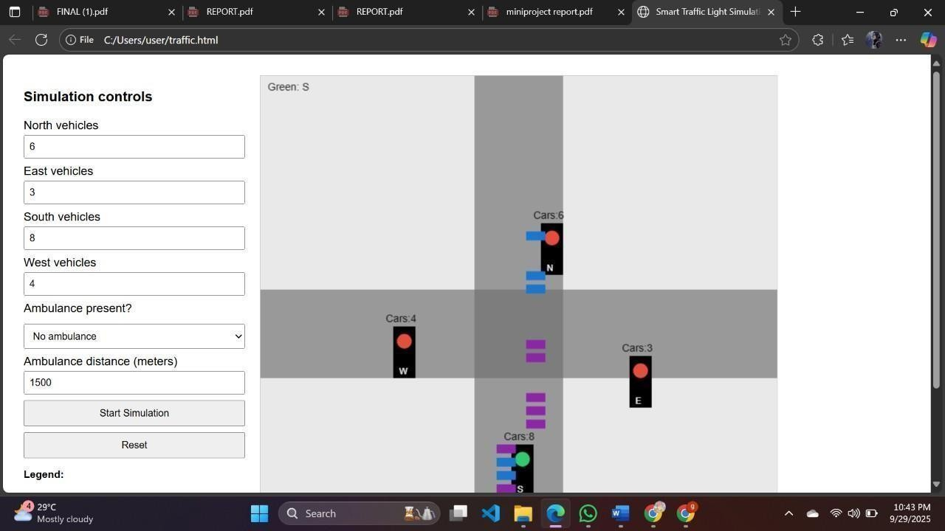

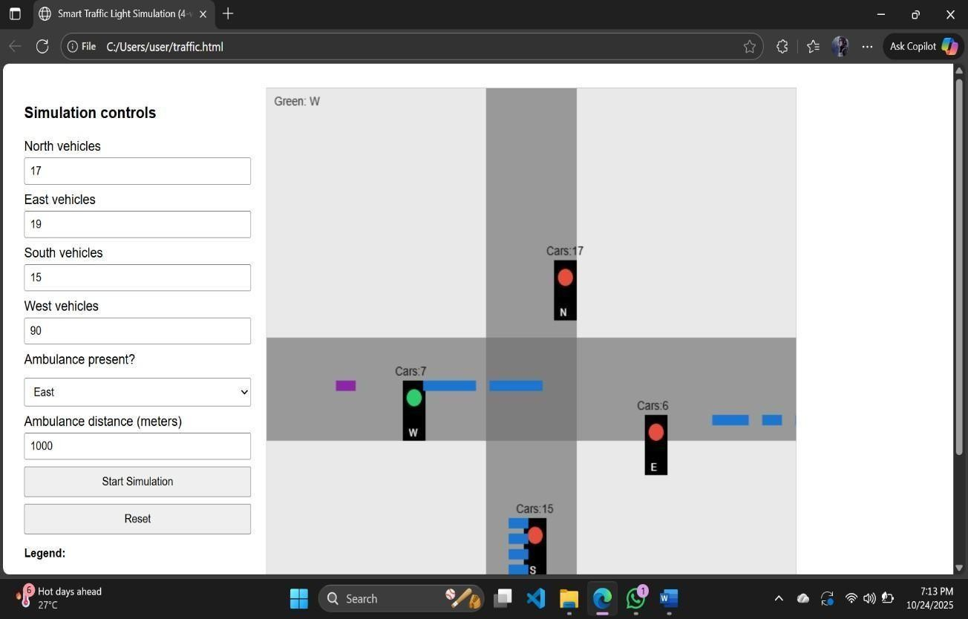

Fig:A.8.3. Screenshot of the running page

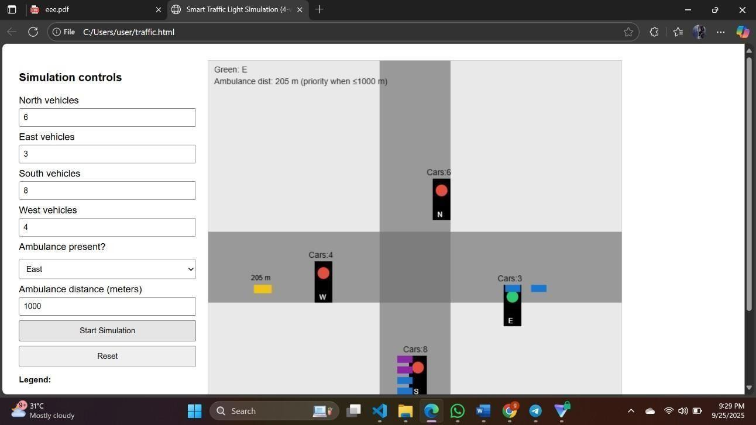

Fig:A.8.4. Screenshot of the output page

Page 1 of 10 - Cover Page Submission ID trn:oid:::2945:317462163

**A3. PLAGIARISM REPORT**

# 18907 72899

### k22

Turnitin

Document Details

Submission ID trn:oid:::2945:317462163

6 Pages

3,261 Words

18,079 Characters

Submission Date

Oct 10, 2025, 4:21 AM GMT+3

Download Date

Oct 10, 2025, 4:22 AM GMT+3

File Name unknown_filename

File Size

201.1 KB

Page 1 of 10 - Cover Page Submission ID trn:oid:::2945:317462163

 Page 2 of 11 - Integrity Overview Submission ID trn:oid:::2945:317462163

### 7% Overall Similarity

The combined total of all matches, including overlapping sources, for each database.

Filtered from the Report

 Bibliography

Match Groups

13 Not Cited or Quoted 6%

Matches with neither in-text citation nor quotation marks

2 Missing Quotations 1%

Matches that are still very similar to source material

1 Missing Citation 0%

Matches that have quotation marks, but no in-text citation

0 Cited and Quoted 0%



Matches with in-text citation present, but no quotation marks

Top Sources

6%  Internet sources

4% Publications



5% Submitted works (Student Papers)

Integrity Flags

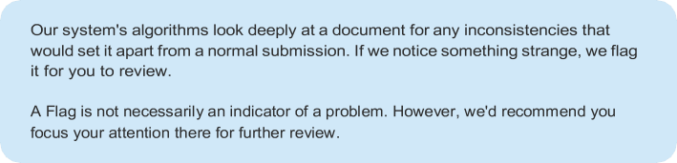0 Integrity Flags for Review

Page 2 of 11 - Integrity Overview Submission ID trn:oid:::2945:317462163



Match Groups

Page 3 of 11 - Integrity Overview Submission ID trn:oid:::2945:317462163

Top Sources

13 Not Cited or Quoted 6%

|  |  |
| --- | --- |
| 6% | Internet sources |
| 4% | Publications |
| 5% | Submitted works (Student Papers) |

Matches with neither in-text citation nor quotation marks

2 Missing Quotations 1%

Matches that are still very similar to source material

1 Missing Citation 0%

Matches that have quotation marks, but no in-text citation

0 Cited and Quoted 0%



Matches with in-text citation present, but no quotation marks

Top Sources

The sources with the highest number of matches within the submission. Overlapping sources will not be displayed.

Internet

[www.irejournals.com](https://www.irejournals.com/paper-details/1704269) <1%

Internet

[www.ijraset.com](https://www.ijraset.com/research-paper/intelligent-traffic-system) <1%



papers

Central Queensland University on 2025-04-25 <1%

Publication

[Akshansh Jha, Pradyut Agrawal, Ravneet Kaur, Anju Agrawal, Monika Bhattachar…](https://doi.org/10.1109/ICI60088.2023.10421439) <1%



papers

King's Own Institute on 2025-05-18 <1%



papers

Ghana Technology University College on 2024-05-18 <1%

Publication

[Manoj Sheshmal Kavedia, Jitendrakumar Namdeo Shinde. "Reinforcement Learni…](https://doi.org/10.1109/ICIICS59993.2023.10421012) <1%

Internet

[ijarcce.com](https://ijarcce.com/issues/volume-12-issue-7-july-2023/) <1%

Internet

[ijres.org](https://ijres.org/papers/Volume-12/Issue-9/12094050.pdf) <1%



Internet

[www.irjmets.com](https://www.irjmets.com/uploadedfiles/paper/issue_6_june_2023/42786/final/fin_irjmets1688226571.pdf) <1%

Page 3 of 11 - Integrity Overview Submission ID trn:oid:::2945:317462163

Page 4 of 11 - Integrity Overview Submission ID trn:oid:::2945:317462163

11

Internet

[www.mdpi.com](https://www.mdpi.com/2079-9292/12/5/1177) <1%



Internet

[www.andhraloyolacollege.ac.in](https://www.andhraloyolacollege.ac.in/staff_profiles/Dr.%20A.%20Madhuri%20%20.pdf) <1%



Internet

[www.techscience.com](https://www.techscience.com/files/csse/2023/TSP_CSSE-46-1/TSP_CSSE_35135/TSP_CSSE_35135.epub) <1%



Internet

[www.semanticscholar.org](https://www.semanticscholar.org/paper/Iot-Ambulance-With-Automatic-Traffic-Light-Control-Sivaraj-Vigneshwaran/611c74a8f87a1295100bda849387bdaa085f467c) <1%



Publication

[Kian Raheem Qasim, Nor M. Naser, Ahmed J. Jabur. "An IoT-Enhanced Traffic Lig…](https://doi.org/10.3390/fi16100377) <1%

Page 4 of 11 - Integrity Overview Submission ID trn:oid:::2945:317462163

 Page 5 of 11 - Integrity Submission Submission ID trn:oid:::2945:317462163

Smart Traffic Light System using IOT

LINCY JEMINA S, GNANESHWAR G, HARISHKUMAR S*

[lincyyabez@gmail.com,](mailto:lincyyabez@gmail.com)*[harishpec779@gmail.com,](mailto:harishpec779@gmail.com) [ggnanesh49@gmail.com](mailto:ggnanesh49@gmail.com)

Department of CSE, Panimalar Engineering College, Chennai, India

*Corresponding Author Email : [harishpec779@gmail.com](mailto:harishpec779@gmail.com)

Page 5 of 11 - Integrity Submission Submission ID trn:oid:::2945:317462163

 Page 6 of 11 - Integrity Submission Submission ID trn:oid:::2945:317462163

## Light

Smart Traffic

System using IOT



**4**

Abstract:

A smart traffic light system using sensors technology is great example of how cities can increase traffic monitoring and reduce congestion in real time. This system uses IoT sensors like cameras, infrared detectors, and vehicle counters at intersections to measure traffic density. The information gathered by these sensors is transmitted wirelessly to middle control system, which processes the information and adjusts the traffic lights as needed. By adjusting the lights upon the traffic conditions, the system helps reduce the time drivers spend waiting at red lights. This, in turn, decreases the amount of time vehicles idle, which lowers fuel use. It also helps reduce air pollution in urban areas. Additionally, the system could be adapted to give priority to emergency vehicles, similar to how regular traffic lights respond in emergencies. The IoT sensors would just need to be programmed to recognize and clear the way for emergency vehicles, just like traditional traffic lights do.

Keywords: Congestion management involves using data collection to monitor traffic in real time, which helps in optimizing traffic flow. This system also prioritizes emergency vehicles to ensure they can move through busy areas quickly. By keeping track of traffic conditions as they happen, operators can make timely decisions to improve overall traffic efficiency.



**5**

###### I.INTRODUCTION:



**15**

As the world's population moves from rural to In cities, traffic management has become a serious concern. More the vehicle in urban areas has grown quickly, a lot of pressure in city roads. Traditional traffic signals, which either rely on manual control or fixed time cycles, are not good enough for handling these changing traffic conditions. These systems can't adjust to real-time changes, leading to problems like traffic jams, Long journey times, more fuel consumption, and increased emissions.



**12**

One big problem with current systems is that they are not flexible. Fixed-time signals keep running even

when there are no cars, making people wait longer and causing delays for drivers. Manual control helps during busy or emergency times, but it takes a lot of work and is not always accurate. Even systems that use simple sensors to detect cars can't track how many cars there are, how fast they're moving, or which lanes should get priority. Also, there's no special treatment for vehicles for Emergency like ambulances, fire rescue trucks, and police belongings, which can cause delays that may cost lives or damage resources.

To address these issues, using a Smart Traffic Light System with the IoT has shown to a smart and effective solution. IoT connects sensors, cameras, controllers, and servers in the cloud, allowing them to share information and make better decisions. In our proposed smart traffic system, real-time traffic density is measured using infrared sensors, cameras, and either image processing or detection methods (or both).

Based on this data, traffic lights are adjusted in

traffic and shorter ones to lanes with less, making the flow of traffic more efficient.

###### LITERATURE REVIEW:

Numerous researchers have studied smart traffic management using IoT technologies.[1]

Holkar, A., Hande, T., Lokhande, P., and Badade, V.

Gaikwad, V.,

Controller " They used

(2023)

System

Traffic

Intelligent Computing Techniques.

Data Science and

with IoTin their paper titled "

looked into Intelligent

Raspberry Pi and OpenCV for surveillance and

automatic traffic signal regulation, noting improvements in traffic flow. They considered real- time vehicle detection and congestion limits, but their system wasn't reliable when vehicle colors were similar to the road surface.

[2]Arun Kumar (2022) also introduced a Smart Traffic Light Control System IJFANS

in the

journal –

Science. Their system used PIC microcontrollers with IR sensors and XBee technology, including an

International Journal of Food and Nutritional

Page 6 of 11 - Integrity Submission Submission ID trn:oid:::2945:317462163

Page 7 of 11 - Integrity Submission Submission ID trn:oid:::2945:317462163

emergencyoverride. Traffic signals were adjusted based on traffic density, with longer green lights during high traffic and priority given to emergency vehicles. However, the system had limitations, such as only working at a single junction, requiring manual override, and not considering pedestrians.

In another study, [ and

V.C. Gerogiannis

an Intelligent Traffic

3]S.C. Rai, S.P. Nayak, B. Acharya,



**6**

**11**

proposed

the Electronics (MDPI). Theyused inductive loops and IR sensors to detect vehicles and determine prioritization. Their system improved traffic flow and reduced waiting times, but the high cost of the technology and the complexity of maintaining large-scale sensor networks were major drawbacks.

Signaling System Based on IoT in

journal



**7**

Other researchers have also explored innovative IoT- based solutions. For example, [4]

Faisal Al Kalbani,



**14**

and (2023) presented an ICT- at the 4th

Syed Imran

Based Smart Traffic Light Controller

Nada Al Bulushi,



**1**

**13**

Their system used Arduino UNO with IR sensors and RFID to prioritize emergency vehicles. While it allowed for adaptive traffic control and reliable emergency responses, there were issues with scaling their vehicle detection system and hardware reliability.

Middle East College Conference.



**2**

[5]Gunashree H.S., Harshitha D.V., Siddesh Prasad B.C., Karthik Kumar J., and Dimple R. proposed an

IoT-based Smart Traffic Signal Monitoring System



**10**

in their paper (IRJMETS). Their system used line-of-sight RF communication but had limited practical use beyond the scope of their

Sowmya K.S., Soumya Ranjan Sahoo,

Using Vehicle Density

study. [6]Dr.

discussed a Smart

Urmila M and



**8**

in traffic management, focusing on real-time data, AI, and sensor cooperation. It noted that IoT systems improve traffic efficiency with real-time monitoring, adaptive control, and predictive management. However, challenges like large-scale deployment, cybersecurity risks, and interoperability issues still exist.

[8]Megha Balmiki, Sahali Dutta, Ankita Majumder,

Osmeeta Chauhan, and others (2022) proposed a

in JETIR –

Smart Traffic Lighting System

Emerging Technologies and Innovative Research.

Journal of

They used IR and ultrasonic sensors with an AT89C51 microcontroller to manage traffic signals in real time and track emergency vehicles. The system improved waiting times and traffic flow, but high implementation costs, complex maintenance, and limited efficiency in emergency services were noted.

[9]

Jain, Preeth T Jain, Dr. Anita Walia,

Dr. Supriya

Rahul Biju, Sakshi Jain, Nehal Hemdev, Teesha P

and

(2023) developed a

Rai

Smart Traffic Management

System published in IRE Journals. [10]

Parasrampuria,

Gargi Sharma

an

Pratik Prakash, Aadarsh Singh, Aayush

Using IoT

(2021) created

and

described

IoT-based smart traffic management system

in the

International Journal of Electrical, Electronics

They used IR sensors and Arduino Nano, with simulations on Proteus and a web-based live monitor. Their system reduced waiting times and monitored traffic and emergency vehicles in real time. However, they faced issues with limited range and adjustment requirements for real-world applications.

and Computers.

Traffic Management System Using IoT

, Harshith J. Raj



**9**

**4**

in the

[11]G. Goutham, T. Maheshwar Reddy, N. Varun Reddy V. Karthik, and K. Sai Sudheer (2020) designed

International Journal of Creative Research Thoughts. Their model used YOLOv3 for vehicle detection, IR sensors for density control, and an NFC system for emergency vehicle prioritization. Combining AI and IoT, their system could help reduce emergency vehicle wait times if integrated across a city. However, the initial setup and ongoing maintenance costs and complexity are major considerations.

Shailesh Shivajirao Bhise (2025)

Application in a Smart Traffic Management System

an IoT

[7]

published

in

the

The paper reviewed IoT applications



**3**

an Intelligent

in the Research

IoT-based

International

Journal of Engineering

Traffic Management System

(IRJET0).

and Technology

They used Arduino UNO and IR sensors to detect vehicle density and simulate traffic control. Their system allowed for quicker clearance of emergency vehicles and safe traffic guidance. However, sensor range limitations, hardware costs, and scalability issues in large-scale real-world environments were noted.

Biotechnology.

Journal for Research in Applied Sciences and

Page 7 of 11 - Integrity Submission Submission ID trn:oid:::2945:317462163

Page 8 of 11 - Integrity Submission Submission ID trn:oid:::2945:317462163

###### EXISTING SYSTEM:

Most of the control of traffic and management systems today rely upon fixed-time or manual control methods, which do not have the ability to sense traffic conditions in real time. Fixed-time signals operate on set time intervals, which means they cannot adjust to changing traffic density or the presence of emergency vehicles. This can result in unnecessary delays. Semi- automated systems, even when they include road sensing technology, are not able to adapt quickly to sudden events like accidents or a sudden increase in traffic volume. Systems that are commonly considered include: fixed-time traffic signals, manually controlled signals, and semi-triggered automated systems. Fixed- time signals use a preset timeline to determine how long each lane gets a green light, for example, 30 seconds per lane. The timing is fixed and does not take into account the actual presence of vehicles or emergency vehicles. If vehicles are already on the road during the pre-scheduled green light, this can cause problems and lead to inefficient traffic flow. Manual control requires traffic police or operators to manage traffic during busy periods, special events, VIP movements, or emergencies. This approach is often time-consuming and not always effective. Semi- triggered automated systems use devices like inductive loops or pressure switches to detect vehicle presence. These systems can only identify if a vehicle is in a specific location or among several lanes, giving a general idea of traffic volume. However, they are not equipped to adjust dynamically for changing traffic conditions or to prioritize emergency vehicle paths for safety.

###### DRABACKS:

The current traffic management systems have several major flaws that make them less efficient and dependable. One problem is that these systems aren't capable of adjusting to changing traffic conditions in today times. Traffic signals keep running on set

schedules,matter how much or how little traffic is actually moving. This can cause unnecessary delays. For example, if there are no vehicles at an intersection, the light might still stay red, making the wait longer for everyone.Another serious issue is that these systems don't have the ability to detect Emergency

vehicles, such as medical vehicles, fire rescue things, and police belongings like their cars etc. This can create dangerous delays, especially in urgent situations where quick passage is needed. Sometimes, traffic officers try to fix these problems by manually changing signals, but this process is time-consuming and can lead to mistakes, making the system less effective. When vehicles sit idling for long periods at traffic lights, it wastes both time and fuel, which are big problems. Also, idling engines, especially those running on carbon-based fuel, produce a lot of pollution and emissions. Another big shortcoming is the lack of proper monitoring and data collection. These systems often don't allow for easy access to real- time or historical data, which means traffic authorities can't analyze trends or make improvements. Without this data, it's hard to plan better strategies. Lastly, these systems aren't built to grow or adapt. Making changes usually needs a lot of money and effort, which makes it hard to keep up with the needs of modern cities.

###### PROPOSEDSYSTEM: A.SYSTEMARCHITECTURE:

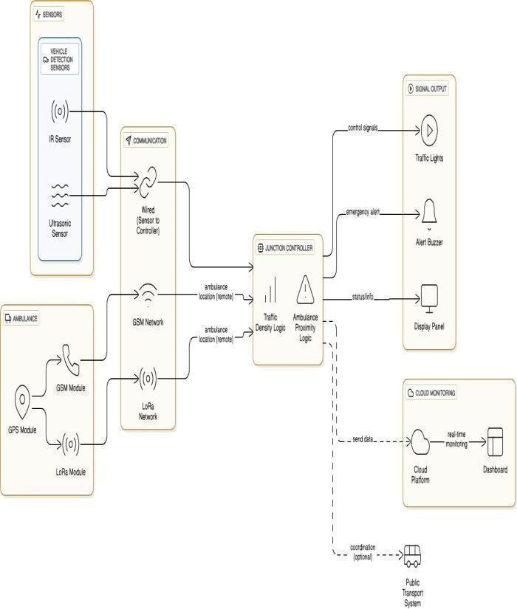

Fig.1. Architecture of IoT-Based Smart Traffic Light System with Emergency Vehicle Priority

Page 9 of 11 - Integrity Submission Submission ID trn:oid:::2945:317462163

The diagram show an architecture of an sensors Smart Traffic Light Systems designed for real-time traffic management and prioritizing emergency vehicles. Vehicle detection is done using IR and ultrasonic sensors that send data through wires to the junction controller. The ambulance is equipped with GPS and GSM/LoRa modules to share its location over communication networks.

The junction controller uses traffic density logic and ambulance proximity logic to process data from both the sensors and the ambulance. It then decides on the right signal timing based on this information and gives priority to the ambulance.

Once a decision is made for each traffic light, the controller sends the correct signal to the traffic lights, activates one or more buzzers for alerts, and updates the display panels for people on site.

The system also sends information about its status and traffic density data to a cloud platform. This allows traffic authorities to monitor everything in real time and view it on a dashboard when needed. Overall, by keeping track of traffic violations and giving priority to emergency vehicles based on traffic density at intersections, the system makes traffic management more efficient, safe, and reliable in urban areas.

###### B.MODULE DESCRIPTION:

The preposed system consist of five modules

1. Traffic Detection Module
2. Emergency Vehicle Detection Module
3. Controller Module y
4. IoT Communication Module
5. Signal Actuation Module

TrafficDetectionModule:

The traffic detection module is designed to monitor how many cars are on the road. It uses infrared sensors to count all the vehicles present. Additionally, it has a camera that uses OpenCV to analyze a real-time video feed and identify vehicles. The system can also measure the size of each vehicle, giving priority to larger ones. This helps improve the flow of traffic and reduces traffic jams.

EmergencyVehicleDetectionModule:

The emergency vehicle detection module identifies ambulances and fire trucks using detection devices that may include tags, RFID readers, or GPS modules. If an emergency vehicle is recognized, the system interrupts an normal signal cycle for providing a clear path for the vehicle. This allows emergency services to reach their destination without delays by giving them immediate access to the scene or emergency location.

Controller Module:

The controller module, which could be a Raspberry Pi, ESP32, or similar device, acts like the main part of the process. It gathers data for the sensor camera, processes that information, and uses the programmed logic to change how long traffic signals stay on. This module lets the traffic lights respond to how traffic is behaving instead of following a fixed schedule.

IoT Communication Module:

This module enables communication between the traffic system and the cloud through Wi-Fi. Traffic data and signal data are transmitted to IoT platforms like ThingSpeak or Firebase, allowing local authorities to monitor the system from a distance. Connecting to the cloud also lets end-users view real-time updates and manually control the system when needed.

Signal Actuation Module:

The signal actuation module is in charge of managing the traffic lights. It uses LED lights or relays to show the standard red, yellow, and green signals. These signals are controlled via GPIO pins on the controller, based on logic that is calculated using real-time data. The module also allows for longer green light times when there is a higher volume of traffic or when emergency vehicles are present.

C.ALGORITHM:

Algorithm 1: Smart Traffic Light System Using IoT

1. Input: Traffic density statistics (D), Emergency automobile repute (E)
2. Output: Optimized traffic signal timing (T)

Page 9 of 11 - Integrity Submission Submission ID trn:oid:::2945:317462163

Page 10 of 11 - Integrity Submission ID trn:oid:::2945:317462163

1. Initialize gadget modules: Sensors, Controller, IoT verbal exchange, Signal actuation
2. Acquire traffic density from IR sensorsand digicam (OpenCV)
3. Process density records to calculate quantity of vehicles in keeping with lane
4. If Emergency vehicle detected (E = TRUE):
   1. Identify nearest lane with emergency vehicle
   2. Override ordinary cycle and set GREEN signal for emergency lane
   3. Maintain RED indicators for different lanes till emergency vehicle passes
5. Else (no emergency vehicle):
   1. Compare density values across all lanes
   2. Assign GREEN signal length proportional to traffic density
   3. Assign shorter GREEN indicators to low-density lanes
6. Update traffic lights through Signal Actuation Module
7. Transmit visitors facts and gadget repute to IoT cloud server
8. Display real-time statistics on monitoring dashboard.



###### IMPLEMENTATION DETAILS:

The smarter traffic light system mentioned earlier combines both hardware and software to better manage traffic flow. IR sensors and cameras help measure how crowded the roads are, while RFID readers, tags, and GPS modules help identify

emergency vehicles so they can move through more easily. A Raspberry Pi or ESP32 serves as the main control unit, connected to LED traffic lights and a Wi- Fi module to link the system to the cloud. For the software, Python, C++, and the Arduino IDE are used to control the hardware, and OpenCV is used for processing images. Cloud platforms like ThingSpeak,

Firebase, or AWS IoT allow real-time monitoring and data storage, while communication protocols similar to MQTT and HTTP ensure reliable data exchange between the controller and the cloud service.

###### CONCLUSION AND FUTURE WORK:

the Smart System solves the problems of traditional management of traffic by being flexible. Unlike traffic lights that follow a fixed schedule or require manual control, this system changes in real time based on how busy or quiet the roads are. It can clear the way to emergency vehicle for the ambulance on the go. Using IoT-enabled sensors such as cameras and cloud connections, it helps cut down waiting times, saves fuel, reduces pollution, and makes traveling easier for everyone.

The system also allows for remote monitoring and keeps track of data, so officials can see how traffic moves, where the busiest spots are, and plan for the future. Its ability to grow and be customized makes it useful in smart cities, where smart and flexible solutions are key for building sustainable and efficient urban areas.

While the system offers a strong base for managing traffic smartly, there are several improvements that could be added later. For example, using AI and Machine Learning can help predict traffic patterns and adjust signal timings better. Deep learning for image recognition can help identify vehicles like cars, buses, and trucks and direct them properly. Real-time accident detection can send instant alerts to emergency services, making roads safer. Integrating vehicle communication with infrastructure (V2I) would let cars and traffic lights talk to each other. Solar-powered traffic lights could help in rural areas with limited power. The system could also connect with other smart city platforms to share data across different areas like transport, security, and emergency services, supporting a more sustainable city. A mobile app could give commuters real-time updates on traffic, wait times, and alternative routes, making their travel experience better. Ultimately, the system could expand from individual intersections to a full network, supporting smart and sustainable urban mobility on a large scale.

###### REFERENCES:

Page 10 of 11 - Integrity Submission ID trn:oid:::2945:317462163

Page 11 of 11 - Integrity Submission Submission ID trn:oid:::2945:317462163

1. V. Gaikwad, A. Holkar, T. Hande, P. Lokhande, and
2. Badade, "Smart Traffic Light System Using Internet of Things," in Data Science and Intelligent Computing Techniques, edited by S. J. Nanda and R. P. Yadav, SCRS, India, 2023, pages 795–808, doi: 10.56155/978-81-955020-2-8-68.
3. A. K. Pipersenia, "A Review Paper on Smart Traffic Light Control System," International Journal of Food and Nutritional Sciences (IJFANS), volume 11, issue 9, September 2022.
4. S. C. Rai, S. P. Nayak, B. Acharya, V. C. Gerogiannis, et al., "ITSS: An Intelligent Traffic Signaling System Based on an IoT Infrastructure," Electronics, MDPI, volume 12, 2023.
5. F. Al Kalbani, N. Al Bulushi, and S. Imran, "IoT Based: Smart Traffic Light Controller," Journal of Student Research, 4th Middle East College Conference, Oman, 2023.
6. G. HS, H. DV, S. Prasad BC, K. Kumar J, and M.

D. R, "IoT Based Smart Traffic Signal Monitoring System Using Vehicle Density," Int. Research Journal of Modernization in Engineering, Tech & Science (IRJMETS), volume 5, June 2023.

1. Dr. S. K. S, S. R. Sahoo, U. M., and H. J. Raj,

"Smart Traffic Management Using IoT," Int. Journal of Creative Research Thoughts (IJCRT), volume 12, issue 5, May 2024.

1. S. S. Bhise, "An IoT Application in a Smart Traffic Management System," Journal for Research in Applied Sciences and Biotechnology, volume 4, issue 1, February 2025.
2. M. Balmiki, S. Dutta, A. Majumder, O. Chauhan, et al., "Smart Traffic Lighting System," Journal of

Emerging Technologies and Innovative Research (JETIR), volume 9, April 2022.

1. R. Biju, S. Jain, N. Hemdev, T. P. Jain, P. T. Jain, Dr. A. Walia, and Dr. S. Rai, "Smart Traffic Management Using Internet of Things (IoT)," IRE Journals, volume 6, issue 10, April 2023.
2. P. Prakash, A. Singh, A. Parasrampuria, and G. Sharma, "An IoT Based Smart Traffic Management System," International Journal of Electrical, Electronics and Computers, volume 6, issue 5, September–October 2021.
3. G. Goutham, T. M. Reddy, N. V. Reddy, V. Karthik, and K. S. Sudheer, "IoT Based Intelligent Traffic Management System," International Research Journal of Engineering and Technology (IRJET), volume 07, issue 06, June 2020.

**A4. PAPER PUBLICATION**

## Smart Traffic Light System using IOT

###### LINCY JEMINA S, GNANESHWAR G, HARISHKUMAR S*

[lincyyabez@gmail.com](mailto:%20lincyyabez@gmail.com),*[harishpec779@gmail.com](mailto:harishpec779@gmail.com), [ggnanesh49@gmail.com](mailto:ggnanesh49@gmail.com)

Department of CSE, Panimalar Engineering College, Chennai, India

*Corresponding Author Email : [harishpec779@gmail.com](mailto:harishpec779@gmail.com)

Abstract:

A Internet of Things-based smart traffic light system technology is a great example of how cities can increase traffic monitoring and reduce congestion in real time. This system uses IoT sensors like cameras, infrared detectors, and vehicle counters at intersections to measure traffic density. The information gathered by these sensors is transmitted wirelessly to middle control system, which processes the information and adjusts the traffic lights as needed. By adjusting the lights based on real-time traffic conditions, the system helps reduce the time drivers spend waiting at red lights. This, in turn, decreases the amount of time vehicles idle, which lowers fuel use. It also helps reduce air pollution in urban areas. Additionally, the system could be adapted to give priority to emergency vehicles, similar to how regular traffic lights respond in emergencies. The IoT sensors would just need to be programmed to recognize and clear the way for emergency vehicles, just like traditional traffic lights do.

Keywords: Congestion management involves using data collection to monitor traffic in real time, which helps in optimizing traffic flow. This system also prioritizes emergency vehicles to ensure they can move through busy areas quickly. By keeping track of traffic conditions as they happen, operators can make timely decisions to improve overall traffic efficiency.

###### I.INTRODUCTION:

As the world's population moves from rural to In cities, traffic management has become a serious concern.The number of vehicles in urban areas has grown quickly, putting a lot of pressure on city roads. Traditional traffic signals, which either rely on manual control or fixed time cycles, are not good enough for

handling these changing traffic conditions. These systems can't adjust to real-time changes, leading to problems like traffic jams, Long journey times, more fuel consumption, and increased emissions.

One big problem with current systems is that they are not flexible. Fixed-time signals keep running even when there are no cars, making people wait longer and causing delays for drivers. Manual control helps during busy or emergency times, but it takes a lot of work and is not always accurate. Even systems that use simple sensors to detect cars can't track how many cars there are, how fast they're moving, or which lanes should get priority. Also, there's no special treatment for Emergency vehicles, such as ambulances, fire engines, and police vehicles, which can cause delays that may cost lives or damage resources.

To address these issues, using a Smart Traffic Light System with the IoT has shown to a smart and effective solution. IoT connects sensors, cameras, controllers, and servers in the cloud, allowing them to share information and make better decisions. In our proposed smart traffic system, real-time traffic density is measured using infrared sensors, cameras, and either image processing or detection methods (or both).

Based on this data, traffic lights are adjusted in

traffic and shorter ones to lanes with less, making the flow of traffic more efficient.

###### LITERATURE REVIEW:

Numerous researchers have studied smart traffic management using IoT technologies.[1] Gaikwad, V., Holkar, A., Hande, T., Lokhande, P., and Badade, V. (2023) looked into Intelligent Traffic Controller System with IoTin their paper titled "Data Science and

Intelligent Computing Techniques." They used Raspberry Pi and OpenCV for surveillance and automatic traffic signal regulation, noting improvements in traffic flow. They considered real- time vehicle detection and congestion limits, but their system wasn't reliable when vehicle colors were similar to the road surface.

[2]Arun Kumar (2022) also introduced a Smart Traffic Light Control System in the IJFANS journal – International Journal of Food and Nutritional Science. Their system used PIC microcontrollers with IR sensors and XBee technology, including an emergencyoverride. Traffic signals were adjusted based on traffic density, with longer green lights during high traffic and priority given to emergency vehicles. However, the system had limitations, such as only working at a single junction, requiring manual override, and not considering pedestrians.

In another study, [3]S.C. Rai, S.P. Nayak, B. Acharya, and V.C. Gerogiannis proposed an Intelligent Traffic Signaling System Based on IoT in the journal Electronics (MDPI). They used inductive loops and IR sensors to detect vehicles and determine prioritization. Their system improved traffic flow and reduced waiting times, but the high cost of the technology and the complexity of maintaining large-scale sensor networks were major drawbacks.

Other researchers have also explored innovative IoT- based solutions. For example, [4]Faisal Al Kalbani, Nada Al Bulushi, and Syed Imran (2023) presented an ICT-Based Smart Traffic Light Controller at the 4th Middle East College Conference. Their system used Arduino UNO with IR sensors and RFID to prioritize emergency vehicles. While it allowed for adaptive traffic control and reliable emergency responses, there were issues with scaling their vehicle detection system and hardware reliability.

[5]Gunashree H.S., Harshitha D.V., Siddesh Prasad B.C., Karthik Kumar J., and Dimple R. proposed an IoT-based Smart Traffic Signal Monitoring System Using Vehicle Density in their paper (IRJMETS). Their system used line-of-sight RF communication but had limited practical use beyond the scope of their study. [6]Dr. Sowmya K.S., Soumya Ranjan Sahoo, Urmila M, and Harshith J. Raj discussed a Smart Traffic Management System Using IoT in the

International Journal of Creative Research Thoughts. Their model used YOLOv3 for vehicle detection, IR sensors for density control, and an NFC system for emergency vehicle prioritization. Combining AI and IoT, their system could help reduce emergency vehicle wait times if integrated across a city. However, the initial setup and ongoing maintenance costs and complexity are major considerations.

1. Shailesh Shivajirao Bhise (2025) published an IoT Application in a Smart Traffic Management System in the Journal for Research in Applied Sciences and Biotechnology. The paper reviewed IoT applications in traffic management, focusing on real-time data, AI, and sensor cooperation. It noted that IoT systems improve traffic efficiency with real-time monitoring, adaptive control, and predictive management. However, challenges like large-scale deployment, cybersecurity risks, and interoperability issues still exist.
2. Megha Balmiki, Sahali Dutta, Ankita Majumder, Osmeeta Chauhan, and others (2022) proposed a Smart Traffic Lighting System in JETIR – Journal of Emerging Technologies and Innovative Research. They used IR and ultrasonic sensors with an AT89C51 microcontroller to manage traffic signals in real time and track emergency vehicles. The system improved waiting times and traffic flow, but high implementation costs, complex maintenance, and limited efficiency in emergency services were noted.
3. Rahul Biju, Sakshi Jain, Nehal Hemdev, Teesha P Jain, Preeth T Jain, Dr. Anita Walia, and Dr. Supriya Rai (2023) developed a Smart Traffic Management System Using IoT published in IRE Journals.
4. Pratik Prakash, Aadarsh Singh, Aayush Parasrampuria, and Gargi Sharma (2021) created an IoT-based smart traffic management system described in the International Journal of Electrical, Electronics and Computers. They used IR sensors and Arduino Nano, with simulations on Proteus and a web-based live monitor. Their system reduced waiting times and monitored traffic and emergency vehicles in real time. However, they faced issues with limited range and adjustment requirements for real-world applications.

[11]G. Goutham, T. Maheshwar Reddy, N. Varun Reddy V. Karthik, and K. Sai Sudheer (2020) designed

an IoT-based Intelligent Traffic Management System in the International Research Journal of Engineering and Technology (IRJET0).

They used Arduino UNO and IR sensors to detect vehicle density and simulate traffic control. Their system allowed for quicker clearance of emergency vehicles and safe traffic guidance. However, sensor range limitations, hardware costs, and scalability issues in large-scale real-world environments were noted.

###### EXISTING SYSTEM:

Most of the traffic control and management systems in use today rely on fixed-time or manual control methods, which do not have the ability to sense traffic conditions in real time. Fixed-time signals operate on set time intervals, which means they cannot adjust to changing traffic density or the presence of emergency vehicles. This can result in unnecessary delays. Semi- automated systems, even when they include road sensing technology, are not able to adapt quickly to sudden events like accidents or a sudden increase in traffic volume. Systems that are commonly considered include: fixed-time traffic signals, manually controlled signals, and semi-triggered automated systems. Fixed- time signals use a preset timeline to determine how long each lane gets a green light, for example, 30 seconds per lane. The timing is fixed and does not take into account the actual presence of vehicles or emergency vehicles. If vehicles are already on the road during the pre-scheduled green light, this can cause problems and lead to inefficient traffic flow. Manual control requires traffic police or operators to manage traffic during busy periods, special events, VIP movements, or emergencies. This approach is often time-consuming and not always effective. Semi- triggered automated systems use devices like inductive loops or pressure switches to detect vehicle presence. These systems can only identify if a vehicle is in a specific location or among several lanes, giving a general idea of traffic volume. However, they are not equipped to adjust dynamically for changing traffic conditions or to prioritize emergency vehicle paths for safety.

###### DRABACKS:

The current traffic management systems have several major flaws that make them less efficient and dependable. One problem is that these systems aren't able to adjust to changing traffic conditions in real time. Traffic signals keep running on set

schedules,matter how much or how little traffic is actually moving. This can cause unnecessary delays. For example, if there are no vehicles at an intersection, the light might still stay red, making the wait longer for everyone.Another serious issue is that these systems don't have the ability to detect Emergency vehicles, such as medical vehicles, fire engines, and police vehicles. This can create dangerous delays, especially in urgent situations where quick passage is needed. Sometimes, traffic officers try to fix these problems by manually changing signals, but this process is time-consuming and can lead to mistakes, making the system less effective. When vehicles sit idling for long periods at traffic lights, it wastes both time and fuel, which are big problems. Also, idling engines, especially those running on carbon-based fuel, produce a lot of pollution and emissions. Another big shortcoming is the lack of proper monitoring and data collection. These systems often don't allow for easy access to real-time or historical data, which means traffic authorities can't analyze trends or make improvements. Without this data, it's hard to plan better strategies. Lastly, these systems aren't built to grow or adapt. Making changes usually needs a lot of money and effort, which makes it hard to keep up with the needs of modern cities.

###### PROPOSEDSYSTEM: A.SYSTEMARCHITECTURE:

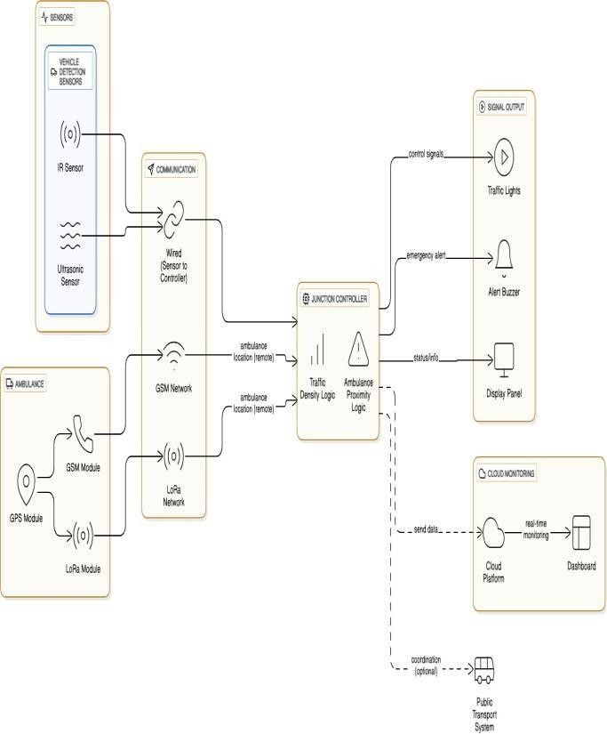

Fig.1. Architecture of IoT-Based Smart Traffic Light System with Emergency Vehicle Priority

The diagram shows the architecture of an IoT-based Smart Traffic Light System designed for real-time traffic management and prioritizing emergency vehicles. Vehicle detection is done using IR and ultrasonic sensors that send data through wires to the junction controller. The ambulance is equipped with GPS and GSM/LoRa modules to share its location over communication networks.

The junction controller uses traffic density logic and ambulance proximity logic to process data from both the sensors and the ambulance. It then decides on the right signal timing based on this information and gives priority to the ambulance.

Once a decision is made for each traffic light, the controller sends the correct signal to the traffic lights, activates one or more buzzers for alerts, and updates the display panels for people on site.

The system also sends information about its status and traffic density data to a cloud platform. This allows traffic authorities to monitor everything in real time and view it on a dashboard when needed. Overall, by keeping track of traffic violations and giving priority to emergency vehicles based on traffic density at intersections, the system makes traffic management more efficient, safe, and reliable in urban areas.

###### B.MODULE DESCRIPTION:

The preposed system consist of five modules

1. Traffic Detection Module
2. Emergency Vehicle Detection Module
3. Controller Module y
4. IoT Communication Module
5. Signal Actuation Module

TrafficDetectionModule:

The traffic detection module is designed to monitor how many cars are on the road. It uses infrared sensors to count all the vehicles present. Additionally, it has a camera that uses OpenCV to analyze a real-time video feed and identify vehicles. The system can also measure the size of each vehicle, giving priority to larger ones. This helps improve the flow of traffic and reduces traffic jams.

EmergencyVehicleDetectionModule:

The emergency vehicle detection module identifies ambulances and fire trucks using detection devices that may include tags, RFID readers, or GPS modules. If an emergency vehicle is recognized, the system interrupts the normal traffic signal cycle to provide a clear path for the vehicle. This allows emergency services to reach their destination without delays by giving them immediate access to the scene or emergency location.

Controller Module:

The controller module, which could be a Raspberry Pi, ESP32, or similar device, acts like the brain of the system. It gathers data from the sensors and cameras, processes that information, and uses the programmed logic to change how long traffic signals stay on. This

module lets the traffic lights respond to how traffic is behaving instead of following a fixed schedule.

IoT Communication Module:

This module enables communication between the traffic system and the cloud through Wi-Fi. Traffic data and signal data are transmitted to IoT platforms like ThingSpeak or Firebase, allowing local authorities to monitor the system from a distance. Connecting to the cloud also lets end-users view real-time updates and manually control the system when needed.

Signal Actuation Module:

The signal actuation module is in charge of managing the traffic lights. It uses LED lights or relays to show the standard red, yellow, and green signals. These signals are controlled via GPIO pins on the controller, based on logic that is calculated using real-time data. The module also allows for longer green light times when there is a higher volume of traffic or when emergency vehicles are present.

C.ALGORITHM:

Algorithm 1: Smart Traffic Light System Using IoT

1. Input: Traffic density statistics (D), Emergency automobile repute (E)
2. Output: Optimized traffic signal timing (T)
3. Initialize gadget modules: Sensors, Controller, IoT verbal exchange, Signal actuation
4. Acquire traffic density from IR sensors and digicam (OpenCV)
5. Process density records to calculate quantity of vehicles in keeping with lane
6. If Emergency vehicle detected (E = TRUE):
   1. Identify nearest lane with emergency vehicle
   2. Override ordinary cycle and set GREEN signal for emergency lane
   3. Maintain RED indicators for different lanes till emergency vehicle passes
7. Else (no emergency vehicle):
   1. Compare density values across all lanes
   2. Assign GREEN signal length proportional to traffic density
   3. Assign shorter GREEN indicators to low-density lanes
8. Update traffic lights through Signal Actuation Module
9. Transmit visitors facts and gadget repute to IoT cloud server
10. Display real-time statistics on monitoring dashboard.

###### RESULTS AND DISCUSSIONS: IMPLEMENTATION DETAILS:

The smarter traffic light system mentioned earlier combines both hardware and software to better manage traffic flow. IR sensors and cameras help measure how crowded the roads are, while RFID readers, tags, and GPS modules help identify

emergency vehicles so they can move through more easily. A Raspberry Pi or ESP32 serves as the main control unit, connected to LED traffic lights and a Wi- Fi module to link the system to the cloud. For the software, Python, C++, and the Arduino IDE are used to control the hardware, and OpenCV is used for processing images. Cloud platforms like ThingSpeak, Firebase, or AWS IoT allow real-time monitoring and data storage, while communication protocols similar to MQTT and HTTP ensure reliable data exchange between the controller and the cloud service.

###### CONCLUSION AND FUTURE WORK:

This Smart Traffic Light System solves the problems of traditional traffic management by being flexible. Unlike traffic lights that follow a fixed schedule or require manual control, this system changes in real time based on how busy or quiet the roads are. It can clear the way for emergency vehicles like ambulances and fire trucks on the go. Using IoT-enabled sensors such as cameras and cloud connections, it helps cut down waiting times, saves fuel, reduces pollution, and makes traveling easier for everyone.

The system also allows for remote monitoring and keeps track of data, so officials can see how traffic

moves, where the busiest spots are, and plan for the future. Its ability to grow and be customized makes it useful in smart cities, where smart and flexible solutions are key for building sustainable and efficient urban areas.

While the system offers a strong base for managing traffic smartly, there are several improvements that could be added later. For example, using AI and Machine Learning can help predict traffic patterns and adjust signal timings better. Deep learning for image recognition can help identify vehicles like cars, buses, and trucks and direct them properly. Real-time accident detection can send instant alerts to emergency services, making roads safer. Integrating vehicle communication with infrastructure (V2I) would let cars and traffic lights talk to each other. Solar-powered traffic lights could help in rural areas with limited power. The system could also connect with other smart city platforms to share data across different areas like transport, security, and emergency services, supporting a more sustainable city. A mobile app could give commuters real-time updates on traffic, wait times, and alternative routes, making their travel experience better. Ultimately, the system could expand from individual intersections to a full network, supporting smart and sustainable urban mobility on a large scale.

###### REFERENCES:

1. V. Gaikwad, A. Holkar, T. Hande, P. Lokhande, and

V. Badade, "Smart Traffic Light System Using Internet of Things," in Data Science and Intelligent Computing Techniques, edited by S. J. Nanda and R. P. Yadav, SCRS, India, 2023, pages 795–808, doi: 10.56155/978-81-955020-2-8-68.

1. A. K. Pipersenia, "A Review Paper on Smart Traffic Light Control System," International Journal of Food and Nutritional Sciences (IJFANS), volume 11, issue 9, September 2022.
2. S. C. Rai, S. P. Nayak, B. Acharya, V. C. Gerogiannis, et al., "ITSS: An Intelligent Traffic Signaling System Based on an IoT Infrastructure," Electronics, MDPI, volume 12, 2023.
3. F. Al Kalbani, N. Al Bulushi, and S. Imran, "IoT Based: Smart Traffic Light Controller," Journal of Student Research, 4th Middle East College Conference, Oman, 2023.
4. G. HS, H. DV, S. Prasad BC, K. Kumar J, and M.

D. R, "IoT Based Smart Traffic Signal Monitoring System Using Vehicle Density," Int. Research Journal of Modernization in Engineering, Tech & Science (IRJMETS), volume 5, June 2023.

1. Dr. S. K. S, S. R. Sahoo, U. M., and H. J. Raj,

"Smart Traffic Management Using IoT," Int. Journal of Creative Research Thoughts (IJCRT), volume 12, issue 5, May 2024.

1. S. S. Bhise, "An IoT Application in a Smart Traffic Management System," Journal for Research in Applied Sciences and Biotechnology, volume 4, issue 1, February 2025.
2. M. Balmiki, S. Dutta, A. Majumder, O. Chauhan, et al., "Smart Traffic Lighting System," Journal of Emerging Technologies and Innovative Research (JETIR), volume 9, April 2022.
3. R. Biju, S. Jain, N. Hemdev, T. P. Jain, P. T. Jain, Dr. A. Walia, and Dr. S. Rai, "Smart Traffic Management Using Internet of Things (IoT)," IRE Journals, volume 6, issue 10, April 2023.
4. P. Prakash, A. Singh, A. Parasrampuria, and G. Sharma, "An IoT Based Smart Traffic Management System," International Journal of Electrical,

Electronics and Computers, volume 6, issue 5, September– October 2021.

* 1. G. Goutham, T. M. Reddy, N. V. Reddy, V. Karthik, and K. S. Sudheer, "IoT Based Intelligent Traffic Management System," International Research Journal of Engineering and Technology (IRJET), volume 07, issue 06, June 2020.

CHAPTER 9 REFERENCES

1. V. Gaikwad, A. Holkar, T. Hande, P. Lokhande, and V. Badade, "Smart Traffic Light System Using Internet of Things," in Data Science and Intelligent Computing Techniques, edited by S. J. Nanda and R. P. Yadav, SCRS,India, 2023, pages 795–808, doi: 10.56155/978-81-955020-2-8-68.
2. A. K. Pipersenia, "A Review Paper on Smart Traffic Light Control System," International Journal of Food and Nutritional Sciences (IJFANS), volume 11, issue 9, September 2022.
3. S. C. Rai, S. P. Nayak, B. Acharya, V. C. Gerogiannis, et al., "ITSS: An Intelligent Traffic Signaling System Based on an IoT Infrastructure," Electronics, MDPI, volume 12, 2023.
4. F. Al Kalbani, N. Al Bulushi, and S. Imran, "IoT Based: Smart Traffic Light Controller," Journal of Student Research, 4th Middle East College Conference, Oman, 2023.
5. G. HS, H. DV, S. Prasad BC, K. Kumar J, and M. D. R, "IoT Based Smart Traffic Signal Monitoring System Using Vehicle Density," Int. Research Journal of Modernization in Engineering, Tech & Science (IRJMETS), volume 5, June 2023.
6. Dr. S. K. S, S. R. Sahoo, U. M., and H. J. Raj, "Smart Traffic Management Using IoT," Int. Journal of Creative Research Thoughts (IJCRT), volume 12, issue 5, May 2024.
7. S. S. Bhise, "An IoT Application in a Smart Traffic Management System," Journal for Research in Applied Sciences and Biotechnology, volume 4, issue 1, February 2025.
8. M. Balmiki, S. Dutta, A. Majumder, O. Chauhan, et al., "Smart Traffic Lighting System," Journal of Emerging Technologies and Innovative Research (JETIR), volume 9, April 2022.
9. R. Biju, S. Jain, N. Hemdev, T. P. Jain, P. T. Jain, Dr. A. Walia, and Dr. S. Rai, "Smart Traffic Management Using Internet of Things (IoT)," IRE Journals, volume 6, issue 10, April 2023.
10. P. Prakash, A. Singh, A. Parasrampuria, and G. Sharma, "An IoT Based Smart Traffic Management System," International Journal of Electrical, Electronics and Computers, volume 6, issue 5, September–October 2021.
11. G. Goutham, T. M. Reddy, N. V. Reddy, V. Karthik, and K. S. Sudheer, "IoT Based Intelligent Traffic Management System," International Research Journal of Engineering and Technology (IRJET), volume 07, issue 06, June 2020.