Builds and image with image name

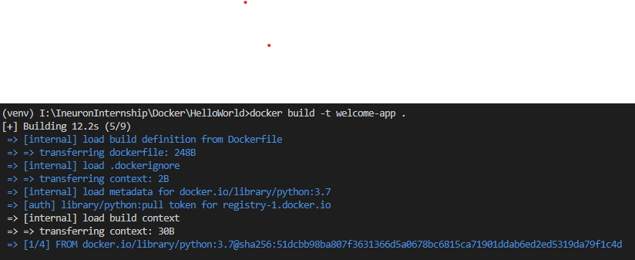

Lists out all the images that are built

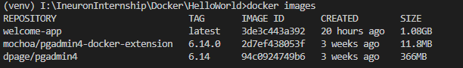

Searching for certain images by giving image name

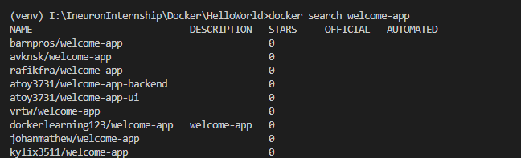

Removes an image.

I:\IneuronInternship\Dockerasks\docker_remove_image.png

Note: if container is running we cannot remove image..we should stop container and then remove image

Stops the container with given container id

I:\IneuronInternship\Dockerasks\docker_stop.png

Pushes image to docker pub

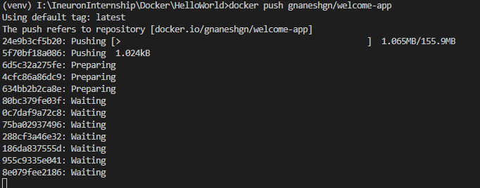

To run an image

I:\IneuronInternship\Dockerasks\docker_run.png

TO stop a container

I:\IneuronInternship\Dockerasks\docker_stop.png

To check docker verions

I:\IneuronInternship\Dockerasks\docker_version.png

To check to which port container is running

I:\IneuronInternship\Dockerasks\docker_port.png

To pause a docker

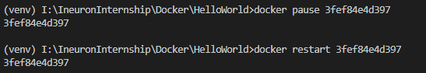

Then restart

-t 10 means it will restart after 10seconds

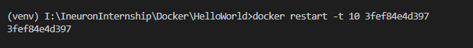

To save image in tar file

I:\IneuronInternship\Dockerasks\docker_save.png

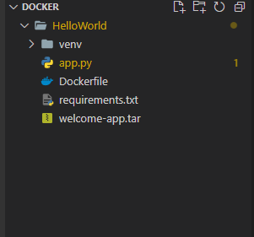

TO load tar image

I:\IneuronInternship\Dockerasks\docker_load.png

To pull image from docker hub

