Texas Office of the Attorney General



Clearcase Delivery Documentation

Feb 24, 2016

Contents

1 Revision History 4

2 Introduction 5

2.1 Purpose 5

2.2 Definitions 5

3 DCAs which needs to be delivered will be placed in the file mentioned as below 6

4 DCAs mentioned will be the input and it has to be in CSV file 7

5 Modify in the Delivery script 8

6 Troubleshooting steps 10

Table of Tables

Table 1:Definitions 5

Table of Figures

**No table of figures entries found.**

# Revision History

**Change Record**

69

| Date | Author | Version | Change Reference |
| --- | --- | --- | --- |
|  |  |  |  |
| 24-Feb-2016 | Accenture | 1.0 | Initial draft |
|  |  |  |  |
|  |  |  |  |
|  |  |  |  |

**Reviewers**

| Name | Position |
| --- | --- |
|  |  |
| Gnanesh | SCM Sr.Analyst |
|  |  |

**Distribution**

| Copy No. | Name | Location |
| --- | --- | --- |
|  |  |  |
|  |  |  |
|  |  |  |

**Note to Holders:**

If you receive an electronic copy of this document and print it out, please write your name on the equivalent of the cover page, for document control purposes.

If you receive a hard copy of this document, please write your name on the front cover, for document control purposes.

# Introduction

The purpose of this document is to carryout deliver process using UCM Clearcase.

## Purpose

In order to complete the delivery from child streams to parent streams, steps mentioned will have important considerations for flawless delivery.

## Definitions

|  |  |
| --- | --- |
| **Acronym** | **Definition** |
| DCA | Development Change Activity |
| CQ | Clearquest |
|  |  |
|  |  |

Table 1:Definitions

# DCAs which needs to be delivered will be placed in the file mentioned as below

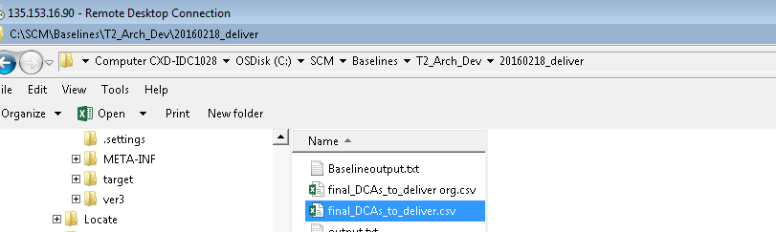

# DCAs mentioned will be the input and it has to be in CSV file

The list of DCAs chosen for delivery must be added in the .csv format and it has to suffix with “@\t2_pvob” and it should look similar as below

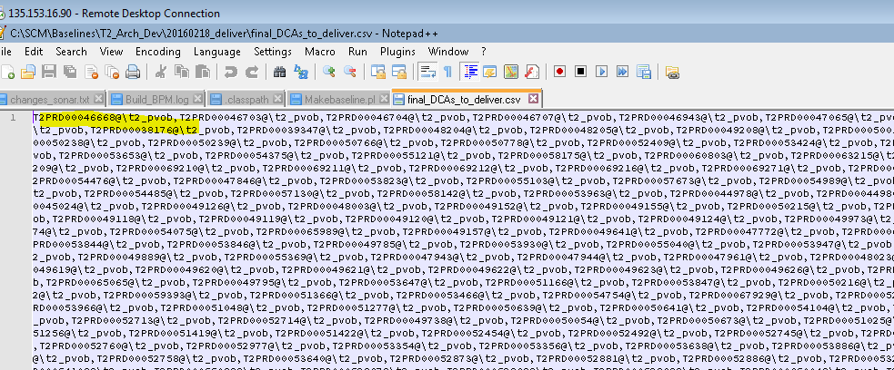

# Modify in the Delivery script

Here we need to modify the script as per the stream from where we need to delivery

***$act - path where the DCAs present in .csv format

***$int_view –view tag where the deliverables can be seen after delivery

***In system command make sure from stream and to stream are correct

*** Also , we should be in the exact component path and view should be proper

**\*\*\*Clearquest client will be running during clearcase delivery***.**

Eg,If delivery starts from Architecture stream to main dev stream then the component is t2_arch_code

So path will be **C:\ccviews\T2_Arch_Dev_1\t2_arch_code**

**Open command prompt**

**cd to C:\ccviews\T2_Arch_Dev_1\t2_arch_code**

**ccperl “Deliver.pl” > “output.txt” 2>&1**

**copy the script under the component path**

Eg. shown below delivery happening from **T2_Arch_Dev** to **T2_SrcCd_Main_Dev** stream



*#!C:\Perl64\bin\perl.exe*

*use strict;*

*use warnings;*

*my $arry;*

*my $i = 0;*

*my $j = $.;*

*my $act = 'C:\SCM\Baselines\T2_Arch_Dev\20160218_deliver\final_DCAs_to_deliver.csv';*

*open (ACT, "$act") || die $!;*

*my @arr = <ACT>;*

*print '-'x 50,"\n";*

*print "activities included :","\n";*

*print @arr,"\n";*

*print '-'x 50,"\n";*

*my $int_view = '6s5g_T2_Arch_Dev_int';*

*print"Integration view: $int_view","\n";*

*print '-'x 50,"\n";*

*print "Deliver to $int_view STATUS AS SHOWN BELOW","\n";*

*print '-'x 50,"\n";*

*#print "cleartool deliver -preview -stream stream:T2_Arch_Dev@\t2_pvob -activities @arr -to $int_view");"";*

*#****First step***

*system("cleartool deliver -force -stream stream:T2_Arch_Dev@\\t2_pvob -to $int_view -target stream:T2_SrcCd_Main_Dev@\\t2_pvob -activities @arr");*

*#****Secondstep***

*#system("cleartool deliver -complete -force -stream stream:T2_Arch_Dev@\\t2_pvob -to $int_view -target stream:T2_SrcCd_Main_Dev@\\t2_pvob -activities @arr");*

*close(ACT);*

Preview step to check the DCAs which are going to deliver to destination stream. [Optional]

**In First Step,**

We need to execute the command using system command which consists of

*cleartool deliver –force*

*-force option is to avoid manual intervention from the users*

**In Second Step**

If no merge conflicts then can see all the files in checked out state in the “destination stream”. Comment the first system command which we used in first step.

Uncomment the System command which has cleartool deliver –complete –force option enabled.

**Deliver scripts only work as long as there are no non-trivial merge in the destination stream(s).  So script will work as long as there are no merge conflicts in the destination stream(s); otherwise it will fail.**

# Troubleshooting steps

If clear quest client is not running, then delivery will be in progress state.

If we give the below command

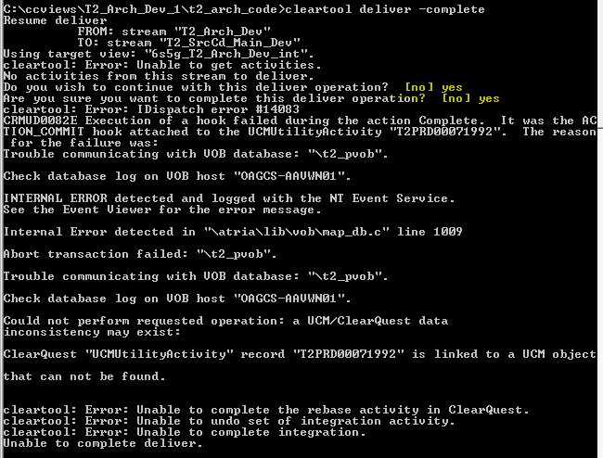

After Logging into CQ client, it shows it got completed.

We need to have CQ running while we execute clear tool deliver –complete.

