**OVERVIEW**

The data as described by Myles O'Neill .This data set includes 721 Pokemon, including their number, name, first and second type, and basic stats: HP, Attack, Defense, Special Attack, Special Defense, and Speed. It has been of great use when teaching statistics to kids. With certain types you can also give a geeky introduction to machine learning.

This are the raw attributes that are used for calculating how much damage an attack will do in the games. This dataset is about the pokemon games (NOT pokemon cards or Pokemon Go).

**OBJECTIVES**

* To provide data of pokemons
* To describe different types of pokemons
* To know the strongest and weakest pokemons

**COLUMNS AND DATA TYPE**

|  |  |
| --- | --- |
| Number | Int |
| Name | String |
| Type 1 | String |
| Type 2 | String |
| Total | Int |
| Hp | Int |
| Attack | Int |
| Defense | Int |
| Sp_Atk | Int |
| Sp_Def | Int |
| Speed | Int |
| Generation | Int |
| Legendary | String |

**PROBLEM STATEMENTS:**

1)Find out the average HP (Hit points) of all the Pokémon

2)Find the powerful and moderate pokemons (hp>avg hp(powerul),hp<avg hp(moderate))

3)Find out the top 10

->Pokémons according to their HP’s

->Pokémons based on their Attack stat

->Pokémons based on their Defense stat,total power

->Pokémons having a drastic change in their attack and sp.attack

->Pokémons based on their defense and sp.defense

->Pokémons according to their fastest Pokémons

4)The attack distribution of pokemons across all generations

5)All stat analysis of pokemons

6)Compare Charmander and Mega Venusaur

7)Distribution of various pokemons by type

**HIVE QUERIES**

* **Using Database and Creating New Table to upload the data**

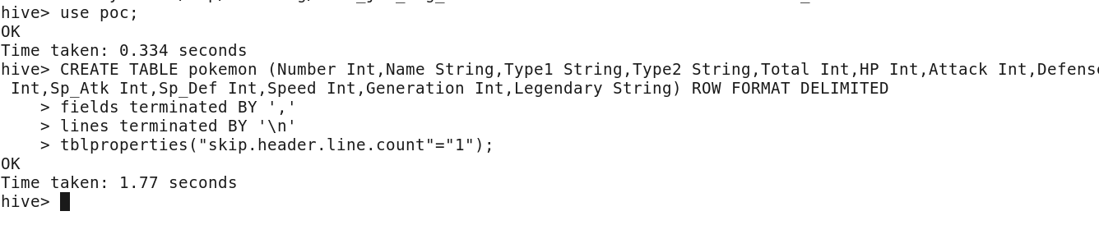

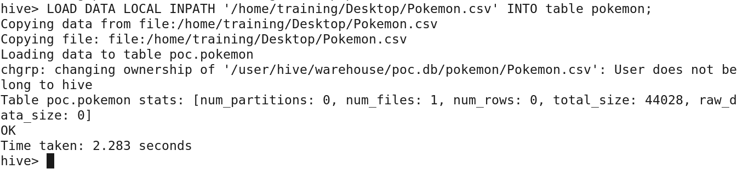

* **Description of table pokemon**

**Command**:describe pokemon;

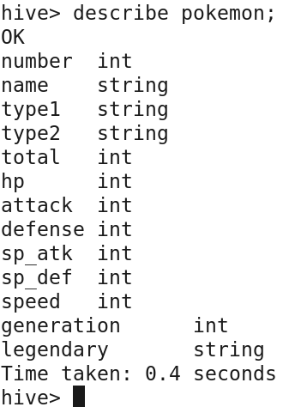

**PROBLEM STATEMENT 1:Find out the average HP (Hit points) of all the Pokémon**

**Command:**Select avg(HP) from pokemon;

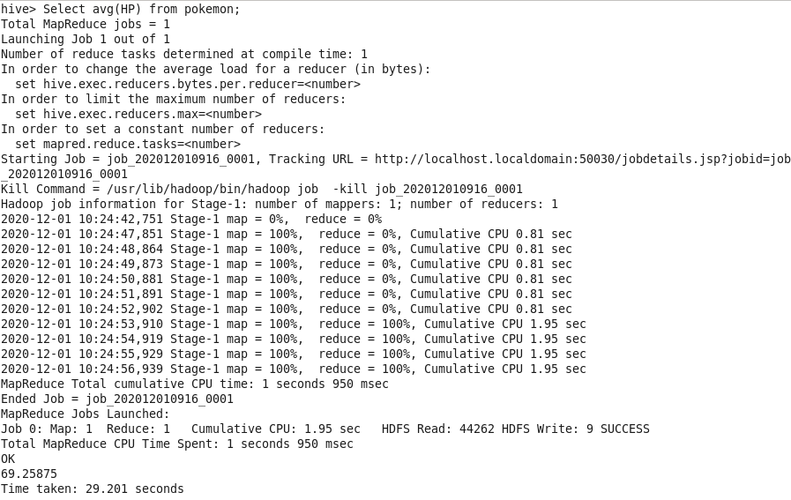

In the above screenshot, you can see that the average Hit point of the Pokémon is **69.25875**

**PROBLEM STATEMENT 2:** Find the powerful and moderate pokemons **condition**:(hp>avg then hp(powerul),hp<avg hp then (moderate))

To count the number of powerful and moderate we divide them from table and put them in new table as per condition

**Command**:create table pokemon1 as select *, IF(HP>69.25875, 'powerful', IF(HP<69.25875, 'Moderate','powerless')) AS power_rate from pokemon;

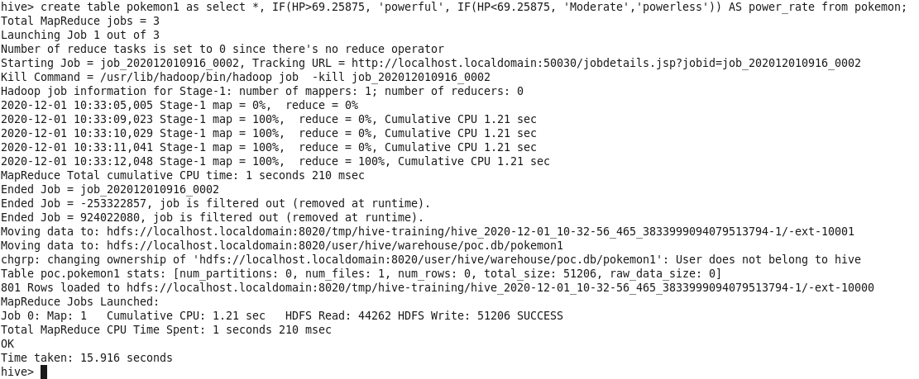

As new table is created now we can count names

**Command**:select COUNT(name),power_rate from pokemon1 group by power_rate;

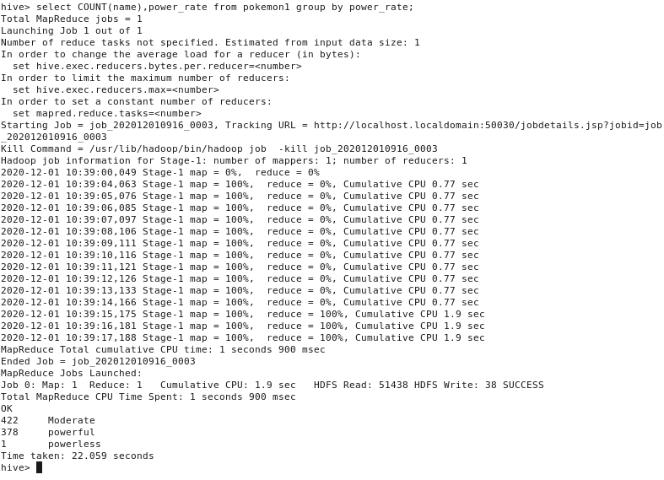

In the above screenshot, you can see the count of

Moderate-422

Powerful-378

powerless-1

**PROBLEM STATEMENT 3:**Find out the top 10

->Pokémons according to their HP’s

->Pokémons based on their Attack stat

->Pokémons based on their Defense stat

->Pokémons having a drastic change in their attack and sp.attack

->Pokémons based on their defense and sp.defense

->Pokémons according to their fastest Pokémons

* **Pokémons according to their HP’s**

**Command:**select name,hp from pokemon1 order by hp desc limit 10;

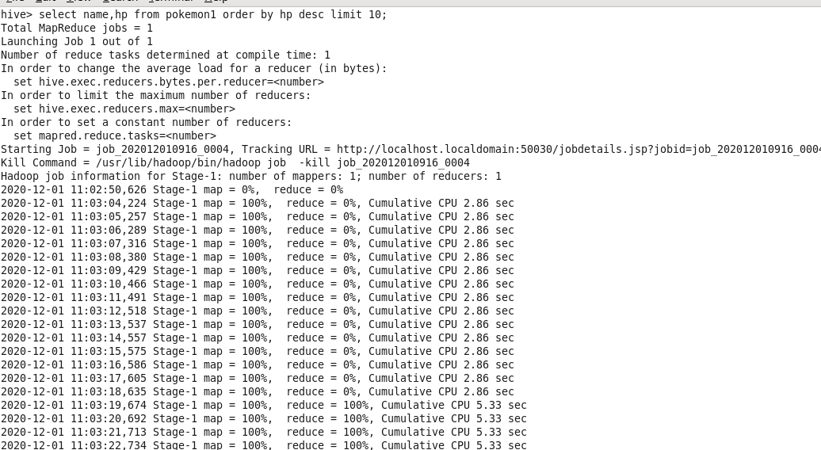

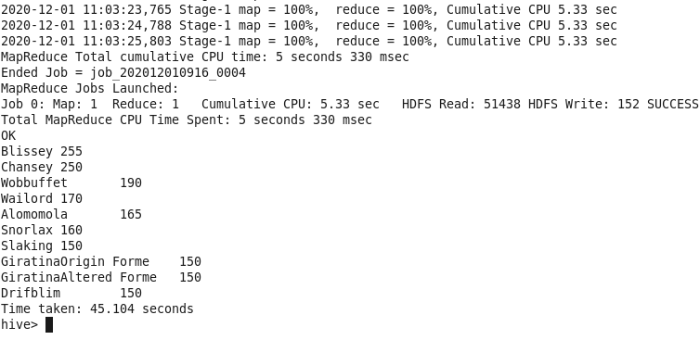

**From the above screen shot, we can see the top 10 according to HP .**

* **Pokémons based on their Attack stat**

**Command:**select name,attack from pokemon1 order by attack desc limit 10**;**

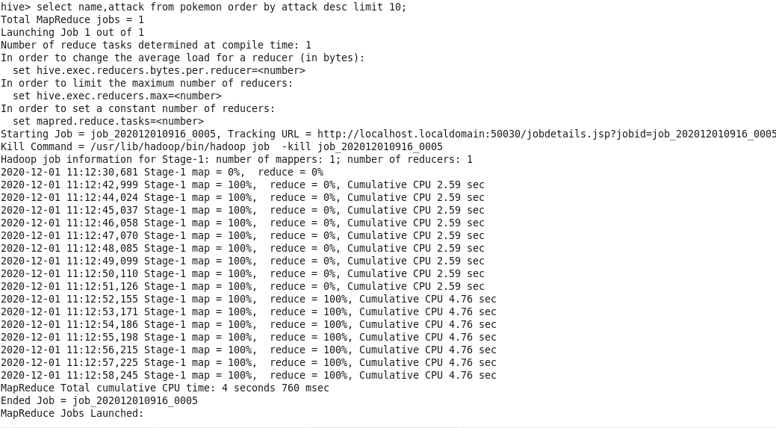

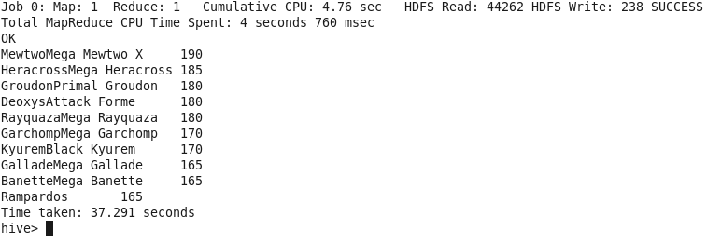

**From the above screen shot, we can see the top 10 according to Attack stat** .

* Pokémons based on their Defense stat

**command**:select name,defense from pokemon order by defense desc limit 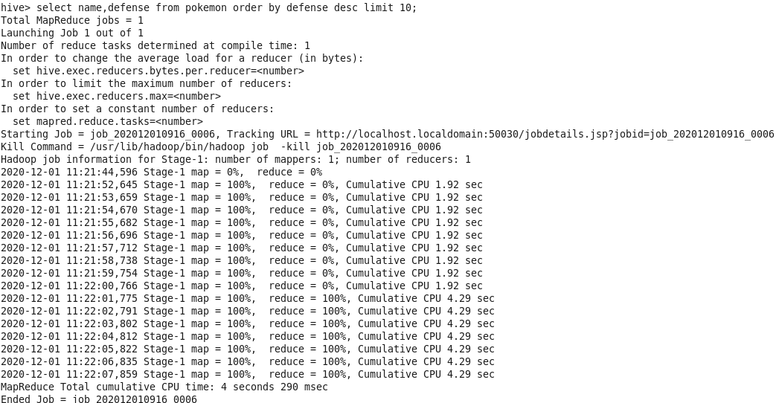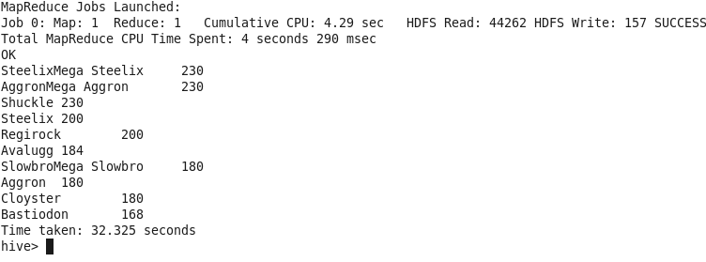

**From the above screen shot, we can see the top 10 according to Defense stat** .

* **Pokémons having a drastic change in their attack and sp.attack**

**Command:**select name,(attack-sp_atk) as atk_diff from pokemon order by atk_diff limit 10;

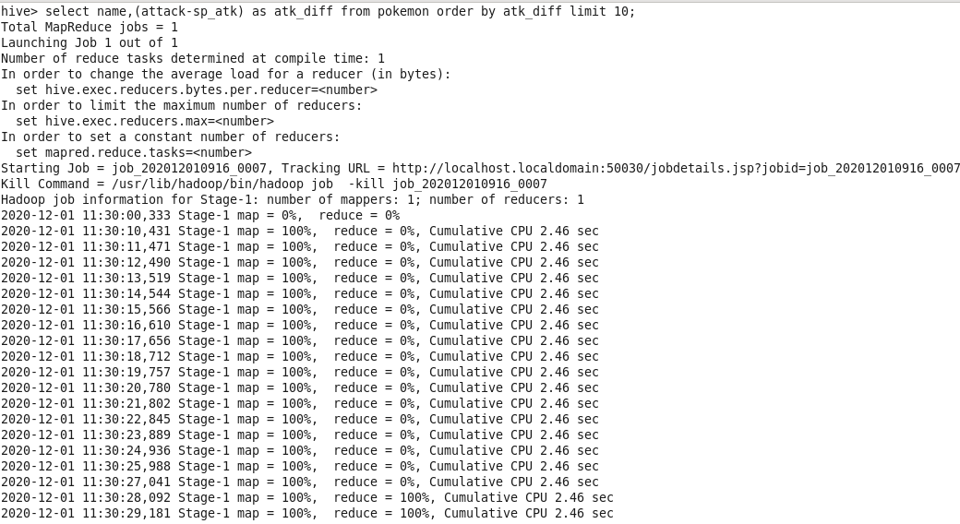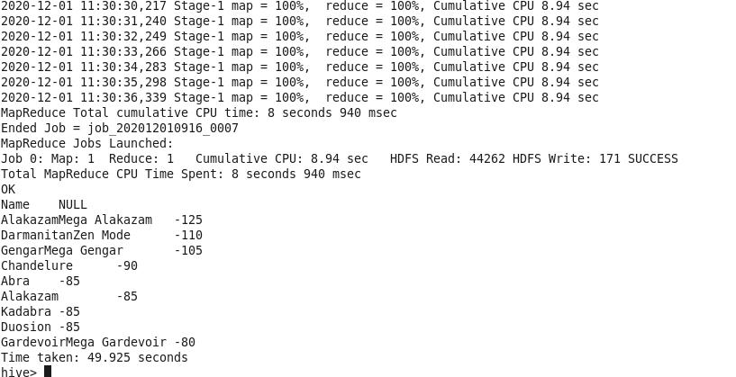

**From the above screen shot ,we can seePokémons having a drastic change in their attack and sp.attack**

* **Pokémons based on their defense and sp.defense**

**command:**select name,(defense-sp_def) as def_diff from pokemon order by def_diff limit 10;

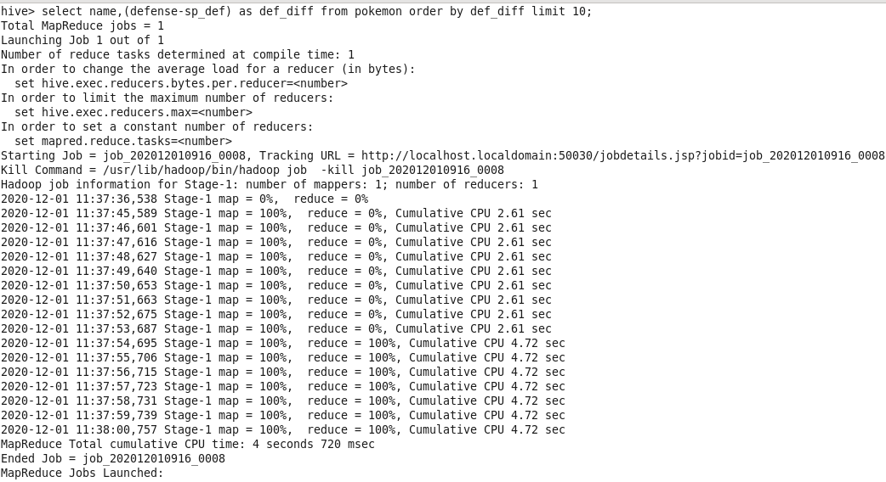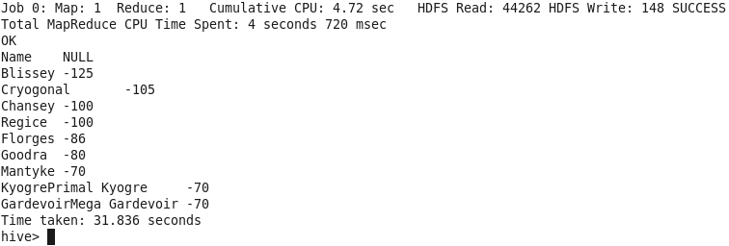

**From the above screen shot ,we can seePokémons having a drastic change in their defense and sp.defense**

* Pokémons according to their fastest Pokémons

**Command:**Select name, speed from pokemon order by speed desc limit 10;

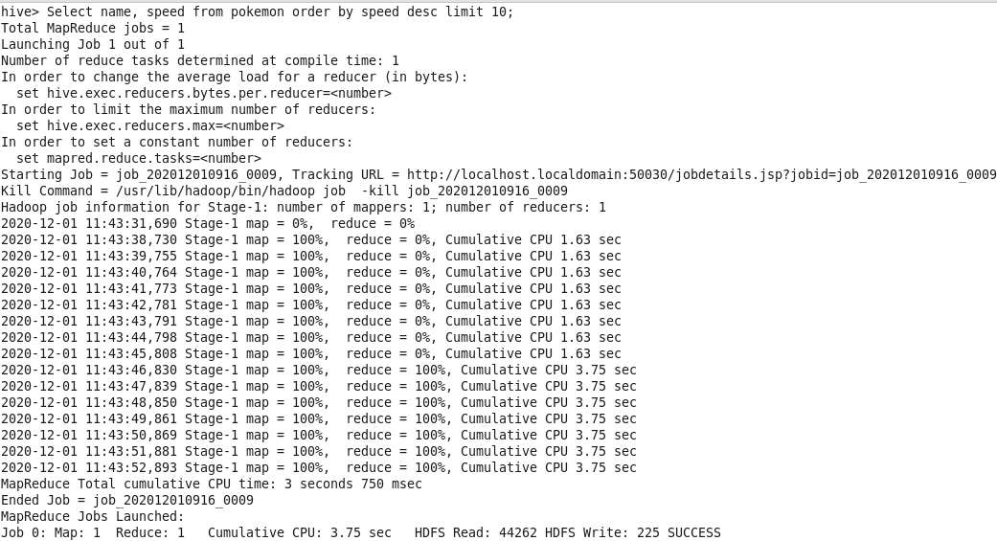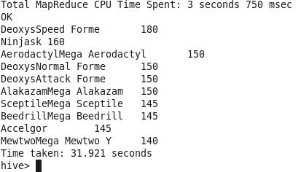

**From the above screen shot ,we can seePokémons which are fastest based on speed**

**PROBLEM STATEMENT 4:** The attack distribution of pokemons across all generations

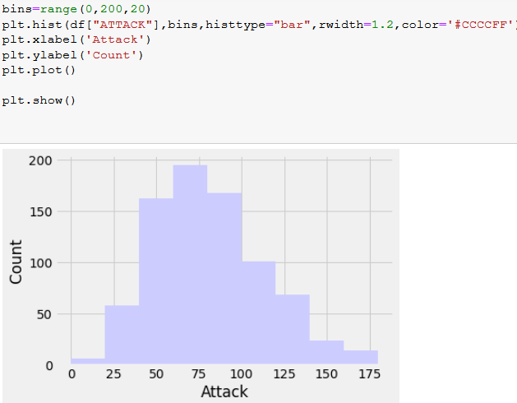

**PROBLEM STATEMENT 5:**All stat analysis of pokemons

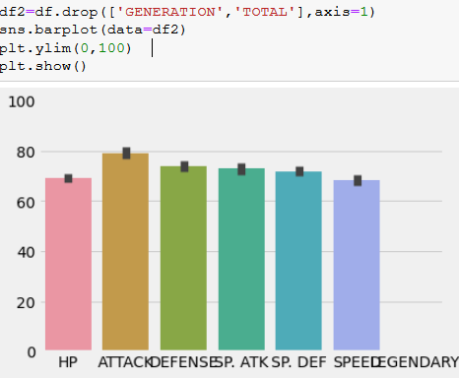

**PROBLEM STATEMENT 6:**Compare Charmander and Mega Venusaur

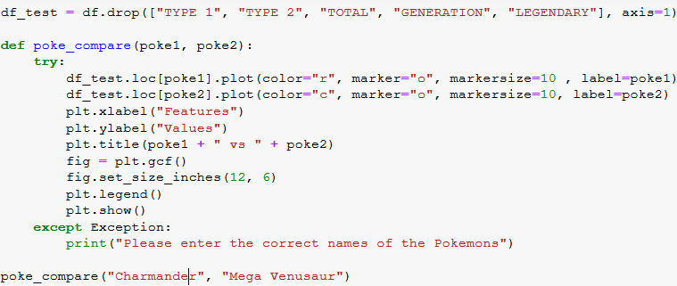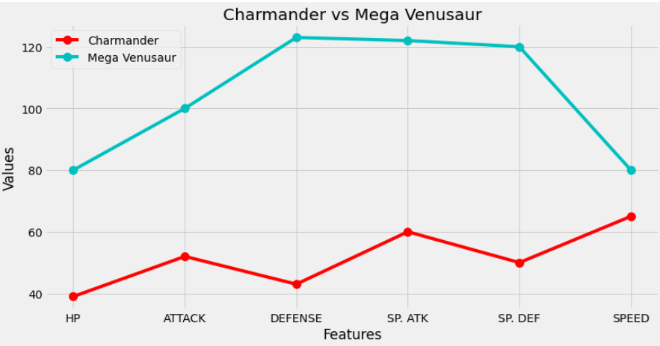

**PROBLEM STATEMENT 7:**Distribution of various types of pokemons

