SCHOOL OF INNOVATION AND MANAGEMENT (SoIM)
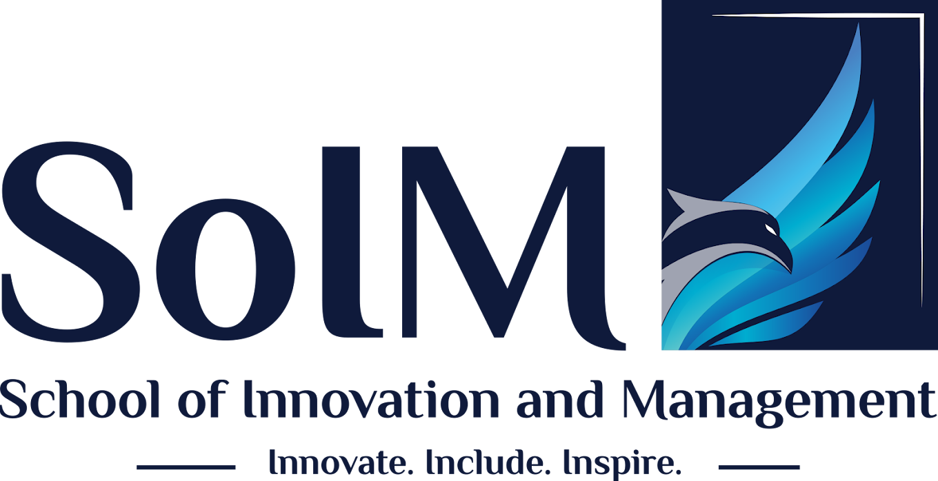
INDUSTRIAL VISIT REPORT
Hindustan Coca-Cola Beverages Pvt. Ltd. (HCCB) — Ameenpur Unit
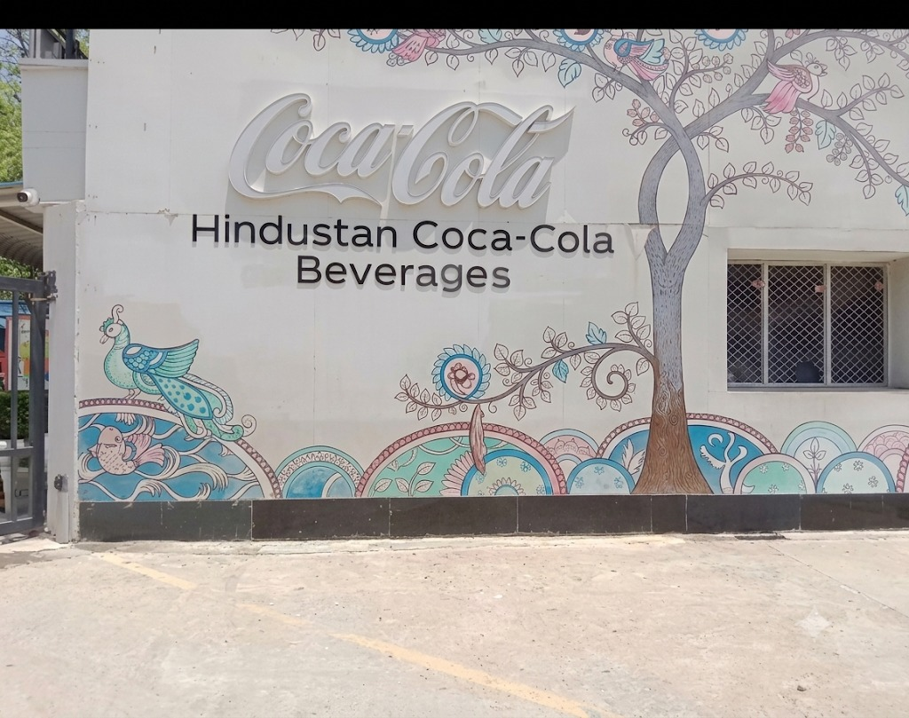
Hindustan Coca-Cola Beverages plant, Ameenpur, Hyderabad

Particulars | Details
Name of Student | Gnaneshwari Mahimaluru
Roll Number | PGBA25002
Programme / Department | PGDM – Business Analytics
Company Visited | Hindustan Coca-Cola Beverages Pvt. Ltd. (HCCB), Ameenpur Unit, Miyapur, Hyderabad
Date of Visit | 19th August 2026
Institution | School of Innovation and Management (SoIM)
Submitted To | Prof. K. Lakshmi Revathi

Acknowledgement
I would like to express my sincere gratitude to Dr. Samala Nagaraj, Dean and Faculty of Ethics, Responsibility and Sustainability (ERS), School of Innovation and Management, for his valuable guidance, support and encouragement throughout this project.
I sincerely thank Prof. K. Lakshmi Revathi and the faculty of the School of Innovation and Management for organizing this industrial visit and for their continuous guidance throughout the preparation of this report. Their support helped me connect classroom concepts with real-world industrial practices.
I would also like to express my sincere gratitude to the management and staff of Hindustan Coca-Cola Beverages Pvt. Ltd. (Ameenpur Unit) for permitting our visit and for patiently explaining their operations, production processes, quality systems, safety measures and supply-chain activities. Their insights greatly enriched my understanding of large-scale FMCG beverage manufacturing.
Finally, I thank my classmates and group members for their cooperation and teamwork during the visit and in the preparation of this report.

Objectives of the Industrial Visit
The industrial visit to the Coca-Cola plant was undertaken with the following objectives:
- To understand the day-to-day operations of a large-scale FMCG manufacturing organization.
- To observe the beverage production and bottling process from raw material to finished product.
- To study the quality-control, hygiene and workplace safety standards followed in the plant.
- To understand the supply chain and distribution network of a global beverage company.
- To learn about Coca-Cola’s marketing and branding strategies.
- To relate theoretical management concepts learned in class to real industrial practices.
- To develop an understanding of plant layout, machinery hierarchy and working conditions in a manufacturing unit.

About the Coca-Cola Company

History
The Coca-Cola Company began in Atlanta, Georgia, in 1886 when Dr. John Pemberton’s beverage was first served at Jacobs’ Pharmacy. Over the decades it grew from a single soft-drink brand into a global total-beverage enterprise with an extensive portfolio and a worldwide bottling-partner system. In India, Coca-Cola’s beverages are manufactured and distributed largely through Hindustan Coca-Cola Beverages Pvt. Ltd. (HCCB), the company’s largest bottling partner in the country, which operates several plants across India, including the Ameenpur Unit in Hyderabad, Telangana.

Purpose / Vision
“Refresh the world. Make a difference.” Coca-Cola’s vision centres on crafting the brands and drinks that people love, refreshing them in body and spirit, while building a more sustainable business and a better shared future.

Mission
Coca-Cola’s mission is to refresh the world and make a difference — inspiring moments of optimism and happiness through its brands and actions, and creating value for consumers, communities and stakeholders alike.

Products of Coca-Cola (India Portfolio)
Coca-Cola’s Indian portfolio, largely bottled through HCCB, includes a wide range of beverage categories:
- Carbonated soft drinks: Coca-Cola, Thums Up, Sprite, Fanta, Limca.
- Juices and juice-based drinks: Maaza, Minute Maid (Pulpy Orange, Nimbu Fresh, Mango).
- Packaged drinking water: Kinley.
- Energy and sports drinks: Sting, Powerade.
- Tea and coffee: Georgia (tea/coffee range).
- Value-added dairy and other beverages introduced in select markets.

Plant Location and Layout Overview
Particulars | Details
Operating Company | Hindustan Coca-Cola Beverages Pvt. Ltd. (HCCB)
Unit Name | Ameenpur Unit
Plant Address | D-2, Survey No. 169, Industrial Estate, Ameenpur, Miyapur, Hyderabad, Telangana 502033
District | Sangareddy, Telangana
Nature of Business | Manufacturing and bottling of carbonated soft drinks, juices and packaged beverages

The plant layout is organized as a sequential flow from raw-material receipt to finished-goods dispatch. Broadly, the layout consists of a raw-material and syrup preparation area, the water-treatment plant, the production/filling hall housing the bottling lines, a quality-control laboratory, a packaging and labelling section, a warehouse for finished-goods storage, and a dispatch yard for outbound logistics. Administrative offices and visitor/reception areas are located separately from the production floor, and landscaped premises with the brand’s signage surround the manufacturing block.
Operational flow: Water Treatment → Syrup / Batching → Mixing & Proportioning → Bottle / Can Washing → Filling & Sealing → Labelling & Coding → Quality Inspection → Packing → Palletizing → Warehouse Storage → Dispatch.

Manufacturing Process Flow (Water Treatment to Bottling)
The manufacturing process observed during the visit follows a continuous, automated line. The key steps, in sequence, are:
- Water Treatment: Incoming water is filtered, softened, chlorinated and passed through reverse osmosis (RO) to meet beverage-grade purity standards.
- Syrup Preparation / Batching: Sugar or sweetener syrup is prepared and blended with concentrate as per standardized recipes in the syrup room.
- Mixing and Carbonation: Treated water, syrup and CO₂ are combined in precise, controlled proportions and cooled using a mixer-proportioner (carbo-cooler).
- Bottle / Can Washing: Empty bottles, cans or PET preforms are cleaned, rinsed and sterilized before filling.
- Filling and Capping / Seaming: The beverage is filled into containers and immediately capped or seamed under hygienic, high-speed conditions.
- Labelling and Coding: Product labels and batch/date codes are applied to filled containers.
- Quality Inspection: Automated vision and sensor-based systems check fill-level, seal integrity and label placement; defective units are rejected.
- Packing and Palletizing: Bottles/cans are grouped into crates, trays or cartons, packed, and stacked onto pallets.
- Warehouse Storage and Dispatch: Finished pallets are moved to the warehouse and dispatched to distributors as per demand.
Programmable Logic Controllers (PLCs) and a central control room monitor and coordinate the entire line, allowing supervisors to track speed, downtime and rejection rates in real time.

Quality Control and Hygiene Standards Observed
Quality and hygiene are treated as critical, non-negotiable aspects of operations at the plant. Key observations include:
- Quality checks conducted at multiple stages — raw materials, in-process production, packaging and finished goods.
- Personal protective equipment such as hairnets, aprons, gloves and safety footwear worn on the production floor.
- Ear protection provided in high-noise sections of the plant.
- Hand-sanitization stations and restricted, authorized-only entry into the syrup and filling rooms.
- Automated vision and sensor-based inspection systems checking fill-level, seal integrity and label accuracy on every unit.
- Clearly marked emergency exits, fire extinguishers and safety signage displayed across the facility.
These practices reflect the standardization and quality-assurance culture needed to protect consumer trust and the reputation of a global brand.

Supply Chain and Distribution System
An efficient supply chain ensures that Coca-Cola products reach customers at the right time and in the required quantity. The supply chain observed follows this flow:
Suppliers → Raw Materials → Manufacturing → Packaging → Warehouse → Distribution → Retailers → Consumers
Effective supply-chain management helps the organization reduce delays, control inventory, optimize transportation and ensure product availability across urban and rural markets. Close coordination among production, warehousing, logistics, distributors and retailers is essential to this system.

Marketing and Branding Strategy
Coca-Cola is known for its strong marketing and branding strategies, which work closely with operations and distribution to ensure the product is both desirable and available. Key elements include:
- A strong, consistent global brand identity.
- Emotional advertising and storytelling that builds consumer connection.
- Wide product availability supported by extensive distribution.
- Promotional campaigns and seasonal offers.
- Product diversification to serve changing consumer preferences.
- Sponsorship of sports, entertainment and cultural events.
- Digital and social-media marketing to engage younger consumers.
This visit reinforced that effective marketing alone is not sufficient — a strong distribution and supply-chain network is equally important to ensure the product actually reaches the consumer.

Key Learnings and Observations
As a management student, this visit offered several practical insights beyond textbook knowledge:
- Operations management concepts such as process flow, standardization and automation come alive on an actual production line.
- Quality control is embedded at every stage of production, not just checked at the end.
- Supply-chain coordination between production, warehousing, logistics and retail is critical to product availability.
- Marketing strategy and operational efficiency must work together — a great campaign is ineffective without reliable supply.
- Workplace discipline, safety culture and employee training are as important as machinery in ensuring consistent output.
- Large organizations rely on structured coordination between departments to maintain consistency at scale.

SWOT Analysis of Coca-Cola
STRENGTHS  - Globally recognized, trusted brand with strong consumer loyalty.  - Extensive distribution network reaching urban, semi-urban and remote markets.  - Broad and diversified beverage portfolio (soft drinks, juices, water, tea/coffee).  - Advanced automation and PLC-controlled lines ensuring consistent product quality. | WEAKNESSES  - Heavy dependence on sugar-based, carbonated beverages.  - High water and energy consumption in production.  - Vulnerability to rising input, sugar and packaging costs.  - Growing health-consciousness reducing demand for aerated drinks.
OPPORTUNITIES  - Expansion into low/no-sugar and natural-juice product lines.  - Growing rural and semi-urban markets in India.  - Sustainable packaging (rPET, recyclable bottles) as a differentiator.  - Digital marketing and e-commerce-driven sales growth. | THREATS  - Intense competition from PepsiCo and local beverage brands.  - Regulatory and taxation pressure on sugary drinks.  - Water scarcity and environmental regulations at plant locations.  - Changing consumer preference toward health drinks and homemade beverages.

Suggestions / Recommendations
- Continue investing in sustainable packaging and resource-efficient production.
- Increase investment in water-recycling and rainwater-harvesting initiatives, especially at plants in water-stressed regions.
- Increase data-driven demand forecasting and inventory optimization.
- Strengthen rural distribution and affordable, smaller pack sizes to deepen penetration in semi-urban and rural markets.
- Expand consumer-focused digital campaigns and e-commerce partnerships.
- Continue employee training in automation, safety and quality.
- Strengthen consumer awareness around recycling and responsible packaging.

Conclusion
The industrial visit to HCCB Ameenpur Unit was a highly enriching academic experience. It provided practical exposure to manufacturing operations, quality control, supply-chain management, marketing and organizational functioning that cannot be fully appreciated through classroom study alone.
The visit helped establish that the success of a company like Coca-Cola depends not only on the quality of its product but also on efficient operations, strong distribution, effective marketing, employee coordination and continuous improvement. As management students, it provided practical insight into how efficiency, standardization, teamwork and customer-focused distribution contribute to organizational performance.

Annexure — Photographs from the Visit
Figure 1. Entrance signage and mural, Hindustan Coca-Cola Beverages, Ameenpur | 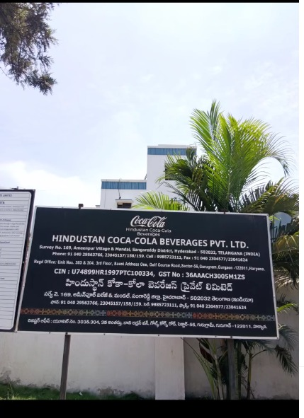  Figure 2. Statutory nameboard with plant registration and address details

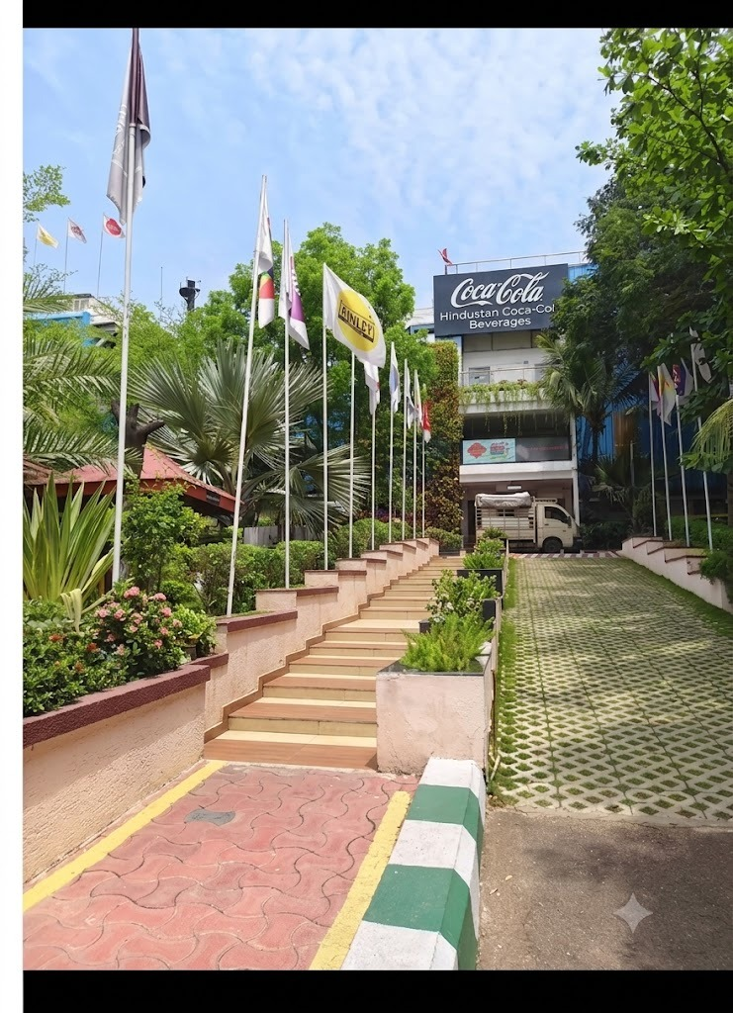  Figure 3. Approach walkway leading to the Ameenpur plant building | 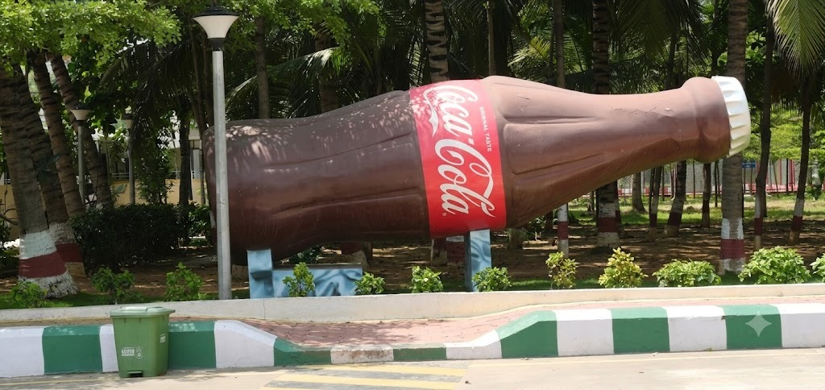  Figure 4. Giant Coca-Cola bottle installation on the plant premises

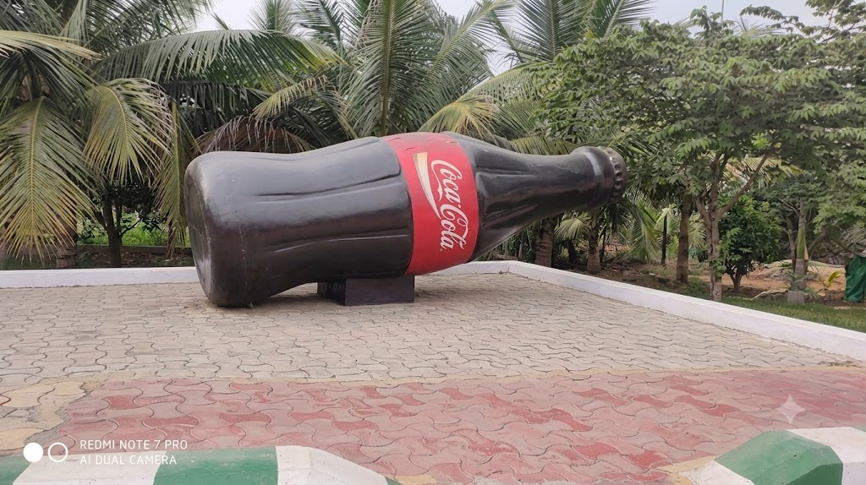
Figure 5. Giant Coca-Cola bottle installation — alternate view

References
- The Coca-Cola Company — Official Website: https://www.coca-colacompany.com
- Hindustan Coca-Cola Beverages Pvt. Ltd. — Official Website: https://www.hccb.in
- Plant signage and statutory nameboard observed during the industrial visit, Ameenpur Unit, Hyderabad.
- Class discussions and briefing provided by plant personnel during the industrial visit.

