PYTHON


INTRODUCTION
- First version of Python is in 1991.
- Invented by Guido Von Rossum
- Python gets its name from British Comedy program – “Monty Python’ s Flying Circus”
- Python website: https://python.org/
- Current version of Python: Python release 3, version: 3.14.7; Released on: 5-Aug-2026
- Tutorial link: The Python Tutorial — Python 3.14.7 documentation

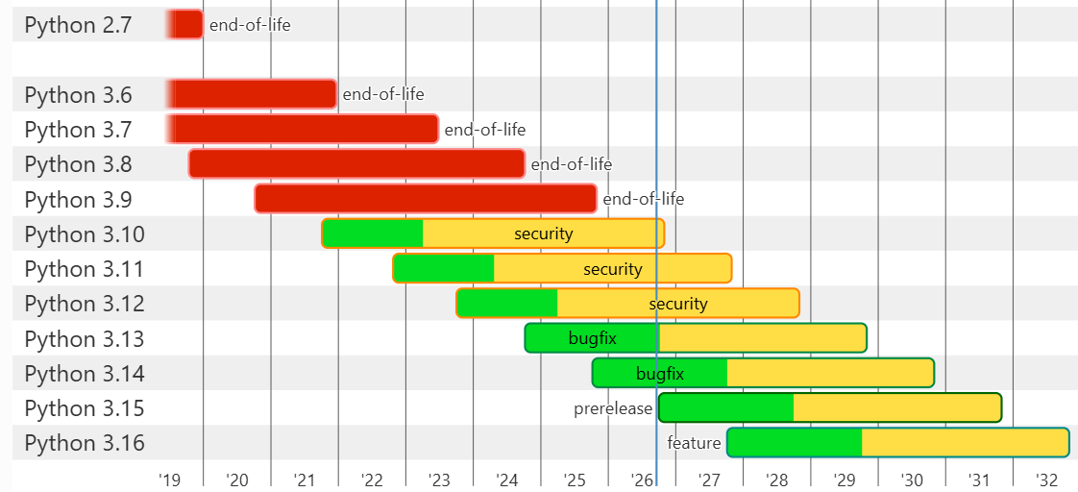
- Red → End-of-life (no updates at all).
- Yellow → Security-only support (only critical security patches).
- Light Green → Bugfix support (no new features, but bugs are fixed).
- Green → Feature releases (new features actively added).

PROGRAMMING AND THE PYTHON SHELL
Ok, computers understand only binary code or machine language. They do not understand any spoken language used by humans.
But programming languages convert the language that is understood by humans to binary code and serve as a mediator between humans and computers.

Programming languages are of various types.
- Low-level programming language: Ex: Assembly language, where there’s roughly a one-to-one correspondence between machine instructions and assembly language instructions

HELLO WORLD! program in assembly language below:
.equ STDOUT, 1
.equ SVC_WRITE, 64
.equ SVC_EXIT, 93
.text
.global _start
_start:
stp x29, x30, [sp, -16]!
mov x0, #STDOUT
ldr x1, =msg
mov x2, 13
mov x8, #SVC_WRITE
mov x29, sp
svc #0 // write(stdout, msg, 13);
ldp x29, x30, [sp], 16
mov x0, #0
mov x8, #SVC_EXIT
svc #0 // exit(0);
msg: .ascii "Hello World!\n"
.align 4

The same HELLO WORLD! program written in C++ language is below:
#include <iostream>
int main () {
std::cout << "Hello World!" << std::endl;
}

In Python, the same HELLO WORLD! program is written as below:
print(‘Hello World!’)

C++ and Python are High-level programming languages.
The abstraction in the statements increases as we are moving from low-level programming languages to high-level programming languages.

COMPILATION AND INTERPRETATION
Compilation is a process whereby source code in some programming language is converted into binary code for execution on a particular architecture. The program which performs this conversion is called a compiler.

In case of interpreted languages, source code is converted to intermediate code, and this code is executed by another program. This intermediate code is called bytecode. Python is an interpreted language.

Execution of a Python program:

  - PYTHON SHELL:
Python shell can be invoked by typing python in the command prompt. Then the three greater than symbols appear which is called the python prompt.
> python
>>>

>>> 1
1
In the above example, ‘1’ is called an integer literal.
Literals evaluate to themselves.

>>> 1 + 5
6
In the above example, ‘1+5’ is an expression.
An expression is a syntactically valid sequence of symbols(constants, variables, functions, and operators) that evaluates to a value.
Above expression uses binary infix operator; binary because it uses 2 operands/literals and infix because the ‘+’ operator is placed in between these 2 operands.

  - REPL:
This process—of entering an expression and having Python evaluate it
and display the result—is called REPL.
REPL stands for ‘Read-Evaluate-Print-Loop’, which means that the programmer gets to see the result of each portion of the code they enter.

Exercise:
Write a simple Hello World program from Visual Studio Code and execute it

SYNTAX and SEMANTICS
SYNTAX:
Syntax is a set of rules. Python follows syntax rules. If the syntax is incorrect, then it gives error or bug or defect.
Syntax need not have a meaning.
Examples:
The statue is floating
The air is an insect

SEMANTICS:
Semantics carries meaning that can be ambiguous or unambiguous in English language.
Examples:
The colour of my pen ink is red -> unambiguous
Python is an interpreted language -> unambiguous
The turkey is ready to eat -> ambiguous
However, in a programming language, if we’ve produced a syntactically valid statement or expression, it has only one “interpretation.” But again, this can be syntactically correct and semantically correct or incorrect.
For example, C = (F – 32) / 1.8
This is the formula for converting Fahrenheit to Celsius.

>>> f = 90
>>> c = (f – 32) * 1.8
>>> 104.4
Now, the above result is incorrect, because the formula is wrong, which means that the semantics is wrong. Instead of dividing by 1.8, it is being multiplied by 1.8.
The above code does not give any error or bug or defect, but the overall result will be wrong. This is a problem of semantics. This is a semantic error, not a syntactical error.
So, while coding along with the syntax rules, every developer should also maintain the semantics of the code and make sure the meaning of the code is intact or correct.

TYPES AND LITERALS
All objects in Python have a type, and literals are fixed values of a given type. For example, the literal 1 is an integer and is of type int (short for “integer”).
>>> print(type(1))
<class ‘int’>

WHAT ARE TYPES?
For example, there are different kinds of buildings like a home, or a commercial complex, or a government office, etc.., each serving different purpose and function.
Similarly, in Python there are different types each serving a different purpose.

WHAT ARE LITERALS?
A literal is simply fixed values of a given type. For example, 1 is a literal.
It means, literally, the integer 1. Literals evaluate to themselves.

PYTHON TYPES and LITERALS:
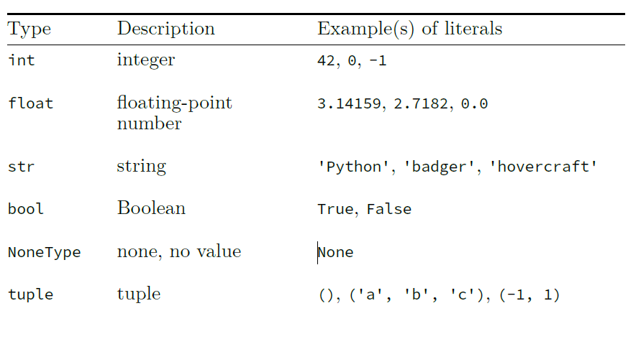
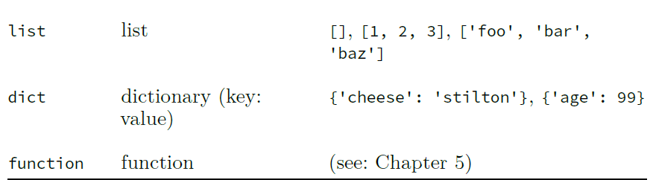

int:
Instead of writing 1000000, you can use underscore for easy reading.
For example, 10_00_000. This represents 10lakhs.
Integer type examples: 2, -100, 56, 0

float:
Float type examples: 0.0, -45.67, 45.90

str:
Strings must be delimited with single quotations or double quotations or triple quotations to differentiate them from variable names and identifiers.
String type examples: ‘abc’, “123karthik”, “karthik@345$*&”, “”, “ “,
“”” My name is Karthik and I am a Python expert”””
Triple quotations are used to write multi-line strings
“””My name is Karthik,
I am a Chief Digital and AI Officer”””

bool:
bool type is also called as Boolean. Bool has only 2 special literals, True and False. These are not strings and so do not require any quotation marks to delimit them.

NoneType:
NoneType has only 1 special literal None. This is also not a string. NoneType represents the absence of a value.

tuple:
A tuple is an immutable sequence of values
Immutable: Once the tuple is created, it cannot be changed.
It can have zero values too
The elements of a tuple can be of any type – including another tuple. This means tuple is heterogeneous.
Empty tuple is represented by ()
Except in the case of an empty tuple, tuples need not be enclosed in parenthesis.
Tuple examples:
()
(1,2,3)
(1, ‘karthik’, 456, 67.90)
23, 45, 56
(0)
(1, 2, (9, 89, 99), ‘abc’, 34.56, ())

list:
A list is a mutable sequence of values
Mutable: Once the list is created, it can be changed.
It can have zero values too
The elements of a list can be of any type – including another list or a tuple. This means list is also heterogeneous.
Empty list is represented by []
Lists must be enclosed in square brackets, including empty lists.
Examples of lists:
[]
[1, 2, 3]
[23.5, 56, 99, (), [4,5,6], [56,”abc”,67,(),[99,89]]]

dict:
Dictionaries are mutable like lists.
Dictionary store values as key and value pairs.
Dictionary can have values as other dictionaries, tuples, lists.
Dictionaries are also heterogeneous just like tuples and lists

DYNAMIC TYPING and STATIC TYPING

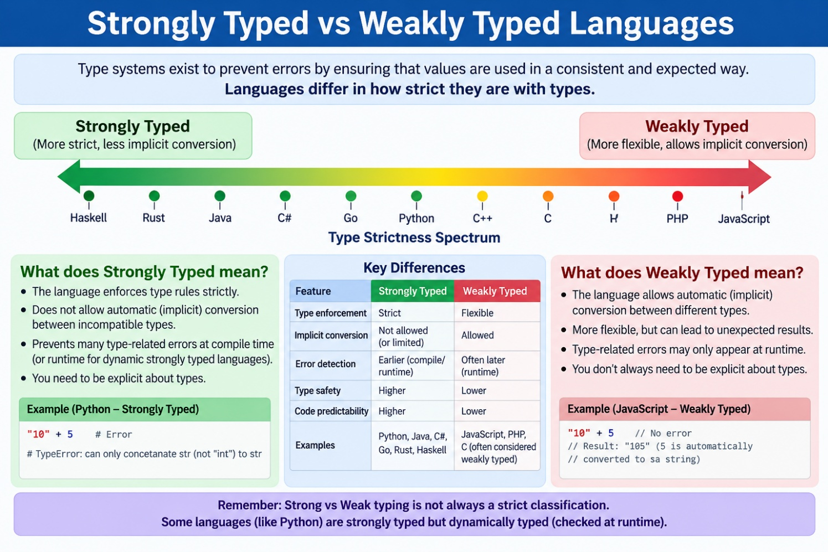

Python is a strongly typed language because
- Python prevents most type errors at runtime, and
- performs very few implicit conversions between types—hence, it’s more accurately characterized as being strongly typed

STATICALLY TYPED:
Statically typed means that
- the types are known at compile time—and
- types of objects (variables) cannot be changed at runtime—the time when the program is run.
For example, in Java/C:
int x = 1;
x = “My name is Karthik!”;
gives type incompatibility error at run time as we are trying to change the variable ‘x’ from integer to ‘string’ at the run time.

In the above example in Java/C, type annotation for ‘x’ is used and once it is declared while coding, it cannot be changed at the run time.

However, RUST uses type inference.
Type inference is when the compiler or interpreter can infer something’s
type without having to be told explicitly.
For example, in RUST:
let x = 1;
x = ‘My name is Karthik!’
The above code also gives type incompatibility error at runtime even though type inference is used.

Python is dynamically typed language.
Dynamically typed means that the types of variables CAN be changed at the run time.

For example, in Python:
>>> x = 1
>>> print(type(x))
<class ‘int’>
>>> x = ‘My name is Karthik!’
>>> print(type(x))
<class ‘str’>
This time, the above code does not give type incompatibility error.

MEMORY ALLOCATION

The highlighted in RED colour in the above diagram represents x = 65 stored inside the memory in 2 bytes.

The highlighted in RED colour in the above diagram represents x = ‘A’ stored inside the memory in 2 bytes.

The main difference between the above two representations is in the storage of other bits. These other bits stored in the memory of the computer tells Python that either ‘x’ is an integer or ‘x’ is a character by storing the ‘type’ information.

VARIABLES, STATEMENTS and EXPRESSIONS

What is a variable?
A variable is the combination of a name and an associated value which
has a specific type.
A variable/name can hold different values at different times; however, a variable can only hold one value at any time.

ASSIGNMENT STATEMENTS:
For example, below are the assignment statements.
x = 20
x = 2 + 3

‘=’ is the assignment operator.
Variable name is on the left-hand side of the operator
Expression to be evaluated is on the right-hand side of the operator

x = 20
Ideally, the above statement should be read as “Let x equal 20” or “x gets 20”.
“x is equal to 20” may not be used because the value of ‘x’ can change at any time. This also indicates an assertion and kind of final conclusion with respect to the value of ‘x’, which is not the case.

Variable used in an assignment statement can be reused in another statement as a resultant value.
Examples:
y = 10
y = y + 1
y = y + 2

MEMORY ALLOCATION OF VARIABLES
id() This function returns the address of the memory allocated to a variable name
For example:
>>> x = 20
>>> id(x)
2001
>>> y = x
>>> id(y)
2001
>>> x = 50 // x = 20 is gone forever here.
>>> id(x)
>>> 3001
>>> id(y)
2001

From the above example, it is clear that a name is associated with only one value at any time and a value can have any number of names.
For example:
>>> x = 50
>>> y = x
>>> z = y
>>> id(x)
1001
>>> id(y)
1001
>>> id(z)
1001
>>> x = 100
>>> id(x)
2001
>>> id(y)
1001
>>> id(z)
1001
>>> print(x)
100
>>> print(y)
50
>>> print(z)
50

CONSTANTS
A constant is a variable that has a value that will be left unchanged throughout a
program.

There are times when we would want to use the same value multiple times in a program. In this case, we assign this value to a variable and use this variable many times in the program.

For example:
HOURS_IN_A_DAY = 24
In the above, HOURS_IN_A_DAY is called as constant.

Why are constants used?
Constants improve the readability of programs because they provide meaningful and recognizable names for fixed values.

Note: Use all constants in uppercase as it is a good practice, but this is not enforced by Python as a rule.

EXPRESSIONS
Definition of expressions is listed above. Please use ‘Find’ option in Word to search for the definition.

The simplest expression is a literal. For example, here ‘1’ is the simplest expression that evaluates to itself.
>>> 1 // 1 is an integer literal
1

>>> 5.75 // 5.75 is a float literal
5.75
>>> ‘Karthik’ // ‘Karthik’ is a string literal
Karthik
>>> True // True is a Boolean literal
True

Other complex expressions use different operators. These are also called binary infix operators.

Below are a few of the arithmetic infix operators:
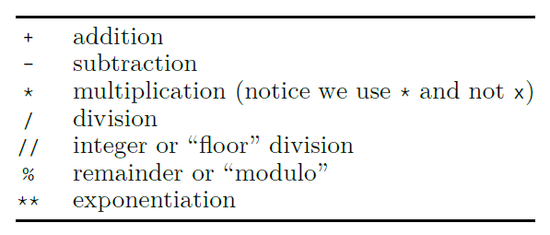

>>> 1 + 2
3
>>> 3 – 2
1
>>> 2 * 10
20
>>> 10 / 2
5.0

In the last example above, Python returns a floating-point number even though 2 integer operands are divided.

What do you think the below result will be?
>>> 2 + 3.0
5.0
Python uses implicit type conversion and converts 2 to 2.0

PRECEDENCE OF OPERATORS
Multiplication and Division have higher precedence than addition and subtraction.
Parenthesis are used to group operators of lower precedence expressions to handle complex arithmetic operations or for more readability or to remove ambiguity.
For example:
>>> (5 + 7) * 3 – 4 * (3 + 4 + 5)
-12

UNARY OPERATORS
Unary operators are operators with a single operand.
For example:
>>> -1
-1
>>> -(9 * 9)
-81

ORDER OF PRECEDENCE
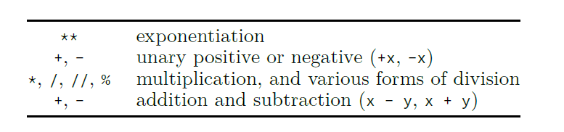

PEDMAS
P – Parenthesis
E – Exponentiation
D – Division
M – Multiplication
A – Addition
S – Subtraction

OPERATOR OVERLOADING
Operator overloading is basically operator behaving differently in different contexts.
For example:
>>> ‘Karthik is a’ + ‘Project Manager’
Karthik is a Project Manager

In the above example, ‘+’ operator does not behave as an arithmetic operator rather it joins or concatenates 2 strings together.

For example, ‘*’ operator with string operands multiplies the same string as shown below:
>>> ‘Karthik’ * 3
KarthikKarthikKarthik

What will be the below result?
>>> ‘Karthik’ * 0
‘’ // gives an empty string because ‘Karthik’ is multiplied by 0
// copies of ‘Karthik’ string.

AUGMENTED ASSIGNMENT OPERATORS
Python provides augmented assignment operators as shown below:
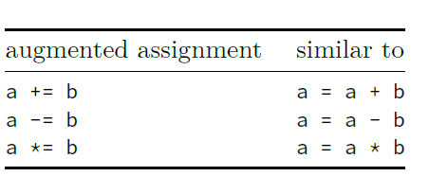

For example:
>>> x = 10
>>> x += 10
>>> print(x)
Note: In augmented assignment operators, left-hand side is evaluated first, then the right-hand side is evaluated and then the result is assigned to the variable on the left-hand side.
In the above example, ‘x’ is evaluated first(x = 10), then ‘x’ is added to 10 on the right-hand side and the result 20 is assigned to ‘x’ on the left-hand side.

EUCLIDEAN OR FLOOR DIVISION
This has various names: Euclidean division, Floor division, Integer division, Quotient. It is represented with symbol, ‘//’
For example:
15 / 2 = 7 r 1
In the above example,
15 is dividend
2 is divisor or modulus(in case of ‘modulo’ operator)
7 is quotient or Euclidean quotient
1 is remainder

For example:
>>> 15 // 2 // calculates Euclidean quotient
7
>>> 15 % 2 // calculates remainder
1
>>> 15 / 2 // gives result with decimal point
7.5

Other examples:
>>> 5 // 2
2
>>> 5.0 // 2.0
2.0

>>> 5.0 // 2
2.0
>>> 5 // 2.0
2.0
Dividend is Zero:
>>> 0 // 2
0
>>> 0 // 2.0
0.0
>>> 0.0 // 2
0.0
>>> 0.0 // 2.0
0.0

MODULO OPERATOR: (%)
Examples:
>>> 5 % 2
1
>>> 5.0 % 2
1.0
>>> 5 % 2.0
1.0
>>> 5.0 % 2.0
1.0
Dividend is Zero:
>>> 0 % 2
0
>>> 0.0 % 2
0.0
>>> 0 % 2.0
0.0
>>> 0.0 % 2.0
0.0

Dividend is less than divisor:
>>> 2 // 5
0
>>> 2 % 5
2

Now, what does the below expression evaluate to, when divisor is <0?
>>> 5 // -2
-3
>>> 5 % -2
-1

In the above example, 5 // -2 gives -3 instead of -2. This is because for floor division, Python calculates floating-point quotient first and then applies mathematical ‘floor’ function on the quotient.
The floor function is a mathematical function which, given some number
𝑥, returns the largest integer less than or equal to 𝑥.
So, the quotient in this case is -2.5 and the largest integer less than or equal to -2.5 is -3.
Similarly, 5 % -2 gives -1 as per the below calculation:
Dividend = (Divisor * Quotient) + (Remainder)
5 = (-2 * -3) + (-1)
5 = 6 – 1
5 = 5
Also, the largest integer less than or equal to -1 is -1.

However,
>>> 6 // -2
-3
>>> 6 % -2
0
The above examples are good and straight forward.

Note: The same case applies when dividend is also <0.

What happened when both dividend and divisor are both <0?
>>> -5 // -2
2
>>> -5 % -2
-1

Note: The modulus operator always gives the result with the same sign as that of the second operand.

EXPONENTIATION
Exponentiation operator is an infix operator.
It is represented by ‘**’
There is also a function called, pow() in Python used for the same purpose.
For example:
b ** x Here, ‘b’ is the base and ‘x’ is the power/exponent

Some examples below:
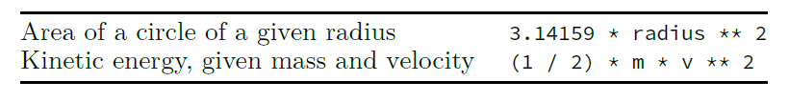
If both operands are integers and exponent is +ve, then the result will be an integer
If anyone of the operands is float, then the result will be float

More examples:
>>> 9 ** 2
81
>> 9.0 ** 2
81.0
>>> pow(9, 2)
81
>>> pow(9.0, 2)
81.0

>>> 9 ** 0
1
>>> -9 ** 0
-1
>>> -9.0 ** 0
-1.0

Now, what happens if the exponent is <0?
>>> 9 ** 0.5 // this calculates the square root of 9
3.0
>>> 9 ** -2 // this is equivalent to 1 / 81
0.012345679012345678

