BUSINESS RESEARCH METHODS
PILOT STUDY & RESPONSE SUMMARY REPORT
“Factors Influencing the Choice of Online Learning Platforms: A Study of Indian Learners”
Submitted by
Gnaneshwari M – PGBA25005
Under the Guidance of
Dr. Rajkumar Rayabaram
School of Innovation & Management (SoIM), Hyderabad
Post Graduate Diploma in Management – Business Analytics (PGDM-BA)
2025–27
Submitted to: drrrajkumar@soim.edu.in
Component: Pilot Study & Response Summary | Due Date: 26-09-2026
Pilot data collected via Google Forms: https://forms.gle/TuXFoP5REX5sP16Q8

1. Introduction and Purpose of the Pilot Study
Before proceeding to full-scale data collection, a pilot study was conducted to test the questionnaire developed for this research project on factors influencing the choice of online learning platforms among Indian learners. The pilot serves three purposes: (a) to check whether the questions are clear, unambiguous and interpreted consistently by respondents, (b) to verify that the survey's routing and skip logic work as intended, and (c) to obtain a preliminary sense of response patterns and data quality before the instrument is circulated more widely for the main study.
This report summarises the responses received during the pilot, the profile of pilot respondents, and the issues identified in the instrument, along with the modifications recommended before the questionnaire is finalised for the main data collection phase.

2. Pilot Administration Details
Parameter | Detail
Mode of administration | Online, self-administered (Google Forms)
Sampling method | Convenience sampling among student and professional contacts
Pilot sample size (n) | 35 respondents
Screening criteria | 18 years or older; used an online learning platform in the last 6 months
Survey link used | https://forms.gle/TuXFoP5REX5sP16Q8
Questionnaire sections piloted | A – Screening, B – Platform usage/context, C – Attitudinal (Likert) items, D – Demographics

3. Pilot Respondent Profile (Section D)
The demographic profile of the 35 pilot respondents is summarised below.

Age Group
Age Group | Count | %
18 – 20 years | 6 | 17.1%
21 – 23 years | 16 | 45.7%
24 – 26 years | 11 | 31.4%
27 – 30 years | 1 | 2.9%
Above 30 years | 1 | 2.9%
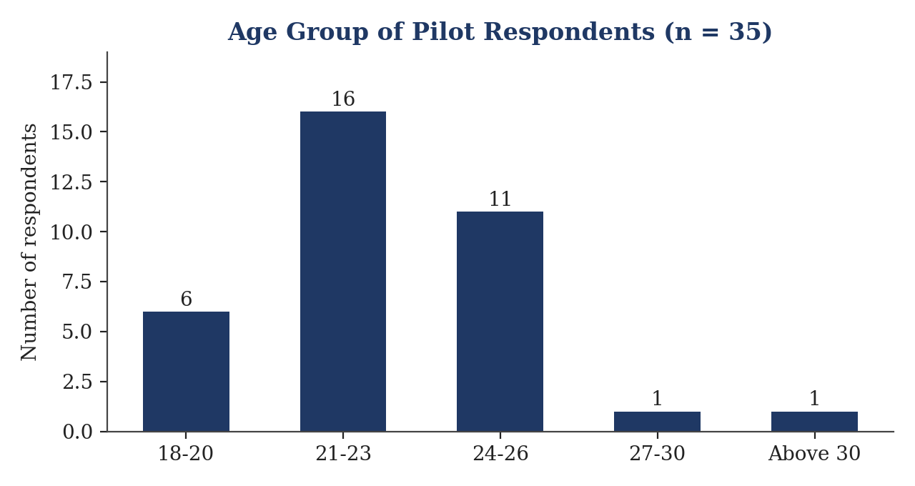

Gender
Gender | Count | %
Male | 9 | 25.7%
Female | 24 | 68.6%
Non-binary / other | 2 | 5.7%
Prefer not to say | 0 | 0.0%
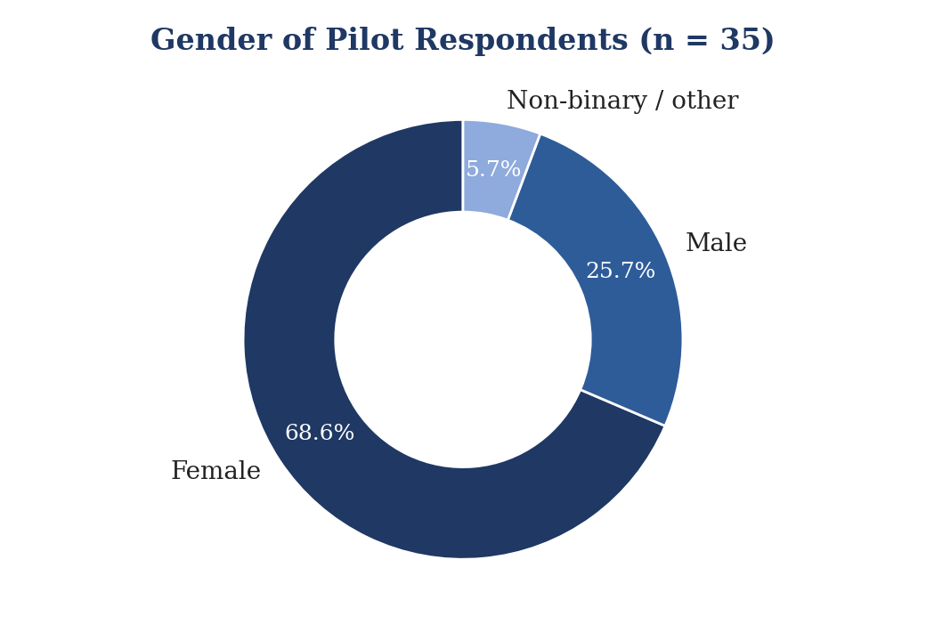

Current Status
Status | Count | %
Undergraduate student | 4 | 11.4%
Postgraduate student | 21 | 60.0%
Doctoral / research scholar | 2 | 5.7%
Working professional | 8 | 22.9%

Location and Household Income
Residence | Count | %
Metro city | 28 | 80.0%
Tier-2 city | 5 | 14.3%
Tier-3 city / small town | 1 | 2.9%
Rural area | 1 | 2.9%
Monthly Household Income | Count | %
Below ₹25,000 | 6 | 17.1%
₹25,000 – 50,000 | 8 | 22.9%
₹50,001 – 1,00,000 | 9 | 25.7%
Above ₹1,00,000 | 4 | 11.4%
Prefer not to say | 8 | 22.9%

4. Section-wise Summary of Pilot Responses

4.1 Section A – Screening Questions
Question | Yes | No
A1. Consented to participate | 33 (94.3%) | 2 (5.7%)
A2. Aged 18 or older | 33 (94.3%) | 2 (5.7%)
A3. Used a platform in the last 6 months | 26 (74.3%) | 9 (25.7%)
Note: 9 respondents answered “No” to A3 and, per the instrument's design, should have been routed to the end of the survey. All 35 respondents nonetheless completed Sections B, C and D (see Section 5 of this report).
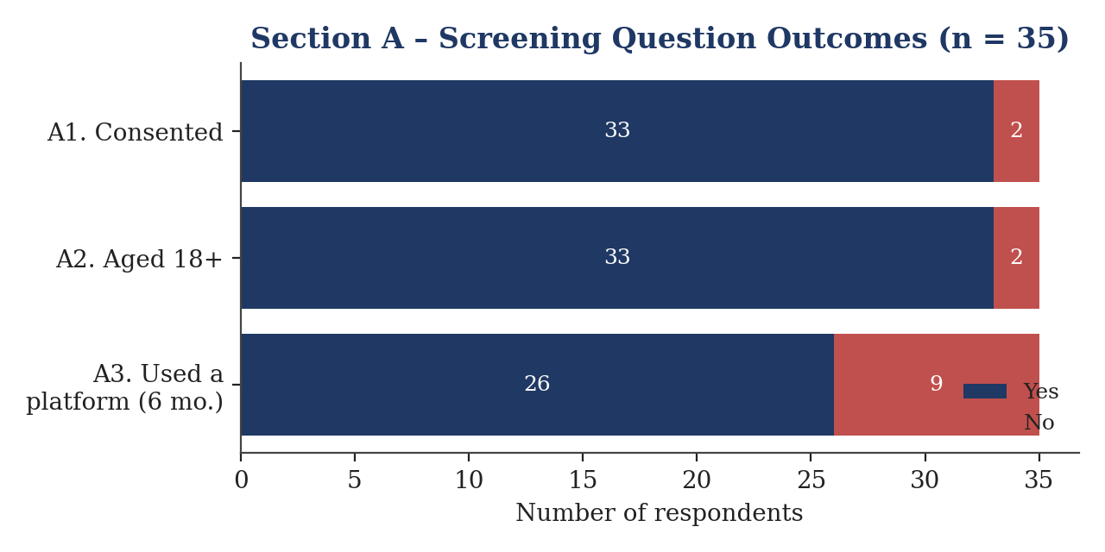

4.2 Section B – Platform Usage and Context
Platform used the most (B1) | Count | %
YouTube learning channels | 13 | 37.1%
Udemy | 6 | 17.1%
LinkedIn Learning | 5 | 14.3%
Live-class tool (Teams/Zoom/Meet) | 3 | 8.6%
Coursera | 2 | 5.7%
Other (please specify) | 2 | 5.7%
Unacademy / PhysicsWallah / SWAYAM / NPTEL (each) | 1 each | 2.9% each
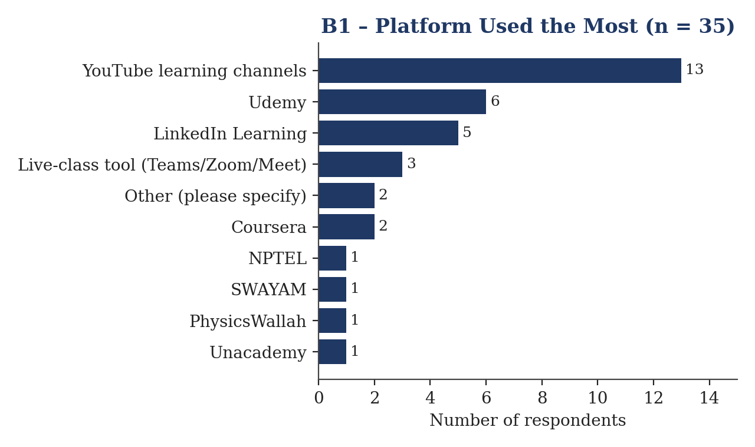

Usage Pattern | Top Response | Share
How platform was chosen (B2) | Chose it myself from several options | 68.6%
Duration of use (B3) | More than 2 years | 31.4%
Hours spent per week (B4) | 6 – 10 hours | 31.4%
Who pays for access (B5) | It is free to me | 45.7%
Main internet connection (B7) | Campus or institution Wi-Fi | 31.4%
Main device used (B8) | Laptop | 71.4%
Monthly mobile data spend (B9) | Not sure | 31.4%

4.3 Section C – Attitudinal Constructs (5-point Likert scale)
Each construct mean below is the average of its item means, computed from the response-frequency counts exported for the pilot (1 = Strongly Disagree to 5 = Strongly Agree). All construct means fall between the midpoint (3.0) and “Agree” (4.0), indicating a generally moderate-to-positive perception of the platform among pilot respondents, with no construct showing a floor or ceiling effect.
Construct (Items) | Mean (1–5)
Usefulness (C1–C4) | 3.52
Ease of Use (C5–C8) | 3.53
Social Influence (C9–C11) | 3.30
Facilitating Conditions (C12–C15) | 3.56
Enjoyment (C16–C18) | 3.54
Price and Value (C19–C21) | 3.41
Mobile Data Cost (C22–C26) | 3.37
Continuance Intention (C27–C30) | 3.51
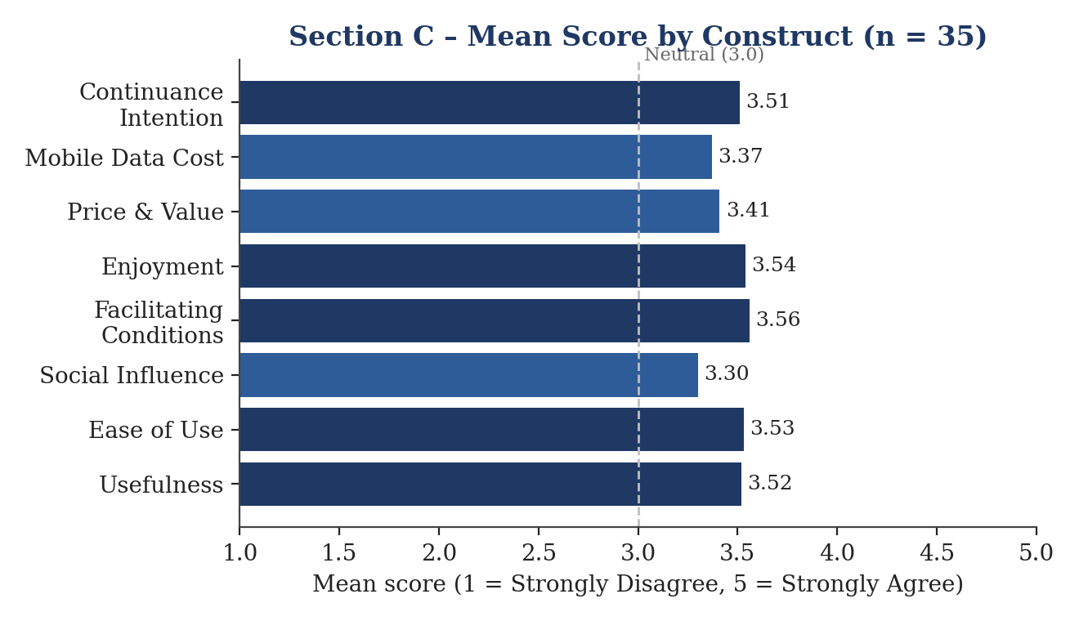

5. Data Quality Checks Arising from the Pilot
Two instrument-level issues were identified from the pilot responses. Both relate to the online form's configuration rather than to question wording, and both should be corrected before the questionnaire is used for the main data collection.

5.1 Skip Logic for Ineligible Respondents Not Enforced
Question A3 asks whether the respondent has used an online learning platform in the last six months, with “No” marked as “(end of survey)” in the instrument. In the pilot, 9 of 35 respondents answered “No”, yet all 35 respondents' data appears against every subsequent section. This indicates that the Google Form was not configured with section-based branching to route ineligible respondents to the end of the survey.

5.2 “Other, Please Specify” Fields Not Conditionally Gated
Several free-text follow-up questions (B1a, B5a, B6a, D3a) received far more responses than the number of respondents who selected “Other” on the preceding question. For example, B5a (“If you selected Other, please specify”) received 11 responses although B5 recorded 0 respondents choosing “Other.” Most of these extra responses are non-informative text such as “NA”, “No” or “None”, confirming that these fields were shown to all respondents rather than only to those who selected “Other.”

5.3 Attention-Check Item (C31)
Item C31 (“To show that you are reading carefully, please tick '4' for this statement”) was answered correctly – i.e., with “Agree” – by only 16 of 35 respondents (45.7%). A correct-response rate below 50% on a straightforward attention check is higher than the usual 10–15% failure rate expected in careful self-administered surveys, and suggests either response fatigue toward the end of a long Likert block or that the instruction is not sufficiently prominent.
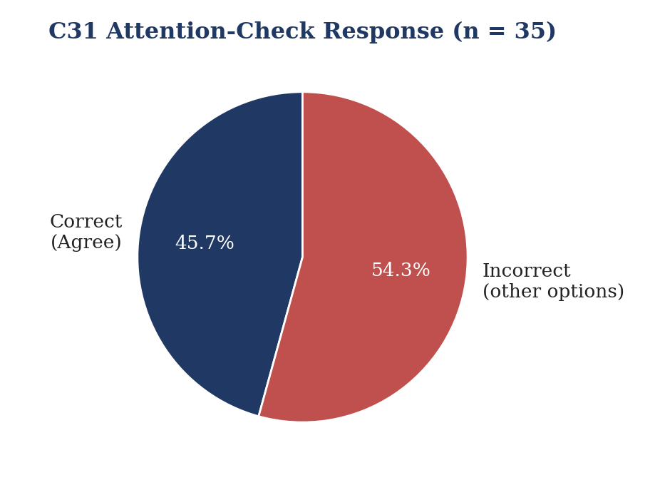

6. Modifications Recommended Before Final Data Collection
- Enable section-based branching (“Go to section based on answer”) on A2 and A3 so that respondents who are under 18 or have not used a platform in the last six months are routed directly to the end of the survey.
- Convert all “Other, please specify” items (B1a, B5a, B6a, D3a) into conditional questions that appear only when “Other” is selected on the parent question, using Forms section branching rather than a plain follow-up question.
- Re-test the corrected form in Preview mode end-to-end, using at least one response path for every branch (eligible/ineligible; each “Other” option), before circulating the final link.
- Retain the attention-check item (C31) but make the instruction more prominent (e.g., bold text) and consider moving it earlier in the Likert block to reduce the effect of respondent fatigue.
- Use the corrected sample size and screening logic outcome (only eligible respondents, i.e., those answering “Yes” to A2 and A3) as the basis for the final analysis, and treat the pilot's B/C/D responses from ineligible respondents as data-quality evidence only, not as valid main-study observations.

7. Conclusion
The pilot study, based on 35 responses, confirmed that the questionnaire's core screening, usage and attitudinal items are being understood and answered consistently, and that respondents' attitudes toward their chosen platform are moderately positive across all constructs. However, the pilot also surfaced two configuration issues – incomplete skip logic for ineligible respondents and ungated “Other” follow-up fields – that must be corrected in the Google Form before the instrument is used for full-scale data collection. With these corrections applied and re-verified, the questionnaire is considered ready to proceed to the main data collection phase.

