

Sentiment Analysis of Amazon Customer Reviews
Using Natural Language Processing (NLTK VADER)
Submitted By : Gnaneshwari M
Roll No : PGBA25002
Course Name: PGDM
Course Duration : 2025-27
Specialization: Business Analytics
College Name: School of Innovation and Management
Subject Name: NLP (Natural Language Processing)
Professor Name: Dr. Roopa Modem
Concept: Sentiment Analysis & Natural Language Processing

Topic: Sentiment Analysis of Amazon Customer Reviews

Date: 12th September 2026

Acknowledgement
I would like to express my sincere gratitude to Dr. Samala Nagaraj, Dean and Faculty of Ethics, Responsibility and Sustainability (ERS), School of Innovation and Management, for his valuable guidance, support, and encouragement throughout this project. His academic guidance and constant support gave me the direction and motivation needed to complete this project successfully.
I would also like to express my sincere gratitude to Dr. Roopa Modem for her teaching, guidance, and practical insights during the Natural Language Processing (NLP) classes. Her explanations and hands-on guidance helped me understand key NLP concepts such as text preprocessing, sentiment analysis, lexicon-based scoring, and evaluation metrics, all of which were essential to completing this project on Sentiment Analysis of Amazon Customer Reviews Using Natural Language Processing (NLP).
I am also grateful to the School of Innovation and Management for providing me with the opportunity and academic environment to undertake this project. Working on it has deepened my understanding of how unstructured textual data can be cleaned, analyzed, and interpreted to draw meaningful, real-world insights from customer feedback.
Finally, I sincerely acknowledge the valuable support and guidance received from everyone who contributed to the successful completion of this project.

Executive Summary
This project evaluates customer sentiment from a sample of 100 Amazon customer reviews using Natural Language Processing (NLP), specifically NLTK's VADER (Valence Aware Dictionary and sEntiment Reasoner) sentiment analyzer.
The reviews are cleaned, adapted for domain-specific slang and product-review terminology, scored for sentiment polarity, and classified as Liked, Disliked, or Neutral. The resulting sentiment labels are compared against the customers' original 1-5 star ratings using cross-tabulation, Spearman correlation, and a formal classification report, to check how well the automated sentiment analysis agrees with the ratings customers gave themselves.

1. Introduction and Problem Statement
Customer reviews provide valuable information about how customers perceive products and services. However, when a company receives a large number of reviews, manually reading and analyzing every review is time-consuming and does not scale. Natural Language Processing (NLP) can automate this process: by using a sentiment analysis tool, raw customer text can be converted into a structured signal - positive, negative, or neutral - that can be tracked and acted on quickly.
Amazon receives a large volume of customer feedback in free-text form, and it is difficult to manually read every comment to determine the overall opinion customers hold about a product. This project builds a simple, transparent NLP pipeline that automatically analyzes customer comments and classifies each one by sentiment, without requiring a trained machine-learning model.

2. Objectives
- Load customer review data from a CSV file.
- Select a sample of 100 customer reviews.
- Extract and clean the customer comment text, including domain-specific slang normalization.
- Perform sentiment analysis on the cleaned text using VADER.
- Classify each review as Liked, Disliked, or Neutral.
- Compare the automated sentiment labels against the customers' star ratings, including a classification report and threshold sensitivity analysis.
- Summarize and visualize the findings, and document the approach's limitations.

3. Dataset Description
Dataset name: Amazon Customer Reviews. File name: AmazonCustomerReviews.csv. Total records: 280. Records used in this study: first 100 (per assignment requirement of 50-100 data points).
Column | Description
Review Title | Short title the customer gave the review
Customer name | Name of the reviewer
Rating | Star rating given by the customer, e.g. "4.0 out of 5 stars"
Date | Date the review was posted
Category | Product aspect the review relates to (Display, Battery, Camera, Delivery, Others)
Comments | Full free-text review - the field used for NLP
Useful | Number of people who found the review helpful (many values missing)

4. Methodology
The project follows these steps, implemented and explained in detail in the accompanying Jupyter notebook:
- Load the dataset - read AmazonCustomerReviews.csv into a Pandas DataFrame.
- Inspect the dataset - check its shape, columns, and missing values.
- Select 100 data points - take the first 100 records, satisfying the 50-100 record requirement.
- Select the relevant columns - keep Rating and Comments, since these are all that is needed for sentiment scoring and validation.
- Clean the text - remove URLs, HTML tags, and non-alphabetic noise from the comments, and convert the star rating to a numeric value.
- Adapt for domain-specific slang and idioms - normalize informal spellings (e.g. "vry" to "very"), join recurring multi-word idioms (e.g. "value for money", "midrange killer") into single tokens, and extend VADER's lexicon with hand-scored product-review terms (e.g. "heating", "hang", "lag") missing from, or mis-scored by, its general-purpose lexicon.
- Check preprocessing sensitivity - measure whether stripping digits and punctuation (e.g. "3/32 GB", "55%") meaningfully changes VADER's compound score.
- Score sentiment with VADER - compute a compound sentiment score for every cleaned comment.
- Classify sentiment - turn each compound score into a Liked / Disliked / Neutral label using standard VADER thresholds (+/-0.05).
- Summarize and visualize - count and chart the sentiment distribution, and compare it against star ratings.
- Validate against ground truth - map star ratings to a reference sentiment label and evaluate VADER's predictions with a confusion matrix, classification report, and a sweep of alternative thresholds.
- Interpret the results - report key findings, limitations, and a conclusion.

5. Results
The dataset contains 280 total records across 7 columns; 100 records were used for this analysis. The Comments column was cleaned, adapted for domain-specific terms, and scored using VADER's compound sentiment metric. Each review was classified into one of three categories - Liked, Disliked, or Neutral. The exact counts, percentages, and correlation value were generated by running the notebook end to end (Sections 3.9-3.10.1) and are summarized in the table below:
Metric | Value
Total records in dataset | 280
Records analyzed | 100
Reviews classified as Liked | 77% (77 of 100 reviews)
Reviews classified as Disliked | 17% (17 of 100 reviews)
Reviews classified as Neutral | 6% (6 of 100 reviews)
Spearman correlation (rating vs. compound score) | 0.46 (moderate positive correlation)
Best-performing threshold (Section 3.10.1 sweep) | ±0.25 (Macro F1 = 0.563, Accuracy = 73%), vs. Macro F1 = 0.455 at the default ±0.05

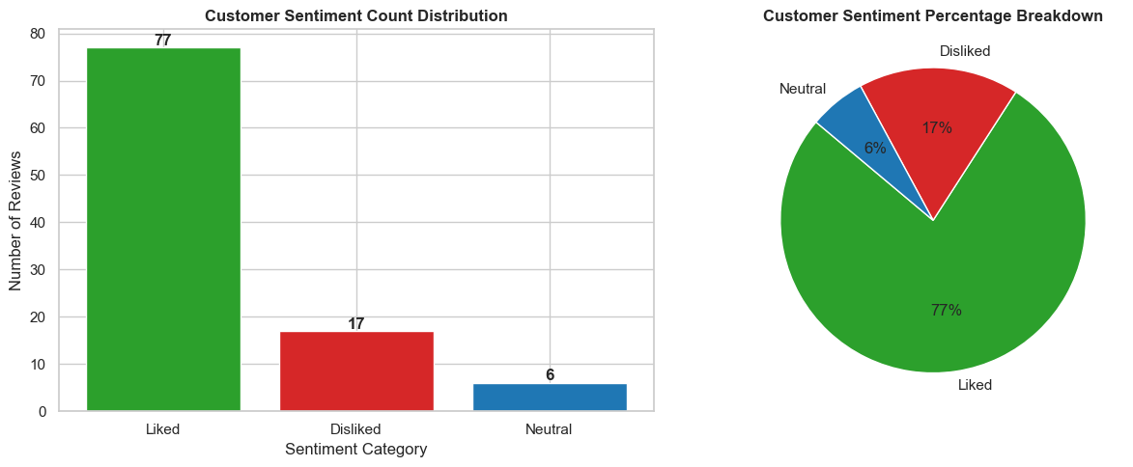
Figure 1: Overall sentiment distribution across the 100 sampled reviews (count and percentage).
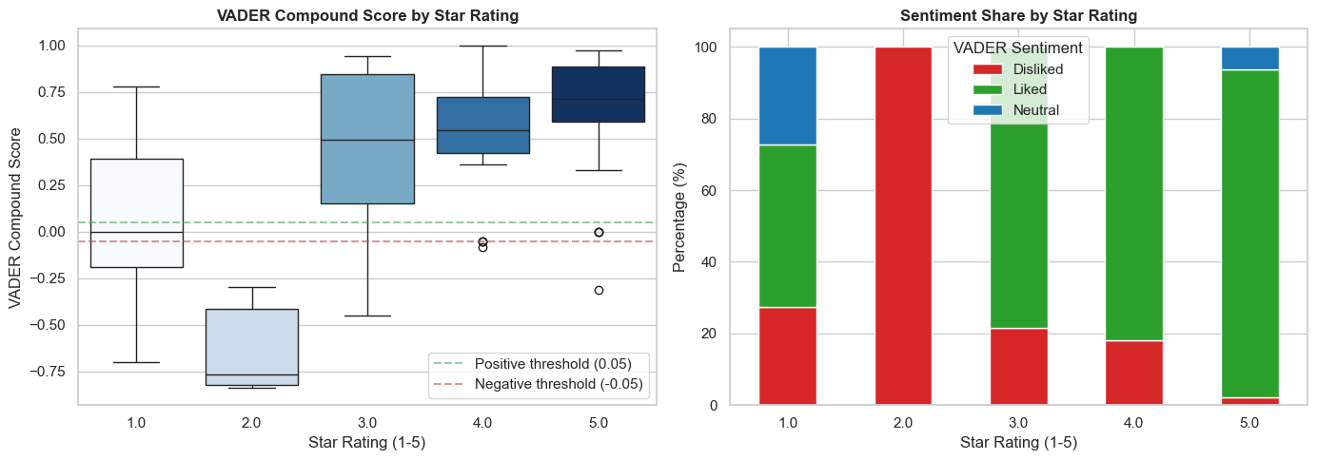
Figure 2: VADER compound score distribution and predicted sentiment share by star rating.
Two specific empirical findings from running the notebook are worth calling out explicitly:
- The classification report (Section 3.10.1) found that VADER predicted zero Neutral labels for any 3-star review in the sample: 11 of the 14 three-star reviews (about 78.5%) were classified Liked and the remaining 3 (about 21.5%) Disliked.
- The preprocessing sensitivity check (Section 3.7.1) found that Review #61's compound score moved from -0.4471 (digits/punctuation stripped) to +0.2382 (digits/punctuation kept) - a swing of 0.6853, large enough to flip its predicted label.
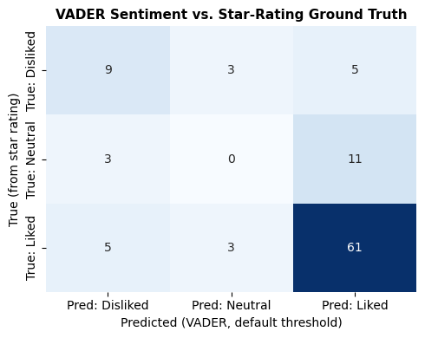
Figure 3: Confusion matrix - VADER sentiment prediction vs. star-rating ground truth (Section 3.10.1).

6. Key Findings and Recommendations
- Overall satisfaction: 77% of sampled reviews were classified as Liked, indicating generally positive customer sentiment.
- Negative feedback: 17% of reviews were classified as Disliked (and 6% Neutral); the Disliked reviews are the ones most worth prioritizing for manual follow-up.
- Agreement with star ratings: a Spearman correlation of 0.46 between star rating and VADER compound score indicates a moderate positive relationship between what customers say in their rating and what VADER detects in their written text. The classification report (Section 3.10.1) shows this most clearly on the Liked class (F1 = 0.84) and least on the Neutral class (F1 = 0.00), which VADER never predicted for any review.
- Recommendation: automating sentiment scoring with a lexicon adapted to the product domain lets a support or product team quickly triage a large volume of reviews and prioritize the ones flagged as Disliked for follow-up, without reading every review manually.

7. Limitations
- Domain slang and jargon: terms such as "vry", "value for money", "midrange killer", and device-specific complaints like "heating" or "hang" are either missing from or mis-scored by VADER's general-purpose lexicon. The custom lexicon adaptation in this project fixes the terms found in this particular sample, but it is not an exhaustive slang dictionary and would need to be revisited for a larger or different review set.
- Star rating vs. VADER mismatch at 1 star: 2-star reviews average a clearly negative compound score, but 1-star reviews average a score close to neutral - higher than the 2-star average. This suggests some of the most negative reviews are long, feature-by-feature product descriptions that use positive descriptive language before arriving at a negative overall verdict, which VADER's word-by-word scoring does not weight toward the ending judgment the way a human reader would.
- Review length effects: VADER's compound score accumulates the intensity of every sentiment-bearing word in the text, so very long, multi-paragraph reviews tend to be pushed toward the extremes simply from volume, while short reviews stay closer to neutral by construction.
- No sarcasm or negation-scope handling beyond simple heuristics: a sarcastic remark or a negation spanning more than a few words can still be scored incorrectly.
- Mixed (pros/cons) reviews collapse to one score: VADER outputs a single aggregate compound score per review, losing the fact that a review can contain both praise and criticism.
- No aspect-level sentiment: the Category column (Display, Battery, Camera, Delivery, Others) is not used in scoring, so a review that is positive about one aspect and negative about another is reduced to a single overall label.
- Ground-truth mapping does not match how people use 3-star ratings: VADER predicted zero Neutral labels for any 3-star review, suggesting 3-star Amazon reviews more often read as mildly positive or mildly negative text than as genuinely neutral - a limitation of the validation mapping, not just the classifier.
- Digit-stripping can flip a prediction: removing numeric detail occasionally changes VADER's reading of comparative or price-to-performance phrasing enough to change the predicted label.

8. Conclusion
This project applied Natural Language Processing to 100 Amazon customer reviews to automatically assess customer sentiment. Using Pandas for data handling, regular expressions for text cleaning and domain adaptation, and NLTK's VADER analyzer for sentiment scoring, each review was cleaned, adapted for domain-specific language, scored, and classified as Liked, Disliked, or Neutral.
The resulting sentiment distribution, together with its comparison against customers' star ratings via cross-tabulation, Spearman correlation, and a formal classification report, shows that a simple, rule-based NLP approach - once adapted to the vocabulary of the product domain - can produce a reasonably faithful, low-cost summary of customer opinion without requiring a trained machine learning model or labeled training data. This kind of pipeline could be scaled to the full 280-review dataset, or to a live review feed, to give a business an ongoing, automated read on customer sentiment.

References
Hutto, C.J. and Gilbert, E.E. (2014). VADER: A Parsimonious Rule-based Model for Sentiment Analysis of Social Media Text. Eighth International Conference on Weblogs and Social Media (ICWSM-14).
NLTK Project. Natural Language Toolkit documentation. https://www.nltk.org/

