
SCHOOL OF INNOVATION AND MANAGEMENT
POST GRADUATE DIPLOMA IN MANAGEMENT (PGDM)
PGDM – BUSINESS ANALYTICS
SUMMER INTERNSHIP REPORT
“DIGITAL MARKETING PRACTICES AND PATIENT ENGAGEMENT
AT CARE HOSPITALS”
Submitted by
GNANESHWARI MAHIMALURU
Registration No.: PGBA25002
Internship Title: Digital Marketing Intern
Organization: CARE Hospitals, Hitech City, Hyderabad, Telangana
Department: Marketing & BD – Digital Marketing
Internship Duration: 12 May 2026 – 27 June 2026
Submitted to
School of Innovation and Management
PGDM (2025–27) | Trimester III
Date of Submission: 20 August 2026

ACKNOWLEDGEMENTS
I would like to express my sincere gratitude to CARE Hospitals, Hitech City, Hyderabad, for providing me with the opportunity to undertake my summer internship in Digital Marketing. The internship gave me practical exposure to healthcare communication, digital content creation, competitor analysis, patient feedback, information verification, and AI-assisted content development.
I am thankful to the management and the members of the Marketing and Business Development function for their guidance and for allowing me to observe and participate in departmental and marketing interactions. I also acknowledge the support of the Human Resources department and the guidance reflected in my internship completion certificate issued by CARE Hospitals.
I am grateful to the faculty members and mentors at the School of Innovation and Management for connecting classroom concepts with practical business situations. Finally, I thank everyone who contributed directly or indirectly to the successful completion of this internship and report.

DECLARATION
I, Gnaneshwari Mahimaluru, Registration No. PGBA25002, hereby declare that the internship report entitled “Digital Marketing Practices and Patient Engagement at CARE Hospitals” is an original account of my learning and work exposure during my summer internship at CARE Hospitals, Hitech City, Hyderabad, from 12 May 2026 to 27 June 2026.
I further declare that this report has been prepared for the academic requirements of the Post Graduate Diploma in Management (PGDM), School of Innovation and Management, and that the information presented is based on my internship presentation materials, internship completion certificate, observations, activities, and learning during the internship. Wherever external or organizational information has been used, it has been appropriately acknowledged.
Name: Gnaneshwari Mahimaluru
Registration Number: PGBA25002
Program: PGDM – Business Analytics
Institution: School of Innovation and Management

INTERNSHIP REPORTING – BASIC INFORMATION
Your Name | Gnaneshwari Mahimaluru
Designation | Digital Marketing Intern
Name of the Company | CARE Hospital, Hitech City, Hyderabad
Mode of Work | Offline
Internship Duration | 12 May 2026 – 27 June 2026
Reporting Supervisor | Zeeshan Sir
Reporting Supervisor's Mobile Number | 6309865696
Reporting Supervisor's Email ID | zeeshanali.mohammed@carehospitals.com
HR Contact | Nischala
HR Contact Number | +91 90143 86909

INTERNSHIP CERTIFICATE
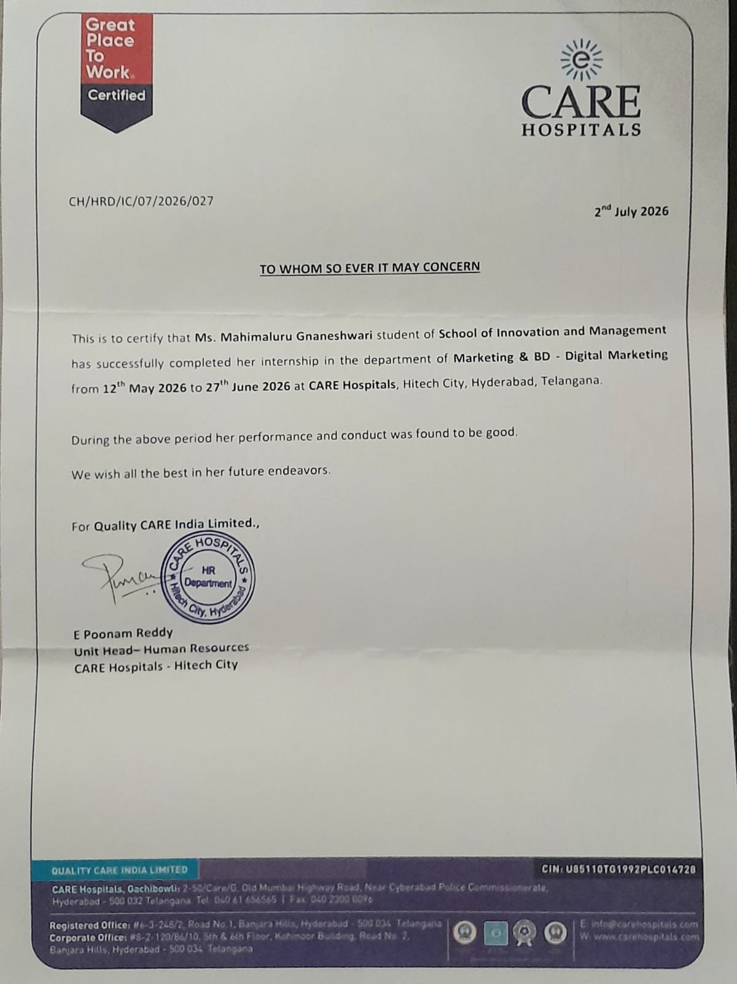

TABLE OF CONTENTS
ACKNOWLEDGEMENTS 2
DECLARATION 3
INTERNSHIP CERTIFICATE 4
TABLE OF CONTENTS 6
1. EXECUTIVE SUMMARY 8
2. COMPANY PROFILE 8
2.1 Digital Communication Context 9
2.2 Internship Work Environment 9
3. INDUSTRY OVERVIEW 10
3.1 Key Characteristics Observed 10
3.2 Competitive Landscape Reviewed 11
4. OBJECTIVES OF THE INTERNSHIP 11
5. PROJECT TITLE AND SCOPE 12
5.1 Project Title 12
5.2 Scope of Work 12
5.3 Major Awareness Campaign 12
6. RESEARCH METHODOLOGY 13
7. ROLES AND RESPONSIBILITIES 14
8. LEARNING OUTCOMES 14
8.1 Digital Marketing Skills 14
8.2 Analytics and Research Skills 14
8.3 Content and AI Skills 14
8.4 Professional Skills 15
9. APPLICATION OF PGDM CONCEPTS 15
10. CHALLENGES FACED AND SOLUTIONS 16
11. RECOMMENDATIONS 17
11.1 Digital Marketing Recommendations 17
11.2 AI and Content Recommendations 17
11.3 Recommendations for Future Interns 18
12. CONCLUSION 18
13. WEEKLY INTERNSHIP REPORTING 19
Week 1: 12 May – 16 May 2026 19
Week 2: 19 May – 23 May 2026 20
Week 3: 26 May – 30 May 2026 21
Week 4: 2 June – 6 June 2026 21
Week 5: 7 June – 11 June 2026 22
Week 6: 12 June – 16 June 2026 23
Week 7: 17 June – 21 June 2026 24
Week 8: 22 June – 27 June 2026 24
14. REFERENCES 25
15. APPENDICES 28
Appendix A – Internship Completion Certificate 28
Appendix B – Awareness Video Evidence 28
Appendix C – Competitor Analysis Evidence 29
Appendix D – Internship Presentation Evidence 30
Appendix E – Weekly Internship Record 31

1. EXECUTIVE SUMMARY
The summer internship at CARE Hospitals, Hitech City, Hyderabad, was undertaken as a Digital Marketing Intern in the Marketing & Business Development function from 12 May 2026 to 27 June 2026. The internship provided practical exposure to the use of digital communication in a healthcare environment, where accuracy, trust, patient engagement, and responsible communication are particularly important.
The major activities covered during the internship included doctor-information verification, competitor analysis, patient feedback and information verification, healthcare awareness content creation, and AI-assisted video development. The competitor review considered CARE Hospitals alongside KIMS Hospitals, Yashoda Hospitals, Apollo Hospitals, and AIG Hospitals, with attention to social media presence, awareness campaigns, content formats, doctor-focused content, patient engagement, videos/reels, and health education.
A significant practical project was the development of a patient-friendly awareness campaign on robotic-assisted bariatric surgery. The work involved topic research, scripting, content development, and the creation of an awareness video using AI-assisted tools for visuals and voiceover.
The internship also demonstrated the connection between patient experience and digital reputation. Feedback observed during the internship highlighted the importance of accurate documentation, verification, responsive communication, and service-quality monitoring. Overall, the experience strengthened practical skills in digital marketing, healthcare branding, competitor research, content creation, AI-assisted workflows, professional communication, and the application of Business Analytics thinking to real-world observations.

2. COMPANY PROFILE
CARE Hospitals is presented in the internship material as a multi-specialty healthcare organization based in Hyderabad, committed to patient-focused care across a broad range of medical services. The official CARE Hospitals website describes the organization as a multi-specialty healthcare network and separately provides an official profile for the HITEC City hospital. The HITEC City facility is described as a 220-bed hospital with seven operation theatres, 120 critical-care beds and services across more than 20 specialties (CARE Hospitals, n.d.-a, n.d.-b).
Organizational Feature | Internship Presentation Information
Hospital type | Multi-specialty tertiary care hospital (CARE Hospitals, n.d.-b)
Location | Hitech City, Hyderabad, Telangana
Capacity highlighted | 220-bed tertiary care hospital (CARE Hospitals, n.d.-b)
Medical coverage | 20+ medical specialties (CARE Hospitals, n.d.-b)
Operation theatres | 7 modern operation theatres (CARE Hospitals, n.d.-b)
Critical care | 120+ critical care beds (CARE Hospitals, n.d.-b)
Technology | Advanced diagnostic and surgical technology
Care approach | Multidisciplinary and patient-focused

2.1 Digital Communication Context
The internship presentation identifies digital communication as an important mechanism for awareness, engagement, and outreach. External research supports the importance of information quality and trust in online health communication: systematic reviews have found substantial variation in the quality of online health information and identified trustworthiness, expertise, clarity and other source/content characteristics as important to consumers' evaluations (Daraz et al., 2019; Zhang & Kim, 2022). Research also indicates that online health information can influence health-related decision-making and can support more informed patient participation when it complements professional care (Thapa et al., 2021).

2.2 Internship Work Environment
The internship involved exposure to the Sales & Marketing environment and interactions with the Marketing and Business Development function. The internship began in May 2026 and was completed on 27 June 2026. A temporary break occurred from 7 June to 11 June because of a JCI audit, after which the internship resumed on 12 June.

3. INDUSTRY OVERVIEW
The internship provided exposure to healthcare digital marketing, a domain where communication has to balance marketing objectives with patient needs and information accuracy. Research on hospital social media shows that digital channels can function as communication and feedback mechanisms, while the evidence should be interpreted carefully rather than treated as proof of causation (Richter & Kazley, 2020; Huppertz & Otto, 2018).

3.1 Key Characteristics Observed
- Patient trust is closely related to the credibility and quality of health information available to patients. Research on online health information identifies information quality, source characteristics and perceived trustworthiness as important factors in how consumers evaluate health information (Daraz et al., 2019; Zhang & Kim, 2022).
- Healthcare awareness content should translate complex medical subjects into clear, understandable and patient-friendly communication. Research on online health information and health decisions supports the importance of understandable, useful information in helping consumers engage with healthcare decisions (Zhang & Kim, 2022; Thapa et al., 2021).
- Competitor digital presence can be used as an input for structured competitive analysis and benchmarking. Competitive-intelligence research describes systematic collection, analysis and interpretation of information about competitors and the external environment as a basis for strategic planning (Tahmasebifard & Wright, 2018).
- Video, reels, infographics, doctor-focused content, and patient-oriented stories were among the formats considered during the internship's competitor review. Research indicates that hospital social-media activity can be associated with patient satisfaction and that patient-generated social-media feedback can provide useful signals about patient experience; these findings do not establish that any particular format caused better outcomes (Richter & Kazley, 2020; Huppertz & Otto, 2018).
- Feedback mechanisms can reveal service and communication issues and can provide information for quality-improvement discussions. A systematic review found that patient-feedback interventions have been used to address communication, responsiveness, patient education and other dimensions of patient-centred care, although the evidence base remains heterogeneous (Wong et al., 2020).

3.2 Competitive Landscape Reviewed
Hospital | Digital Areas Considered
CARE Hospitals | Social presence, awareness campaigns, content themes, doctors, engagement, video/reels, health education
KIMS Hospitals | Same comparison parameters
Yashoda Hospitals | Same comparison parameters
Apollo Hospitals | Same comparison parameters
AIG Hospitals | Same comparison parameters  Research-support note: Official hospital websites were used only to verify organizational or service descriptions. The comparative observations about social-media presence, content themes, videos/reels and engagement practices are internship observations; no external engagement metrics or performance rankings have been added.

4. OBJECTIVES OF THE INTERNSHIP
The internship was structured to bridge academic learning with practical healthcare digital marketing. The principal objectives were:
- Understand digital marketing strategies specific to the healthcare sector.
- Learn platform-specific social media content and engagement practices.
- Evaluate the digital strategies of competing healthcare organizations.
- Understand how patient feedback can support service improvement.
- Support healthcare awareness and communication initiatives.
- Gain practical exposure to digital communication in a hospital environment.
- Develop skills in accurate information verification and patient-facing communication.

5. PROJECT TITLE AND SCOPE

5.1 Project Title
Digital Marketing Practices and Patient Engagement at CARE Hospitals: Competitor Analysis, Information Verification and Healthcare Awareness Content

5.2 Scope of Work
Workstream | Scope
Doctor-information verification | Profile audit, data validation, credential accuracy and consistency across digital platforms.
Competitor analysis | Review of social media presence, campaigns, formats, doctor content, engagement and health education.
Patient feedback | Collection/review of feedback and identification of communication or documentation improvement opportunities.
Healthcare content | Research, scripting and development of patient-friendly awareness content.
AI-assisted video | Use of AI tools for visual generation, scripting support and voiceover while retaining editorial oversight.

5.3 Major Awareness Campaign
The major content project was an awareness campaign on robotic-assisted bariatric surgery. The campaign involved studying the topic, developing ideas and scripts, preparing patient-friendly communication, and producing a video with AI-assisted visuals and voiceover. CARE Hospitals' official information confirms that its robotic-surgery services include gastrointestinal and bariatric surgery, while authoritative medical sources describe metabolic and bariatric surgery and the published evidence on robotic-assisted approaches (CARE Hospitals, n.d.-c; National Institute of Diabetes and Digestive and Kidney Diseases, n.d.; Leang et al., 2024).
Campaign/video reference: https://youtube.com/shorts/EfKeGjykakA?feature=share

6. RESEARCH METHODOLOGY
The internship activities followed a practical workflow from research and verification to content creation, digital communication, and feedback-based improvement. External literature was used in this final report only to contextualize the internship work; the descriptions of activities, observations and learning remain based on the internship presentation, certificate and internship records.
Stage | Method Applied | Output / Learning
Research | Topic and competitor research | Content ideas, benchmarks and healthcare communication insights
Verification | Review of doctor profiles, departments, room allocations and other information | Improved awareness of data accuracy and trust signals
Feedback | Collection and review of patient responses and observations | Identification of satisfaction patterns and improvement opportunities
Planning | Content planning and scripting | Structured patient-friendly messaging
Creation | AI-assisted visuals, video and voiceover | Healthcare awareness video
Review | Editorial oversight and feedback | More accurate and purposeful communication
The methodology was primarily observational, analytical and project-based. It relied on the activities and materials available during the internship rather than on a formal statistical survey. Therefore, the findings should be understood as internship observations and practical learning rather than as a generalized clinical or market study.

7. ROLES AND RESPONSIBILITIES
- Assisted with verification of doctor information, profiles, departments and room allocations.
- Reviewed competitor digital presence and identified content and engagement practices.
- Studied healthcare awareness campaigns and different content formats used by peer hospitals.
- Collected and reviewed patient feedback to identify communication and service-improvement opportunities.
- Supported the development of healthcare awareness content.
- Researched robotic-assisted bariatric surgery for a patient-friendly awareness campaign.
- Developed content ideas and scripts for the awareness video.
- Used AI-assisted tools for visuals, content assistance and voiceover creation.
- Participated in departmental and marketing interactions and gained exposure to hospital operations.

8. LEARNING OUTCOMES

8.1 Digital Marketing Skills
- Healthcare branding
- Social media strategy
- Digital outreach
- Healthcare awareness communication

8.2 Analytics and Research Skills
- Competitor analysis
- Patient feedback analysis
- Information verification
- Identification of communication gaps

8.3 Content and AI Skills
- Content planning and scripting
- Video development
- AI-assisted content workflows
- Visual and voiceover creation

8.4 Professional Skills
- Team collaboration
- Professional communication
- Understanding of hospital operations
- Responsible handling of patient-facing information

9. APPLICATION OF PGDM CONCEPTS
PGDM Area | Application During Internship
Business Analytics | Competitor comparison, patient feedback review, identification of patterns and information inconsistencies. (Wedel & Kannan, 2016; Iacobucci et al., 2019)
Marketing Management | Healthcare branding, awareness campaigns, digital outreach and audience engagement. (Vollrath & Villegas, 2022)
Consumer / Patient Behaviour | Understanding patient expectations, trust, feedback and communication needs. (Zhang & Kim, 2022; Thapa et al., 2021)
Business Communication | Patient-friendly scripts, healthcare awareness messaging and professional departmental interaction.
Technology & AI | Use of ChatGPT, Gemini, Canva, Google Flow AI and ElevenLabs in the content workflow. (World Health Organization, 2021; Li et al., 2024)
Strategic Thinking | Benchmarking competitors and identifying opportunities for stronger digital communication. (Tahmasebifard & Wright, 2018; Vollrath & Villegas, 2022)
The internship helped connect classroom concepts with an operational healthcare environment. In particular, Business Analytics was experienced not only as numerical analysis but also as structured observation, comparison, verification, and interpretation of feedback for decision support. Marketing-analytics research emphasizes the use of data and analytical methods to support marketing decisions, while digital marketing analytics is most useful when connected to broader strategy and the customer decision journey (Wedel & Kannan, 2016; Iacobucci et al., 2019; Vollrath & Villegas, 2022).

10. CHALLENGES FACED AND SOLUTIONS
Challenge / Observation | Response / Learning
Healthcare information requires high accuracy. | Used structured verification of profiles and patient-facing information before considering communication outputs. (Daraz et al., 2019; Zhang & Kim, 2022)
Medical subjects can be difficult for general audiences. | Focused on patient-friendly language, structured scripts and awareness-oriented communication.
Competitor content is diverse across platforms. | Used consistent comparison parameters such as themes, formats, videos, doctor content and engagement.
Patient feedback can reveal sensitive service issues. | Approached observations from a service-improvement and communication perspective rather than treating individual feedback as a generalized finding.
AI-generated content requires review. | Maintained editorial oversight and treated AI as an assistance tool rather than a replacement for human verification. (World Health Organization, 2021; Wei et al., 2024)
Internship continuity was interrupted by the JCI audit. | Resumed work after the temporary 7–11 June break and continued the internship from 12 June.

11. RECOMMENDATIONS

11.1 Digital Marketing Recommendations
- Maintain consistent and accurate doctor profiles across the hospital website and relevant digital platforms. This recommendation is consistent with research showing that source quality, information quality and credibility affect consumers' evaluation of online health information (Daraz et al., 2019; Zhang & Kim, 2022).
- Build a structured healthcare awareness content calendar covering specialties, procedures, prevention and patient education. The purpose should be to provide clear, useful information rather than simply increase promotional output (Thapa et al., 2021; Richter & Kazley, 2020).
- Use a balanced mix of short-form videos, infographics, doctor-led content and patient-oriented educational material. The specific mix should be evaluated using audience response and service objectives rather than assumed to be universally effective (Richter & Kazley, 2020).
- Continue competitor benchmarking to identify useful content formats and engagement practices. Competitive-intelligence research supports systematic monitoring and analysis of competitors as an input to strategic planning (Tahmasebifard & Wright, 2018).
- Use patient feedback as an input for communication and service-quality improvement. Research supports the use of patient feedback in quality-improvement processes, while also noting that feedback should be interpreted systematically rather than treated as representative of all patients (Wong et al., 2020; Huppertz & Otto, 2018).

11.2 AI and Content Recommendations
- Use AI tools to accelerate ideation, scripting, visual development and voiceover production while retaining human review. WHO guidance emphasizes ethical governance, human oversight and risk management in AI for health, and systematic reviews of ChatGPT in healthcare highlight limitations in accuracy and reliability (World Health Organization, 2021; Li et al., 2024; Wei et al., 2024).
- Create a standard approval checklist for medical accuracy, clarity, tone, branding and patient suitability before publishing. This is particularly important because medical AI outputs can be inconsistent or inaccurate and should not be treated as a substitute for expert review (World Health Organization, 2021; Wei et al., 2024).
- Maintain consistency between AI-assisted content and the hospital's patient-focused communication approach. AI should be treated as an assistance tool within a controlled content workflow, with human judgment applied to accuracy, context, privacy and suitability (World Health Organization, 2021; Li et al., 2024).

11.3 Recommendations for Future Interns
- Maintain a daily or weekly record of tasks, learning, challenges and supervisor feedback from the first day.
- Save evidence of completed projects, campaign links and analytical observations for the final report.
- Ask for feedback regularly rather than waiting until the end of the internship.
- Connect every practical task to at least one PGDM concept to make the final presentation and report stronger.

12. CONCLUSION
The summer internship at CARE Hospitals provided meaningful practical exposure to digital marketing in a healthcare environment. The experience demonstrated, from my internship perspective, that healthcare digital communication involves accurate information, health education, patient engagement, feedback analysis and reputation-related communication. External research supports the importance of information quality, patient feedback and responsible digital communication in healthcare (Daraz et al., 2019; Wong et al., 2020; Huppertz & Otto, 2018).
Through competitor analysis, doctor-information verification, patient feedback review and healthcare awareness content creation, I developed a stronger understanding of how digital communication can support patient trust and engagement. The robotic-assisted bariatric surgery awareness campaign further provided hands-on experience in research, scripting, video development and AI-assisted content creation.
The internship also strengthened my ability to apply Business Analytics and management concepts to real-world observations. Overall, the experience improved my digital marketing, research, communication, content and professional skills and provided valuable insight into the operational context of a multi-specialty hospital.

13. WEEKLY INTERNSHIP REPORTING
The weekly record below documents the internship activities, skills learned, challenges, responses, goals and reflections during the internship period.

Week 1: 12 May – 16 May 2026
Number of days worked | 5 days
Number of days absent | 0
Average working hours | Approximately 9 hours/day
Summary of tasks performed | Orientation to the hospital and Marketing & Business Development environment; understanding healthcare digital marketing activities; observing hospital operations; beginning research on CARE Hospitals' digital presence and competitor hospitals.
Skills learned | Healthcare marketing basics, professional communication, observation, digital research and competitor analysis.
Challenges faced | Understanding the healthcare environment and the importance of accuracy in patient-facing communication.
How challenges were addressed | Used structured observation, research and departmental guidance to understand the healthcare marketing environment.
Outline of goals for the upcoming week | Build familiarity with the hospital, department and digital marketing workflow.
Reflection | Understood that healthcare marketing differs from regular marketing because patient trust, accuracy and responsible communication are especially important.
Supervisor feedback | Guidance and feedback received during assigned departmental and marketing activities.

Week 2: 19 May – 23 May 2026
Number of days worked | 5 days
Number of days absent | 0
Average working hours | Approximately 9 hours/day
Summary of tasks performed | Conducted competitor analysis of CARE Hospitals, KIMS Hospitals, Yashoda Hospitals, Apollo Hospitals and AIG Hospitals; reviewed social media content, awareness campaigns, doctor-focused content, videos/reels and engagement practices.
Skills learned | Competitor benchmarking, comparative analysis, social media observation and identification of content trends.
Challenges faced | Comparing hospitals with different digital strategies while maintaining consistent parameters.
How challenges were addressed | Used consistent comparison parameters and structured review of content themes and engagement practices.
Outline of goals for the upcoming week | Deepen competitor benchmarking and identify useful content formats.
Reflection | Learned how competitor analysis can identify content opportunities and reveal different approaches to patient communication.
Supervisor feedback | Guidance and feedback received during assigned departmental and marketing activities.

Week 3: 26 May – 30 May 2026
Number of days worked | 5 days
Number of days absent | 0
Average working hours | Approximately 9 hours/day
Summary of tasks performed | Assisted with verification and updating of doctor information, including departments, room allocations and digital profile-related information; reviewed the importance of consistency and accuracy in hospital information.
Skills learned | Data verification, attention to detail, information management and structured checking.
Challenges faced | Ensuring information was accurate and consistent before patient-facing or digital use.
How challenges were addressed | Applied structured checking and cross-verification to improve accuracy.
Outline of goals for the upcoming week | Continue information verification and connect accuracy with patient engagement.
Reflection | Learned how small inaccuracies in healthcare information can affect patient experience and trust.
Supervisor feedback | Guidance and feedback received during assigned departmental and marketing activities.

Week 4: 2 June – 6 June 2026
Number of days worked | 5 days
Number of days absent | 0
Average working hours | Approximately 9 hours/day
Summary of tasks performed | Collected and reviewed patient feedback and observations to understand patient satisfaction, communication gaps and possible service-improvement opportunities.
Skills learned | Feedback analysis, pattern identification, patient-experience understanding and analytical thinking.
Challenges faced | Patient feedback can involve sensitive individual experiences and therefore needs careful interpretation.
How challenges were addressed | Reviewed feedback as individual observations and focused on patterns and service-improvement opportunities.
Outline of goals for the upcoming week | Translate feedback observations into practical communication and service-improvement insights.
Reflection | Learned that patient feedback can be an important source of business insight and can reveal communication and service gaps.
Supervisor feedback | Guidance and feedback received during assigned departmental and marketing activities.

Week 5: 7 June – 11 June 2026
Number of days worked | 0 days
Number of days absent | 5 working days
Average working hours | Not applicable
Summary of tasks performed | Internship activities were temporarily paused because of JCI audit activities.
Skills learned | Awareness of quality standards, accreditation processes and operational priorities in healthcare.
Challenges faced | Temporary interruption in internship continuity.
How challenges were addressed | Resumed internship activities after the audit period.
Outline of goals for the upcoming week | Resume internship activities after the audit period.
Reflection | The JCI audit period provided exposure to the importance of quality, compliance, patient safety and standardized processes in healthcare organizations.
Supervisor feedback | Guidance and feedback received during assigned departmental and marketing activities.

Week 6: 12 June – 16 June 2026
Number of days worked | 5 days
Number of days absent | 0
Average working hours | Approximately 9 hours/day
Summary of tasks performed | Resumed internship activities; researched robotic-assisted bariatric surgery and began developing ideas for a patient-friendly healthcare awareness campaign.
Skills learned | Research, healthcare content planning, simplification of complex topics and audience-focused communication.
Challenges faced | Converting a complex medical topic into simple, understandable and patient-friendly communication.
How challenges were addressed | Used research and structured scripting to simplify the topic while retaining appropriate healthcare context.
Outline of goals for the upcoming week | Develop the awareness campaign script and content assets.
Reflection | Learned that healthcare awareness content must balance simplicity with accuracy and responsible communication.
Supervisor feedback | Guidance and feedback received during assigned departmental and marketing activities.

Week 7: 17 June – 21 June 2026
Number of days worked | 5 days
Number of days absent | 0
Average working hours | Approximately 9 hours/day
Summary of tasks performed | Developed content ideas and scripts for the robotic-assisted bariatric surgery awareness video; worked with AI-assisted tools including ChatGPT, Gemini AI, Canva, Google Flow AI and ElevenLabs for scripting, visuals and voiceover.
Skills learned | AI-assisted content creation, scriptwriting, visual communication, voiceover generation and content workflow management.
Challenges faced | Ensuring AI-assisted content remained relevant, clear and suitable for healthcare communication.
How challenges were addressed | Reviewed AI-assisted outputs and applied editorial judgment to the content workflow.
Outline of goals for the upcoming week | Complete and review the awareness video.
Reflection | Gained practical experience using AI productively while understanding the need for human review and editorial oversight.
Supervisor feedback | Guidance and feedback received during assigned departmental and marketing activities.

Week 8: 22 June – 27 June 2026
Number of days worked | 6 days
Number of days absent | 0
Average working hours | Approximately 9 hours/day
Summary of tasks performed | Completed the healthcare awareness video; reviewed internship activities and learning; participated in departmental interactions and reflected on healthcare branding, patient engagement, digital communication and Business Analytics concepts.
Skills learned | Video content development, project completion, professional reflection, teamwork and application of management concepts.
Challenges faced | Bringing research, scripting, visuals and voiceover into one coherent patient-awareness communication output.
How challenges were addressed | Integrated the research, script, visuals and voiceover and reviewed the final communication output.
Outline of goals for the upcoming week | Complete internship documentation and summarize learning outcomes.
Reflection | Consolidated learning from the internship and understood how analytics, accurate information, patient feedback and technology can support better communication and engagement.
Supervisor feedback | Guidance and feedback received during assigned departmental and marketing activities.

14. REFERENCES
Research support note: External references below are used to support general healthcare, digital communication, patient engagement, AI governance, robotic-surgery and marketing-analytics claims. Internship-specific activities, observations, attendance and learning outcomes remain based on the student's own internship records and are not presented as externally validated findings.

External References
AIG Hospitals. (n.d.). About us. https://www.aighospitals.com/about-us
Apollo Hospitals. (n.d.). About Apollo Hospitals. https://www.apollohospitals.com/international-patient-services/about-us
CARE Hospitals. (n.d.-a). About us. https://www.carehospitals.com/about-us
CARE Hospitals. (n.d.-b). CARE Hospitals, HITEC City, Hyderabad. https://www.carehospitals.com/hospital-detail/care-hospital-hi-tech-city
CARE Hospitals. (n.d.-c). Robot-assisted surgery. https://www.carehospitals.com/speciality/robotic-assisted-surgery
Daraz, L., Morrow, A. S., Ponce, O. J., Beuschel, B., Farah, M. H., Katabi, A., Alsawas, M., Majzoub, A. M., Benkhadra, R., Seisa, M. O., Ding, J. F., Prokop, L., & Murad, M. H. (2019). Can patients trust online health information? A meta-narrative systematic review addressing the quality of health information on the internet. Journal of General Internal Medicine, 34(9), 1884–1891. https://doi.org/10.1007/s11606-019-05109-0
Huppertz, J. W., & Otto, P. (2018). Predicting HCAHPS scores from hospitals' social media pages: A sentiment analysis. Health Care Management Review, 43(4), 359–367. https://doi.org/10.1097/HMR.0000000000000154
Iacobucci, D., Petrescu, M., Krishen, A., & Bendixen, M. (2019). The state of marketing analytics in research and practice. Journal of Marketing Analytics, 7(3), 152–181. https://doi.org/10.1057/s41270-019-00059-2
KIMS Hospitals. (n.d.). About us. https://www.kimshospitals.com/about-us/
Leang, Y. J., Mayavel, N., Yang, W. T. W., Kong, J. C. H., Hensman, C., Burton, P. R., & Brown, W. A. (2024). Robotic versus laparoscopic gastric bypass in bariatric surgery: A systematic review and meta-analysis on perioperative outcomes. Surgery for Obesity and Related Diseases, 20(1), 62–71. https://doi.org/10.1016/j.soard.2023.08.007
Li, J., Dada, A., Puladi, B., Kleesiek, J., & Egger, J. (2024). ChatGPT in healthcare: A taxonomy and systematic review. Computer Methods and Programs in Biomedicine, 245, 108013. https://doi.org/10.1016/j.cmpb.2024.108013
National Institute of Diabetes and Digestive and Kidney Diseases. (n.d.). Weight-loss (metabolic & bariatric) surgery. https://www.niddk.nih.gov/health-information/weight-management/bariatric-surgery
Richter, J. P., & Kazley, A. S. (2020). Social media: How hospital Facebook activity may influence patient satisfaction. Health Marketing Quarterly, 37(1), 1–9. https://doi.org/10.1080/07359683.2020.1713573
Tahmasebifard, H., & Wright, L. T. (2018). The role of competitive intelligence and its sub-types on achieving market performance. Cogent Business & Management, 5(1), 1540073. https://doi.org/10.1080/23311975.2018.1540073
Thapa, D. K., Visentin, D. C., Kornhaber, R., West, S., & Cleary, M. (2021). The influence of online health information on health decisions: A systematic review. Patient Education and Counseling, 104(4), 770–784. https://doi.org/10.1016/j.pec.2020.11.016
Vollrath, M. D., & Villegas, S. G. (2022). Avoiding digital marketing analytics myopia: Revisiting the customer decision journey as a strategic marketing framework. Journal of Marketing Analytics, 10(2), 106–113. https://doi.org/10.1057/s41270-020-00098-0
Wedel, M., & Kannan, P. K. (2016). Marketing analytics for data-rich environments. Journal of Marketing, 80(6), 97–121. https://doi.org/10.1509/jm.15.0413
Wei, Q., Yao, Z., Cui, Y., Wei, B., Jin, Z., & Xu, X. (2024). Evaluation of ChatGPT-generated medical responses: A systematic review and meta-analysis. Journal of Biomedical Informatics, 151, 104620. https://doi.org/10.1016/j.jbi.2024.104620
Wong, E. S. P., Mavondo, F., & Fisher, J. (2020). Patient feedback to improve quality of patient-centred care in public hospitals: A systematic review of the evidence. BMC Health Services Research, 20(1), 530. https://doi.org/10.1186/s12913-020-05383-3
World Health Organization. (2021). Ethics and governance of artificial intelligence for health: WHO guidance. https://www.who.int/publications/i/item/9789240029200
Yashoda Hospitals. (n.d.). About Yashoda Hospitals, Hyderabad, India. https://www.yashodahospitals.com/overview
Zhang, Y., & Kim, Y. (2022). Consumers' evaluation of web-based health information quality: Meta-analysis. Journal of Medical Internet Research, 24(4), e36463. https://doi.org/10.2196/36463
Internal Internship Sources
CARE Hospitals. (2026, July 2). Internship completion certificate issued to Gnaneshwari Mahimaluru.
Mahimaluru, G. (2026). Digital Marketing Internship at CARE Hospitals [Internship presentation].
School of Innovation and Management. (2026). PGDM (2025–27) Summer Internship Project – Format.
School of Innovation and Management. (2026). PGDM (2025–27) Summer Internship Reporting Template.
Mahimaluru, G. (2026). Robotic Bariatric Surgery awareness video [Internship project]. https://youtube.com/shorts/EfKeGjykakA?feature=share

15. APPENDICES

Appendix A – Internship Completion Certificate
The CARE Hospitals internship completion certificate is included in Section 4 after the Basic Information section.

Appendix B – Awareness Video Evidence
Robotic-assisted bariatric surgery awareness video created during the internship: https://youtube.com/shorts/EfKeGjykakA?feature=share
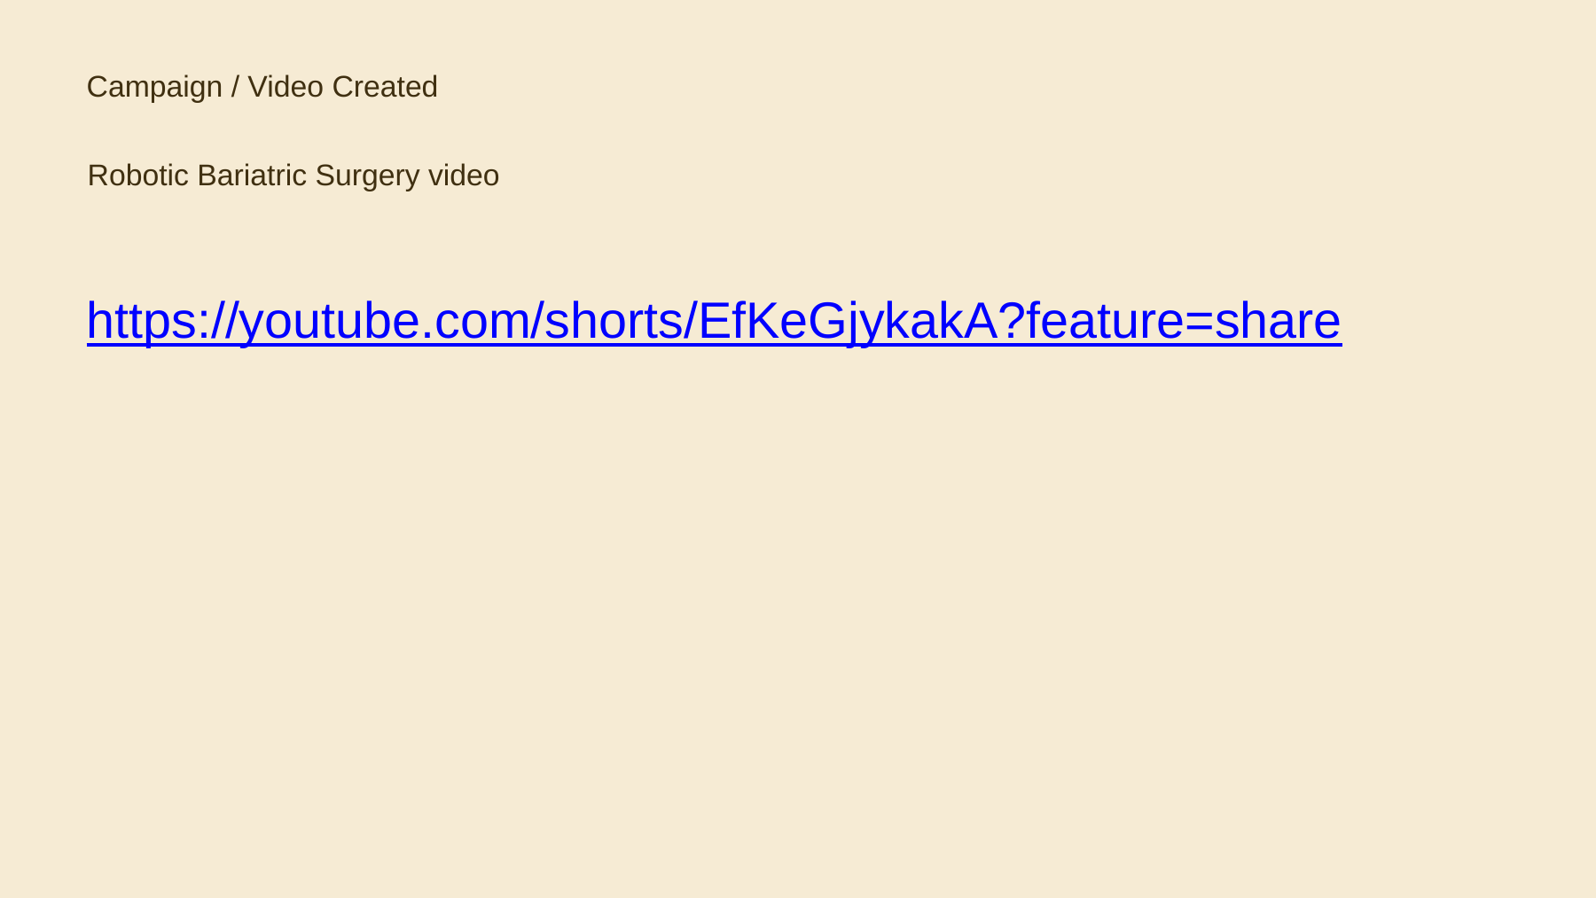
Figure B1. Campaign/video created during the internship.

Appendix C – Competitor Analysis Evidence
Selected presentation evidence of the competitor-analysis activity.
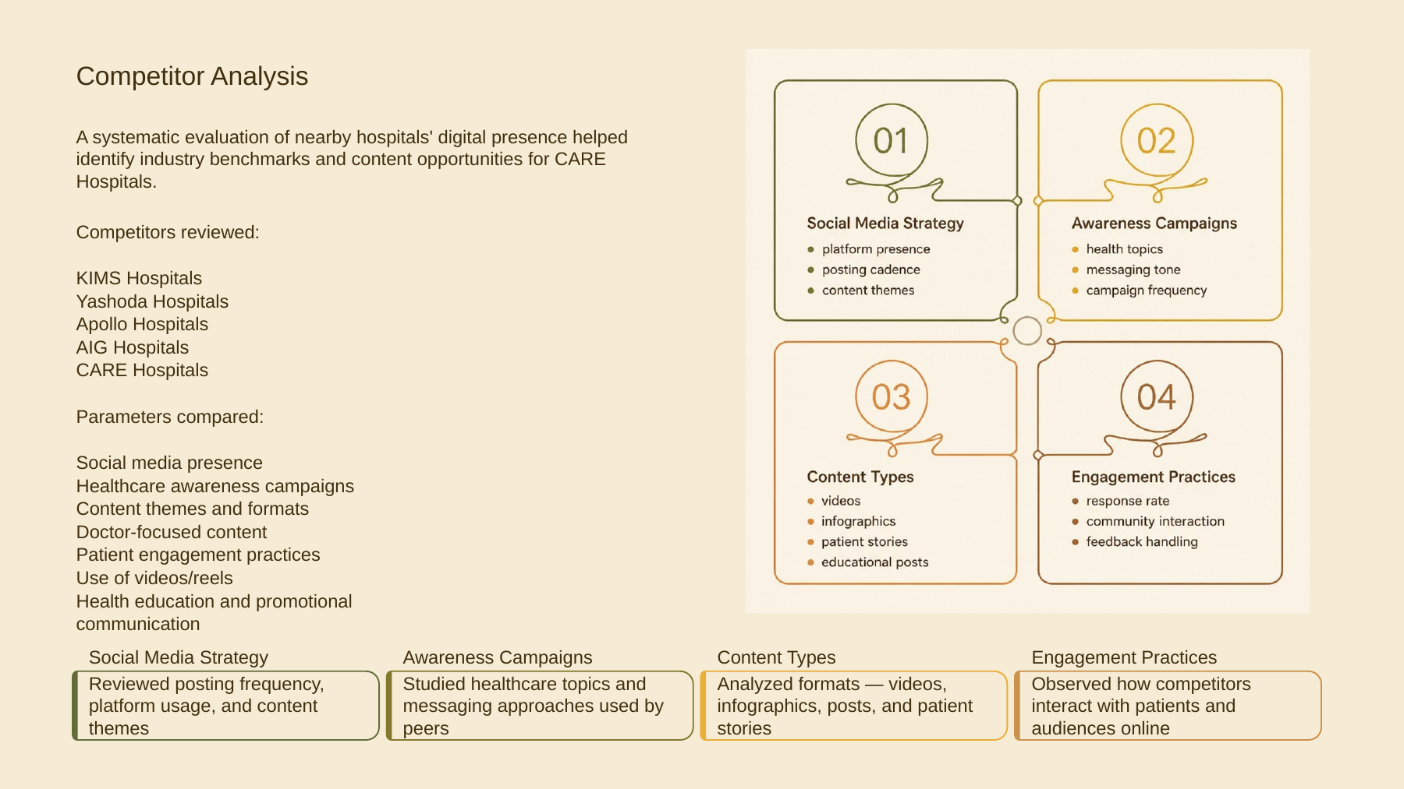
Figure C1. Competitor analysis presented during the internship.

Appendix D – Internship Presentation Evidence
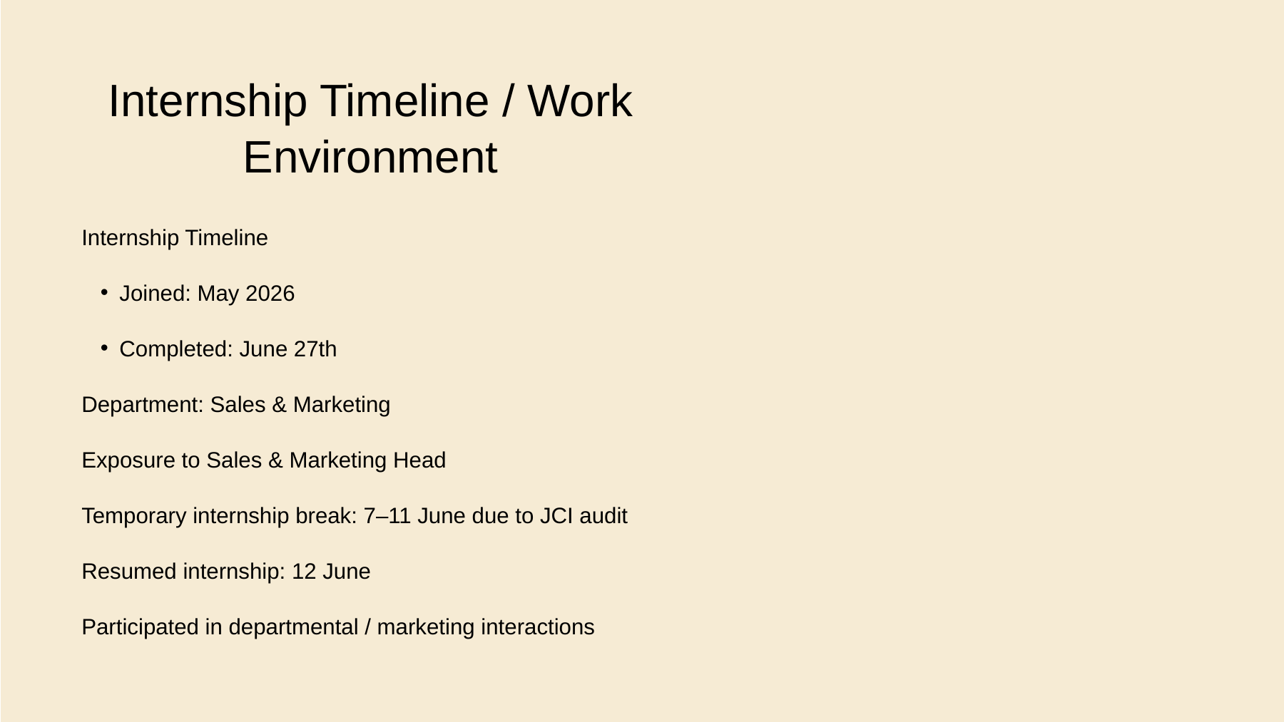
Figure D1. Internship timeline and work environment.
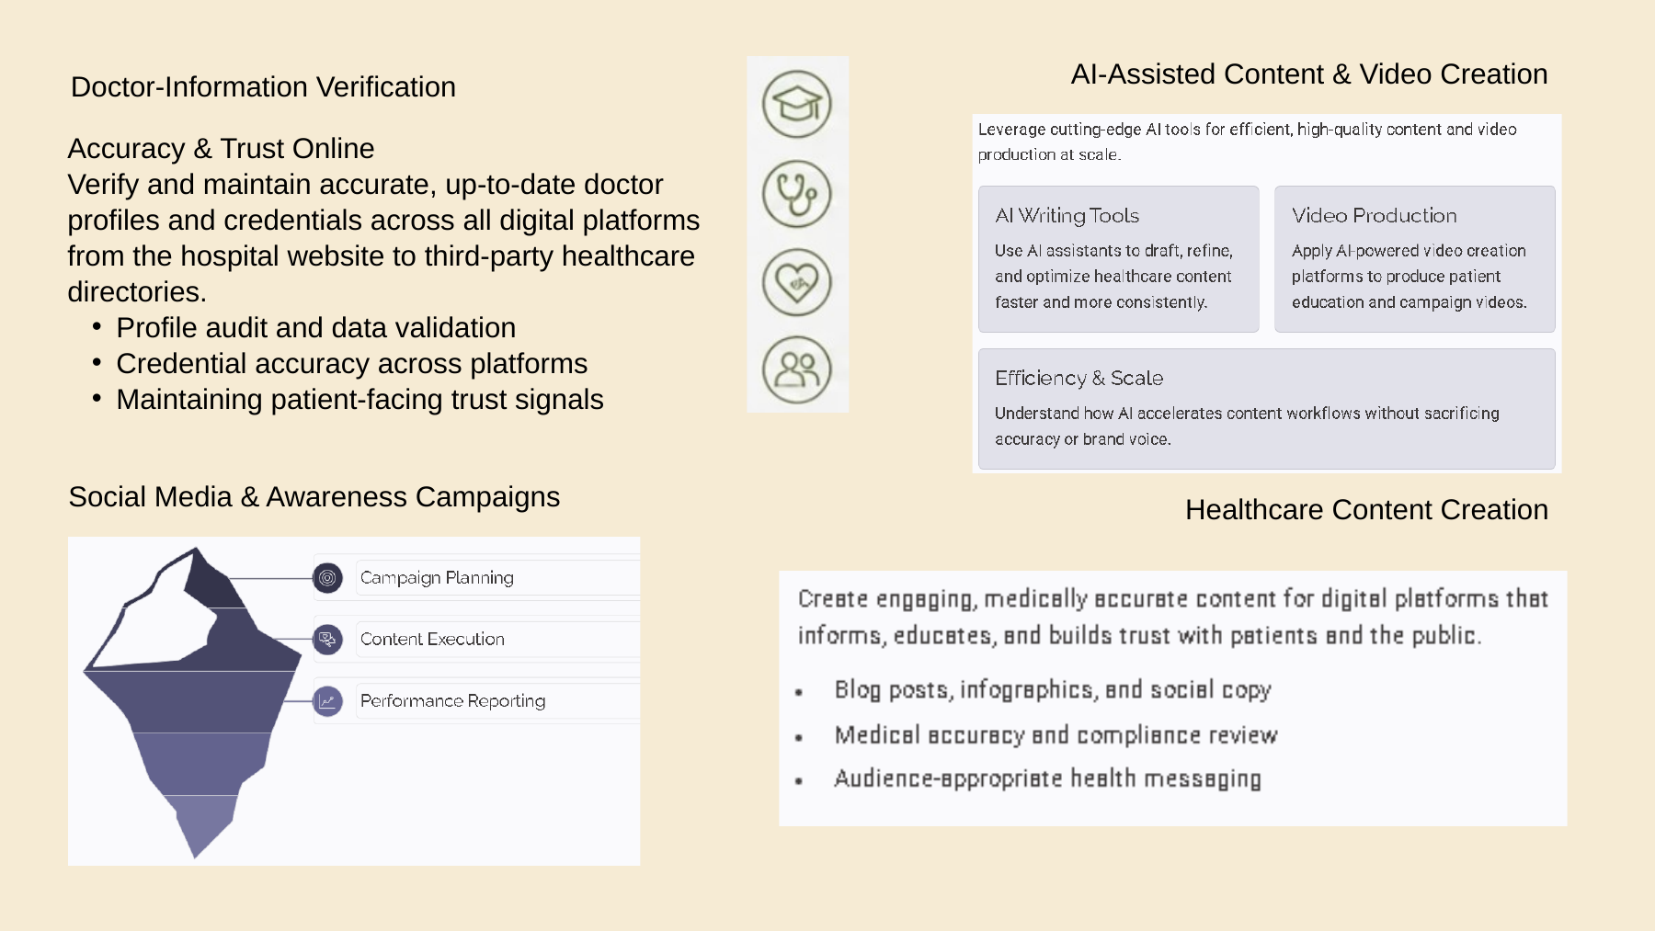
Figure D2. Doctor-information verification and AI-assisted content creation.
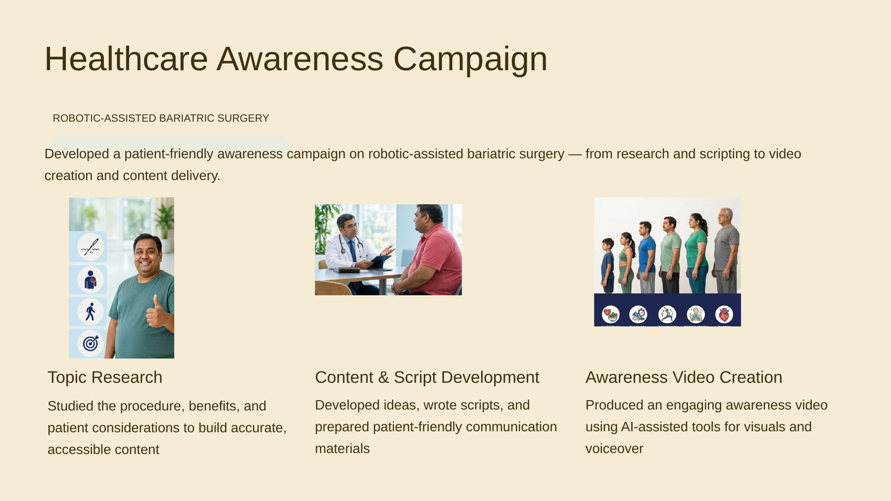
Figure D3. Robotic-assisted bariatric surgery awareness campaign.
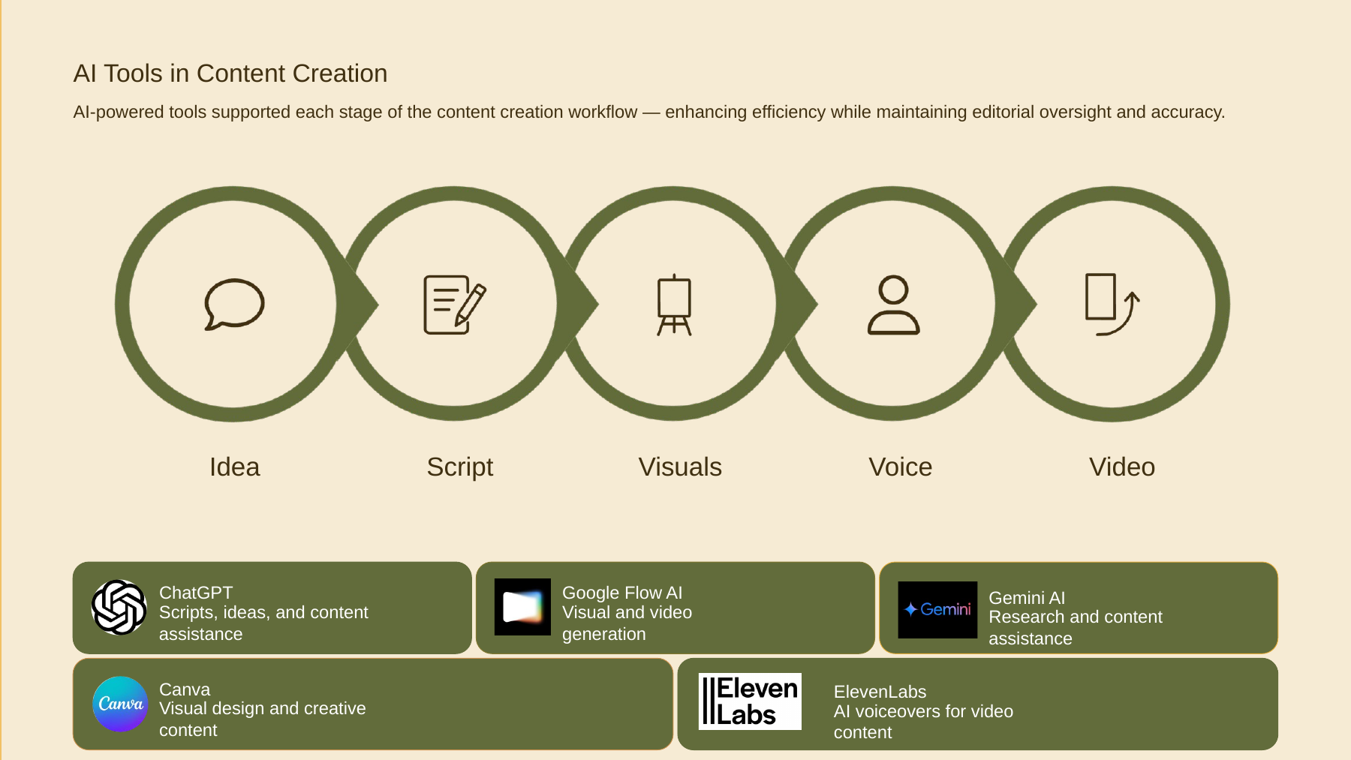
Figure D4. AI-powered tools used in the content creation workflow.

Appendix E – Weekly Internship Record
The detailed weekly internship record is provided in Section 13. The internship covered 36 working days, with activities paused from 7 June to 11 June 2026 for the JCI audit.

