**Stock Chart Marketing**

**MileStone1**

**Name: Gnaneshwari V**

**EmployeeId: 765514**

**Login Page:**

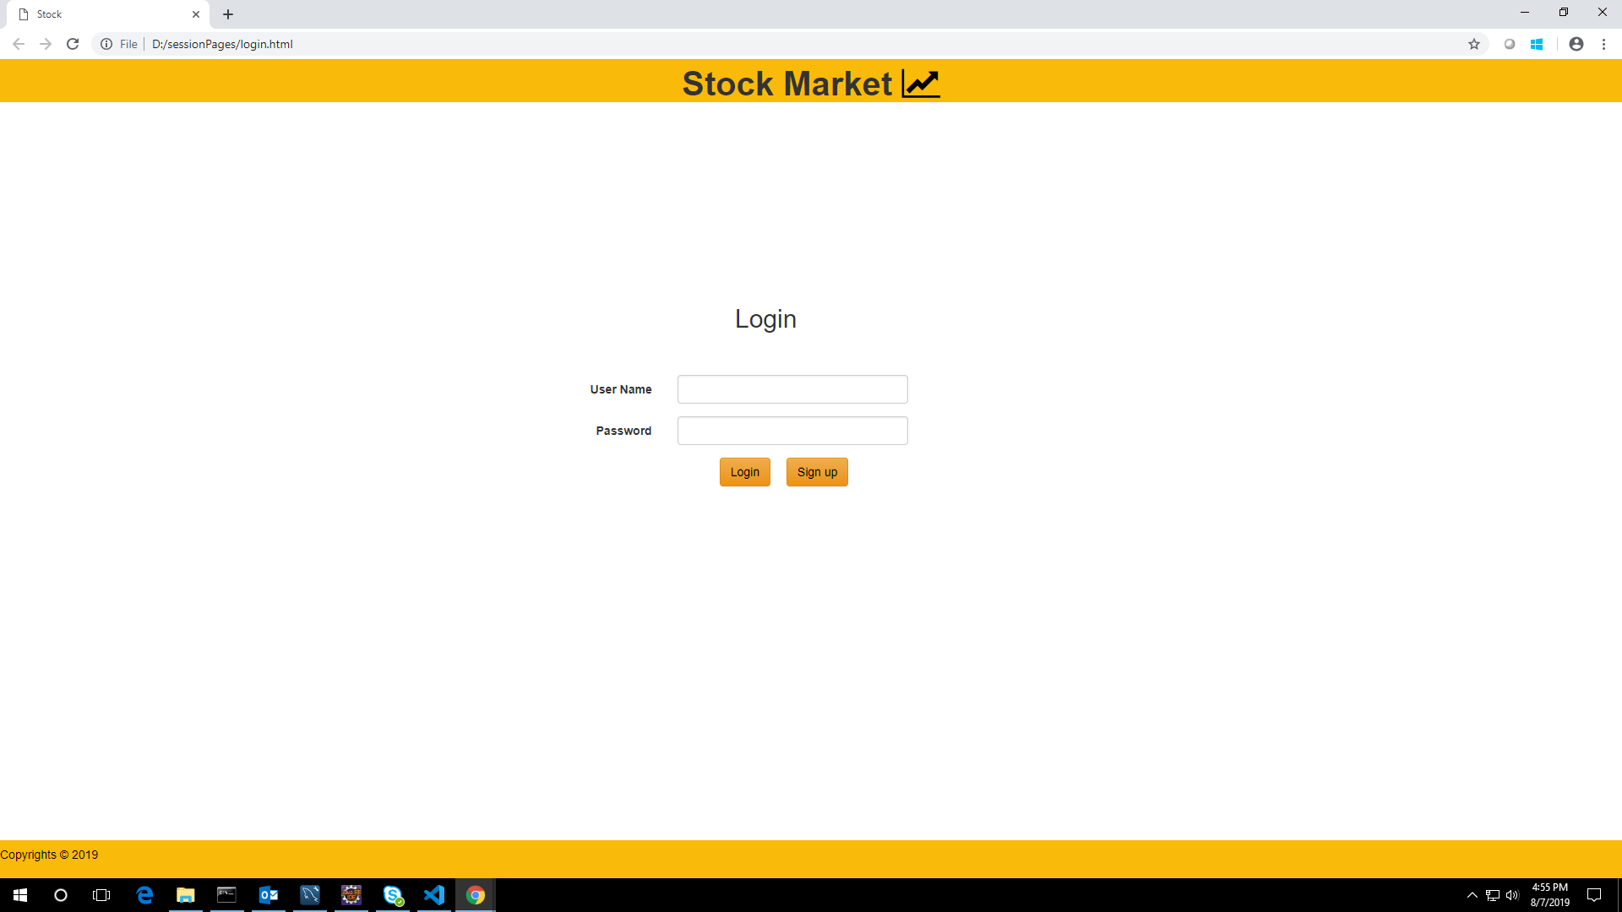

**SignUp Page:**

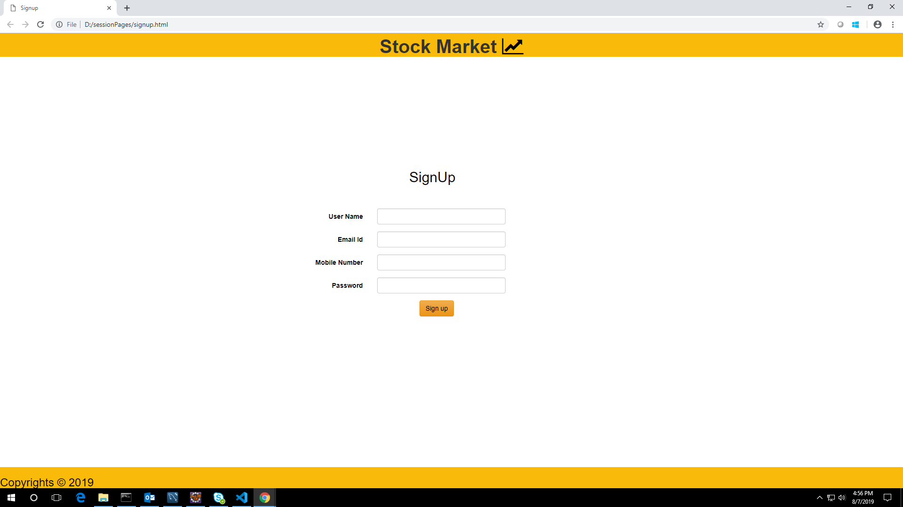

**AdminLandingPage:**

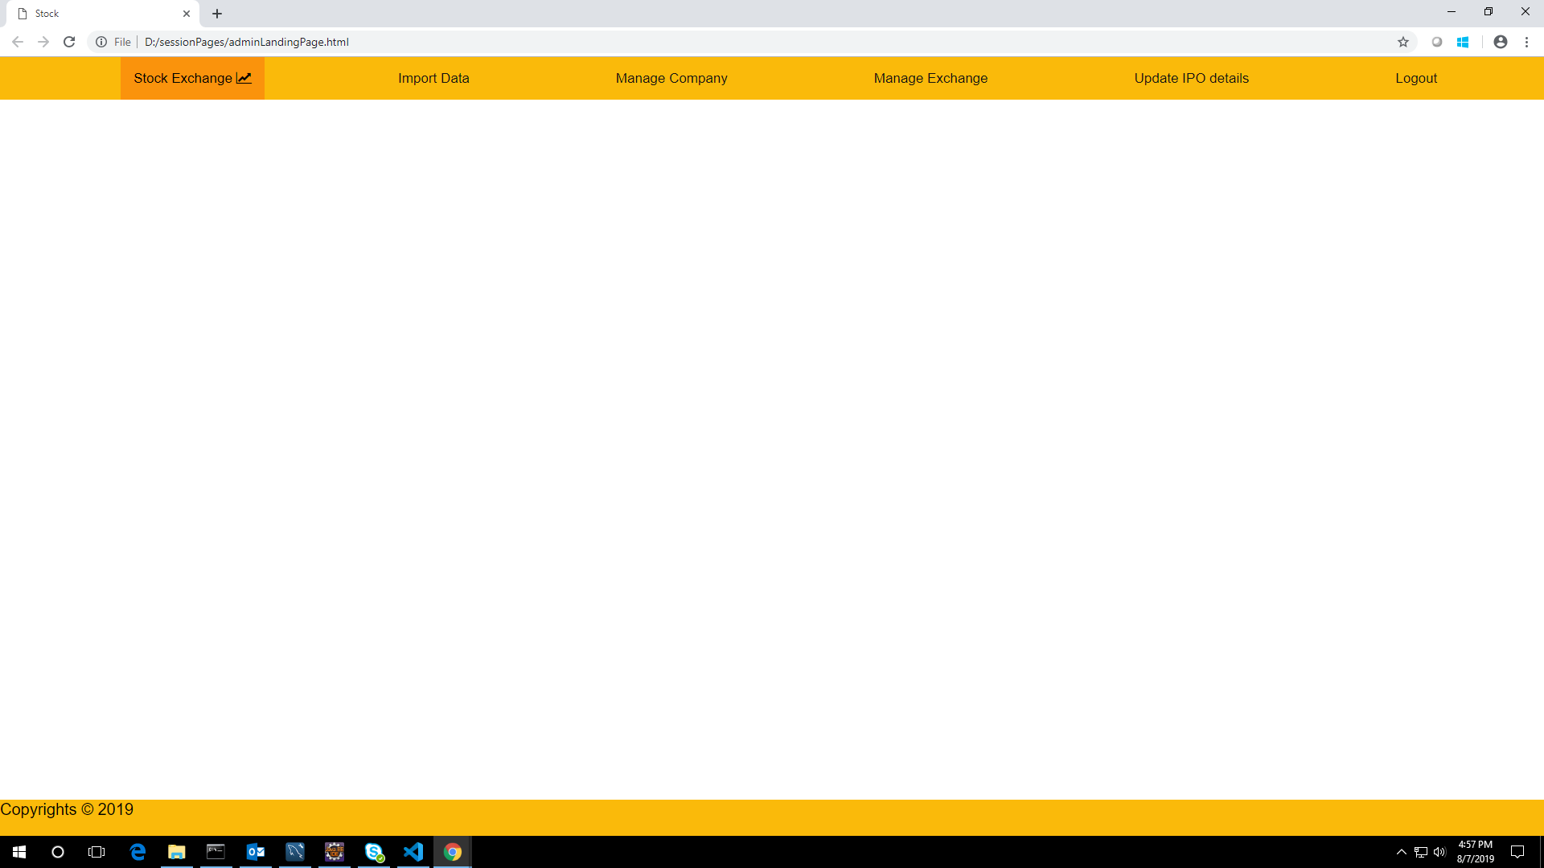

**AddNewCompany:**

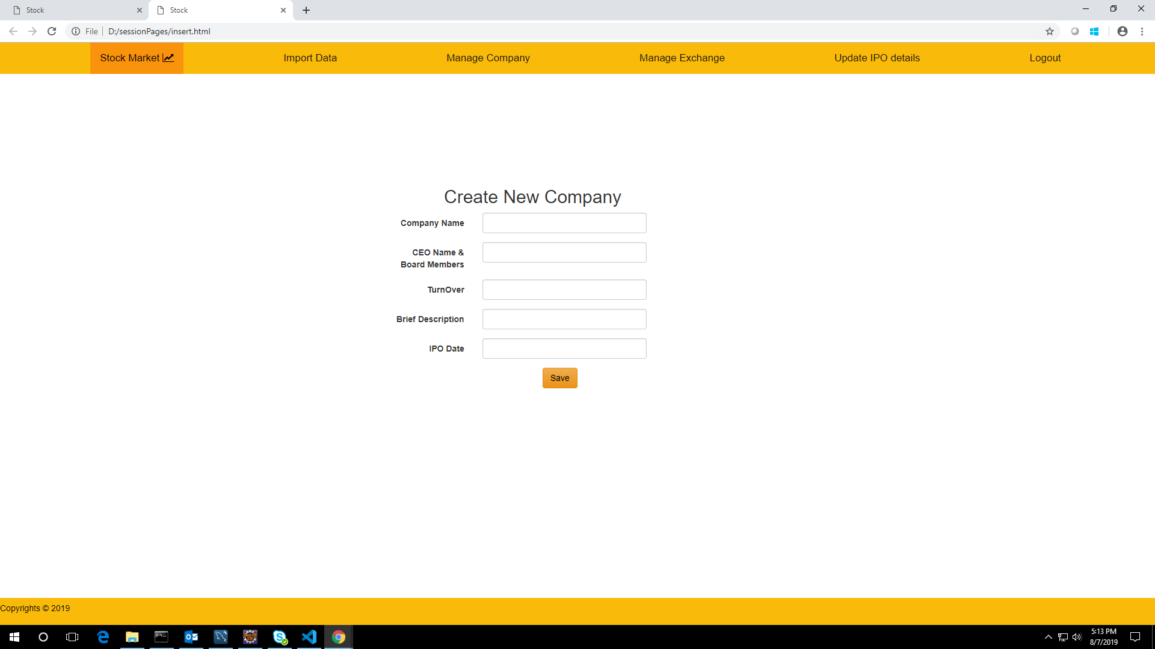

**CompanyList:**

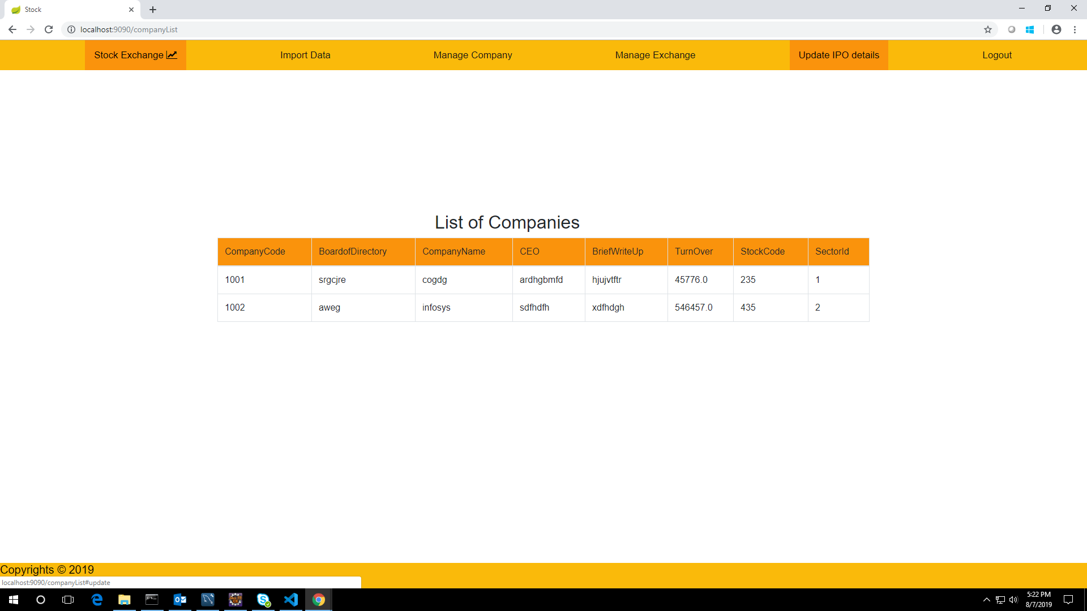

**ComparisionChart:**

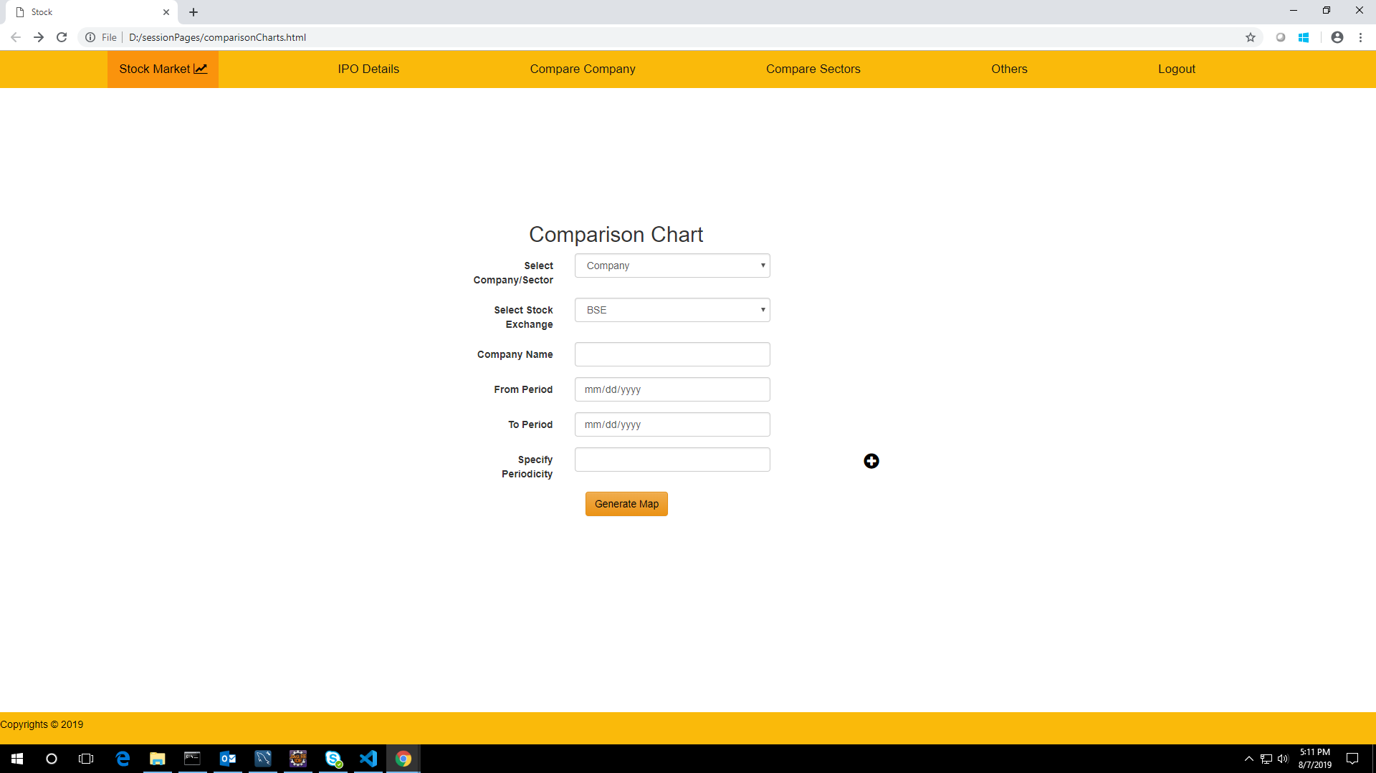

**UserLandingPage;**

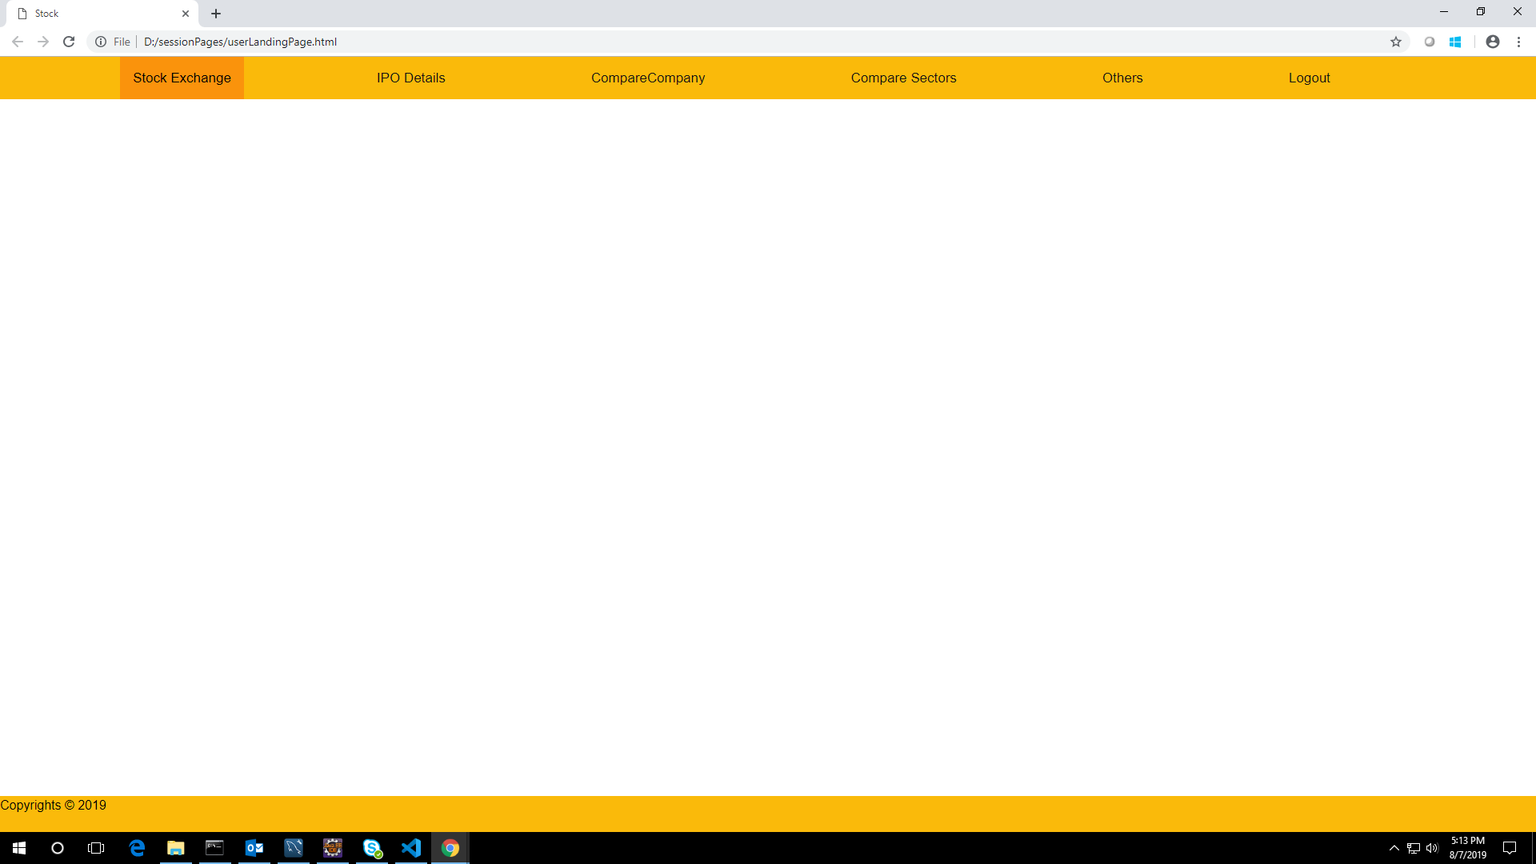

**ImportStock:**

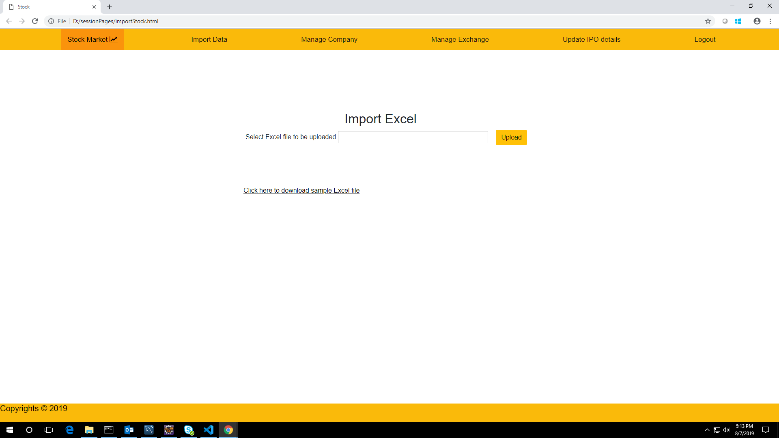

**Summary:**

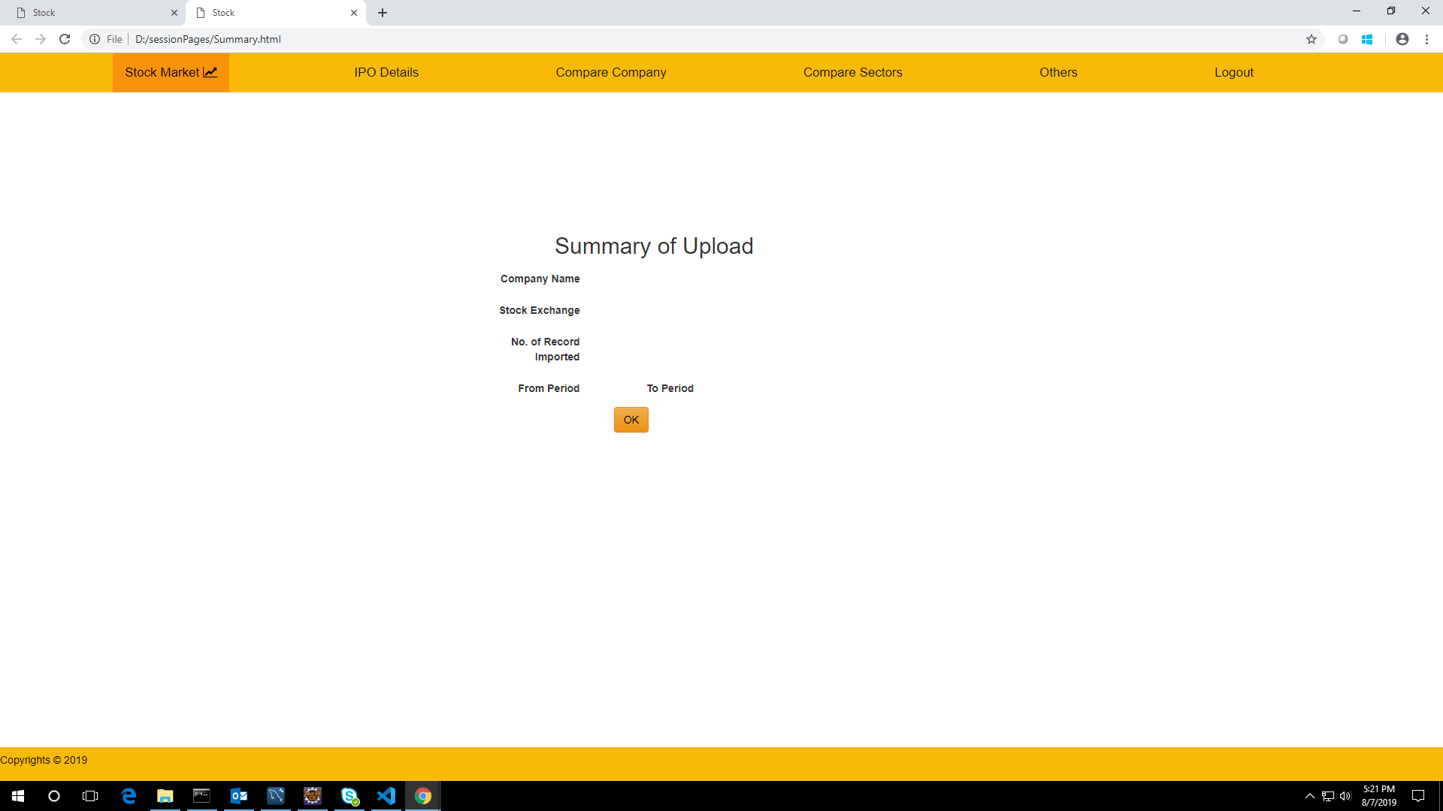

**GitHub Link:**

[**https://github.com/gnaneshwarivenkatesan/MileStone1**](https://github.com/gnaneshwarivenkatesan/MileStone1)

**SchemaDiagram:**

