**Stock Market Charting**

**MileStone 2**

**Gnaneshwari V (765514)**

**GitHubLink:**

[**https://github.com/gnaneshwarivenkatesan/MileStone2**](https://github.com/gnaneshwarivenkatesan/MileStone2)

**AddCompanyPage:**

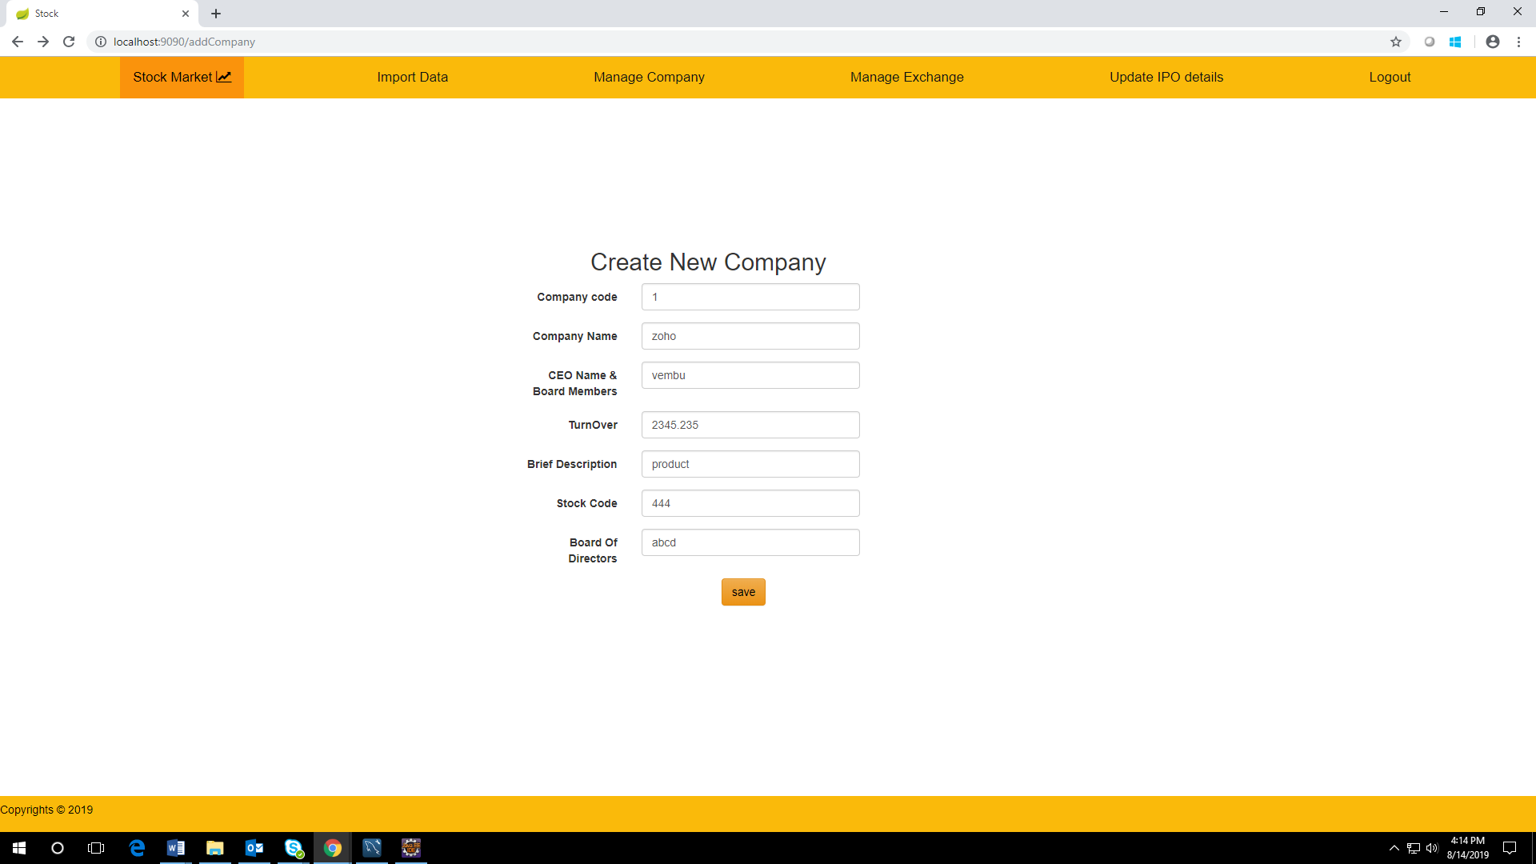

**CompanyListPage:**

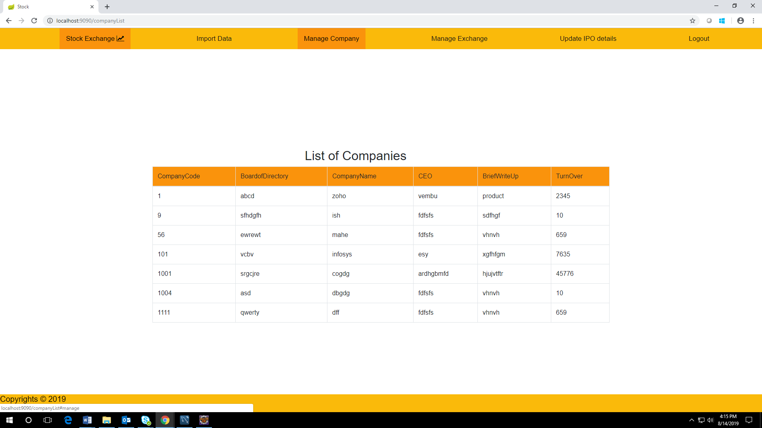

**AddStockExchangePage:**

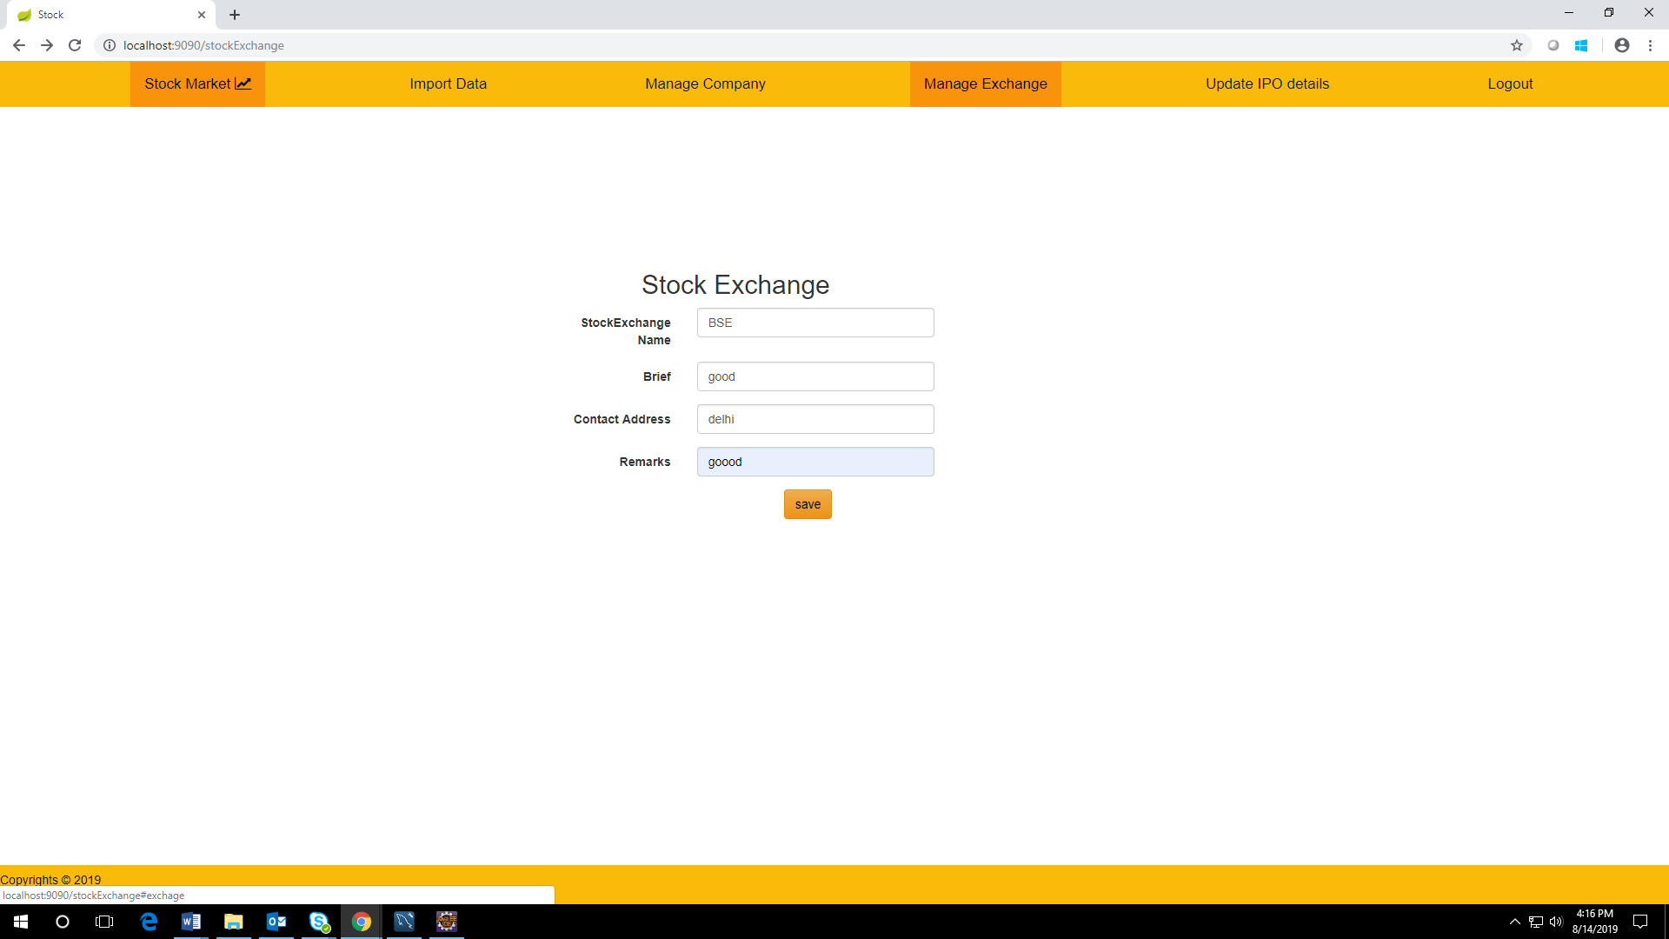

**StockExchangeList:**

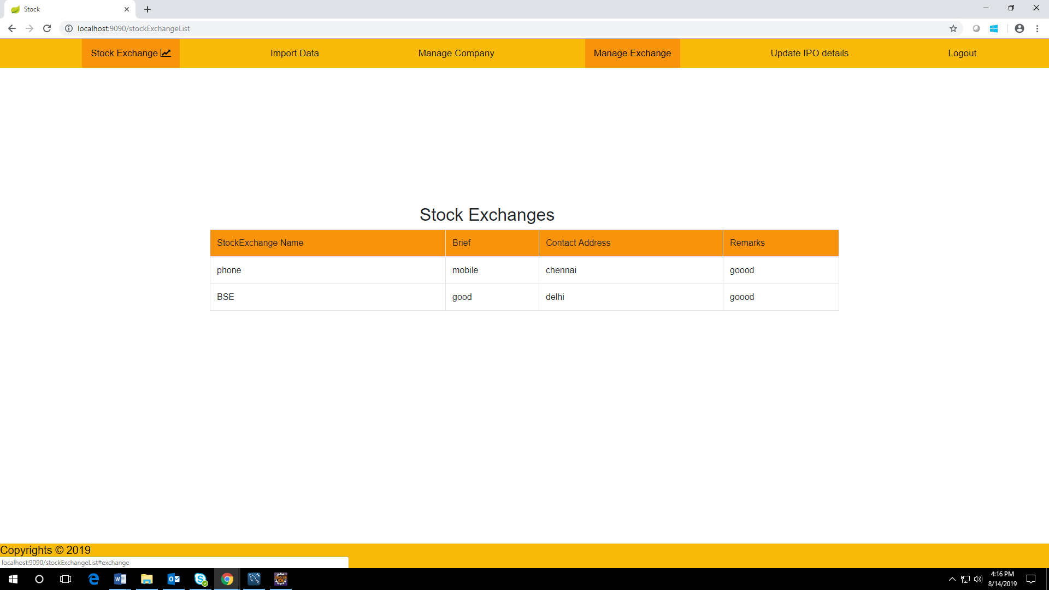

**IPODetailsPage:**

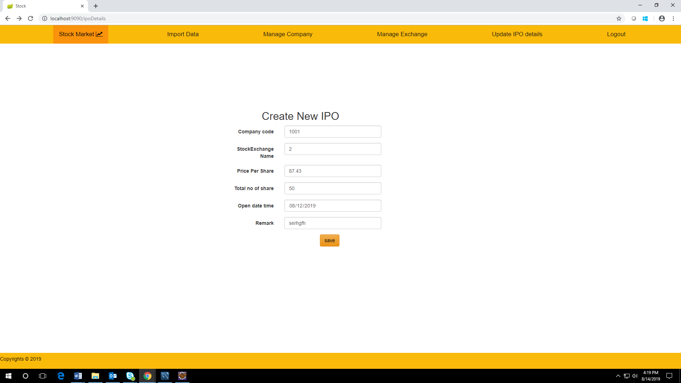

**IpoListPage:**

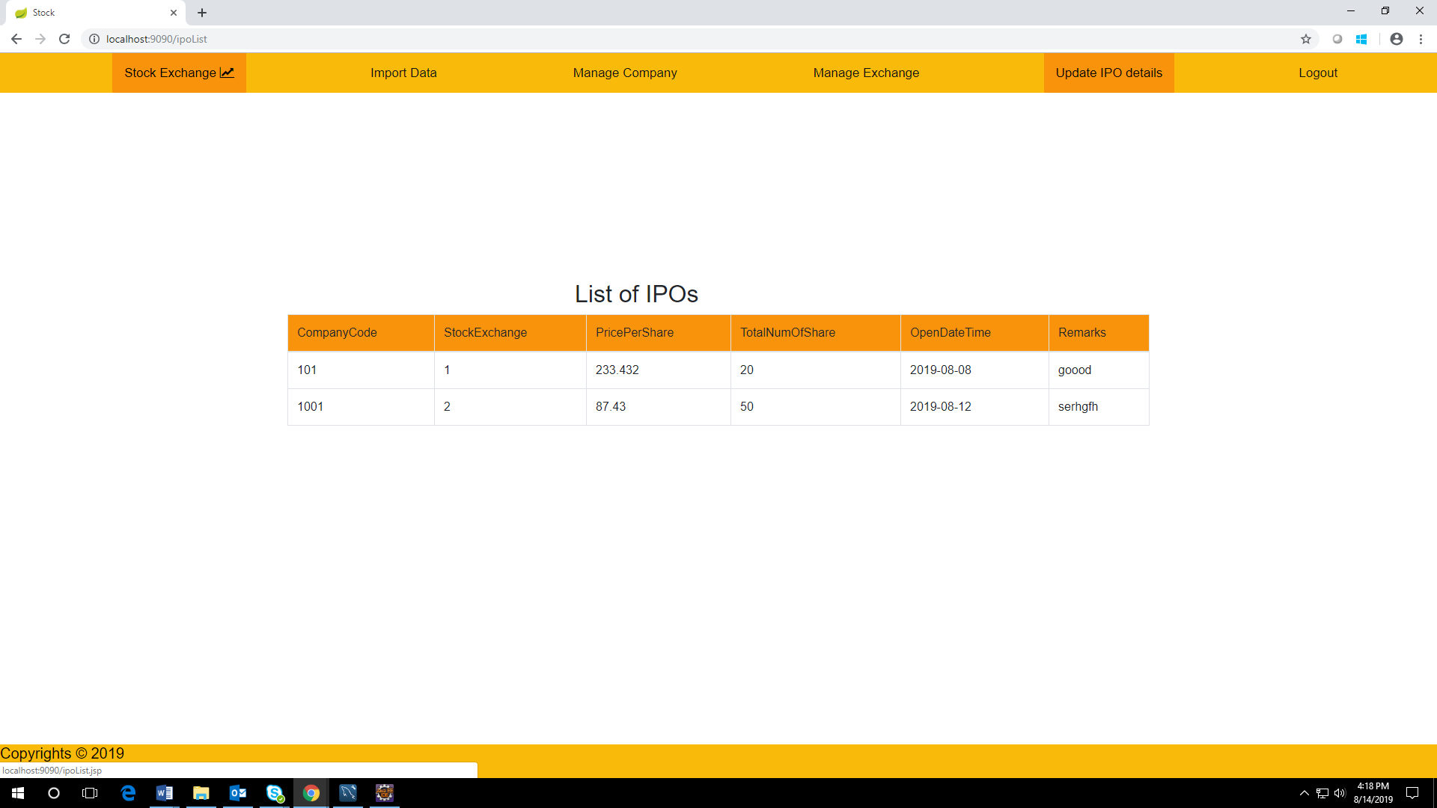

**SignUpPage:**

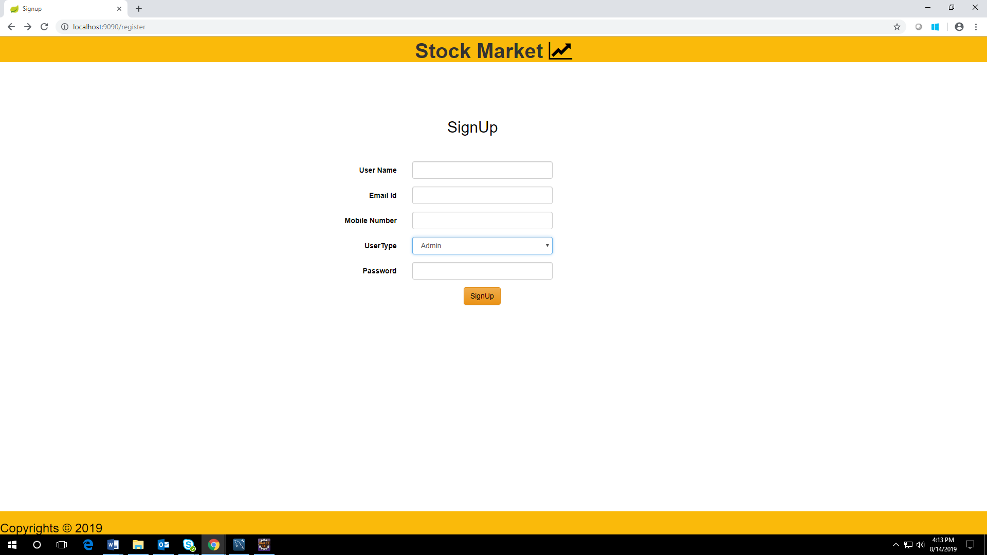

**LoginPage:**

