REVIEW-INFORMED SKINCARE
PRODUCT DISCOVERY
Using NLP and Data Analytics
Week 2: Data Sourcing Strategy & Initial Exploratory Analysis
Prepared by: Muppur Gnaneswar
Data Science with Python Analyst Internship
YuvaIntern
03 November 2026

1. Executive Summary
This Week 2 work continues the Week 1 problem definition: exploring customer feedback in beauty and skincare reviews using review text, star ratings, and product information. The selected working source is the publicly hosted Amazon Beauty Reviews CSV available through Hugging Face. A 10,000-row sample was loaded into a dedicated Python 3.12 Conda environment and inspected in JupyterLab using Pandas, NumPy, and Matplotlib.
The initial sample contains 10,000 records and 10 columns. The mean rating is 4.1183, the median and mode are both 5, and 58.96% of records have a 5-star rating. Initial quality checks found one missing title, one missing review text, and 13 exact duplicate rows. Review length averaged 297.16 characters, with a median of 162.5 characters. These are descriptive results for the loaded sample only; they should not be generalized to the full dataset or market.

2. Project Context and Week 2 Objectives
The project aims to organize customer ratings and written reviews into useful descriptive summaries of feedback. Week 1 established research questions about recurring review topics, differences between product categories, differences between lower- and higher-rated reviews, the usefulness of simple sentiment methods, and potential business follow-up questions.
- Identify and compare potential data sources relevant to beauty and skincare review analysis.
- Document the selected source, access route, available fields, and limitations that need verification.
- Load a manageable sample and inspect its structure, completeness, rating distribution, and review text.
- Plan exploratory statistics and visualizations that can support the Week 1 research questions and hypotheses.
- Record likely cleaning and preprocessing requirements without presenting planned work as completed.

3. Data Source Identification and Selection

3.1 Selected working dataset
Dataset name: Amazon Beauty Reviews dataset (CSV hosted on Hugging Face).
Loading route used in the notebook:
dataset_path = "hf://datasets/jhan21/amazon-beauty-reviews-dataset/amazon_beauty_reviews_dataset.csv"
df_raw = pd.read_csv(dataset_path, nrows=10000)
The notebook loads the first 10,000 records for initial exploration. The source is a beauty-review dataset, not a verified skincare-only dataset. The sample itself includes examples that appear outside the intended skincare scope (for example, a review mentioning cat treats and another mentioning acrylic-paint use). Therefore, the dataset must be checked and filtered using product metadata before making skincare-category claims.
Source page: https://huggingface.co/datasets/jhan21/amazon-beauty-reviews-dataset (The dataset page, data card, licence, terms, provenance, and exact field definitions should be reviewed and recorded before redistribution or any use beyond the permitted analysis.)

3.2 Candidate source comparison
Candidate source | Potential value | Limitations / checks
Hugging Face: jhan21/amazon-beauty-reviews-dataset (selected for initial work) | Direct CSV access through the Hugging Face data URI; includes ratings, titles, review text, product identifiers, and other review metadata in the inspected sample. | Confirm data card, licence, provenance, collection method, field definitions, and whether product metadata is sufficient to isolate skincare products.
Amazon Reviews’23 / McAuley Lab (All_Beauty) | Documented large-scale review resource with review text, ratings, and product-related metadata; a possible alternative or validation source. | Beauty category is broader than skincare; check exact files, access instructions, licence/terms, schema, and category coverage before selection.

The selected Hugging Face CSV is being used as the current working source because it could be loaded in the notebook. This technical accessibility does not, by itself, establish that the dataset is representative, fully skincare-relevant, or unrestricted for reuse.

4. Sample Structure and Available Fields
The inspected 10,000-row sample contains the following 10 fields:
Field | Observed type in Pandas | Initial analytical use
rating | int64 | Star-rating distribution and comparisons.
title | string | Short review heading; repeated title counts.
text | string | Written review content; review-length and future text analysis.
images | string | Image metadata/payload representation; needs source-specific interpretation.
asin | string | Product identifier.
parent_asin | string | Parent product identifier.
user_id | string | Reviewer identifier; avoid exposing or analyzing unnecessarily.
timestamp | string | Review timestamp; parse and validate before time analysis.
helpful_vote | int64 | Helpful-vote count, if relevant.
verified_purchase | bool | Purchase-verification indicator; not proof of review accuracy.

The inspected DataFrame has 10,000 rows and 10 columns. The source's full schema and definitions should be checked against the dataset documentation; the types above are the types observed in this sample, not a substitute for the official data dictionary.

5. Initial Exploratory Data Analysis: Actual Sample Results

5.1 Rating distribution
Star rating | Review count | Percentage
1 star | 858 | 8.58%
2 stars | 581 | 5.81%
3 stars | 977 | 9.77%
4 stars | 1,688 | 16.88%
5 stars | 5,896 | 58.96%
Total | 10,000 | 100.00%

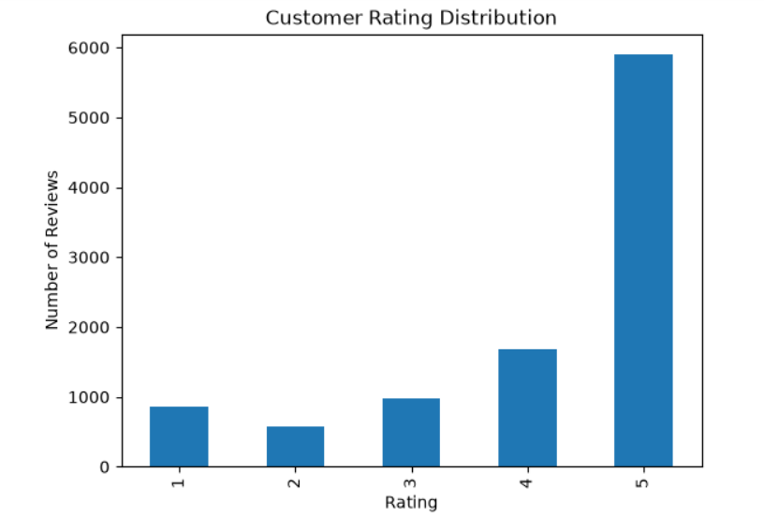
Figure 1: Customer Rating Distribution of the 10,000 Amazon Beauty Reviews Sample
Observation: 5-star reviews form the largest rating group (58.96%) in this sample. The combined share of 4-star and 5-star reviews is 75.84%. This describes the selected 10,000 rows only. It does not establish that all beauty or skincare customers are generally satisfied.

5.2 Summary statistics
Measure | Observed result | Interpretation
Mean rating | 4.1183 | Average star rating in the sample.
Median rating | 5.0 | Middle rating is 5 stars.
Mode rating | 5 | Most frequently occurring rating.

The mean is lower than the median because the distribution includes lower ratings while the most common value is 5. The mean, median, and mode summarize different aspects of the rating distribution and should be reported together.

5.3 Repeated titles and review text
The most frequent titles included “Five Stars” (528), “Four Stars” (113), “Three Stars” (57), “One Star” (53), and “Great” (43). The most frequent exact review texts included “Love it” (17), “Great product” (13), “Great” (13), “Perfect” (10), and “Nice” (9). Exact text frequency does not identify all semantically similar reviews; different wording may express the same theme.

5.4 Data quality checks
Check | Observed result | Initial interpretation / action
Missing rating | 0 | No missing rating values in this sample.
Missing title | 1 | Retain raw data; decide whether title is required for a given analysis.
Missing review text | 1 | Do not treat a missing text as a negative review; exclude only from text-specific analysis or handle explicitly.
Exact duplicate rows | 13 | Inspect duplicate records and identifiers before deciding whether to remove them.
Review length | Mean 297.16 characters; median 162.5; min 0; max 10,205 | Review lengths vary widely. Investigate empty and unusually long entries; character count is not a measure of review quality.

The duplicate check used exact row matching across all columns. Two different customers may write identical review text, so duplicate review text alone should not be used as a deletion rule. The 13 exact duplicate rows should be inspected against identifiers and source semantics before removal.

6. Exploratory Analysis Plan and Link to Week 1 Hypotheses
Week 1 question / hypothesis | Planned analysis | Current status
RQ1: Common review themes | Token/phrase frequency and manual review of representative comments; later use count-based features or TF-IDF if appropriate. | Not yet performed; exact repeated text counts are an initial descriptive step only.
H1: Themes differ by skincare category | First identify valid skincare products and assign categories; compare theme counts and proportions with category sample sizes. | Pending product metadata validation and skincare filtering.
H2: Lower- and higher-rated reviews differ | Define rating bands before analysis; compare common terms/themes and report group sizes. | Rating distribution is complete; text comparison is pending.
H3: Simple sentiment may disagree with manual interpretation | If sentiment analysis is used, manually label a documented sample and compare predictions with human labels. | Not yet performed.
H4: Ratings plus review text provide richer summaries | Compare rating-only summaries with summaries that include recurring review themes and examples. | Initial rating statistics completed; review-theme summary pending.

The current notebook provides baseline descriptive statistics. It does not yet test H1–H4. Category comparisons and theme-based conclusions must wait until product relevance and category labels are validated.

7. Planned Visualizations
- Bar chart of review counts by star rating (created in the notebook).
- Rating percentages chart to show the relative distribution of ratings.
- Review-length distribution, with attention to extreme values and the long tail.
- After skincare filtering: review counts by product category and rating distribution within each category.
- After theme extraction: frequency plots for selected terms or themes, with representative review examples.

8. Data Cleaning and Preprocessing Requirements
- Preserve an unchanged raw DataFrame and perform changes on a separate working copy.
- Inspect missing title and text values; retain missingness information and handle them according to the analysis being performed.
- Investigate the 13 exact duplicate rows using product/review identifiers and source documentation before removal.
- Validate rating values and confirm that the expected range is 1–5.
- Parse timestamp from string to a proper datetime type only after checking its format, timezone convention, and invalid values.
- Check product identifiers and product metadata to identify skincare-relevant products; do not assume every beauty record is skincare.
- For text analysis, preserve the original review text and create a separate processed-text field; standardize case and whitespace carefully.
- Do not remove negation terms such as “not” during text preprocessing because they can reverse the meaning of a review.
- Review empty, extremely short, and unusually long reviews; document any filtering thresholds before applying them.

9. Risks, Limitations, and Mitigations
Risk / limitation | Why it matters | Mitigation
Beauty dataset may include non-skincare products | The project focuses on skincare categories; unrelated products can distort results. | Validate product titles/metadata and document a reproducible skincare inclusion rule.
Sample limited to first 10,000 rows | The sample may not represent the full dataset or all time periods/products. | Describe it as an initial sample; later consider a justified sampling method or broader data extraction.
Self-selection and rating bias | People who post reviews may differ from customers who do not. | Avoid treating review percentages as population-wide customer satisfaction.
Review text can be short, mixed, sarcastic, or ambiguous | Simple word counts and sentiment tools may misinterpret context. | Inspect representative examples and manually validate a sample.
Privacy and identifiers | User identifiers are not necessary for the initial research question. | Avoid publishing user IDs or unnecessary personal information; use only fields needed for analysis.
Dataset licence and provenance not yet verified in this analysis | Public accessibility does not automatically mean unrestricted reuse. | Review the dataset card, source documentation, licence, and terms before redistribution or external publication.

10. Reproducibility and Tools
The analysis was performed in JupyterLab using a dedicated Conda environment named skincare-ds. The notebook confirmed the active interpreter path as C:\Users\muppu\anaconda3\envs\skincare-ds\python.exe. The reported versions were Pandas 3.0.6 and NumPy 2.5.4. The workflow uses Python, Pandas, NumPy, and Matplotlib; the notebook also imports Seaborn and Hugging Face support packages.
The notebook is the reproducible companion to this report. It contains the dataset-loading step, sample inspection, rating summaries, missing-value and duplicate checks, review-length calculation, and a rating-distribution chart. The output values in this report correspond to the 10,000-row notebook sample.

11. Conclusion and Next Steps
Week 2 established a working data source and completed an initial descriptive inspection of 10,000 review records. The sample has a high share of 5-star ratings, a mean rating of 4.1183, one missing title, one missing review text, and 13 exact duplicate rows. Review length varies substantially. These findings provide a concrete starting point for data-quality review and further exploration.
The most important next step is to validate which records genuinely relate to skincare. After that, the project can compare categories and rating bands, explore review themes, and decide whether a simple sentiment method is useful. No claim is made at this stage that the hypotheses have been confirmed.

12. References
- Hugging Face dataset page: https://huggingface.co/datasets/jhan21/amazon-beauty-reviews-dataset
- Amazon Reviews’23 / McAuley Lab dataset documentation: https://amazon-reviews-2023.github.io/main.html
- Pandas documentation: https://pandas.pydata.org/docs/
- NumPy documentation: https://numpy.org/doc/
- Matplotlib documentation: https://matplotlib.org/stable/

