REVIEW-INFORMED SKINCARE
PRODUCT DISCOVERY
Using NLP and Data Analytics
Week 3: Data Cleaning and Preprocessing Pipeline Development
Prepared by: Muppur Gnaneswar
Data Science with Python Analyst Internship
YuvaIntern
10 November 2026

1. Executive Summary
This Week 3 work develops a reproducible data cleaning and preprocessing pipeline for the Review-Informed Skincare Product Discovery project. It continues the Week 2 analysis using the Amazon Beauty Reviews CSV hosted on Hugging Face. The notebook loads the first 10,000 records, preserves an unchanged raw copy, profiles the data, applies field-specific cleaning decisions, creates analysis-ready subsets, and exports a quality audit and cleaning log.
The selected source is a broad All Beauty review dataset, not a verified skincare-only dataset. The Week 2 sample included records that appear outside the intended skincare scope. Therefore, this submission demonstrates cleaning of the available beauty-review sample; product metadata validation and skincare filtering remain necessary before skincare-specific analysis.
The pipeline deliberately avoids automatic deletion based only on missingness or review length. Missing titles are handled differently from missing review bodies; invalid ratings and timestamps are flagged; duplicates are checked using appropriate identifiers; and long reviews are flagged for inspection rather than discarded. The notebook records actions and rationale to support reproducibility.

2. Project Context and Week 3 Objectives
The project aims to use customer ratings, review text, and product information to identify useful patterns in beauty and skincare feedback. Week 2 established a working data source and initial descriptive results. Week 3 focuses on preparing reliable data for later exploratory analysis and NLP.
- Preserve the raw dataset and create a separate working copy for cleaning.
- Identify missing values, duplicates, invalid ratings, timestamp problems, inconsistent fields, and unusual review lengths.
- Apply appropriate cleaning methods with clear explanations and reasons for each decision.
- Create cleaned master and analysis-specific datasets without unnecessary record loss.
- Use Python libraries such as Pandas, NumPy, regular expressions, and Matplotlib appropriately.
- Document the full workflow with a step-by-step pipeline, flowchart, quality audit, and cleaning log.

3. Data Source and Working Sample

3.1 Selected dataset
Dataset: Amazon Beauty Reviews dataset (CSV hosted on Hugging Face).
Source page: https://huggingface.co/datasets/jhan21/amazon-beauty-reviews-dataset
Loading route used in the notebook:
dataset_path = "hf://datasets/jhan21/amazon-beauty-reviews-dataset/amazon_beauty_reviews_dataset.csv"
df_raw = pd.read_csv(dataset_path, nrows=10000)
The first 10,000 rows are used as a practical working sample and to maintain continuity with Week 2. The source page describes a much larger dataset, but the results in this report must be interpreted as sample-level results only.

3.2 Fields and expected analytical use
Field | Purpose | Cleaning / validation
rating | Customer star score | Numeric conversion; validate range 1–5; flag invalid values
title | Review headline | Trim whitespace; fill missing title with empty string
text | Review body | Identify blank text; normalize conservatively
images | Review image metadata | Retain unless image analysis is required
asin / parent_asin | Product identifiers | Preserve as strings; inspect missingness and distinct values
user_id | Reviewer identifier | Avoid unnecessary exposure; not a unique review ID
timestamp | Review time | Parse to UTC datetime; flag conversion failures
helpful_vote | Helpfulness count | Inspect type, range, missingness and distribution
verified_purchase | Purchase indicator | Inspect categories; do not infer review accuracy

3.3 Dataset suitability and limitations
The source is technically accessible and contains review text, ratings, and product identifiers. However, accessibility does not prove representativeness or skincare relevance. Product metadata must be used to establish a reproducible skincare inclusion rule. Public availability also does not automatically grant unrestricted redistribution rights; the dataset card, provenance, licence, and terms should be checked before sharing data.

4. Tools and Why They Are Used
Tool / library | Use in this pipeline | Why suitable
Pandas | Load, inspect, clean, validate, filter and export tabular data | Provides DataFrame operations for reproducible data preparation
NumPy | Boolean masks and numeric checks | Supports efficient conditional operations and missing-value handling
Regular expressions (re) | Remove HTML tags and normalize whitespace | Useful for controlled text normalization
Matplotlib | Rating and review-length diagnostic plots | Makes imbalance and extreme values easier to inspect
JupyterLab | Run code with explanations and outputs | Keeps code, decisions, results and documentation together

5. Step-by-Step Data Cleaning and Preprocessing

5.1 Load and preserve raw data
Read the first 10,000 rows and store them in df_raw. Create a deep working copy called df. The raw data is never overwritten, allowing before-and-after comparisons.

5.2 Initial profiling
Inspect shape, column names, data types, missing-value counts, duplicate rows and descriptive statistics. Profiling identifies actual issues before cleaning decisions are made.

5.3 Standardize column names
Convert column names to lowercase snake_case. This makes field references consistent and reduces errors caused by spaces or capitalization.

5.4 Handle missing values
Trim title and text fields and identify whitespace-only values. Fill a missing title with an empty string because the review body may still be useful. Keep missing review bodies in the master dataset but exclude them from NLP-specific analysis. Do not invent ratings or identifiers.

5.5 Detect and handle duplicates
Check exact duplicate rows and stable review identifiers separately. The loaded source schema does not contain a review_id field, so review-ID deduplication could not be performed. The user_id field identifies a reviewer, not an individual review, and was not used as a deduplication key. Thirteen exact duplicate rows were removed.

5.6 Validate ratings
Convert rating to numeric and check that it is between 1 and 5. Missing, non-numeric, or out-of-range ratings are flagged. They are excluded from rating-dependent analysis rather than silently corrected.

5.7 Parse timestamps
Convert timestamp values to UTC datetime and flag unparseable values. Preserve the original timestamp field so the transformation can be checked.

5.8 Normalize review text
Create separate cleaned title and body fields. Remove HTML tags and normalize repeated whitespace. Preserve punctuation, numbers, negation words such as “not”, and non-English characters at this stage because they may carry sentiment or product meaning.

5.9 Review length and low-information checks
Calculate word and character counts. Flag very short reviews and IQR-based length outliers. Do not automatically remove long reviews because they may contain detailed product feedback.

5.10 Inspect inconsistent and constant fields
Inspect distinct values for fields such as verified_purchase, ASIN, and parent ASIN. A constant field may reflect the sample or source limitations; document it before deciding whether it should be excluded.

5.11 Create analysis-ready subsets
Retain a cleaned master dataset. Create an NLP-ready subset containing non-empty review text and a valid-rating text subset for rating-based comparisons. Keep the inclusion rules explicit.

5.12 Create audit and export outputs
Generate a raw-versus-cleaned quality audit and a cleaning log. Export the cleaned master, NLP subset, audit, and log as separate CSV files.

6. Data Quality Issues and Cleaning Decisions
Issue | How it is checked | Decision and rationale
Missing title | isna and blank-string checks | Fill with empty string; review body may still contain useful information
Missing review body | isna and blank-string checks | Retain in master; exclude from NLP subset because no text is available
Invalid rating | Numeric conversion and 1–5 range check | Flag and exclude from rating-dependent analysis; never fabricate a score
Duplicate rows | Exact row matching | Inspect and remove confirmed duplicate records only
Duplicate review ID | Stable review identifier check, if available | Do not substitute user_id for a review ID
Invalid timestamp | Datetime parsing with errors='coerce' | Flag failed conversions; retain original timestamp
Unusually long review | IQR rule on word count | Flag for inspection; do not automatically delete
Very short / empty text | Word count and empty-string checks | Flag low-information records and define analysis subset explicitly
Constant metadata | Distinct-value counts | Report as a possible source/sample limitation; do not assume it is erroneous

7. Overall Data Preprocessing Pipeline Flowchart
The following flowchart summarizes the order of operations. Each stage is implemented in the accompanying notebook, with a quality audit and cleaning log generated for reproducibility.
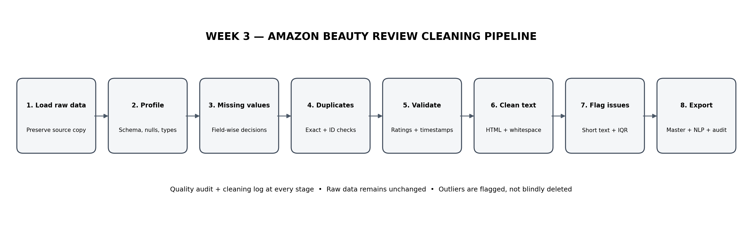
Figure 1: End-to-end Amazon Beauty review cleaning and preprocessing pipeline

8. Quality Audit and Evidence
The following results are taken from the executed notebook outputs and the exported quality-audit CSV for the 10,000-row working sample. The raw dataset contained 10,000 rows and 2 missing cells. Thirteen exact duplicate rows were removed, leaving 9,987 records in the cleaned master dataset. Missing titles were filled with empty strings. Two review-body fields remain empty after normalization; one record has an empty combined review text and is excluded from the NLP-ready subset. All ratings and timestamps passed the validation checks. The IQR rule flagged 728 review-length outliers, which were retained rather than automatically deleted.
Audit measure | Observed result | Interpretation
Raw row count | 10,000 | First 10,000 records loaded from the Hugging Face CSV.
Raw column count | 10 | Original fields available in the working sample.
Raw missing cells | 2 | Two missing cells were detected before cleaning.
Raw exact duplicate rows | 13 | Thirteen exact duplicate rows were identified.
Cleaned master row count | 9,987 | 13 exact duplicate rows were removed; remaining records retained.
Cleaned master column count | 21 | Includes cleaned fields and transparent quality flags.
Missing titles after handling | 0 | Missing titles were filled with empty strings.
Empty cleaned review bodies | 2 | Two review-body fields are empty after normalization.
Invalid or missing ratings | 0 | All retained ratings passed numeric and 1–5 range checks.
Invalid timestamps | 0 | All timestamps were successfully parsed.
Empty combined review text | 1 | One record had no usable combined title/body text and was excluded from NLP-ready data.
Review-length outliers flagged | 728 | IQR method flagged 728 records; they were retained for inspection.
NLP-ready rows | 9,986 | Rows with non-empty combined review text.
Valid-rating NLP rows | 9,986 | NLP-ready rows with valid ratings.

9. Visual Data Diagnostics
The following charts provide visual evidence about the working sample. They complement the quality audit: the rating chart shows the distribution of customer scores, while the boxplot highlights the long-tailed nature of review length. These figures describe the first 10,000 records only.

9.1 Rating distribution
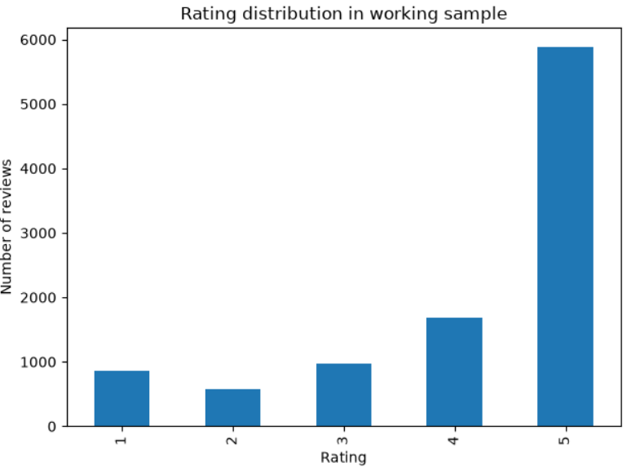
Figure 2: Rating distribution in the 10,000-row Amazon Beauty working sample.
Interpretation: The chart shows that 5-star reviews are the largest group, followed by 4-star reviews. Lower ratings are less frequent in this sample. This imbalance should be considered in later rating comparisons or sentiment modelling; it should not be interpreted as proof of overall customer satisfaction across the beauty or skincare market.

9.2 Review word-count distribution
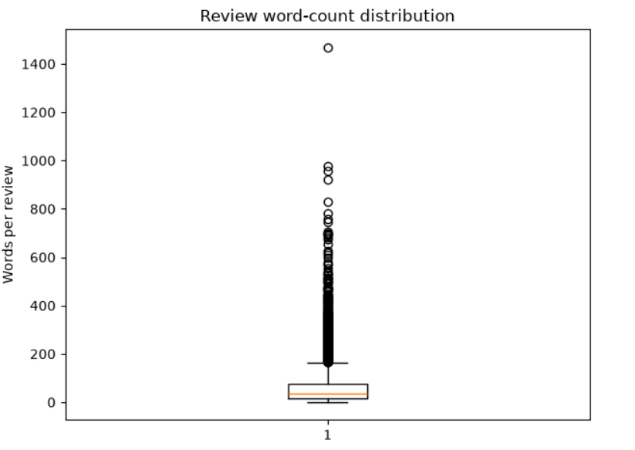
Figure 3: Boxplot of review word counts in the working sample.
Interpretation: The boxplot shows a strongly right-skewed distribution with many high-length observations beyond the upper whisker. These points are potential length outliers under the boxplot rule, not necessarily incorrect reviews. Long reviews may contain detailed product experiences, so they should be flagged for inspection rather than automatically deleted.

10. Reproducibility and Deliverables
The accompanying Jupyter notebook contains executable code, explanations, checks, visual diagnostics, and export steps. Run it from a restarted kernel using Run All Cells. It is designed to generate four outputs:
- amazon_beauty_cleaned_master_10k.csv — cleaned master dataset with quality flags.
- amazon_beauty_nlp_ready_10k.csv — records with non-empty review text.
- amazon_beauty_quality_audit_10k.csv — raw-versus-cleaned quality summary.
- amazon_beauty_cleaning_log_10k.csv — step, issue, action and rationale.
The notebook uses the Hugging Face data URI by default. If network access or package support prevents loading, download the CSV from the dataset page and set LOCAL_CSV to the downloaded file path. Record the exact sample rule and environment used for the final run.

11. Risks, Limitations, and Mitigation
Risk / limitation | Why it matters | Mitigation
All Beauty includes non-skincare products | Unrelated products can distort skincare findings | Validate product metadata and document a skincare inclusion rule
First 10,000 rows only | Sample may not represent all products or time periods | Report sample scope; later use justified sampling or broader extraction
Self-selection and rating bias | Review writers may differ from non-reviewing customers | Avoid population-wide satisfaction claims
Short, mixed, sarcastic or multilingual text | Simple text methods may misinterpret meaning | Inspect representative examples and manually validate a sample
Reviewer identifiers | Identifiers may be sensitive or linkable | Avoid publishing user_id unless necessary and permitted
Licence and provenance need verification | Public access does not automatically permit redistribution | Review current dataset card, provenance, licence and terms

12. How the Cleaned Data Supports Further Analysis
The cleaned master dataset supports descriptive profiling and product-level grouping. The NLP-ready subset can be used for tokenization, keyword frequency, TF-IDF, and sentiment analysis. The valid-rating subset can support comparisons between rating groups and review language. After product metadata is validated and skincare records are isolated, the project can examine themes across cleansers, moisturizers, sunscreens, serums, and other confirmed product categories.
The pipeline does not claim that cleaning alone confirms the Week 1 hypotheses. Category comparisons and sentiment conclusions require further analysis, appropriate sample sizes, and manual validation.

13. Conclusion
Week 3 establishes a structured and reproducible cleaning workflow for the Amazon Beauty Reviews working sample. It preserves raw data, applies field-specific handling decisions, validates ratings and timestamps, performs conservative text normalization, flags unusual records, and creates analysis-specific datasets. The flowchart, audit, and cleaning log make the process easier to inspect and reproduce.
The next critical step is skincare relevance validation using product metadata. Only after that filtering should the project report skincare-specific themes or category comparisons.

14. References
- Hugging Face dataset page: https://huggingface.co/datasets/jhan21/amazon-beauty-reviews-dataset
- Amazon Reviews’23 / McAuley Lab documentation: https://amazon-reviews-2023.github.io/main.html
- Pandas documentation: https://pandas.pydata.org/docs/
- NumPy documentation: https://numpy.org/doc/
- Matplotlib documentation: https://matplotlib.org/stable/

