REVIEW-INFORMED SKINCARE
PRODUCT DISCOVERY
Using NLP and Data Analytics
Week 3: Data Cleaning and Preprocessing Pipeline Development
Prepared by: Muppur Gnaneswar
Data Science with Python Analyst Internship
YuvaIntern
09 November 2026

Executive Summary
During Week 3, the project moved from broad beauty-review dataset exploration to a focused, product-level customer review analysis. In Week 2, an initial sample of 10,000 records from the Amazon Beauty Reviews dataset hosted on Hugging Face was loaded and inspected. That dataset was useful for learning the data analysis workflow, but it was broad and had not been verified as a skincare-only dataset. The Week 2 report therefore identified product-category validation as an important limitation.
To make the next stage more specific and interpretable, Week 3 focused on one selected skincare product: The Derma Co 2% Salicylic Acid + 2% Niacinamide Anti-Acne Face Wash. A Judge.me review-widget extraction workflow collected 162 review records with 162 unique review IDs and no duplicate review IDs. These reviews were then prepared for text analysis, explored through descriptive EDA, classified with a multilingual pretrained sentiment model, and analyzed using TF-IDF keyword extraction.
The executed notebooks provide the sentiment distribution, rating comparison, review-length statistics, date and verified-buyer summaries, frequent-word counts, and TF-IDF keyword outputs. The figures and values in this report are taken from those notebook outputs and interpreted within the limits of the collected sample.

1. Project Background and Continuity from Week 2

1.1 What was completed in Week 2
Week 2 concentrated on data sourcing, environment setup, dataset loading, and initial exploratory analysis. The working source was the Amazon Beauty Reviews dataset available through Hugging Face. The notebook loaded the first 10,000 records using Pandas and retained a raw DataFrame (`df_raw`) alongside a working copy (`df`). The inspected sample contained 10,000 rows and 10 columns.
The Week 2 notebook inspected the first and last records, column names, dimensions, data types, missing values, repeated review titles and review text, rating counts, rating percentages, and review-length statistics. The sample had a mean rating of 4.1183, median rating of 5, and mode rating of 5. There were 13 exact duplicate rows, one missing title, and one missing review-text value. The 5-star category accounted for 5,896 records (58.96%).
The Week 2 report also recorded a key limitation: the source was a broad beauty-product dataset, and the sample had not yet been verified as skincare-only. It explicitly avoided claiming that the sample represented the skincare category. Product metadata inspection and a defensible category filter were listed as future work.

1.2 Why the Week 3 dataset was narrowed
Rather than treating the broad Week 2 sample as a verified skincare dataset, Week 3 used a focused product-level review collection. This was a deliberate refinement of scope. A single-product dataset makes it possible to examine written feedback in the context of one known product instead of mixing reviews from unrelated beauty items. It also provides a clearer starting point for sentiment and keyword analysis.
Dimension | Week 2 | Week 3
Data source | Amazon Beauty Reviews dataset hosted on Hugging Face | The Derma Co product review section using Judge.me review widget
Scope | Broad beauty-product review sample; skincare-only status not verified | One selected skincare product
Sample size | First 10,000 records loaded for initial exploration | 162 collected review records
Main purpose | Dataset sourcing, inspection, baseline EDA and data-quality assessment | Product-specific text preparation, EDA, sentiment estimation and TF-IDF
Text analysis | Repeated titles and exact review-text values inspected | Combined review text analyzed with a multilingual model and TF-IDF
Key limitation | Product categories need validation | Single product and relatively small sample

The two datasets should not be combined or treated as one continuous sample. Week 2 established the general data-analysis workflow and identified a source-scope limitation. Week 3 addressed that limitation by collecting a narrower product-specific dataset. Consequently, Week 2 rating statistics and Week 3 rating statistics describe different datasets and must not be compared as if they were the same population.

2. Business Problem and Research Focus
Star ratings provide a compact numerical expression of customer evaluation, but they do not fully explain why a customer liked or disliked a product. Written reviews may describe experiences, expectations, perceived benefits, concerns, or dissatisfaction. Manually reading every review can be time-consuming, especially when the goal is to organize feedback consistently.
The Week 3 analysis therefore asks: How can customer review text and star ratings for a selected skincare product be analyzed using exploratory data analysis and NLP to summarize predicted sentiment and identify informative words and phrases?

2.1 Week 3 objectives
- Collect product-specific customer reviews and verify review-ID uniqueness.
- Inspect the collected fields and retain columns relevant to the analysis.
- Handle missing review titles and review text without discarding usable review bodies.
- Create a combined text field for each review.
- Explore rating distribution, review length, dates, and other available review attributes.
- Estimate Positive, Neutral, or Negative sentiment using a multilingual pretrained model.
- Compare predicted sentiment with star ratings as an exploratory cross-tabulation.
- Use TF-IDF to identify informative unigrams and bigrams across the review corpus.
- Generate review-level and sentiment-group keyword outputs for manual interpretation.

3. Product and Data Source

3.1 Selected product
The Derma Co 2% Salicylic Acid + 2% Niacinamide Anti-Acne Face Wash.
Product page: https://thedermaco.com/products/2-sali-cinamide-anti-acne-face-wash-with-2-salicylic-acid-2-niacinamide-150-ml-pack-of-2

3.2 Review source and extraction method
The reviews were collected from the product page's publicly displayed Judge.me review section. The extraction workflow used browser automation and HTML parsing to locate individual review cards and read the fields exposed by the widget. The review-card selectors inspected during development included `.jdgm-rev`, with child elements for author, rating, title, body, and timestamp. Review-card attributes also exposed values such as review ID, product title, product URL, verified-buyer status, and helpful-vote counts.
The extraction was ultimately run through a standalone Python script (`scrape_all_reviews.py`) rather than running Playwright's synchronous or asynchronous API directly inside the Windows Jupyter event loop. This approach was adopted after notebook execution encountered Windows subprocess/event-loop compatibility issues. The standalone script completed the extraction and wrote the collected review records to CSV.
Collection validation | Result
Review records collected | 162
Unique review IDs | 162
Duplicate review IDs | 0

The zero-duplicate result refers specifically to duplicate review IDs. It does not automatically prove that all review text is unique or that the source contains every review ever submitted for the product. The report therefore describes the 162 records as the collected review sample.

3.3 Fields collected
Column | Meaning | Use in this project
review_id | Identifier assigned to a review | Uniqueness and record tracking
product_name | Name of the reviewed product | Product context
reviewer_name | Displayed reviewer name | Not required for analysis; exclude from public release
rating | Star rating | Rating distribution and comparison
review_title | Short review heading | Combined NLP text
review_text | Written review body | Main NLP text
review_date | Date associated with the review | Date-based EDA
verified_buyer | Verified-buyer indicator | Optional descriptive EDA
helpful_votes | Helpful vote count | Optional review engagement analysis
not_helpful_votes | Not-helpful vote count | Optional review engagement analysis
product_url | Product page URL | Source reference; not needed as a model feature

4. Data Preparation and Text Preprocessing

4.1 Loading and preserving the data
The raw CSV was loaded into a Pandas DataFrame. A separate working DataFrame was used for cleaning so that the original collected file remained unchanged. This separation is important because it allows the analyst to return to the original source records if a cleaning decision needs to be reviewed.

4.2 Selecting analysis-relevant columns
The project retained review_id, product_name, reviewer_name, rating, review_title, review_text, review_date, and verified_buyer as the core columns in the cleaned working dataset. Helpful-vote fields and product_url were not needed for the primary sentiment and TF-IDF workflow. Reviewer names were not required as model features and should be removed or anonymized before any public data release.

4.3 Handling missing values
The initial collection contained nine missing review titles and no missing values in the other reported columns. Missing review titles were filled with empty strings before concatenation. This decision preserves the review body when a customer has submitted text without a title. Missing titles are not treated as negative feedback.

4.4 Creating combined_review
The review title and review body were joined into a single text field named `combined_review`. The combined field gives subsequent analysis one consistent text input and allows the title to contribute context that may not be repeated in the review body. Rows with no usable combined text were excluded from text modelling.

4.5 Text normalization
The text-preparation workflow standardized text for analysis while retaining English words and Romanized Hinglish written with Latin characters. The intent was to avoid an English-only preprocessing pipeline that could remove or distort code-mixed expressions. The original review text was retained separately so that processed terms could be checked against the source wording.
Text cleaning is not neutral: removing punctuation, stop words, or short tokens can change meaning. In particular, negation terms such as 'not' can reverse sentiment. For this reason, the report recommends checking preprocessing results and interpreting model predictions with the original review text.

5. Exploratory Data Analysis
EDA was used to understand the composition and quality of the 162-review sample before interpreting NLP outputs. The notebook inspected dataset shape, columns, data types, missing values, duplicate IDs, rating counts, review length, review dates, verified-buyer status, and word usage. These checks help identify imbalances and potential data-quality issues that may affect later analysis.

5.1 Missing-value and duplicate checks
The reported initial missing-value check found nine missing review titles and zero missing values in the other columns. Review IDs were unique across all 162 collected records, with zero duplicate IDs. Missing review titles were retained as blank text during preprocessing rather than dropping the corresponding review record.

5.2 Star-rating distribution
The rating frequency was calculated by grouping the `rating` column and counting the number of records in each star category. Percentages were calculated by dividing each category count by the total number of collected reviews. The observed sample is strongly concentrated in the 5-star category.
Star rating | Review count | Percentage
1 star | 4 | 2.47%
2 stars | 0 | 0.00%
3 stars | 0 | 0.00%
4 stars | 26 | 16.05%
5 stars | 132 | 81.48%
Total | 162 | 100.00%

Interpretation: 132 of the 162 collected reviews (81.48%) gave the product 5 stars, while 26 reviews (16.05%) gave 4 stars. Four reviews (2.47%) gave 1 star. No 2-star or 3-star reviews were present in this collected sample. This distribution describes the collected review records only; it should not be interpreted as a representative satisfaction survey of all purchasers.
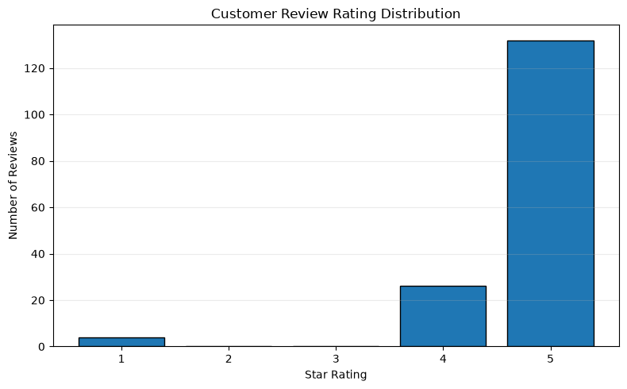
Figure 1. Customer Star-Rating Distribution

5.3 Review-length analysis
Review length was measured by counting the words in the combined review text. This gives a simple indication of how much written feedback is available per record. A histogram helps reveal whether the sample contains mostly short comments, longer descriptions, or a skewed distribution. The actual mean, median, minimum, and maximum review lengths should be copied from the EDA notebook output.
Review-length statistics from the executed notebook: mean 31.10 words; median 28 words; minimum 1 word; maximum 102 words. The distribution is concentrated around shorter reviews, with a smaller number of longer reviews extending beyond 60 words.
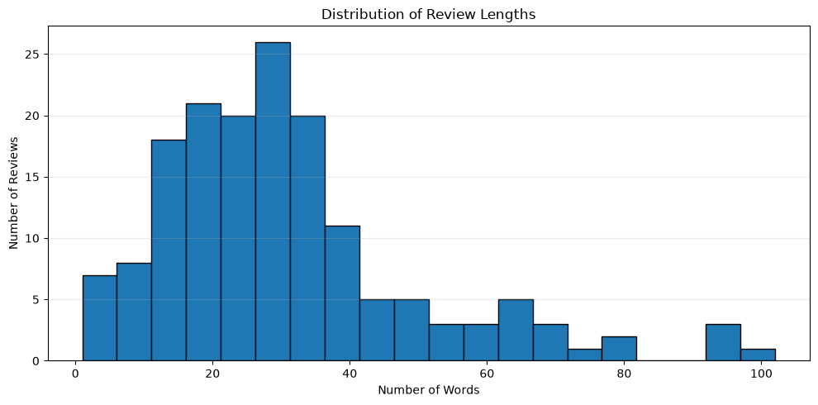

Figure 2. Distribution of Review Length

5.4 Review length by star rating
Review length was grouped by star rating and visualized using a box plot. A box plot displays the median, interquartile range, and potential outliers for each rating group. This can help compare how much customers write at different rating levels. However, the plot does not explain why a review is longer or shorter, and the 1-star group contains only four records, so its distribution is especially uncertain.
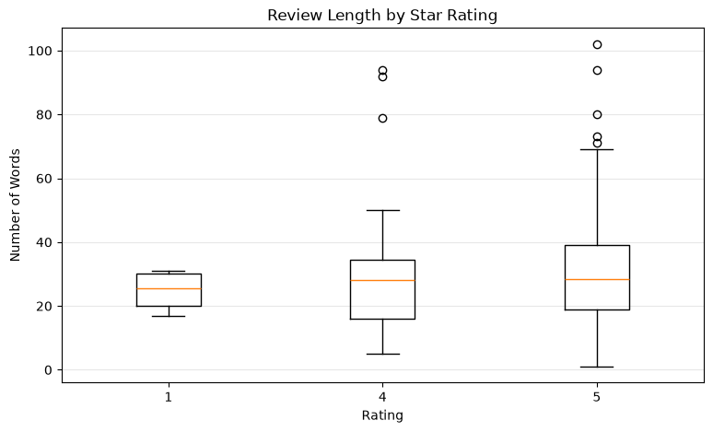
Figure 3. Review Length by Star Rating

5.5 Review-date and verified-buyer analysis
The notebook also examined review dates and verified-buyer status. Date-based analysis can show how the collected reviews are distributed over time, while verified-buyer counts describe the verification field provided by the review widget. These fields are descriptive and do not establish that the sample is complete or that verified and unverified reviewers have different experiences.
All 162 review dates were valid. The monthly review-date output spans March 2024 to September 2026, with the largest monthly count in November 2025 (36 reviews), followed by September 2025 (21) and October 2025 (17). The verified_buyer field was False for all 162 records (100%) and True for zero records. This describes the field values returned by the review widget; it does not establish whether reviewers actually purchased.
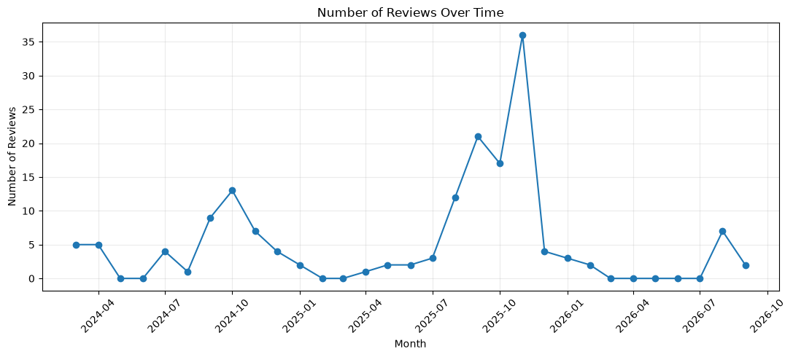

Figure 4. Monthly Distribution of Collected Review Dates

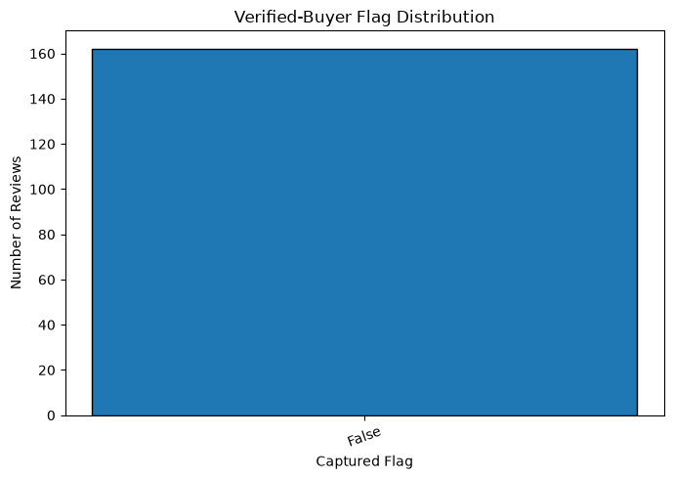
Figure 5. Verified-Buyer Flag Distribution

5.6 Frequent words
Frequent-word analysis counts the terms that occur most often in the prepared review text. Frequency is a useful first inspection, but a frequently used word is not necessarily an important product theme. The same word may be used in different contexts, and similar words may be spelled differently, particularly in Romanized Hinglish.
The most frequent terms were “and” (191), “acne” (169), “the” (160), “i” (150), “my” (143), “skin” (136), “it” (129), “face” (124), “this” (120), and “wash” (110). Common function words remain prominent because this frequency check counts terms rather than identifying validated themes. Product-related words such as acne, skin, face, wash, salicylic, and niacinamide should be checked in their original review context.

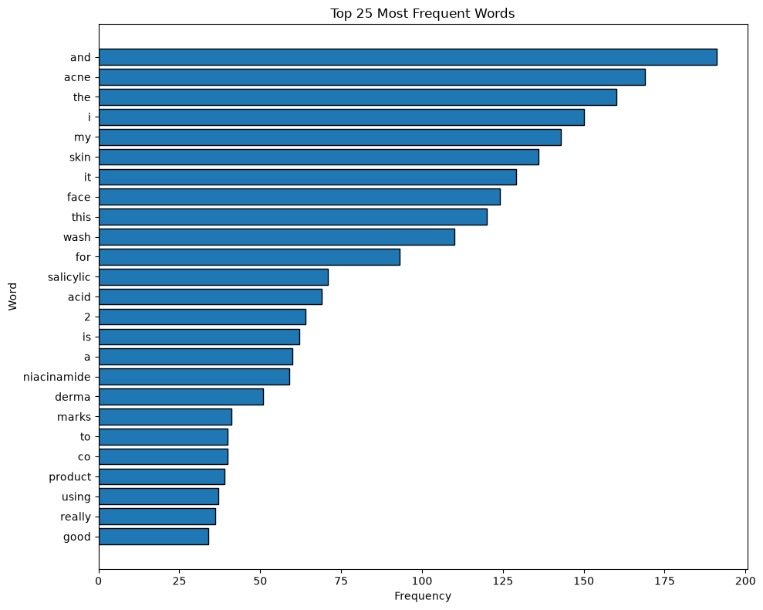
Figure 6. Twenty Most Frequent Words in Review Text

6. Sentiment Analysis

6.1 Purpose and model selection
Sentiment analysis was used to estimate the overall emotional polarity expressed in each written review. The project used the pretrained multilingual model `cardiffnlp/twitter-xlm-roberta-base-sentiment` through the Hugging Face Transformers pipeline. A multilingual model was selected because the review text may contain English and Romanized Hinglish. However, multilingual capability does not guarantee reliable interpretation of every regional-language phrase or code-mixed expression.

6.2 Tokenization and model inference
The combined review text was passed to the model tokenizer, which converts text into token IDs that the Transformer can process. The model then produces class scores for sentiment labels. The notebook used batch inference, truncation, and a maximum sequence length of 512 tokens. The predicted class and its score were stored as `sentiment` and `sentiment_confidence`.
The tokenizer was loaded with `use_fast=False` to use the SentencePiece-based tokenizer path after the environment required the `sentencepiece` and `protobuf` dependencies. The model was run on CPU (`device=-1`) for compatibility with the available environment. Once downloaded, the model files are normally cached locally.

6.3 Sentiment distribution
The predicted labels were counted and converted into percentages. The executed notebook classified 137 reviews as Positive (84.57%), 15 as Neutral (9.26%), and 10 as Negative (6.17%). These are model predictions for this collected sample, not manually verified labels.
Predicted sentiment | Review count | Percentage
Positive | 137 | 84.57%
Neutral | 15 | 9.26%
Negative | 10 | 6.17%
Total | 162 | 100.00%

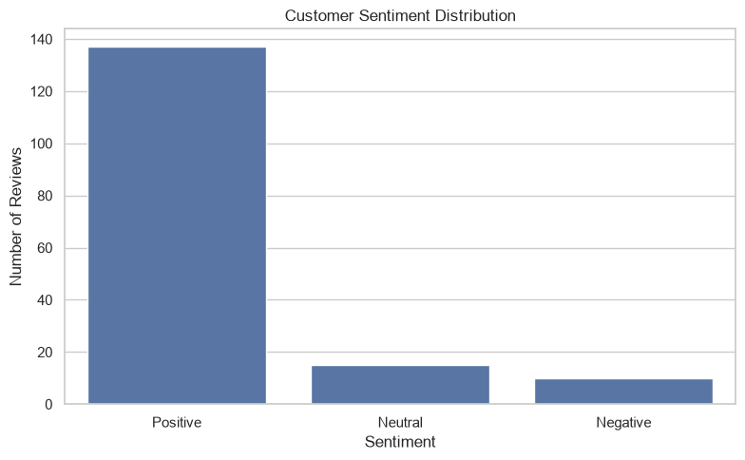
Figure 7. Predicted Sentiment Count
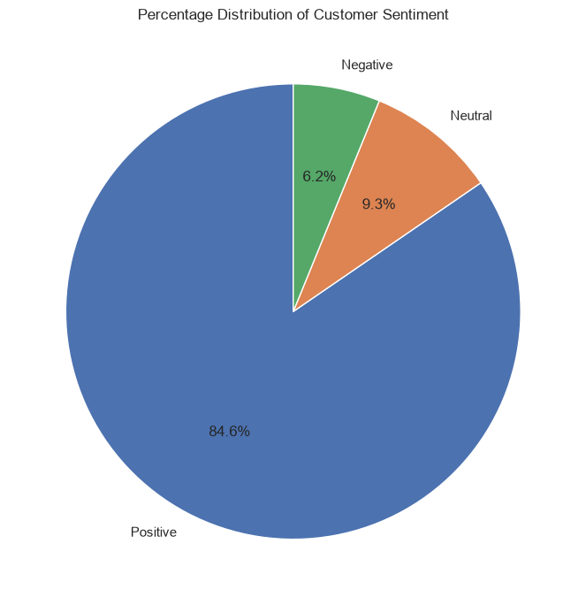

Figure 8. Percentage Distribution of Predicted Sentiment

6.4 Confidence-score interpretation
The model confidence score represents the score associated with the selected class for a review. A high confidence score does not prove that the prediction is correct. The notebook also inspected lower-confidence predictions so that they could be prioritized for manual review. A reliable evaluation of model performance would require a manually labelled validation set and metrics such as accuracy, precision, recall, and F1-score.

6.5 Comparison with star ratings
A cross-tabulation and heatmap compared predicted sentiment labels with the original star ratings. This is useful for identifying cases where the model's text-based prediction and the customer's numerical rating do not appear aligned. The comparison is exploratory: star ratings are not verified sentiment ground truth, and disagreement does not by itself prove that the model is wrong.

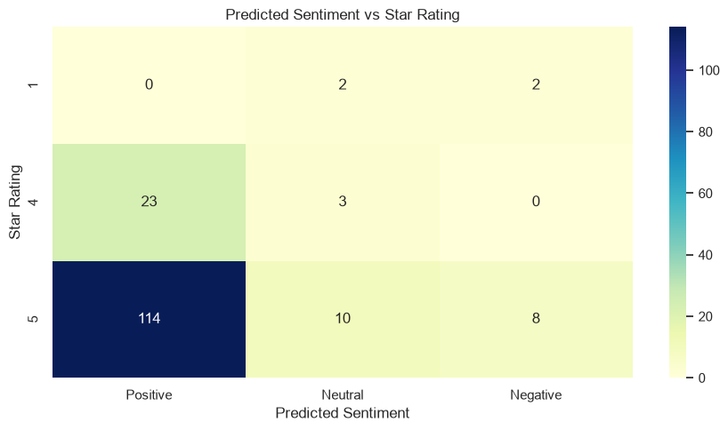
Figure 9. Predicted Sentiment Compared with Star Rating

6.6 Manual review of examples
Representative reviews from each sentiment class should be read in their original form. This step is important because short comments, sarcasm, mixed-language expressions, spelling variation, and product-specific context may affect model predictions. Add a small anonymized example table based on the notebook output.
Predicted class | Anonymized review excerpt | Manual observation
Positive | “It is the super product for pimple remove.” | The positive label is consistent with the approving wording, although the short excerpt provides limited context.
Neutral | “Good 2% Sali-Cinamide Anti-Acne Face Wash with 2% Salicylic Acid & 2% Niacinamide.” | Neutral is plausible because this is largely a product-name description rather than a clear evaluation.
Negative | “Absolutely worth it… but after using it you will feel dryness.” | The prediction is questionable or mixed: most of the review is favorable, but it mentions dryness. Manual validation is important.

7. TF-IDF and Keyword Extraction

7.1 Purpose of TF-IDF
Term Frequency–Inverse Document Frequency (TF-IDF) is a numerical method for representing how informative a term is within a document collection. Term frequency reflects how strongly a term appears in a document, while inverse document frequency reduces the weight of terms that appear across many documents. The resulting scores help identify words and phrases that distinguish individual reviews within the collected corpus.

7.2 Vectorizer configuration
Parameter | Project setting | Reason
ngram_range | (1, 2) | Extract single words and two-word phrases
min_df | 2 | Ignore terms that occur in only one review
max_features | 5000 | Limit vocabulary size
sublinear_tf | True | Apply a logarithmic scaling to term frequency
token_pattern | (?u)\\b\\w+\\b | Define token boundaries for word extraction
stop_words | None | Avoid applying an English-only stop-word list to code-mixed text

The vectorizer was fitted on the prepared review text and transformed each review into a sparse TF-IDF matrix. The matrix contains a score for each term or phrase in each review. The average score across the review collection was then used to rank terms overall.

7.3 Overall top keywords
The notebook ranked terms and phrases by their mean TF-IDF score and displayed the top 20. These terms should be interpreted by reading the original reviews in which they occur. A high TF-IDF score indicates that a term is informative within this corpus; it does not automatically mean that the term is a positive benefit, a negative concern, or a validated customer theme.

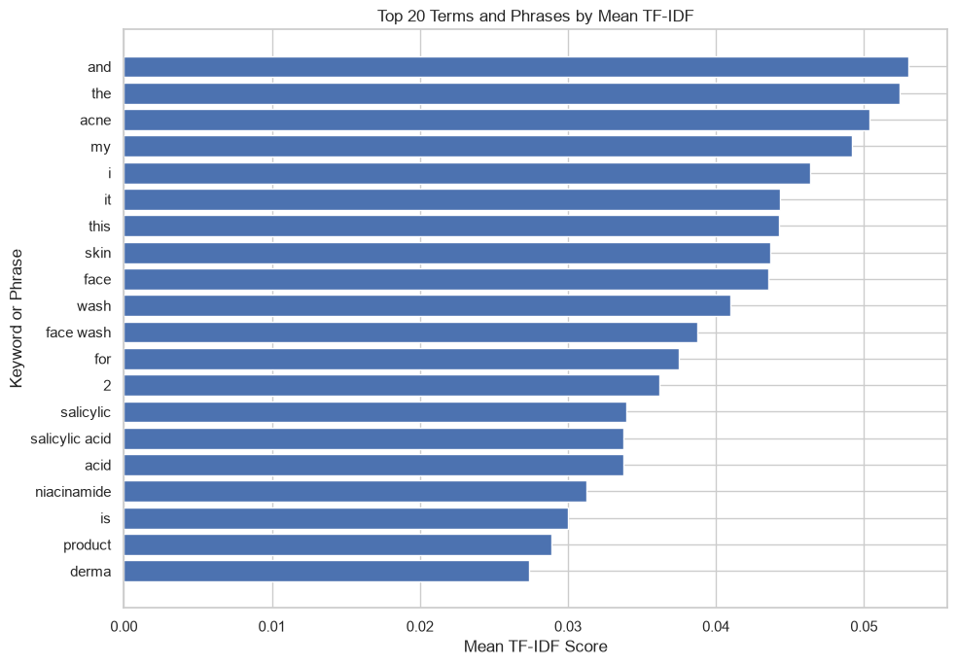
Figure 10. Top 20 Terms and Phrases by Mean TF-IDF

7.4 Keywords by predicted sentiment
The notebook transformed reviews within each predicted sentiment group using the same fitted vectorizer and calculated group-level mean TF-IDF scores. This allows a descriptive comparison of terms that are informative within Positive, Neutral, and Negative groups. It is not a causal analysis and does not establish that a term caused a sentiment classification.

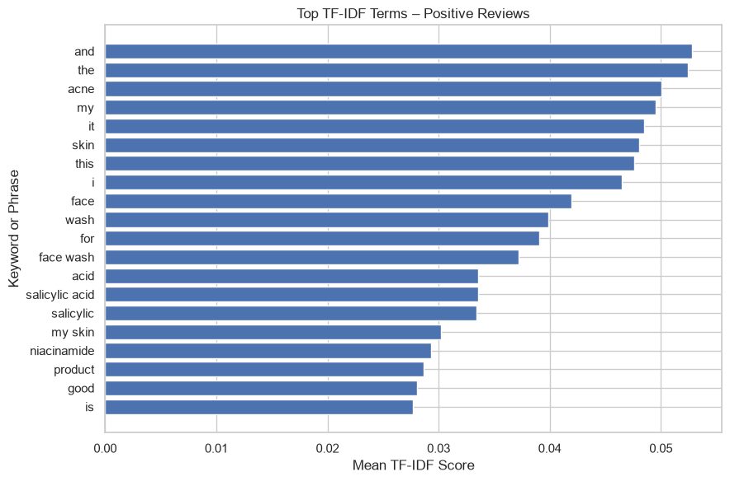
Figure 11. Top TF-IDF Terms in Positive Reviews
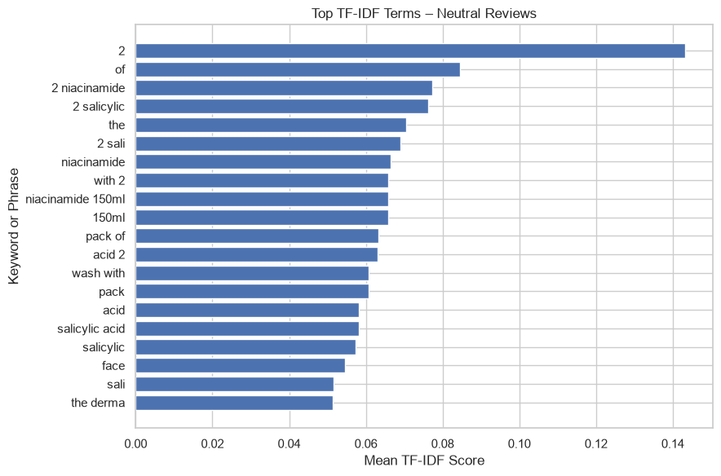
Figure 12. Top TF-IDF Terms in Neutral Reviews
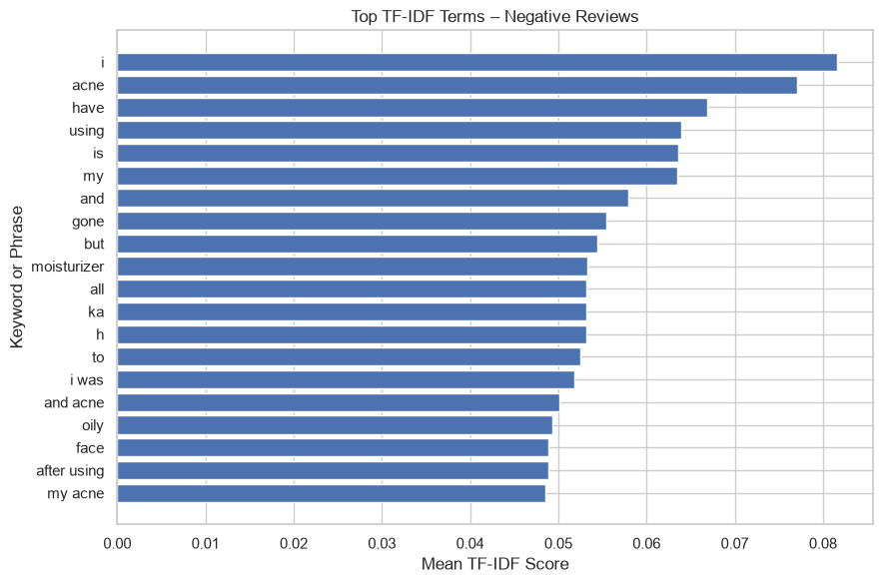
Figure 13. Top TF-IDF Terms in Negative Reviews

7.5 Review-level keywords
For each review, the notebook selected up to three terms or phrases with the largest TF-IDF scores in that review. These terms provide a compact way to inspect what distinguishes one review from the rest of the corpus. They are not complete summaries of the review and may miss negation, context, or multi-word meaning.
Rating | Predicted sentiment | Short anonymized review | Extracted terms
5 | Neutral | Product-name-led review mentioning the face wash and its ingredients | 2; 150ml pack; pack of
5 | Positive | “It is the super product for pimple remove.” | product for; super; remove
5 | Negative | Review praises the product but also mentions dryness after use | will; and acne; you will

8. Results and Interpretation
This section should bring together the EDA, sentiment, and TF-IDF outputs. The purpose is not simply to repeat chart values, but to explain what each result suggests within the boundaries of the collected sample.

8.1 Confirmed dataset findings
- The collection contains 162 review records and 162 unique review IDs, with no duplicate review IDs.
- Nine review titles were missing in the initial data-quality check; other reported columns had no missing values.
- The rating distribution contains 132 five-star reviews (81.48%), 26 four-star reviews (16.05%), and four one-star reviews (2.47%).
- No two-star or three-star reviews were present in the collected sample.

8.2 Findings to complete from notebook outputs
Analysis area | Insert actual result | Interpretation to write
Review length | Mean 31.10 words; median 28; range 1–102 words. | The histogram is concentrated around shorter reviews, with a right tail of longer comments.
Review-date trend | 162 valid dates; March 2024–September 2026; peak month November 2025 (36 reviews). | Review counts vary by month. The peak is descriptive and does not establish a cause.
Verified-buyer status | False: 162 (100%); True: 0 (0%). | All records carry a False flag in the collected widget field; this does not prove purchase status.
Sentiment | Positive: 137 (84.57%); Neutral: 15 (9.26%); Negative: 10 (6.17%). | These are model predictions, not ground-truth labels; the model has not been validated against a manually labelled set.
Overall TF-IDF | Top terms include and, the, acne, my, i, it, this, skin, face, and wash. | Common function words rank highly; inspect original reviews before grouping terms into customer themes.
Sentiment TF-IDF | Positive: acne/skin/face/wash; Neutral: product-name and ingredient terms; Negative: acne/using/moisturizer/but. | These are descriptive group-level terms. Neutral (15) and Negative (10) groups are small, so interpret cautiously.

9. Relationship to Week 1 Research Questions and Hypotheses
The Week 2 README recorded research questions and hypotheses concerning common review themes, differences across skincare categories, differences between higher- and lower-rated reviews, and the value of combining ratings with review text. Week 3 advances some of these questions for one product, but it does not test all of them.

Week 1 question / hypothesis | Week 3 contribution | Status after Week 3
RQ1: What themes appear in customer reviews? | TF-IDF terms and review examples provide initial vocabulary evidence. | Partially explored; themes require manual validation.
H1: Themes differ across skincare categories. | Week 3 focuses on one product only. | Not tested; requires multiple validated product categories.
H2: Lower- and higher-rated reviews differ. | Rating distribution and sentiment/keyword group outputs provide exploratory material. | Not conclusively tested; very few low-rating reviews.
H3: Automated sentiment may differ from manual interpretation. | Predicted sentiment and review examples can be manually inspected. | Not validated until a labelled sample is created.
H4: Ratings plus review text provide richer summaries. | EDA, sentiment, and TF-IDF provide complementary views. | Supported as a workflow rationale, not statistically proven.

10. Technical Challenges and Resolutions
Challenge | What happened | Resolution / learning
Playwright in Windows Jupyter | Async and sync Playwright calls encountered event-loop or subprocess compatibility errors. | Moved browser automation into a standalone Python script and ran it as a separate process.
Pandas installation issue | A package upgrade failed and left the Pandas installation incomplete. | Repaired Pandas through the active Conda environment and verified imports.
Tokenizer dependencies | Transformers could not load the SentencePiece model because protobuf and tokenizer dependencies were missing. | Installed protobuf and sentencepiece; loaded tokenizer with use_fast=False.
Jupyter NameError errors | Variables such as df, plt, and sentiment_summary were unavailable after kernel restart or skipped cells. | Re-ran notebook cells in order and confirmed that each dependency variable was created before use.
Scikit-learn missing | TF-IDF import failed because sklearn was not installed. | Installed scikit-learn in the skincare-ds environment.
Pandas deprecation warning | reset_index(inplace=True) produced a deprecation warning. | Changed to df = df.reset_index(drop=True).

These issues were environment and notebook-execution challenges rather than changes to the collected review records. The final workflow should be tested from a fresh kernel using Run All so that the notebook does not depend on variables left over from earlier interactive sessions.

11. Tools and Technologies
Tool / library | Role in the project
Python | Main programming language
Pandas | CSV loading, data selection, missing-value handling, grouping, and export
NumPy | Numerical calculations and array operations
Matplotlib | Charts and visualizations
Seaborn | Statistical plots and heatmaps
Scikit-learn | TF-IDF vectorization
Hugging Face Transformers | Pretrained sentiment classification pipeline
PyTorch | Backend for Transformer model inference
SentencePiece and protobuf | Tokenizer support
Playwright / HTML parsing | Browser-based review extraction
JupyterLab | Interactive development and documentation
Conda | Isolated project environment

12. Limitations, Ethics, and Data Handling
- The Week 3 sample contains reviews for one product only; conclusions cannot be generalized to other products or the skincare market.
- The 162 reviews are a collected sample from a review widget, not a verified census of every purchaser or every review ever submitted.
- Review platforms can have self-selection effects: people who choose to submit reviews may differ from customers who do not.
- The sample is heavily weighted toward 5-star reviews and contains only four 1-star reviews, with no 2-star or 3-star reviews.
- The pretrained model was not validated against a manually labelled ground-truth set. Model confidence must not be described as accuracy.
- Romanized Hinglish, spelling variation, sarcasm, short comments, and product-specific expressions may reduce sentiment reliability.
- TF-IDF ranks terms statistically and does not independently identify causes, product efficacy, or validated themes.
- Reviewer names and other identifiers should not be included in public analysis outputs. Check source terms and permissions before redistributing raw review text.

13. Conclusion
Week 3 represents a shift from broad dataset familiarization to a focused product-level review analysis. The Week 2 work established the Conda/Jupyter environment and the baseline process for loading, inspecting, and describing review data. It also exposed a limitation in using a broad beauty dataset for skincare-specific claims. Week 3 responded by collecting 162 review records for one named skincare product and applying a structured workflow of preprocessing, EDA, multilingual sentiment estimation, and TF-IDF keyword extraction.
The confirmed results establish the size and rating composition of the collected sample. The sentiment and keyword outputs provide additional model-generated and statistical summaries, but they must be interpreted with manual review and the limitations described above. The next step is to complete the result placeholders using the actual notebook outputs, validate representative sentiment predictions, and prepare a concise evidence-based set of customer feedback themes.

14. Week 3 Deliverables
Stage | Notebook / script | Generated dataset or output
Data collection | 00_Data_Collection.ipynb / scrape_all_reviews.py | thedermaco_all_reviews.csv
Preprocessing | 01_Data_Preprocessing.ipynb | TheDermaCo_Preprocessed_Reviews.csv
EDA | 02_Exploratory_Data_Analysis.ipynb | TheDermaCo_EDA_Analysis.csv
Sentiment analysis | 03_Sentiment_Analysis.ipynb | TheDermaCo_Sentiment_Analysis.csv
TF-IDF | 04_TFIDF_Keyword_Extraction.ipynb | TheDermaCo_TFIDF_Top_Keywords.csv
TF-IDF review keywords | 04_TFIDF_Keyword_Extraction.ipynb | TheDermaCo_TFIDF_Review_Keywords.csv
TF-IDF sentiment keywords | 04_TFIDF_Keyword_Extraction.ipynb | TheDermaCo_TFIDF_Sentiment_Keywords.csv

15. Notebook Figures and Reproducibility
All figures in this report are embedded from the executed Week 3 EDA, sentiment-analysis, and TF-IDF notebooks. The charts are reproduced as notebook outputs; no chart has been created solely to fill a placeholder.
plt.savefig("rating_distribution.png", dpi=300, bbox_inches="tight")

Figure | Report section | Image file | Required?
1 | 5.2 Rating distribution | rating_distribution.png | Included
2 | 5.3 Review length | review_length_histogram.png | Included
3 | 5.4 Review length by rating | review_length_by_rating_boxplot.png | Included
4 | 5.5 Review-date trend | review_dates_over_time.png | Included
5 | 5.5 Verified-buyer status | verified_buyer_distribution.png | Included
6 | 5.6 Frequent words | top_frequent_words.png | Included
7 | 6.3 Sentiment counts | sentiment_distribution_bar.png | Included
8 | 6.3 Sentiment percentages | sentiment_distribution_pie.png | Included
9 | 6.5 Sentiment vs rating | sentiment_vs_rating_heatmap.png | Included
10 | 7.3 Overall TF-IDF | tfidf_top_20_keywords.png | Included
11 | 7.4 Positive keywords | tfidf_positive_keywords.png | Included
12 | 7.4 Neutral keywords | tfidf_neutral_keywords.png | Included
13 | 7.4 Negative keywords | tfidf_negative_keywords.png | Included

The report includes only figures generated by the submitted notebooks. Review-level excerpts are anonymised and included solely as examples for manual interpretation.

16. References
- The Derma Co product page: https://thedermaco.com/products/2-sali-cinamide-anti-acne-face-wash-with-2-salicylic-acid-2-niacinamide-150-ml-pack-of-2
- Hugging Face model: https://huggingface.co/cardiffnlp/twitter-xlm-roberta-base-sentiment
- Hugging Face Transformers documentation: https://huggingface.co/docs/transformers/
- Scikit-learn TF-IDF documentation: https://scikit-learn.org/stable/modules/feature_extraction.html#tfidf-term-weighting
- Pandas documentation: https://pandas.pydata.org/docs/
- NumPy documentation: https://numpy.org/doc/
- Matplotlib documentation: https://matplotlib.org/stable/
- Seaborn documentation: https://seaborn.pydata.org/
- JupyterLab documentation: https://jupyterlab.readthedocs.io/

