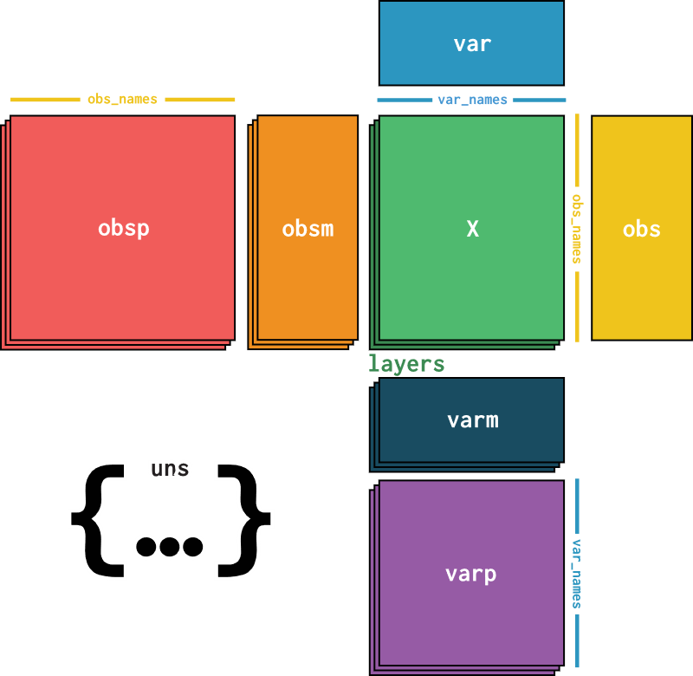

Plans:

For pep – also save peptide details for QC? E.g. points per peak/FWHM etc.