PRACTICAL – 2

1)
AIM:
1. Vending machine (VendingMachine.java, main in this file)
(a) Define an enum Coin with constants ONE, TWO, FIVE, TEN.
(b) In main, set a snack price of 15 and a running total of 0; create a Scanner.
(c) Loop: read a coin name, use a switch expression to convert the Coin to its value
(ONE→1, TWO→2, FIVE→5, TEN→10), add it to the total, and print the total so
far.
(d) Stop the loop once the total reaches 15 or more.
(e) Print the change to return (total − 15).
Expected output: TEN then FIVE prints “Paid. Change: 0”; TEN then TEN prints
“Paid. Change: 5”.

CODE :
public class Thermostat {
private String location;
private int temperature;
private static final int MIN = 16;
private static final int MAX = 30;
private static int activeCount = 0;

public Thermostat(String location, int startTemp) {
this.location = location;
if (startTemp >= MIN && startTemp <= MAX) {
this.temperature = startTemp;
}
else {
this.temperature = 22;
}
activeCount++;
}

public Thermostat(String location) {
this(location, 22);
}

public void raise() {
if (temperature < MAX) {
temperature++;
}
else {
System.out.println("Already at maximum (30)");
}
}

public void lower() {
if (temperature > MIN) {
temperature--;
}
else {
System.out.println("Already at minimum (16)");
}
}

public int getTemperature() {
return temperature;
}

public static int getActiveCount() {
return activeCount;
}

public static void main(String[] args) {
Thermostat thermo1 = new Thermostat("Living Room", 20);
Thermostat thermo2 = new Thermostat("Bedroom");

System.out.println("--- Testing raise() for Thermostat 1 ---");
for (int i = 0; i < 10; i++) {
thermo1.raise();
System.out.println("Current Temperature: " + thermo1.getTemperature());
}

System.out.println("\n--- Testing lower() for Thermostat 1 ---");
for (int i = 0; i < 20; i++) {
thermo1.lower();
System.out.println("Current Temperature: " + thermo1.getTemperature());
}

System.out.println("\nActive Thermostat Count: " + Thermostat.getActiveCount());
}
}

OUTPUT :

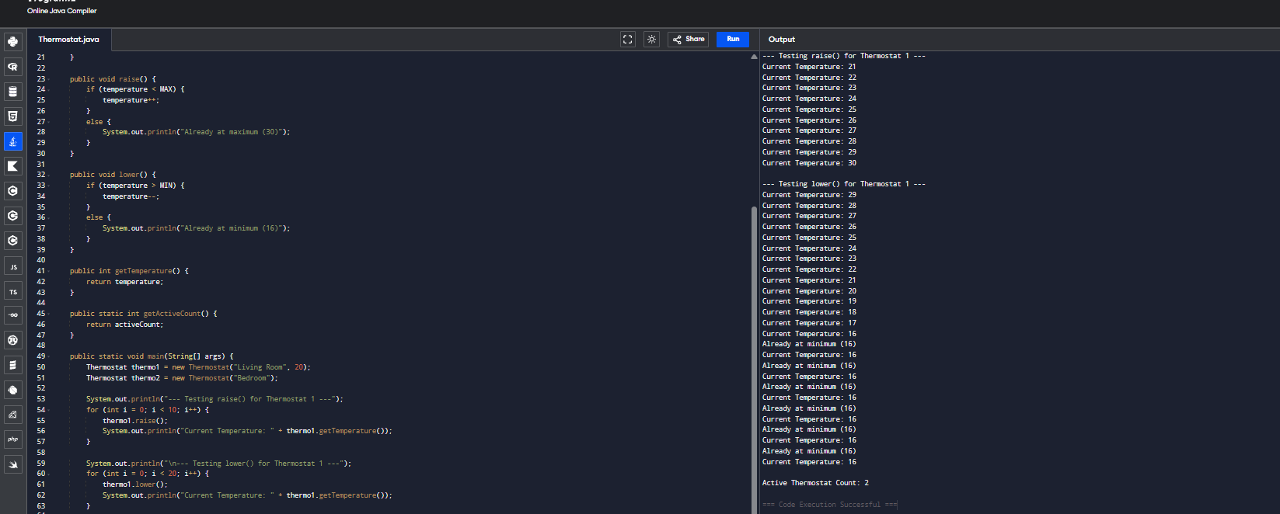
CONCLUSION :
Thus, the Java program for the vending machine was successfully implemented using enum, switch expression, and looping. The program accepts coins, calculates the total amount paid, and displays the change after the snack price is reached.

2)

AIM :
2. Toll booth (TollBooth.java, main in this file)
(a) Define a record Vehicle(String number, String type).
(b) In main, keep a running toll total and three counters (bike, car, truck).
(c) Loop until the user types “done” for the number: build a Vehicle, use a switch
expression on its type for the toll (bike→20, car→50, truck→150), add to the total,
and increment that type’s counter.
(d) After the loop, print the total toll and the type with the highest count.
Expected output: two cars + one bike → “Total toll: 120”, “Most frequent: car”.
CODE :
public class CinemaShow {
private String title;
private int seatsAvailable;
private final int capacity;
private static int totalBooked = 0;

public CinemaShow(String title, int capacity) {
this.title = title;
this.capacity = capacity;
this.seatsAvailable = capacity;
}
public CinemaShow(String title) {
this(title, 100);
}

public boolean book(int n) {
if (n <= this.seatsAvailable) {
this.seatsAvailable -= n;
totalBooked += n;
return true;
}
return false;
}

public void cancel(int n) {
this.seatsAvailable += n;
if (this.seatsAvailable > this.capacity) {
this.seatsAvailable = this.capacity;
}
}

public int getSeatsAvailable() {
return this.seatsAvailable;
}

public static int getTotalBooked() {
return totalBooked;
}

public static void main(String[] args) {
System.out.println("Creating 'Inception' with 50 capacity.");
CinemaShow show = new CinemaShow("Inception", 50);
System.out.println("Initial seats available: " + show.getSeatsAvailable());
System.out.println("----------------------------------------");

System.out.println("Booking 30 seats...");
boolean res1 = show.book(30);
System.out.println("Result: " + res1 + " | Seats left: " + show.getSeatsAvailable());

System.out.println("\nBooking 25 seats (only 20 left)...");
boolean res2 = show.book(25);
System.out.println("Result: " + res2 + " | Seats left: " + show.getSeatsAvailable());

System.out.println("\nCanceling 10 seats...");
show.cancel(10);
System.out.println("Seats left: " + show.getSeatsAvailable());

System.out.println("\nCanceling 40 seats (exceeding initial capacity)...");
show.cancel(40);
System.out.println("Seats left (capped at capacity): " + show.getSeatsAvailable());

System.out.println("----------------------------------------");
System.out.println("Total successful bookings globally: " + CinemaShow.getTotalBooked());
}
}

OUTPUT :
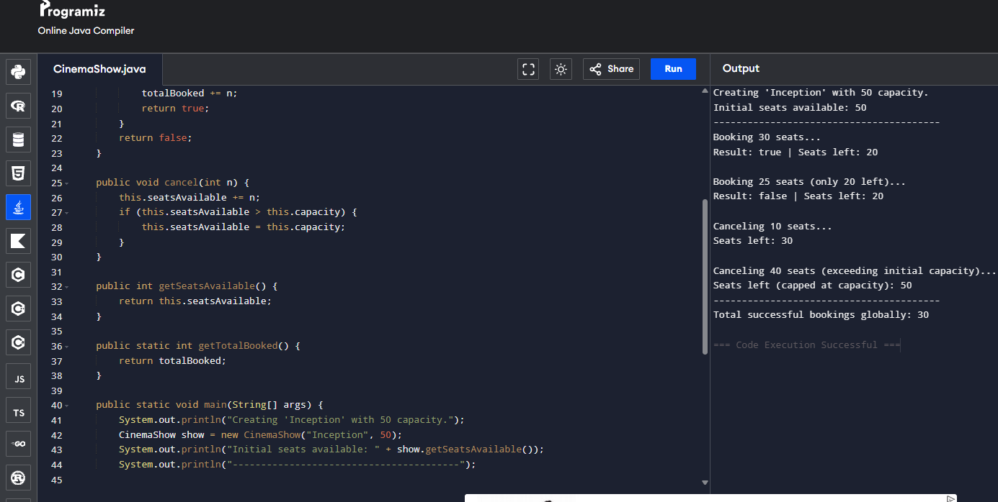
CONCLUSION :
Thus, the Java program for the toll booth was successfully implemented using record, switch expression, and looping. The program calculates the total toll collected, counts different types of vehicles, and displays the most frequently occurring vehicle type.
3)
AIM :
3. (For Advanced Learners – home) Rock-Paper-Scissors-Lizard-Spock (RPSLS.java)
(a) Define an enum Move with ROCK, PAPER, SCISSORS, LIZARD, SPOCK.
(b) Write winner(Move a, Move b) returning 1 if a beats b, -1 if b beats a, 0 for a tie —
use a switch expression listing what each move beats (Scissors cut Paper, Paper
covers Rock, Rock crushes Lizard, Lizard poisons Spock, Spock smashes Scissors,
and the five mirror cases).
(c) In main, play 5 rounds: pick a random computer Move, read the player’s Move, call
winner(), print the round result and keep score.
(d) After 5 rounds, print the overall winner.
Expected output: each round prints both moves and the round winner; ends with a
“You win 3–2” summary.
CODE :
public class parkinglot {
private int twoWheelers;
private int fourWheelers;
private final int twoCap; //if you initialise the variable here it will show error in assigning the value inside constructor.
private final int fourCap;
private static long revenue=0;

public parkinglot(int twoCap, int fourCap){
this.twoCap=twoCap;
this.fourCap=fourCap;
}

public void park(String type){
if(type=="two"){
if(twoWheelers<twoCap){
revenue+=20;
twoWheelers++;
System.out.println("twowheeler Parked");
System.out.println("revenue: "+revenue);
}
else{
System.out.println("Full");
}
}
else if(type=="four"){
if(fourWheelers<fourCap){
revenue+=40;
fourWheelers++;
System.out.println("fourwheeler Parked");
System.out.println("revenue: "+revenue);
}
else{
System.out.println("Full");
}
}
}
public void leave(String type){
if(type=="two"){
if(twoWheelers>0){
twoWheelers--;
System.out.println(twoWheelers+ " twowheelers left");
}
}
else if(type=="four"){
if(fourWheelers>0){
fourWheelers--;
System.out.println(fourWheelers+ " fourwheelers left");
}
}
}
public static void main(String[] args){
parkinglot p=new parkinglot(5, 2);

p.park("two");
p.park("two");

p.leave("two");

p.park("four");
}
}

OUTPUT :
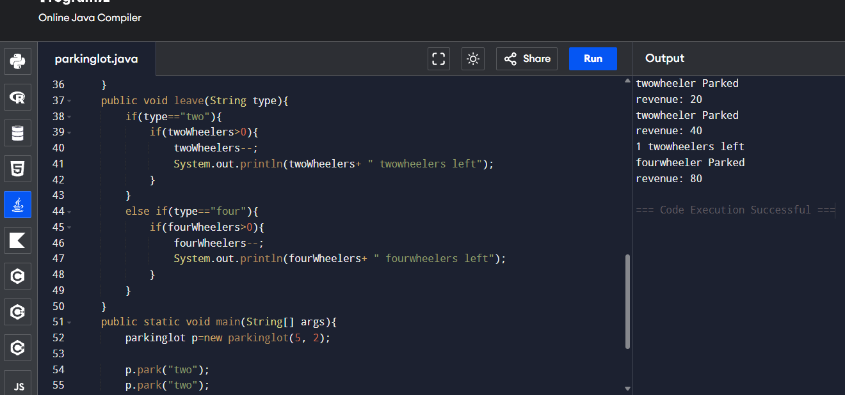
CONCLUSION :
Thus, the Rock-Paper-Scissors-Lizard-Spock game was successfully implemented using enum, switch expression, methods, and random number generation. The program plays five rounds, determines the winner of each round, keeps track of the score, and displays the overall winner at the end.

