PRACTICAL – 3
Aim: Distinct points (Point.java + Driver.java with main)
- Create class Point with private int x, y and a constructor.
- Override toString() to return “(x, y)”.
- Override equals(Object) to be true when both x and y match, and hashCode() to agree
(e.g. Objects.hash(x, y)).
- In Driver.main: build a Point[] with some repeated coordinates.
- Count distinct points: for each point, use equals() to check whether it already appeared earlier; count those that did not.
- Print “Distinct: N”.
Expected output: 5 points with 2 repeats → “Distinct: 3”.

Code Screenshot:
import java.util.Objects;
public class Pract3_1 { static class Point { private int x;
private int y;
Point(int x , int y){ this.x = x;
this.y = y;
}
@Override
public String toString() {
return "(" + this.x + ", " + this.y + ")";
}
@Override
public boolean equals(Object obj) { if (this == obj) {
return true;
}
if (obj == null || getClass() != obj.getClass()) { return false;
}

Point other = (Point) obj;
return this.x == other.x && this.y == other.y;
}

@Override
public int hashCode() {
return Objects.hash(this.x, this.y);
}
}
public static void main(String args[]){ Point p[] = {
new Point(1,2), new Point(2,3), new Point(4,5), new Point(1,3), new Point(6,7), new Point(8,9), new Point(2,7), new Point(4,3),
};
int count = 0;
for(int i = 0 ; i < p.length ; i++){ boolean check = false;
for(int j = 0 ; j < i ; j++){ if(p[i].equals(p[j])){
check = true; break;
}
}

if(!check){ count++;
}
}
System.out.println(count);

}
}

Output Screenshot:
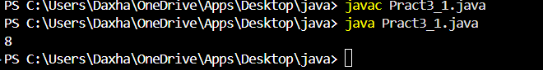

Learning Outcome:
- Learned how to create a class with private variables and a constructor.
- Learned how to override toString(), equals(), and hashCode() methods.
- Learned how to compare objects using the equals() method.
- Learned how to find and count distinct objects in an array by checking for duplicates.

Aim: Duplicate card check (Card.java + Driver.java)
- Create class Card with private String rank, suit and a constructor.
- Override toString() to return rank + “ of ” + suit (e.g. “Queen of Hearts”).
- Override equals()/hashCode() by rank + suit.
- In Driver.main: add cards to a Card[] one at a time; before adding each, use equals()
to check it against the earlier cards.
- Print “Duplicate found: <card>” the first time a repeat appears.
Expected output: a second “Ace of Spades” → “Duplicate found: Ace of Spades”.

Code Screenshot:
import java.util.*;

public class Pract3_2 { static class Card { private String rank; private String suit;
Card(String rank, String suit) { this.rank = rank;
this.suit = suit;
}
@Override
public String toString() {
return "(" + this.rank + ", " + this.suit + ")";
}

@Override
public boolean equals(Object obj) { if (this == obj) {
return true;
}
if (obj == null || getClass() != obj.getClass()) { return false;
}
Card other = (Card) obj;
return Objects.equals(this.rank, other.rank) && Objects.equals(this.suit, other.suit);

}
@Override
public int hashCode() {
return Objects.hash(this.rank, this.suit);
}
}

public static void main(String[] args) { Scanner sc = new Scanner(System.in); System.out.println("Enter No of cards : "); int n = sc.nextInt();
sc.nextLine();

Card c[] = new Card[n]; int count = 0;
for (int i = 0; i < n; i++) { boolean check = false;
System.out.println("Enter rank for card " + (i + 1) + ": "); String r = sc.nextLine();
System.out.println("Enter suit for card " + (i + 1) + ": "); String s = sc.nextLine();
c[i] = new Card(r, s);
for (int j = 0; j < i; j++) { if (c[i].equals(c[j])) { check = true;
break;
}
}
if (!check) { count++;
}
}
System.out.println("Total unique cards: " + count); sc.close();
}
}

Output Screenshot:
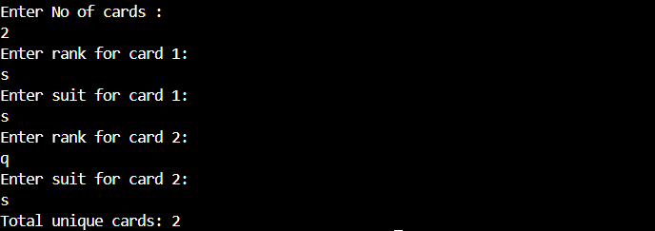

Learning Outcome:

Learned how to create a Card class with private variables and a constructor. Learned how to override toString(), equals(), and hashCode() methods.
Learned how to compare two Card objects to find duplicates.
Learned how to check for duplicate cards while adding them to an array. Learned how to count unique cards and identify repeated cards.

Aim: (For Advanced Learners – home) Fractions (Fraction.java + Driver.java)

- Create class Fraction with private int num, den.
- In the constructor, reduce to lowest terms: compute g = gcd(num, den) and divide
both by g.
- Override toString() to return num + “/” + den.
- Override equals()/hashCode() using the reduced num and den.
- In Driver.main: create several equivalent fractions (1/2, 2/4, 3/6) and confirm they
are all equal and print the same.
Expected output: new Fraction(2,4) prints “1/2” and equals new Fraction(1,2).

Code Screenshot:

public class Pract3_3 {
public static void main(String[] args) { Fraction first = new Fraction(1, 2); Fraction second = new Fraction(2, 4); Fraction third = new Fraction(3, 6);

System.out.println(first); System.out.println(second); System.out.println(third); System.out.println("All equal: "
+ (first.equals(second) && second.equals(third) && first.equals(third)));

}
}

/** An immutable fraction stored in lowest terms. */ class Fraction {
private int num; private int den;

public Fraction(int num, int den) { if (den == 0) {
throw new IllegalArgumentException("Denominator cannot be zero.");
}

long numerator = num; long denominator = den;
long g = gcd(numerator, denominator); numerator /= g;
denominator /= g;

// Keep the denominator positive, so equal values have one representation. if (denominator < 0) {
numerator = -numerator; denominator = -denominator;

}

this.num = Math.toIntExact(numerator); this.den = Math.toIntExact(denominator);
}

private static long gcd(long a, long b) {
a = Math.abs(a);
b = Math.abs(b); while (b != 0) {
long remainder = a % b;
a = b;
b = remainder;
}
return a;
}

@Override
public String toString() { return num + "/" + den;
}

@Override

public boolean equals(Object other) { if (this == other) {
return true;
}
if (!(other instanceof Fraction)) { return false;
}
Fraction fraction = (Fraction) other;
return num == fraction.num && den == fraction.den;
}

@Override
public int hashCode() { return 31 * num + den;
}
}

Output Screenshot:
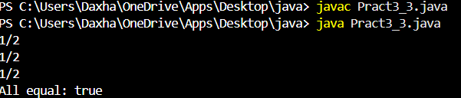

Learning Outcome:

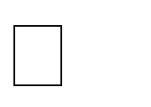
Learned how to create a Fraction class with a constructor and private variables. Learned how to reduce fractions to their lowest terms using the GCD method. Learned how to override toString(), equals(), and hashCode() methods.
Learned how to compare equivalent fractions, such as 1/2, 2/4, and 3/6. Learned how to represent equal fractions in the same simplified form.

