PRACTICAL-4

PART A:
1. Password strength (PasswordChecker.java + Driver1.java)
(a) In PasswordChecker, check four rules — length ≥ 8, contains an uppercase letter,
contains a digit, contains a special character — using regex (e.g. “.*[A-Z].*”) or
String methods.
(b) Write strength(String pw) that counts how many rules pass and returns “Weak” (0–
1), “Medium” (2–3) or “Strong” (4).
(c) In Driver.main: test several passwords; for each, print which rules passed and the
final label.
Expected output: “abc” → Weak; “Abcd1234!” → Strong.Expected output: 5 points with 2 repeats → “Distinct: 3”.

CODE:
Passwordchecker.java:
public class Passwordchecker{
public static Boolean length(String pwd){
return pwd.length()>=8;
}
public static Boolean hasupper(String pwd){
return pwd.matches(".*[A-Z].*");
}
public static Boolean hasdigit(String pwd){
return pwd.matches(".*[0-9].*");
}
public static Boolean hasspecial(String pwd){
return pwd.matches(".*[^a-zA-Z0-9].*");
}
public static String strength(String pwd){
int count=0;
if(length(pwd))
count++;
if(hasupper(pwd))
count++;
if(hasdigit(pwd))
count++;
if(hasspecial(pwd))
count++;

if(count<=1)
return "Weak";
else if(count==4)
return "Strong";
else
return "Medium";
}
}
Driver1.java:
public class Driver1 {
public static void main(String[] args) {
String[] passwords = {"abc", "PasssW","Abcd1234!","HELLO!2"};

for (String pwd : passwords) {

System.out.println("Password: " + pwd);
System.out.println("Length >= 8 : " + Passwordchecker.length(pwd));
System.out.println("Uppercase Letter : " + Passwordchecker.hasupper(pwd));
System.out.println("Contains Digit : " + Passwordchecker.hasdigit(pwd));
System.out.println("Special Character: " + Passwordchecker.hasspecial(pwd));
System.out.println("Strength: " + Passwordchecker.strength(pwd));
System.out.println("----------------------------");
}
}
}

OUTPUT:
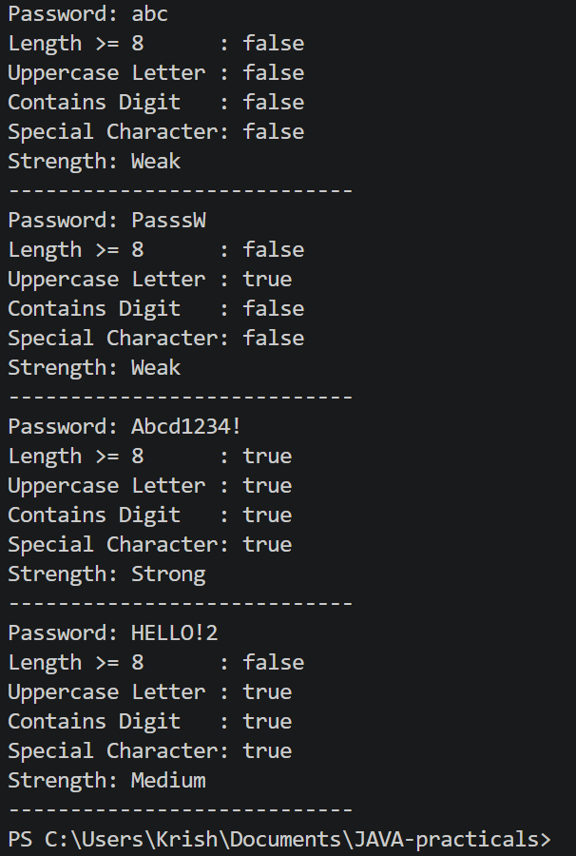

LEARNING OUTCOMES:
- Understand the use of regular expressions (Regex) for validating password rules.
- Learn to check conditions such as length, uppercase letters, digits, and special characters.
- Understand how to create and use methods in Java.
- Learn to calculate password strength based on the number of rules satisfied.
- Understand the use of conditional statements to classify passwords.

2. Chat-log filter (ChatFilter.java + Driver2.java)
(a) In Driver.main, define a String[] of log lines like “10:05 alice Hello there” (include
one malformed line with fewer than 3 parts).
(b) Read a keyword from the user.
(c) For each line, split into time/user/message with split(“ ”, 3); skip lines that do not
have 3 parts.
(d) If the message contains the keyword (case-insensitive), increment a counter and
append “time user: message” to a StringBuilder.
(e) Print “Matches: N” and the built report.
Expected output: keyword “hello” over 3 lines (1 malformed) → “Matches: 1” and
the matching line.

CODE:
Chatfilter.java:
public class Chatfilter {

public static String filter(String[] log, String keywd) {

StringBuilder s = new StringBuilder();
int c = 0;

for (String i : log) {

String[] s1 = i.split(" ", 3);

if (s1.length < 3)
continue;

String time = s1[0];
String user = s1[1];
String msg = s1[2];

if (msg.toLowerCase().contains(keywd.toLowerCase())) {
c++;
s.append(time)
.append(" ")
.append(user)
.append(": ")
.append(msg)
.append("\n");
}
}
return "Matches: " + c + "\n" + s.toString();
}
}

Driver2.java:
import java.util.*;
public class Driver2{
public static void main(String[] args) {

String[] log = {"08:05 Krisha Hello","09:10 Diya Hello everyone!","12:15 Ishita Hello!!"};

Scanner sc = new Scanner(System.in);

System.out.print("Enter keyword: ");
String keyword = sc.nextLine();

System.out.println();
System.out.println(Chatfilter.filter(log, keyword));

sc.close();
}
}
OUTPUT:
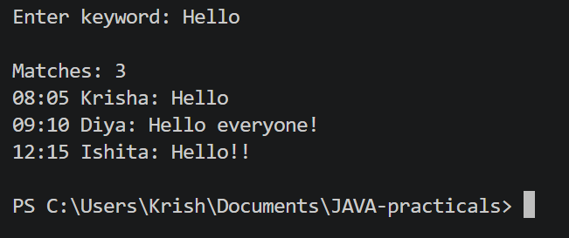

LEARNING OUTCOMES:
- Understand how to process and manipulate strings in Java.
- Learn to use split() to divide a string into meaningful parts.
- Understand case-insensitive string searching using toLowerCase() and contains().
- Learn to handle malformed or invalid input using conditional statements.
- Understand the use of StringBuilder for efficiently constructing a text report.

3. Template filler (TemplateFiller.java + Driver3.java)
(a) In Driver.main, define a template like “Dear {name}, order {id} ships {date}.” and
two parallel arrays: names {“name”, “id”} and values {“Riya”, “A07”} (note {date}
is not supplied).
(b) Compile a Pattern for \{(\w+)\} and get a Matcher on the template.
(c) Walk the matches with a StringBuilder: for each {placeholder}, look up its value in
the names array and replace with the value, or with “[?]” if not found.
(d) Print the filled template.
Expected output: the unsupplied {date} becomes [?].
CODE:
Templatefiller.java:
import java.util.regex.*;
public class Templatefiller {
public static String fill(String template, String[] names, String[] values) {
Pattern pattern = Pattern.compile("\\{(\\w+)\\}");
Matcher matcher = pattern.matcher(template);
StringBuilder result = new StringBuilder();
int last = 0;
while (matcher.find()) {
result.append(template, last, matcher.start());
String placeholder = matcher.group(1);
String replacement = "[?]";
for (int i = 0; i < names.length; i++) {
if (names[i].equals(placeholder)) {
replacement = values[i];
break;
}
}
result.append(replacement);
last = matcher.end();
}
result.append(template, last, template.length());
return result.toString();
}
}
Driver3.java:
public class Driver3 {
public static void main(String[] args) {
String template = "Dear {name}, order {id} ships {date}.";
String[] names = {"name", "id"};
String[] values = {"Krisha", "A17"};
String result = Templatefiller.fill(template, names, values);
System.out.println(result);
}
}
OUTPUT:
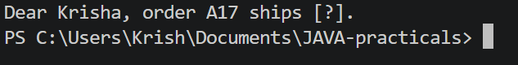

LEARNING OUTCOMES:
- Understand the use of regular expressions for identifying placeholders in text.
- Learn to use Pattern and Matcher for pattern matching in Java.
- Understand how to extract matched text using matcher.group().
- Learn to use StringBuilder for constructing the final output.
- Understand how to replace supplied placeholders with corresponding values and use a default value [?] for missing placeholders.

