Practical 10
1.
AIM :
Thread-pool runner: with a fixed pool of 3 (ExecutorService), submit about 10 Runnable
tasks that print their id and sleep briefly; shut down and await completion, observing the
few threads being reused.
CODE :
import java.util.concurrent.*;

public class Main {
public static void main(String[] args) throws Exception {

ExecutorService pool = Executors.newFixedThreadPool(3);

for (int i = 1; i <= 10; i++) {
int num = i;

pool.execute(() -> {
System.out.println("Task " + num + " running on " +
Thread.currentThread().getName());
});
}

pool.shutdown();
pool.awaitTermination(1, TimeUnit.MINUTES);

System.out.println("All tasks completed");
}
}
OUTPUT :
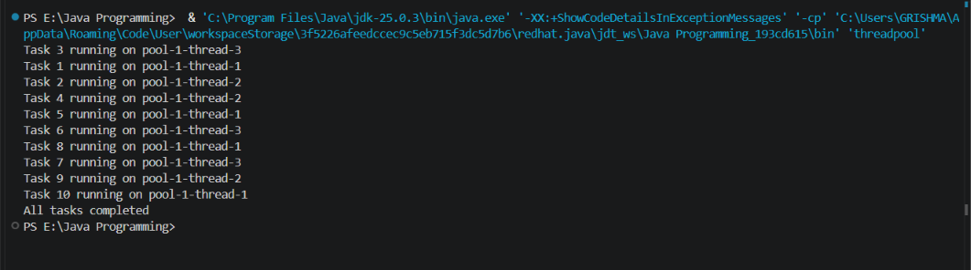
2.
AIM :
Producer–consumer: one thread adds numbers to a small shared buffer and another
removes them, coordinated with wait()/notify(); produce and consume a fixed number of
items in order with none lost.
CODE :
class Buffer {
int num;
boolean available = false;

synchronized void produce(int n) throws InterruptedException {
while (available) {
wait();
}

num = n;
available = true;

System.out.println("Produced: " + n);

notifyAll();
}

synchronized void consume() throws InterruptedException {
while (!available) {
wait();
}

System.out.println("Consumed: " + num);

available = false;

notifyAll();
}
}

public class ProducerConsumer {
public static void main(String[] args) {

Buffer b = new Buffer();

Thread t1 = new Thread(() -> {
try {
for (int i = 1; i <= 5; i++) {
b.produce(i);
}
} catch (InterruptedException e) {
Thread.currentThread().interrupt();
}
});

Thread t2 = new Thread(() -> {
try {
for (int i = 1; i <= 5; i++) {
b.consume();
}
} catch (InterruptedException e) {
Thread.currentThread().interrupt();
}
});

t1.start();
t2.start();
}
}
OUTPUT :
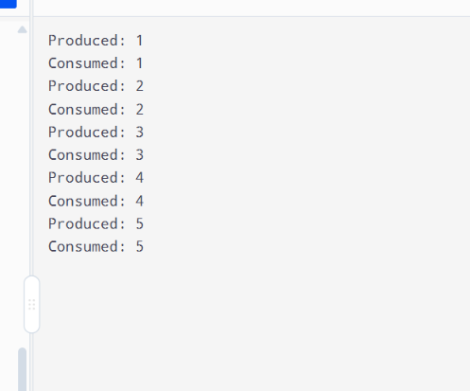
3.
AIM :
(For Advanced Learners – home) Reproduce a deadlock between two threads that lock
two objects in opposite order, then remove it with a consistent lock order. Choose the
scenario yourself.
CODE :
public class Main {

static Object a = new Object();
static Object b = new Object();

static void transfer(String name) {
synchronized (a) {
System.out.println(name + " locked A");

synchronized (b) {
System.out.println(name + " locked B");
System.out.println(name + " transfer completed");
}
}
}

public static void main(String[] args) {

Thread t1 = new Thread(() -> {
transfer("Thread 1");
});

Thread t2 = new Thread(() -> {
transfer("Thread 2");
});

t1.start();
t2.start();
}
}

OUTPUT :
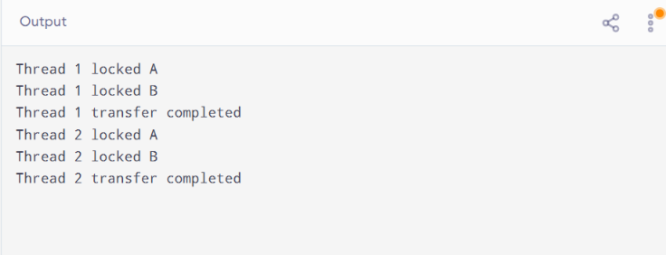

LEARNING OUTCOME :
- Understand and implement multithreading using Java.
- Execute multiple tasks using ExecutorService and thread pools.
- Implement the Producer–Consumer problem using wait() and notify().
- Understand deadlocks and prevent them using a consistent lock order.
- Apply multithreading concepts to process banking transactions safely.

