PRACTICAL-08

1.
AIM:
Guarded calculator: read two numbers and an operator; throw a custom
DivideByZeroException and catch invalid-number input separately, printing a clear
message each time; loop until a valid calculation succeeds and use finally to log each
attempt.

CODE:
import java.util.Scanner;
import java.util.InputMismatchException;

class DivideByZeroException extends Exception {
DivideByZeroException(String message) {
super(message);
}
}

public class GuardedCalculator {

public static void main(String[] args) {
Scanner sc = new Scanner(System.in);
boolean success = false;
int attempt = 0;

while (!success) {
attempt++;

try {
System.out.print("Enter first number: ");
double a = sc.nextDouble();

System.out.print("Enter operator (+, -, *, /): ");
String op = sc.next();

System.out.print("Enter second number: ");
double b = sc.nextDouble();

double result;

switch (op) {
case "+":
result = a + b;
break;

case "-":
result = a - b;
break;

case "*":
result = a * b;
break;

case "/":
if (b == 0) {
throw new DivideByZeroException(
"Cannot divide by zero!"
);
}
result = a / b;
break;

default:
System.out.println("Invalid operator!");
continue;
}

System.out.println("Result: " + result);
success = true;

} catch (DivideByZeroException e) {
System.out.println(e.getMessage());

} catch (InputMismatchException e) {
System.out.println("Invalid number input!");

if (sc.hasNext()) {
sc.next();
}

} finally {
System.out.println("Attempt " + attempt + " completed.");
System.out.println("--------------------");
}
}

sc.close();
}
}
OUTPUT:
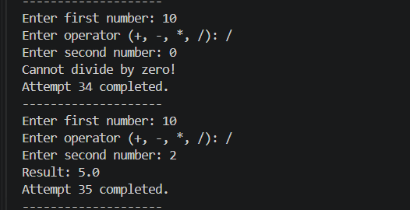
2.
AIM:
Stock issue: a Warehouse where issue(item, qty) throws a custom checked
OutOfStockException carrying the shortfall, and InvalidQuantityException for qty ≤ 0.
Process a list of requests, catching and reporting each failure without stopping the run.

CODE:
import java.util.Scanner;

class OutOfStockException extends Exception {
private int shortfall;

OutOfStockException(int shortfall) {
super("Out of stock! Shortfall: " + shortfall);
this.shortfall = shortfall;
}

public int getShortfall() {
return shortfall;
}
}

class InvalidQuantityException extends Exception {
InvalidQuantityException(String message) {
super(message);
}
}

class Warehouse {
private int stock;

Warehouse(int stock) {
this.stock = stock;
}

void issue(String item, int qty)
throws OutOfStockException, InvalidQuantityException {

if (qty <= 0) {
throw new InvalidQuantityException(
"Invalid quantity! Quantity must be greater than zero."
);
}

if (qty > stock) {
throw new OutOfStockException(qty - stock);
}

stock -= qty;
System.out.println("Issued " + qty + " units of " + item);
System.out.println("Remaining stock: " + stock);
}

int getStock() {
return stock;
}
}

public class WarehouseDemo {
public static void main(String[] args) {
Scanner sc = new Scanner(System.in);

Warehouse warehouse = new Warehouse(20);

System.out.print("Enter number of requests: ");
int n = sc.nextInt();
sc.nextLine();

for (int i = 1; i <= n; i++) {
System.out.println("\nRequest " + i);

System.out.print("Enter item name: ");
String item = sc.nextLine();

System.out.print("Enter quantity: ");
int qty = sc.nextInt();
sc.nextLine();

try {
warehouse.issue(item, qty);
} catch (OutOfStockException e) {
System.out.println(e.getMessage());
} catch (InvalidQuantityException e) {
System.out.println(e.getMessage());
}

System.out.println("Request processed.");
}

System.out.println("\nFinal stock: " + warehouse.getStock());

sc.close();
}
}
OUTPUT:
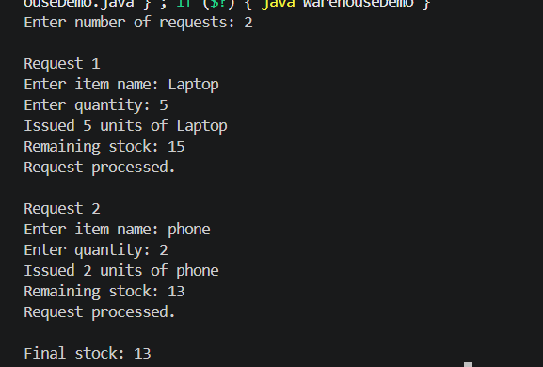
3.
AIM:
(For Advanced Learners – home) Create an AutoCloseable resource and use try-with-
resources to prove it always closes — even when an exception is thrown inside the block

— and that the original error is the one reported. Decide what to model as the resource.

CODE:
class MyResource implements AutoCloseable {

MyResource() {
System.out.println("Resource opened");
}

@Override
public void close() {
System.out.println("Resource closed");
}
}

public class AutoCloseDemo {

public static void main(String[] args) {
try (MyResource resource = new MyResource()) {
System.out.println("Inside try block");
throw new RuntimeException("Original exception occurred");
} catch (RuntimeException e) {
System.out.println("Caught: " + e.getMessage());
}

System.out.println("Program continues");
}
}
OUTPUT:
