Practical 09
1.
AIM:
Counter race: several threads each increment a shared counter many times. Run it
without synchronization to watch the total come out too low, then make the increment
synchronized and confirm it is exactly right every run.

CODE:

class Counter {
int count = 0;

void increment() {
count++;
}

synchronized void synchronizedIncrement() {
count++;
}
}

public class CounterRace {
static final int THREADS = 10;
static final int INCREMENTS = 100000;

public static void main(String[] args) throws InterruptedException {
Counter c1 = new Counter();
Thread[] t1 = new Thread[THREADS];

for (int i = 0; i < THREADS; i++) {
t1[i] = new Thread(() -> {
for (int j = 0; j < INCREMENTS; j++) {
c1.increment();
}
});
t1[i].start();
}

for (int i = 0; i < THREADS; i++) {
t1[i].join();
}

System.out.println("Without Synchronization: " + c1.count);
System.out.println("Expected Count: " + (THREADS * INCREMENTS));

Counter c2 = new Counter();
Thread[] t2 = new Thread[THREADS];

for (int i = 0; i < THREADS; i++) {
t2[i] = new Thread(() -> {
for (int j = 0; j < INCREMENTS; j++) {
c2.synchronizedIncrement();
}
});
t2[i].start();
}

for (int i = 0; i < THREADS; i++) {
t2[i].join();
}

System.out.println("With Synchronization: " + c2.count);
System.out.println("Expected Count: " + (THREADS * INCREMENTS));
}
}

OUTPUT :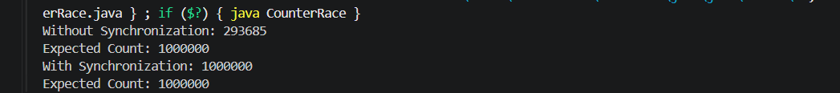
2.
AIM:
Seat booking race: a shared seatsLeft of 5 with about 10 threads each trying to book one
seat. Without synchronization show that more than 5 can succeed (oversell); with a
synchronized book() exactly 5 do.

CODE:
class SeatBooking {
int seatsLeft = 5;
int successfulBookings = 0;

void bookWithoutSync() {
if (seatsLeft > 0) {
try {
Thread.sleep(10);
} catch (InterruptedException e) {
Thread.currentThread().interrupt();
return;
}

seatsLeft--;
successfulBookings++;
System.out.println(Thread.currentThread().getName() + " booked a seat");
} else {
System.out.println(Thread.currentThread().getName() + " failed");
}
}

synchronized void book() {
if (seatsLeft > 0) {
seatsLeft--;
successfulBookings++;
System.out.println(Thread.currentThread().getName() + " booked a seat");
} else {
System.out.println(Thread.currentThread().getName() + " failed");
}
}
}

public class SeatBookingRace {
public static void main(String[] args) throws InterruptedException {
SeatBooking b1 = new SeatBooking();
Thread[] t1 = new Thread[10];

System.out.println("Without Synchronization:");

for (int i = 0; i < 10; i++) {
t1[i] = new Thread(() -> b1.bookWithoutSync(), "Thread-" + (i + 1));
t1[i].start();
}

for (int i = 0; i < 10; i++) {
t1[i].join();
}

System.out.println("Successful bookings: " + b1.successfulBookings);
System.out.println("Seats left: " + b1.seatsLeft);

SeatBooking b2 = new SeatBooking();
Thread[] t2 = new Thread[10];

System.out.println("\nWith Synchronization:");

for (int i = 0; i < 10; i++) {
t2[i] = new Thread(() -> b2.book(), "Thread-" + (i + 1));
t2[i].start();
}

for (int i = 0; i < 10; i++) {
t2[i].join();
}

System.out.println("Successful bookings: " + b2.successfulBookings);
System.out.println("Seats left: " + b2.seatsLeft);
}
}

OUTPUT :
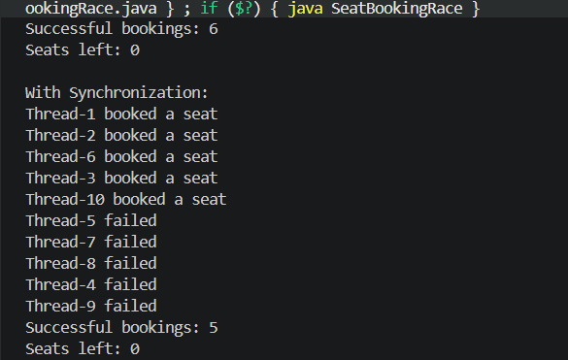

3.
AIM:
(For Advanced Learners – home) Split a large array of numbers across several threads
that add into one shared total, show the wrong result, then fix it two ways and compare;
decide how to measure the difference.

CODE:
import java.util.concurrent.atomic.AtomicLong;

class SharedTotal {
long total = 0;

void add(long value) {
total += value;
}

synchronized void addSync(long value) {
total += value;
}
}

public class ParallelSum {
static final int SIZE = 1000000;
static final int THREADS = 10;

static long[] arr = new long[SIZE];

static void runTest(int mode) throws InterruptedException {
SharedTotal shared = new SharedTotal();
AtomicLong atomicTotal = new AtomicLong(0);

Thread[] threads = new Thread[THREADS];

long start = System.nanoTime();

for (int i = 0; i < THREADS; i++) {
final int startIndex = i * (SIZE / THREADS);
final int endIndex = (i == THREADS - 1)
? SIZE : (i + 1) * (SIZE / THREADS);

threads[i] = new Thread(() -> {
long localSum = 0;

for (int j = startIndex; j < endIndex; j++) {
localSum += arr[j];
}

if (mode == 0) {
shared.add(localSum);
} else if (mode == 1) {
shared.addSync(localSum);
} else {
atomicTotal.addAndGet(localSum);
}
});

threads[i].start();
}

for (Thread t : threads) {
t.join();
}

long end = System.nanoTime();

if (mode == 0) {
System.out.println("Without synchronization: " + shared.total);
} else if (mode == 1) {
System.out.println("With synchronized: " + shared.total);
} else {
System.out.println("With AtomicLong: " + atomicTotal.get());
}

System.out.println("Time: " + (end - start) / 1_000_000.0 + " ms");
}

public static void main(String[] args) throws InterruptedException {
for (int i = 0; i < SIZE; i++) {
arr[i] = 1;
}

System.out.println("Expected total: " + SIZE);

runTest(0);
runTest(1);
runTest(2);
}
}
OUTPUT:
