Practical 11
1.
AIM :
Save/load: make a small class Serializable, save an array of its objects to a file with
ObjectOutputStream, then read it back into fresh objects and confirm the values survived.
Mark one field transient and show it is not saved.
CODE :
import java.io.*;
class Student implements Serializable {
int id;
String name;
transient String password;
Student(int id, String name, String password) {
this.id = id;
this.name = name;
this.password = password;
}
}
public class SaveLoad {
public static void main(String[] args) throws Exception {
Student[] s = {
new Student(1, "Amit", "abc123"),
new Student(2, "Riya", "xyz456")
};
ObjectOutputStream out = new ObjectOutputStream(new FileOutputStream("student.dat"));
out.writeObject(s);
out.close();

ObjectInputStream in = new ObjectInputStream(new FileInputStream("student.dat"));
Student[] data = (Student[]) in.readObject();
in.close();

for (Student st : data) {
System.out.println(st.id + " " + st.name + " " + st.password);
}
}
}

OUTPUT :
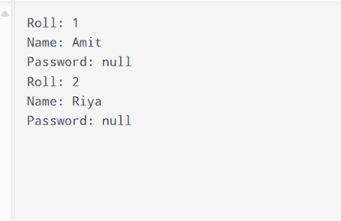
2.
AIM :
Log analyzer: create a few text files, then use Path/Files to read each line by line and
count the total lines and how many contain a keyword across all files; also print each
file’s size from its attributes.
CODE :
import java.nio.file.;
import java.nio.file.attribute.BasicFileAttributes;
import java.io.IOException;
import java.util.;
public class LogAnalyzer {
public static void main(String[] args) throws IOException {
Files.write(Paths.get("log1.txt"), Arrays.asList("Error found", "System running"));
Files.write(Paths.get("log2.txt"), Arrays.asList("Error occurred", "All good", "Error fixed"));
String[] files = {"log1.txt", "log2.txt"};
int totalLines = 0, count = 0;
String keyword = "Error";

for (String file : files) {
Path path = Paths.get(file);
List<String> lines = Files.readAllLines(path);

for (String line : lines) {
totalLines++;
if (line.contains(keyword))
count++;
}

BasicFileAttributes attr = Files.readAttributes(path, BasicFileAttributes.class);
System.out.println(file + " Size: " + attr.size() + " bytes");
}

System.out.println("Total lines: " + totalLines);
System.out.println("Lines containing " + keyword + ": " + count);
}
}
OUTPUT :
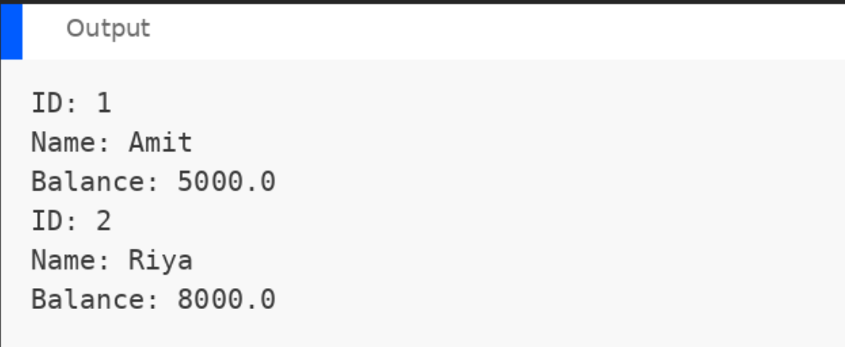
3.
AIM :
(For Advanced Learners – home) Walk a folder tree with NIO and produce a report of
the files it contains (name, size, modified time), writing the summary to a file; decide
what to include.
CODE :
import java.nio.file.;
import java.nio.file.attribute.BasicFileAttributes;
import java.io.;
public class FolderReport {
public static void main(String[] args) throws IOException {
Path folder = Paths.get("lab-NN");
Path report = Paths.get("report.txt");
try (BufferedWriter writer = Files.newBufferedWriter(report);
var stream = Files.walk(folder)) {

stream.filter(Files::isRegularFile).forEach(path -> {
try {
BasicFileAttributes attr = Files.readAttributes(path, BasicFileAttributes.class);

String info = path.getFileName() + " | "
+ attr.size() + " bytes | "
+ attr.lastModifiedTime();

writer.write(info);
writer.newLine();
System.out.println(info);
} catch (IOException e) {
System.out.println("Error reading file");
}
});
}

System.out.println("Report saved to report.txt");
}
}
OUTPUT :
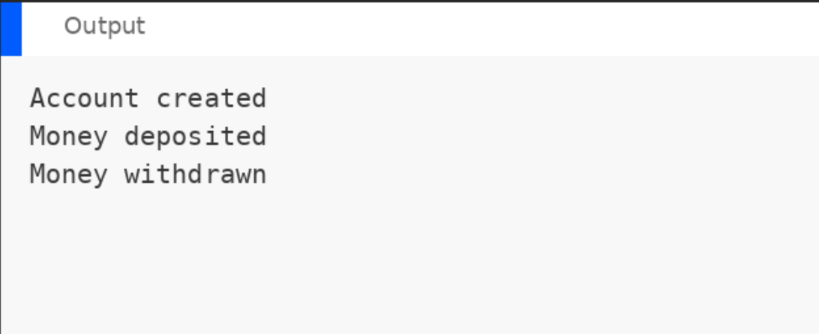

LEARNING OUTCOME :
- Understand serialization and deserialization in Java.
- Save and load objects using ObjectOutputStream and ObjectInputStream.
- Read and write files using Java NIO.
- Maintain transaction logs and generate reports using file handling.

