Practical 12
1.
AIM :
1. Word frequency: split a paragraph into words, count each in a HashMap, and print the
words sorted by frequency (highest first) using a Comparator.
CODE :
import java.util.*;

public class WordFrequency {
public static void main(String[] args) {

String paragraph = "java is easy java is powerful java";
String[] words = paragraph.toLowerCase().split("\\s+");

HashMap<String, Integer> frequency = new HashMap<>();

for (String word : words) {
frequency.put(word, frequency.getOrDefault(word, 0) + 1);
}

List<Map.Entry<String, Integer>> list =
new ArrayList<>(frequency.entrySet());

list.sort((a, b) -> b.getValue().compareTo(a.getValue()));

System.out.println("Word Frequency:");

for (Map.Entry<String, Integer> entry : list) {
System.out.println(entry.getKey() + " : " + entry.getValue());
}
}
}

OUTPUT :
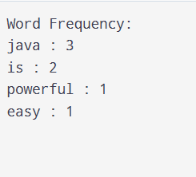
2.
AIM :
Producer–consumer: one thread adds numbers to a small shared buffer and another
removes them, coordinated with wait()/notify(); produce and consume a fixed number of
items in order with none lost.

CODE :
import java.util.*;
public class UniqueVisitors {
public static void main(String[] args) {
List<String> logins = Arrays.asList(
"Aesha", "Krisha", "Grishma",
"Aesha", "Panthi", "Krisha", "Srushti"
);

// Count unique users using HashSet
HashSet<String> uniqueUsers = new HashSet<>(logins);

// Maintain first-seen order using LinkedHashSet
LinkedHashSet<String> orderedUsers = new LinkedHashSet<>(logins);

// Print unique user count
System.out.println("Unique Visitors: " + uniqueUsers.size());

// Print first three distinct names
System.out.println("First Three Distinct Names:");

int count = 0;

for (String name : orderedUsers) {
if (count == 3) {
break;
}

System.out.println(name);
count++;
}
}
}

OUTPUT :
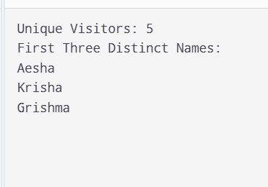
3.
AIM :
(For Advanced Learners – home) Build a leaderboard from player scores held in a Map
and print the top-N sorted by score (ties broken by name); choose the data and sorting
details.
CODE :
import java.util.*;
public class Leaderboard {
public static void main(String[] args) {
// Store player names and scores in a Map
Map<String, Integer> scores = new HashMap<>();

scores.put("Aesha", 95);
scores.put("Krisha", 85);
scores.put("Grishma", 95);
scores.put("Panthi", 75);
scores.put("Srushti", 90);

// Convert Map entries into a List
List<Map.Entry<String, Integer>> players =
new ArrayList<>(scores.entrySet());

// Sort by score (highest first), then by name alphabetically
players.sort(
Comparator.<Map.Entry<String, Integer>, Integer>
comparing(Map.Entry::getValue)
.reversed()
.thenComparing(Map.Entry::getKey)
);

// Print the top 3 players
int topN = 3;

System.out.println("Top " + topN + " Players:");

for (int i = 0; i < Math.min(topN, players.size()); i++) {
System.out.println(
players.get(i).getKey() + " : "
+ players.get(i).getValue()
);
}
}
}

OUTPUT :
