PRACTICAL-13
PART A:
1. Generic containers: a generic box with get/set and a Pair; use them with different types to show type safety without casts, and write a generic method that returns the first element of any array.

CODE:
package lab13;
class Box<T> {
private T value;

public void set(T value) {
this.value = value;
}
public T get() {
return value;
}
}
class Pair<A, B> {
private A first;
private B second;

public Pair(A first, B second) {
this.first = first;
this.second = second;
}

public A getFirst() {
return first;
}

public B getSecond() {
return second;
}
}

public class GenericDemo {

public static <T> T firstElement(T[] array) {
return array[0];
}
public static void main(String[] args) {
Box<Integer> intBox = new Box<>();
intBox.set(100);

Box<String> stringBox = new Box<>();
stringBox.set("Hello");

System.out.println("Integer Box: " + intBox.get());
System.out.println("String Box: " + stringBox.get());

Pair<String, Integer> student =
new Pair<>("Krisha", 21);

System.out.println("Name: " + student.getFirst());
System.out.println("Age: " + student.getSecond());

String[] names = {"Diya", "Krisha", "Ishu"};
Integer[] numbers = {10, 20, 30};

System.out.println("First name: " + firstElement(names));
System.out.println("First number: " + firstElement(numbers));
}
}

OUTPUT:
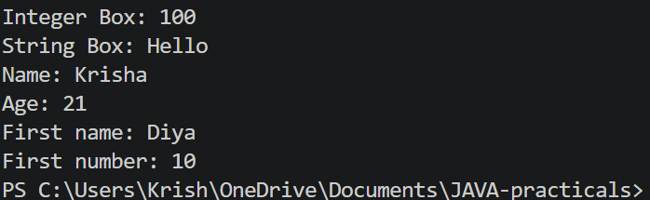

LEARNING OUTCOMES:
- Understand the concept of generics in Java and their advantages.
- Learn to create generic classes such as Box<T> and Pair<A, B>.
- Use generic containers with different data types while maintaining type safety.
- Implement a generic method to return the first element of an array.
- Reduce the need for explicit type casting using generics.

2. Bounded stats: a generic method double average(N[] values) that works for Integer[], Double[] and Long[]; note why it refuses non-Number types.

CODE:
package lab13;
public class BoundedStats {
public static <N extends Number> double average(N[] values) {
double sum = 0;
for (N value : values) {
sum += value.doubleValue();
}

return sum / values.length;
}

public static void main(String[] args) {

Integer[] integers = {10, 20, 30, 40};
Double[] doubles = {10.5, 20.5, 30.5};
Long[] longs = {100L, 200L, 300L};

System.out.println("Integer average: " + average(integers));
System.out.println("Double average: " + average(doubles));
System.out.println("Long average: " + average(longs));
}
}

OUTPUT:
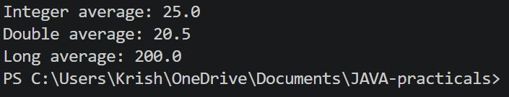

LEARNING OUTCOMES:
- Understand bounded type parameters using extends in Java generics.
- Learn to create a generic method that accepts numeric types using Number.
- Calculate the average of Integer, Double, and Long arrays.
- Use the doubleValue() method to perform calculations on different numeric types.
- Understand why non-numeric types are rejected by the bounded type parameter.

3. Implement a small generic container of your choice (e.g. a stack) backed by an array, reuse it for two different types, and handle the empty case sensibly.

CODE:
package lab13;
class MyStack<T> {

private T[] stack;
private int top;

@SuppressWarnings("unchecked")
public MyStack(int size) {
stack = (T[]) new Object[size];
top = -1;
}

public void push(T value) {

if (top == stack.length - 1) {
System.out.println("Stack is full!");
return;
}
stack[++top] = value;
}

public T pop() {

if (top == -1) {
System.out.println("Stack is empty!");
return null;
}
return stack[top--];
}

public T peek() {

if (top == -1) {
System.out.println("Stack is empty!");
return null;
}
return stack[top];
}

public boolean isEmpty() {
return top == -1;
}
}
public class GenericStackDemo {

public static void main(String[] args) {

MyStack<Integer> intStack = new MyStack<>(5);

intStack.push(10);
intStack.push(20);
intStack.push(30);

System.out.println("Integer stack pop: "
+ intStack.pop());

System.out.println("Integer stack peek: "
+ intStack.peek());

MyStack<String> stringStack = new MyStack<>(5);

stringStack.push("Java");
stringStack.push("Python");
stringStack.push("C++");

System.out.println("String stack pop: "
+ stringStack.pop());

System.out.println("String stack peek: "
+ stringStack.peek());
while (!stringStack.isEmpty()) {
stringStack.pop();
}
System.out.println("Trying to pop from empty stack:");
stringStack.pop();
}
}

OUTPUT:
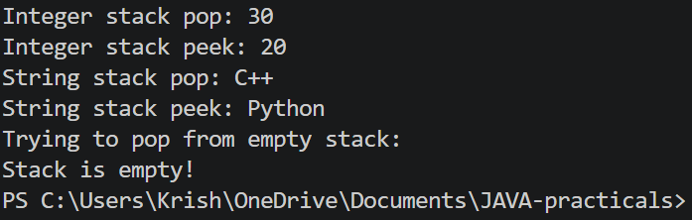

LEARNING OUTCOMES:
- Understand the implementation of a stack using a generic class and an array.
- Learn to perform stack operations such as push(), pop(), and peek().
- Reuse the same generic stack implementation for different data types.
- Handle stack overflow and underflow conditions appropriately.
- Understand how generics provide type safety and code reusability.

