PRACTICAL-14

PART A:
- Assemble and test: build a tiny layered app (a model, a service using an ArrayList, and a menu main), then write two or three JUnit @Test methods checking that adding increases the count and an invalid action throws — practice before testing MiniBank.

CODE:
Model/item.java:
package lab14.model;

public class Item {
private String name;

public Item(String name) {
this.name = name;
}

public String getName() {
return name;
}
}

Service/ItemService.java:
package lab14.service;
import lab14.model.Item;
import java.util.ArrayList;
public class ItemService {
private ArrayList<Item> items = new ArrayList<>();

public void addItem(String name) {
if (name == null || name.trim().isEmpty()) {
throw new IllegalArgumentException("Invalid item name");
}
items.add(new Item(name));
}
public int getCount() {
return items.size();
}

public void performAction(int choice, String name) {
switch (choice) {
case 1 -> addItem(name);
case 2 -> System.out.println("Total items: " + getCount());
default -> throw new IllegalArgumentException("Invalid action");
}
}
}
ItemServiceTest.java:
package lab14;
import org.junit.jupiter.api.Test;
import lab14.service.ItemService;
import static org.junit.jupiter.api.Assertions.*;
public class ItemServiceTest {
@Test
void addingItemIncreasesCount() {
ItemService service = new ItemService();

service.addItem("Book");

assertEquals(1, service.getCount());
}
@Test
void addingMultipleItemsIncreasesCount() {
ItemService service = new ItemService();

service.addItem("Pen");
service.addItem("Pencil");

assertEquals(2, service.getCount());
}
@Test
void invalidActionThrowsException() {
ItemService service = new ItemService();
assertThrows(IllegalArgumentException.class,
() -> service.performAction(9, ""));
}
}

Main.java:
package lab14;
import lab14.service.ItemService;
import java.util.Scanner;
public class Main {
public static void main(String[] args) {
Scanner sc = new Scanner(System.in);
ItemService service = new ItemService();
while (true) {
System.out.println("\n1. Add Item");
System.out.println("2. Show Count");
System.out.println("3. Exit");
System.out.print("Enter choice: ");
int choice = sc.nextInt();
sc.nextLine();

try {
switch (choice) {
case 1:
System.out.print("Enter item name: ");
String name = sc.nextLine();
service.performAction(1, name);
System.out.println("Item added successfully");
break;

case 2:
service.performAction(2, "");
break;

case 3:
System.out.println("Exiting...");
sc.close();
return;

default:
service.performAction(choice, "");
}
} catch (IllegalArgumentException e) {
System.out.println(e.getMessage());
}
}
}
}

OUTPUT:
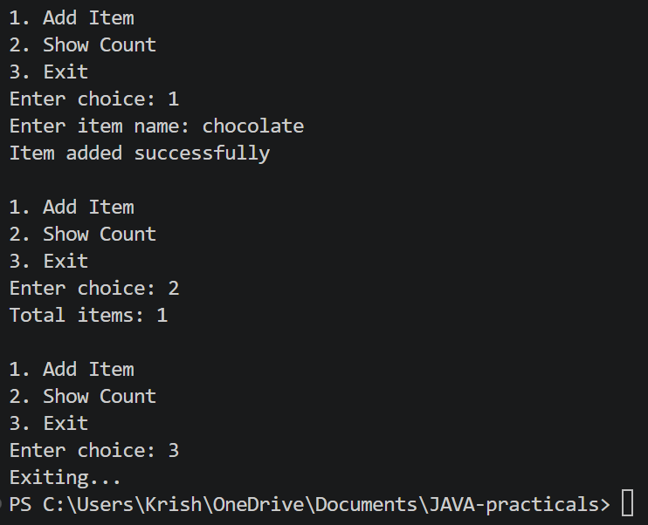

LEARNING OUTCOMES:
- To understand the organization of a Java application into model, service, and main classes.
- To implement data management using ArrayList and exception handling.
- To write and execute JUnit test cases using assertions such as assertEquals() and assertThrows().

- Organise that app into packages, build a runnable JAR, and add a test that saves and reloads its data unchanged.

CODE:
ItemServiceTest.java:
package lab14.test;
import lab14.src.service.ItemService;
import org.junit.jupiter.api.Test;
import java.nio.file.Files;
import java.nio.file.Path;

import static org.junit.jupiter.api.Assertions.*;
public class ItemServiceTest {

@Test
void addingItemIncreasesCount() {
ItemService service = new ItemService();
service.addItem("Book");

assertEquals(1, service.getCount());
}

@Test
void invalidItemThrowsException() {
ItemService service = new ItemService();

assertThrows(IllegalArgumentException.class,
() -> service.addItem(""));
}
@Test
void saveAndReloadPreservesData() throws Exception {
Path file = Files.createTempFile("items", ".dat");

try {
ItemService original = new ItemService();
original.addItem("Book");
original.addItem("Pen");

original.save(file.toString());
ItemService restored = new ItemService();
restored.load(file.toString());
assertEquals(original.getCount(), restored.getCount());
assertEquals(
original.getItems().toString(),
restored.getItems().toString()
);
} finally {
Files.deleteIfExists(file);
}
}
}
Main.java:
package lab14.src;
import lab14.src.service.ItemService;
import java.util.Scanner;

public class Main {
public static void main(String[] args) {
Scanner sc = new Scanner(System.in);
ItemService service = new ItemService();
while (true) {
System.out.println("\n1. Add Item");
System.out.println("2. Show Items");
System.out.println("3. Save Items");
System.out.println("4. Load Items");
System.out.println("5. Exit");
System.out.print("Enter choice: ");
int choice = sc.nextInt();
sc.nextLine();
try {
switch (choice) {
case 1:
System.out.print("Enter item name: ");
service.addItem(sc.nextLine());
System.out.println("Item added.");
break;
case 2:
System.out.println(service.getItems());
break;
case 3:
service.save("items.dat");
System.out.println("Data saved.");
break;
case 4:
service.load("items.dat");
System.out.println("Data loaded.");
break;
case 5:
sc.close();
return;
default:
throw new IllegalArgumentException("Invalid choice");
}
} catch (Exception e) {
System.out.println("Error: " + e.getMessage());
}
}
}
}
Manifest.txt:
Main-Class: lab14.src.Main
OUTPUT:
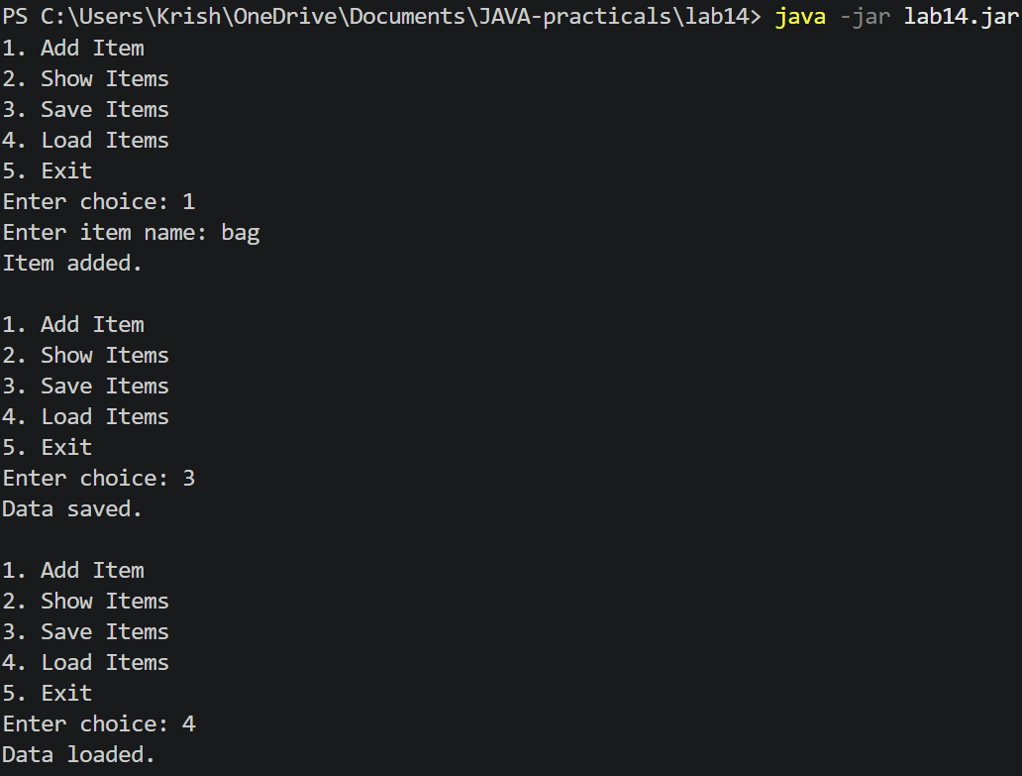

LEARNING OUTCOMES:
- To organize Java classes into packages for better modularity and maintainability.
- To create and execute a runnable JAR file using a manifest file.
- To implement data serialization and deserialization and verify data integrity using JUnit tests.

