User Documentation For Movie Rental Application

Is it possible to Log in/out of this application? If yes the how? ☺

-Yes in this Application registered users are able to Log in/out of the applications.

Screen shot showing log in/out button.

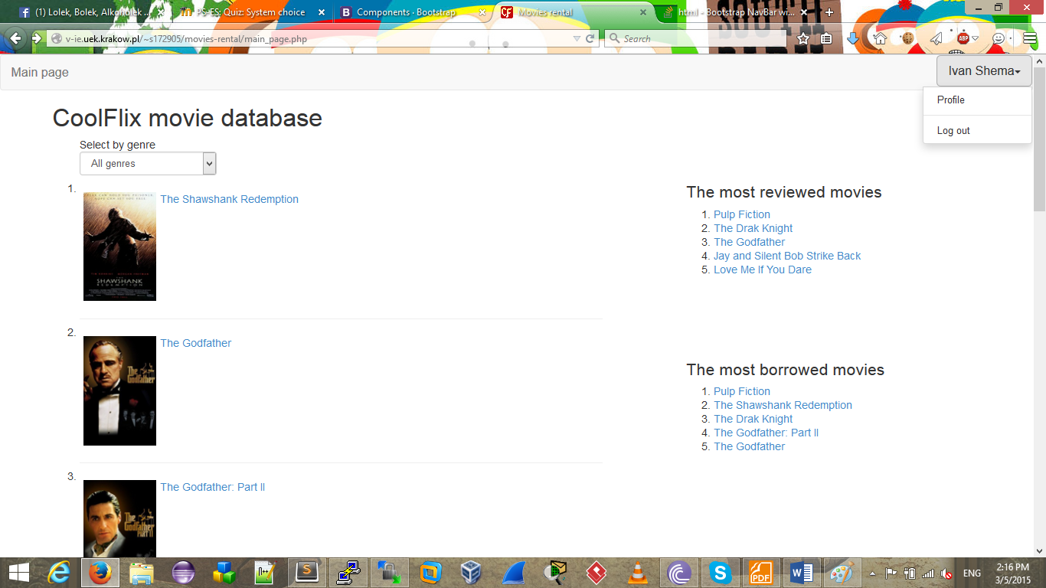

Is this application able to show detailed information about the listed movies??

-A logged in User can be able to visit the home page for details about the movies,

He/she can view the list of available movies by clicking on the available button

Screen-shot of the available page goes here

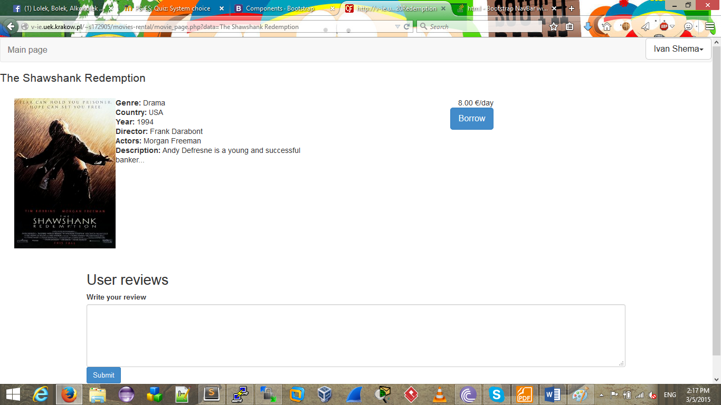

The user may as well want to check the genres that fit his/her choice .

Screen shot of genre button and page goes here.

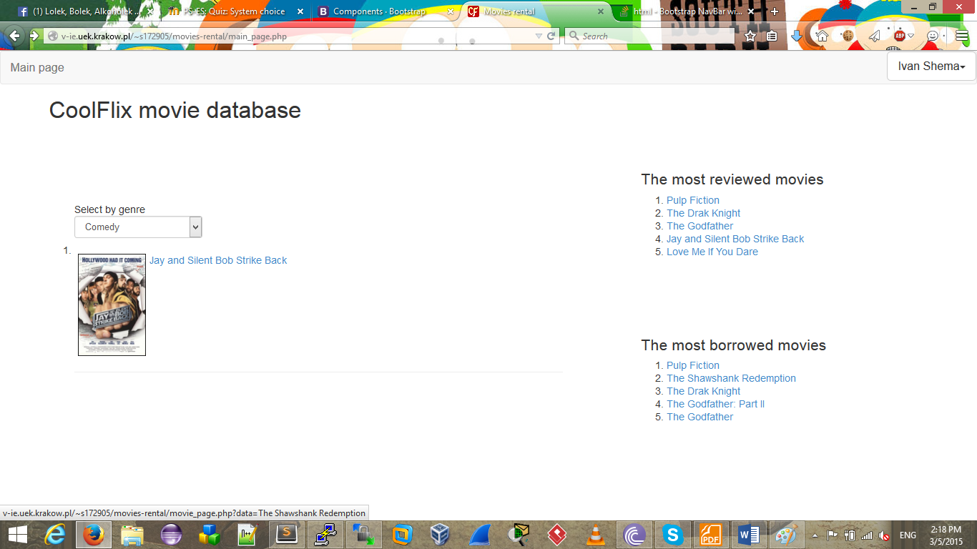

How do I actually select a movie, where are the descriptions…whats the Price of borrowing????

The user can be linked up with the movie of his choice by clicking either the Title link or the Cover link.

After clicking any of the two links (tittle or Cover link) the user is now able to view the description ,cover art and a list of actors

Screen shot if necessary   
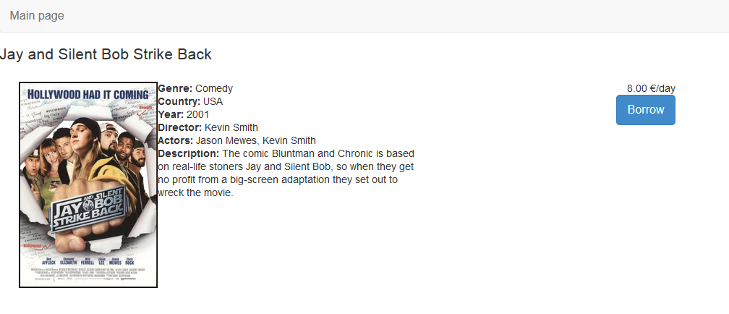

Borrow and Price links are visible as well after clicking the above buttons

On bottom of that A logged in user is able to add a review by clicking the review button

Screen shot goes here.  
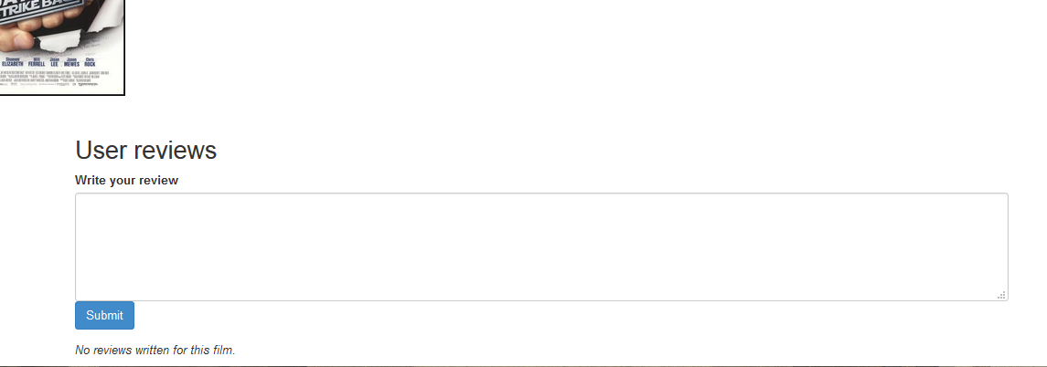

Oh really?? Am able to add my own personal review??? How may I? ☺

Yes a user can add his/her review by clicking the “add review” button, by doing that a text box will appear where the review is supposed to be added. After adding the review the user will send it. He/she is re-directed back to the movie page. However, He/She won’t be able to direct see his/her Review.

Screen shots here  
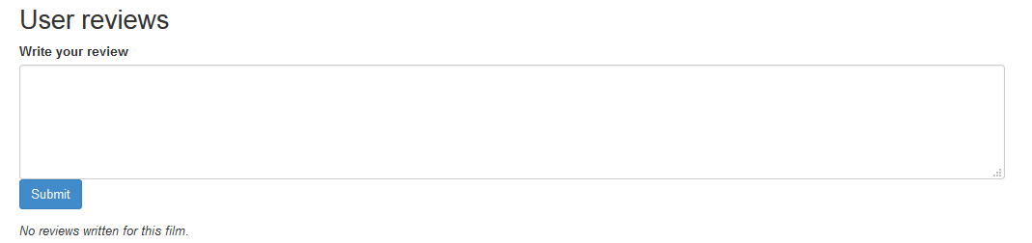

I am new to this application can I start to borrow the movies directly??

If you are not registered to our web-page you will be asked to first register after clicking the Borrow button in order to start borrowing.

When an unknown user is clicks the borrow button he/she is asked to first sign, the registration link will be visible and by then the new user will be able to register.

Screen shots here  
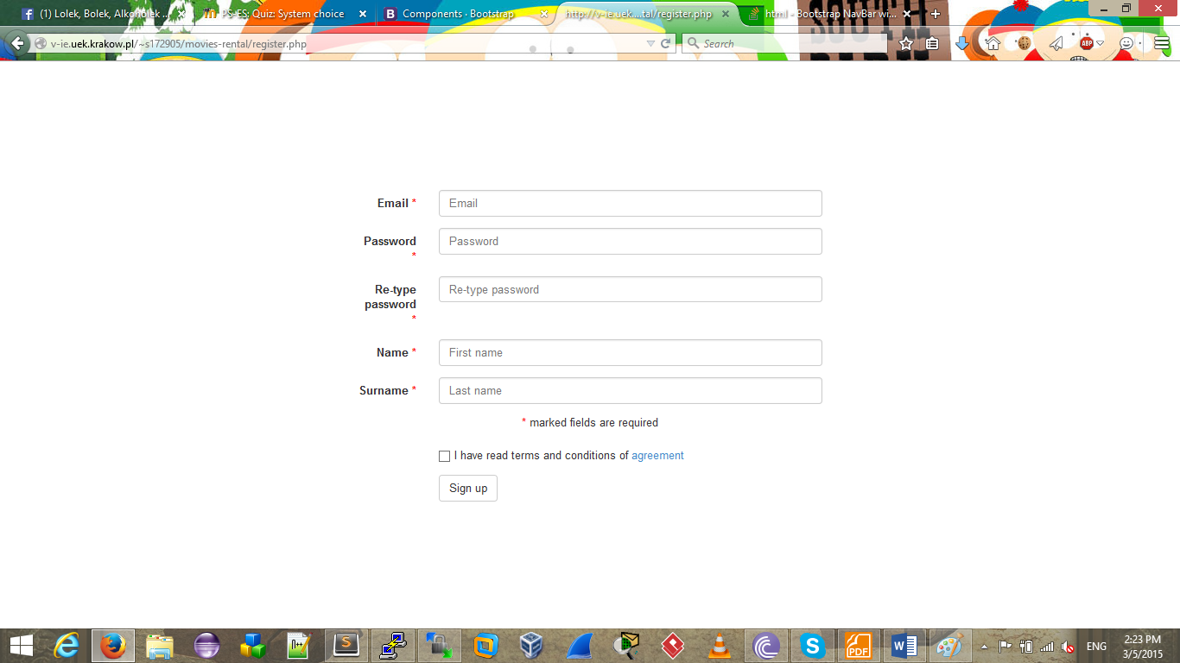

Am already a member what are the ways and terms of borrowing??

Members of our web-page are able to borrow by just clicking the Borrow button that is found in the Movie page. After clicking the Borrow Button the user will be redirected to the page with information about the form, terms and payment date. He as well receives the information about form,terms and payment date in his/her email.

Am I able to see the list of what I have ordered??

Yes as a logged in user you are able to see list of orders and statuses (in progress,paid)  
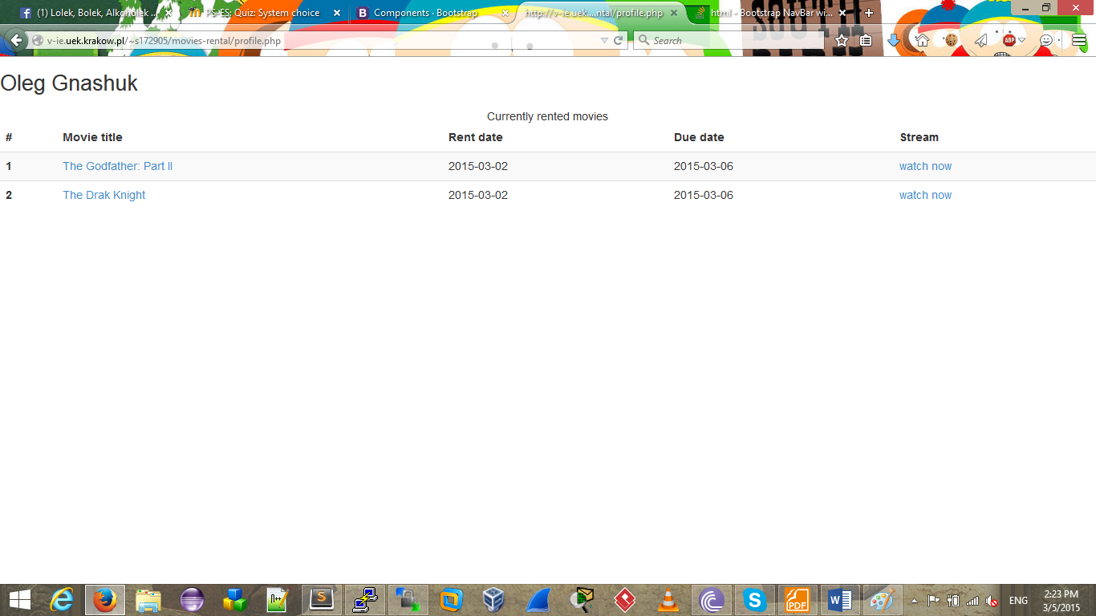

Oh well, So how do I finally watch the movies ?? ☺ ☺

After Borrowing a logged in user will can watch the borrowed movies by clicking the “watch button”. By then you may watch you movie

Screen shots here  
