CS414 Group-H
Bryce Myers
Troy Cogburn
Sky Egelhoff
Nate Gillard

Assignment 4: Design and Implement Iteration I

Assumptions:
1. This pizza ordering system is designed from a in-store register perspective. Meaning the application is designed to be used by a Employee of the pizza restaurant.
2. The ordering system does not keep record of customers to maintain a database of orders or customer record. Each order has a one to one association to a customer and each customer has at most one address, depending on whether the order is for delivery or not.

Updated Domain Model:
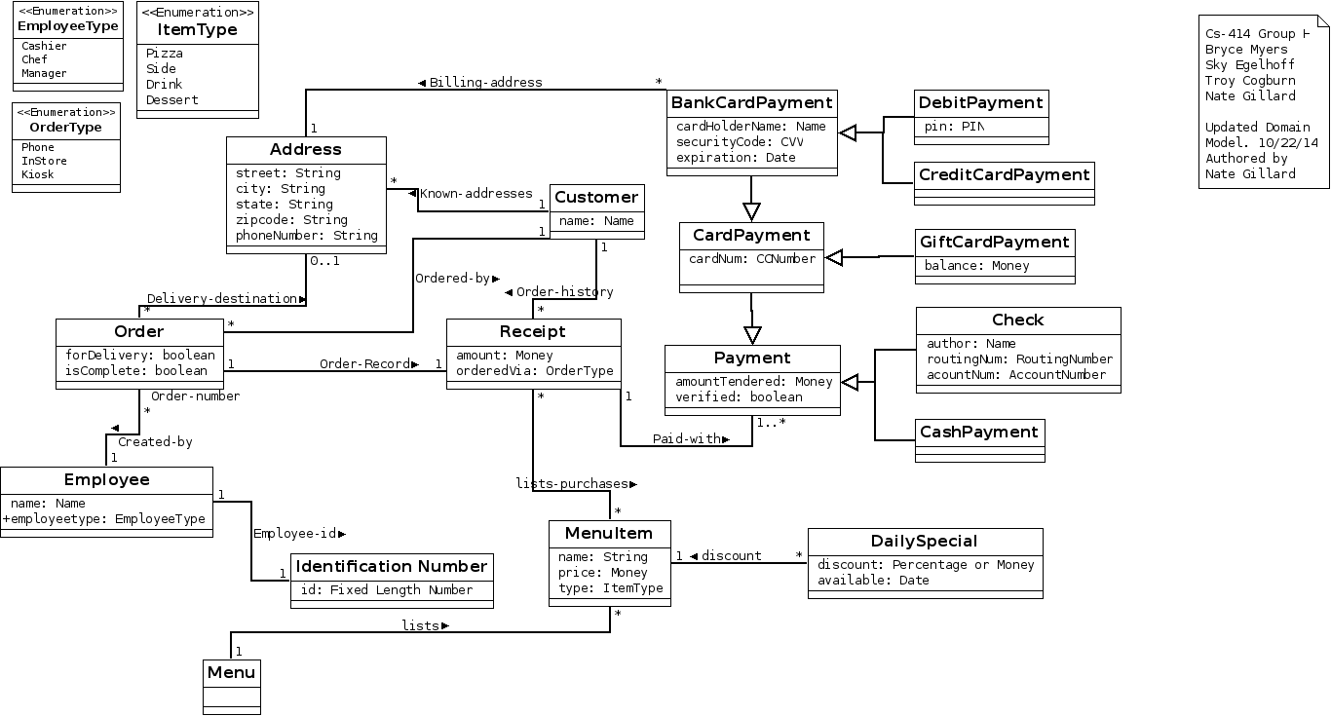

Design Class Model:
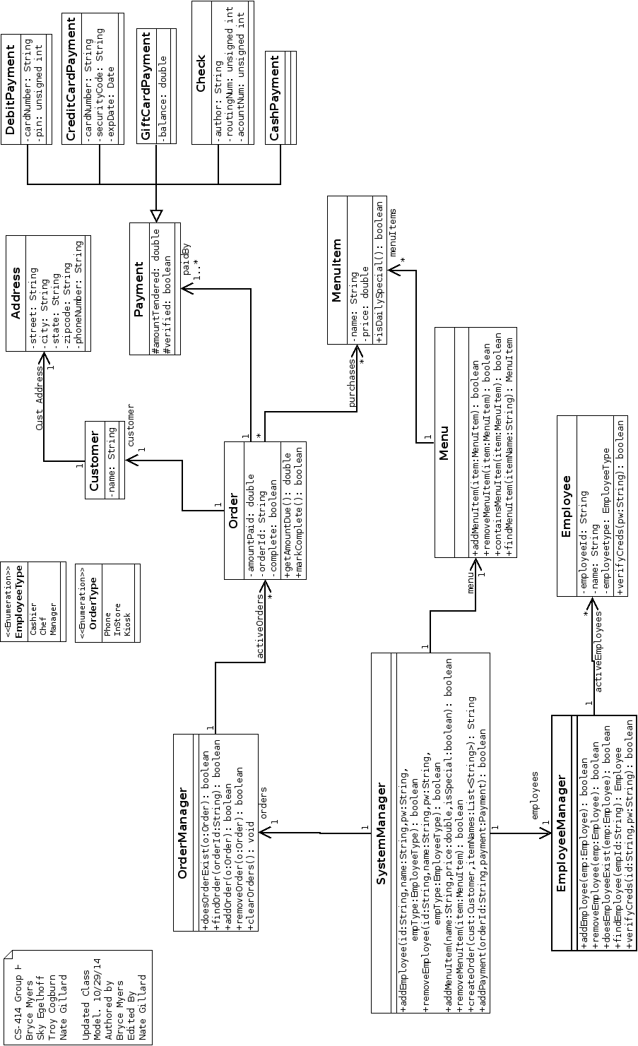

Sequence Diagrams:
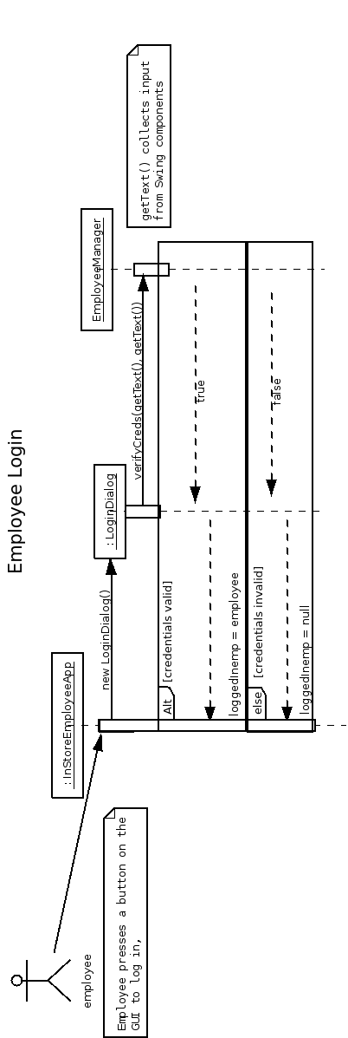

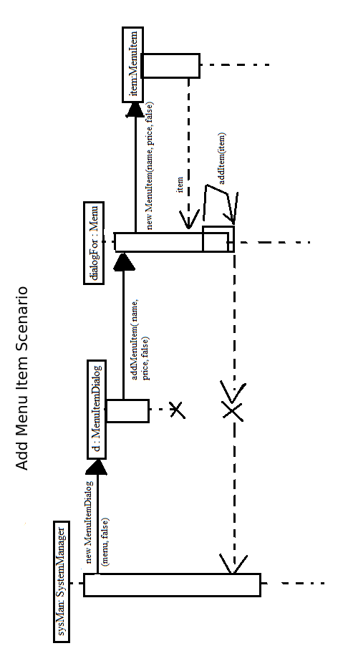

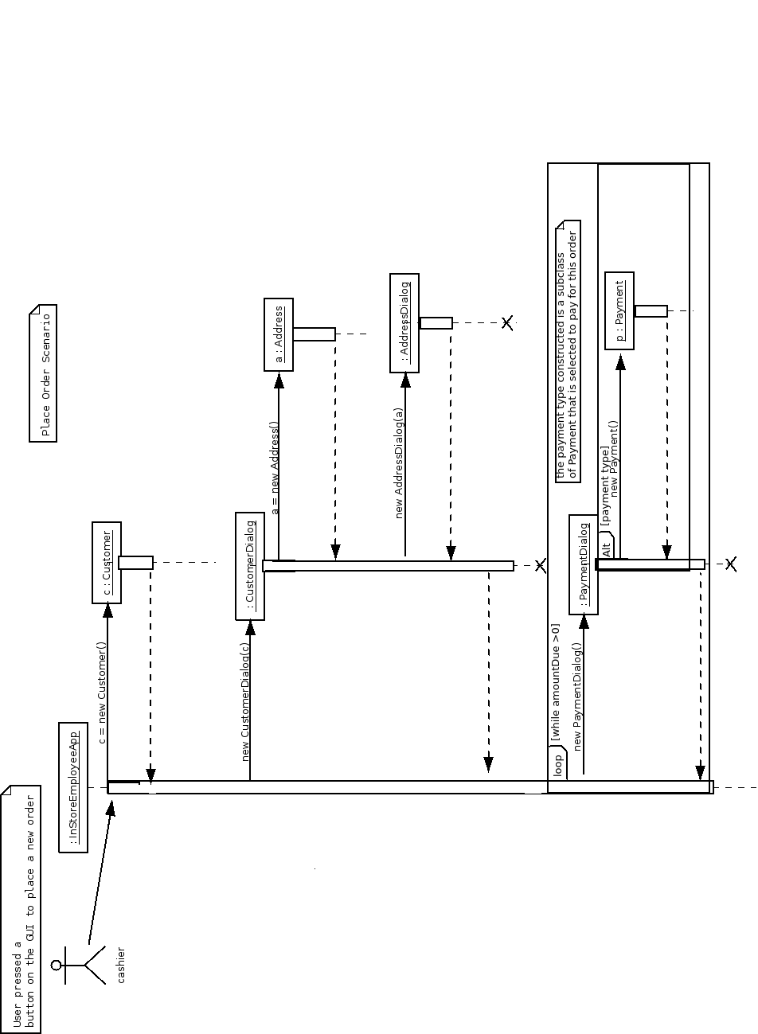

Test Plan:

1. Login Employee:
-Tests the EmployeeManager module.
- The system must allow employees to login to the system.

Instructions:
1. Run the InStoreEmployeeApp by running the provided .jar (rezise the window if needed).
2. Press the Login Employee button.
3. In the dialog that appears enter ‘003’ as ID and ‘password’ as Password.
4. Press Accept.

Result:
The employee has been logged in.
- The employee’s name, Jo Smith, is displayed as the logged in employee.
- Since this employee is a manager more buttons are available (Add/Edit Menu Item, View Orders).

Cleanup:
No clean up required, please stay logged in for next test case.

2. Add Menu Item:
-Tests the Menu (MenuItemManager) module, by performing an add ittem scenario and view menu scenario.
-If the restaurant wants to offer new items there must be a way to add offers to the menu.

Instruction:
1. Run the provided .jar and login as user ‘003’ password ‘password’ if not already logged in.
2. Press the Add menu Item button.
3. In dialog that appears create a name for your item, then give a price, select if this item is a daily special, and finally press the accept button.
4. The dialog will exit, press the View menu button. A new dialog will appear where you will see the item you created listed.
5. Press the back button to return to the main menu.

Result:
The item has been added to the menu.
- The item can be viewed on the menu.

Cleanup:
No clean up required, please stay logged in for the next test case.

3. Place New Order
- tests the OrderManager module, and Place order scenario.

Instruction:
1. Run the provided .jar and login as user ‘003’ password ‘password’ if not already logged in.
2. Press the “Place Order” button.
3. A new dialog will appear for entering the customers address. Please fill these fields with an address real or imaginary, (eg: Street: 123 Seaseme street, City: New York, State: NY, Zip: 08665, Phone: 908-211-4456) then press accept.
4. A new dialog will appear for the customer’s name. Please enter a name (eq Steve MillerBand), then press accept
5. A new dialog will appear. This dialog is for adding items to the order. The top left cell contains the menu. Select items with the mouse (one item at a time), and press the ‘Add selected items to order’ button. (eg add a Pepperoni Pizza and Breadsticks(6)).
6. Once the desired items are added to the order press the ‘accept’ button.
7. A new Dialog will appear for adding payments to the order. Note the Amount due displayed in this dialog.
8. Press the button for cash and enter the amount 10.00 in the new dialogue's text field labeled amount. Then press accept.
9. Press the button for credit payment and enter the amount 3.99 and press accept.
10. A new dialogue will appear for entering the credit payment infromation Fill this information with the name provided in step 4 (or any String). Give a card number (any string), Card Security Code (any string) and Card Expiration date (any string). Press accpet.
11. The program will return to the main screen. Select view orders to see the order has been created.

Results:
The item may now be viewed in the View Order screen.
The total was calculated correctly and payments were applied correctly (minor issues with rounding doubles)

Cleanup:
No clean up required, please stay logged in for the next test case.

Commit log:

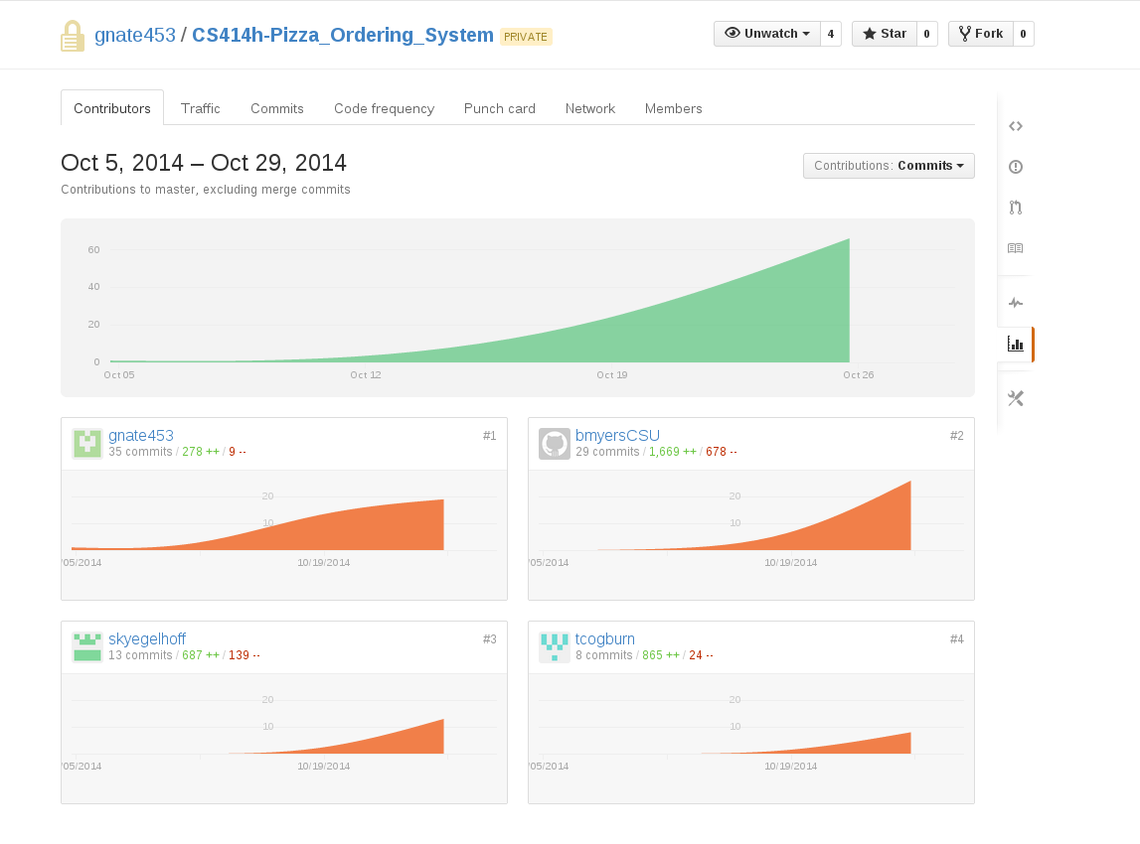
commit 11194ca743d3d9d9c3791b66c67563db5e9da247
Merge: 0fa3171 f6f9086
Author: tcogburn <tcogburn@rams.colostate.edu>
Date: Wed Oct 29 17:40:33 2014 -0600

Merge branch 'master' of git@github.com:gnate453/CS414h-Pizza_Ordering_System.git

commit 0fa31717d8e74f6447748a280e0ab0837b073a98
Author: tcogburn <tcogburn@rams.colostate.edu>
Date: Wed Oct 29 17:40:26 2014 -0600

Changed Attribute types in payment classes

commit f6f9086d8d68f9c08dd73352416798a30a05e192
Merge: 1c263b4 090b3f1
Author: bmyerscsu <bryce.myers@rams.colostate.edu>
Date: Wed Oct 29 17:38:20 2014 -0600

Merge branch 'master' of git@github.com:gnate453/CS414h-Pizza_Ordering_System.git

commit 1c263b4f7cfba2ebe1ecd40eb05a57314b4bc53b
Author: bmyerscsu <bryce.myers@rams.colostate.edu>
Date: Wed Oct 29 17:38:13 2014 -0600

Validation and formatting changes

commit 090b3f163bdbbe03d00be520daa56ee54e47b90b
Author: tcogburn <tcogburn@rams.colostate.edu>
Date: Wed Oct 29 17:37:33 2014 -0600

Added isEmpty() method to Address

commit 03eb6f3585aae739a06adb9698e5f4bb8afc5355
Author: tcogburn <tcogburn@rams.colostate.edu>
Date: Wed Oct 29 17:36:50 2014 -0600

Fixed Remove item bug in place order

commit 1fb642ca89d42aece1fb07a219b4c83a76a6197a
Merge: d8e530e c2df533
Author: tcogburn <tcogburn@rams.colostate.edu>
Date: Wed Oct 29 16:58:25 2014 -0600

Merge branch 'master' of
git@github.com:gnate453/CS414h-Pizza_Ordering_System.git

Conflicts:
a4/src/cs414/groupH/a4/order/OrderDialog.java

commit d8e530ed22180540af3ee59886098da389f50d09
Author: tcogburn <tcogburn@rams.colostate.edu>
Date: Wed Oct 29 16:56:03 2014 -0600

Removed system outs and fixed remove item bug

commit c2df5336dd058bac66baa8b14be8c99d0dfb7a0a
Author: bmyerscsu <bryce.myers@rams.colostate.edu>
Date: Wed Oct 29 16:55:13 2014 -0600

Added validation to login and add/edit menu items

commit 1082076e205e8a3c2e3d84b527bcc5bfe5b25f33
Author: gnate320 <gnate@rams.colostate.edu>
Date: Wed Oct 29 16:53:37 2014 -0600

fixed AddItem seqence diagram file

commit dbd1004bf542aae64c6b711e3f21953b2a56d6ab
Author: gnate320 <gnate@rams.colostate.edu>
Date: Wed Oct 29 16:51:19 2014 -0600

fixed AddItem seqence diagram file

commit 6abe34caf314f7d0746fba2b6d2ab8524827ddb8
Merge: 36bbea9 6984418
Author: gnate320 <gnate@rams.colostate.edu>
Date: Wed Oct 29 16:29:54 2014 -0600

Merge branch 'master' of https://github.com/gnate453/CS414h-Pizza_Ordering_System

commit 36bbea91f89226b39f5c54ae1ebc54457f56b2f8
Author: gnate320 <gnate@rams.colostate.edu>
Date: Wed Oct 29 16:29:07 2014 -0600

Employee login as last sequence diagram.

commit 6984418ba66767bc316f2fdc15140bac52263187
Merge: 9a90e39 c90c705
Author: bmyerscsu <bryce.myers@rams.colostate.edu>
Date: Wed Oct 29 16:07:40 2014 -0600

Merge branch 'master' of git@github.com:gnate453/CS414h-Pizza_Ordering_System.git

commit 9a90e391963e9a099da9d05bc789103467f5e213
Author: bmyerscsu <bryce.myers@rams.colostate.edu>
Date: Wed Oct 29 16:07:17 2014 -0600

Made view orders layout static; fixed order bug

commit c90c7055f13054ee0706a70d12e90400ff83f292
Merge: 85ed400 2e76ed5
Author: gnate320 <gnate@rams.colostate.edu>
Date: Wed Oct 29 16:03:04 2014 -0600

Merge branch 'master' of https://github.com/gnate453/CS414h-Pizza_Ordering_System

commit 85ed4002a902d6cd2b6dfd8a351f1008914a1b95
Author: gnate320 <gnate@rams.colostate.edu>
Date: Wed Oct 29 16:02:58 2014 -0600

updating AddMenuItem sequence diagrams

commit 2e76ed55ac9af5c178f2bd6cf2eafc7e9a6fb8a3
Author: tcogburn <tcogburn@rams.colostate.edu>
Date: Wed Oct 29 16:02:15 2014 -0600

Minor bug fix with grid size

commit 190807a7378a07af125526fab6006cb329dd8f83
Merge: eb1246d 63264ea
Author: bmyerscsu <bryce.myers@rams.colostate.edu>
Date: Wed Oct 29 15:57:25 2014 -0600

Merge branch 'master' of git@github.com:gnate453/CS414h-Pizza_Ordering_System.git

commit eb1246d15d5cc13cf62f142613d012bc3424b6a8
Author: bmyerscsu <bryce.myers@rams.colostate.edu>
Date: Wed Oct 29 15:57:22 2014 -0600

Fixed bug with ordering

commit 42ae89bd15074292a0d1583b48c8153e55e8dd76
Author: gnate320 <gnate@rams.colostate.edu>
Date: Wed Oct 29 15:54:46 2014 -0600

updating place order seqence diagrams

commit 63264ea6e375762a62427fa9b1f84900ea29801b
Author: tcogburn <tcogburn@rams.colostate.edu>
Date: Wed Oct 29 15:54:28 2014 -0600

View Order Details tweeks

commit ed3da85db5ab4ddd033160534509d30c7cf0b163
Merge: 8c44ce9 aab241f
Author: tcogburn <tcogburn@rams.colostate.edu>
Date: Wed Oct 29 15:50:05 2014 -0600

Merge branch 'master' of git@github.com:gnate453/CS414h-Pizza_Ordering_System.git

commit 8c44ce9c0f47c1145ea128e8c591e8f5382d3d6f
Author: tcogburn <tcogburn@rams.colostate.edu>
Date: Wed Oct 29 15:49:55 2014 -0600

Added Initial data and ViewOrderDetails

commit aab241f2a1c2f87dcfcab84ce4d01035a86e5958
Author: bmyerscsu <bryce.myers@rams.colostate.edu>
Date: Wed Oct 29 15:48:44 2014 -0600

Added order validation; fixed order bug

commit f90afe3052f9944480e63f9d3799ee18d1083bad
Author: bmyerscsu <bryce.myers@rams.colostate.edu>
Date: Wed Oct 29 15:29:02 2014 -0600

Changed customer

commit 4b360737629b6f4fa2f7528f545212bd94c985f1
Author: bmyerscsu <bryce.myers@rams.colostate.edu>
Date: Wed Oct 29 15:13:25 2014 -0600

Added options to edit menu item

commit 21c8461dda5c31fe70a7115c2830173717c1a912
Author: bmyerscsu <bryce.myers@rams.colostate.edu>
Date: Wed Oct 29 15:06:36 2014 -0600

Added find order functionality to sysmanager

commit 4085dcd719a100165a4001bc9f41184809ae117b
Author: tcogburn <tcogburn@rams.colostate.edu>
Date: Wed Oct 29 14:43:57 2014 -0600

PlaceOrder multiple payment functionality working

commit 5ea464e83d09a4a1e0c13f07f6eadc1edc4a6c5c
Author: bmyersCSU <bryce.myers@rams.colostate.edu>
Date: Wed Oct 29 14:27:43 2014 -0600

Finished Mark Order Complete functionality

commit 0f00e29a312341d77e50015fec7c6c0482d20b0e
Author: bmyerscsu <bryce.myers@rams.colostate.edu>
Date: Wed Oct 29 13:54:13 2014 -0600

Initial implementation of marking order complete

commit 7439397064f634ba1d4685648d956b78ec932259
Merge: e0ab70e 94f3f82
Author: skyegelhoff <skyegelhoff@gmail.com>
Date: Wed Oct 29 13:34:08 2014 -0600

Merge branch 'master' of https://github.com/gnate453/CS414h-Pizza_Ordering_System

commit e0ab70efaf22c473c0145a505eb0c90019637851
Author: skyegelhoff <skyegelhoff@gmail.com>
Date: Wed Oct 29 13:33:29 2014 -0600

try this

commit fb6ae4958e353b5468ab6b9e9f21aca3320971b0
Author: skyegelhoff <skyegelhoff@gmail.com>
Date: Wed Oct 29 12:53:36 2014 -0600

Place order working almost all the way

commit 94f3f8286f1d3200b771005b2bcbc06055f14d00
Author: bmyerscsu <bryce.myers@rams.colostate.edu>
Date: Wed Oct 29 12:57:59 2014 -0600

Made add/edit menu items more robust

commit 649c9793a82154ae84505cfa83fc102f000fa61b
Author: gnate320 <gnate@rams.colostate.edu>
Date: Wed Oct 29 12:49:56 2014 -0600

updateing Design Class v1.0 to highlight changes

commit fd571e163c368535beb733b6f80192a0ef954613
Author: gnate320 <gnate@rams.colostate.edu>
Date: Wed Oct 29 12:42:29 2014 -0600

updating Design Class Model 2.0

commit 09c0cc8a8e46f1e93653735936a83923474d973b
Author: bmyerscsu <bryce.myers@rams.colostate.edu>
Date: Wed Oct 29 12:36:19 2014 -0600

Added Edit Menu Item functionality

commit b9747cdc1019d5d578bf89dbb194558bd66dabcb
Merge: 63d1adb 0124782
Author: skyegelhoff <skyegelhoff@gmail.com>
Date: Wed Oct 29 12:00:17 2014 -0600

Merge branch 'master' of https://github.com/gnate453/CS414h-Pizza_Ordering_System

commit 0124782631d63c5303d030cf91e121c3e8b76668
Merge: 4103e40 f26aca0
Author: bmyersCSU <bryce.myers@rams.colostate.edu>
Date: Wed Oct 29 11:45:27 2014 -0600

Merge branch 'master' of git@github.com:gnate453/CS414h-Pizza_Ordering_System.git

commit 4103e40b56541ab08dbe3a3724076768c3f24bad
Author: bmyersCSU <bryce.myers@rams.colostate.edu>
Date: Wed Oct 29 11:45:16 2014 -0600

Added ClassDiagram v2.0

commit 63d1adb67ee3af79eded2a3c2db84978c4826b06
Author: skyegelhoff <skyegelhoff@gmail.com>
Date: Wed Oct 29 11:42:17 2014 -0600

Place order and clickable tables etc

commit f26aca0bb1b9ba173e839ddb96678f9b17b49132
Author: bmyerscsu <bryce.myers@rams.colostate.edu>
Date: Wed Oct 29 11:37:06 2014 -0600

Changed createOrder

commit 655c4cad065ea8587e37f4ca7677423fc1eeb747
Author: bmyerscsu <bryce.myers@rams.colostate.edu>
Date: Wed Oct 29 11:28:32 2014 -0600

Added debug case to login with no credentials

commit f93951f5886c0ed76fd90c3a7ff100ab929b85fa
Author: bmyerscsu <bryce.myers@rams.colostate.edu>
Date: Wed Oct 29 11:23:34 2014 -0600

Added ViewOrders functionality to GUI

commit 34ec80d2565769bf04b68f42dd167206d4c07aa5
Author: bmyerscsu <bryce.myers@rams.colostate.edu>
Date: Wed Oct 29 11:20:59 2014 -0600

Fixed login bug

commit ef0d45d174854605c5203a573235a58638d0fb72
Author: skyegelhoff <skyegelhoff@gmail.com>
Date: Wed Oct 29 11:02:59 2014 -0600

added selecting list functionality

commit 01ca92a74acc78a223c27daf09109ee56b6bf69a
Author: gnate320 <gnate@rams.colostate.edu>
Date: Tue Oct 28 19:28:12 2014 -0600

updating doc pngs and pdfs

commit 4416ef5cd309b2a094612a4eba25274f764f6095
Author: gnate320 <gnate@rams.colostate.edu>
Date: Tue Oct 28 19:26:53 2014 -0600

updating doc pngs and pdfs

commit cddde22dcf94d006cb897a02783569274c62dedf
Author: gnate320 <gnate@rams.colostate.edu>
Date: Tue Oct 28 19:09:54 2014 -0600

updating doc pngs and pdfs

commit ee55cc3801eb8a89de3305315afe1ff47c07c7c2
Author: Troy <Troy@10.84.88.205>
Date: Tue Oct 28 16:19:35 2014 -0600

Added this.setModal(true); To several Dialog Classes

commit 43a92bc4e3f5ec7ed35cfde05e311275fa584963
Author: skyegelhoff <skyegelhoff@gmail.com>
Date: Tue Oct 28 14:27:25 2014 -0600

Added OrderDialog class "stub" and changed some additem stuff for
special and regular items

commit 4e3b8e77919170b223ad32327781e9189fa54a6b
Merge: 25d3bff be26c58
Author: Troy <Troy@10.84.88.205>
Date: Tue Oct 28 12:23:13 2014 -0600

Merge branch 'master' of https://github.com/gnate453/CS414h-Pizza_Ordering_System.git

commit 25d3bff8e3c6a9dcf42b787bbe6bfc87792dd093
Author: Troy <Troy@10.84.88.205>
Date: Tue Oct 28 12:23:00 2014 -0600

Address aspect of customer is working properly now

commit be26c58c7bcb23cc43d3618fed9f548d53eccd3d
Author: bmyersCSU <bryce.myers@rams.colostate.edu>
Date: Tue Oct 28 12:17:24 2014 -0600

Changed Receipt to Order/OrderMngr; added buttons to GUI

commit 77a29c3d704076f5d0ba2bd91e1f20e89dc80682
Author: Troy <Troy@Troy-PC>
Date: Tue Oct 28 01:06:08 2014 -0600

Added Customer Dialog. Having troubles with adding addresss though

commit d8f23e4f5bda5d4ef8c01ce2383fefb3d7c03b22
Author: bmyersCSU <bryce.myers@rams.colostate.edu>
Date: Mon Oct 27 22:22:31 2014 -0600

Modified Menu constructors

commit e8de87e532cfcf4bed8371892695a9aadc55fa1c
Merge: 320eee8 df80c27
Author: bmyersCSU <bryce.myers@rams.colostate.edu>
Date: Mon Oct 27 18:21:18 2014 -0600

Merge branch 'master' of
git@github.com:gnate453/CS414h-Pizza_Ordering_System.git

Conflicts:
a4/src/cs414/groupH/a4/gui/InStoreEmployeeApp.java

commit 320eee80e82239892858c423e1c01ef38041d33f
Author: bmyersCSU <bryce.myers@rams.colostate.edu>
Date: Mon Oct 27 18:17:40 2014 -0600

Minor code refactoring

commit df80c2773e11fefd98fca1147929499b93742a55
Author: skyegelhoff <skyegelhoff@gmail.com>
Date: Mon Oct 27 17:59:23 2014 -0600

Added "Add Daily special" uses MenuItemDialog just like regular items,
but with a true boolean when initializing the class

commit aa18fcecbf2a90e96fa94bd6dc851bf669e2d631
Author: bmyersCSU <bryce.myers@rams.colostate.edu>
Date: Mon Oct 27 15:26:31 2014 -0600

Added View Menu button to GUI

commit 296e4fdfe33a410c231e545d2815f09fbcd14f80
Author: bmyersCSU <bryce.myers@rams.colostate.edu>
Date: Mon Oct 27 15:22:46 2014 -0600

Added login functionality to GUI

commit 4143d4f7a99b8f441edcea8f18c04fbafd9a9ac6
Merge: 0fbcf30 3987095
Author: tcogburn <tcogburn@rams.colostate.edu>
Date: Mon Oct 27 15:09:16 2014 -0600

Merge branch 'master' of git@github.com:gnate453/CS414h-Pizza_Ordering_System.git

commit 0fbcf304220a246dfd69878d063fb87c2bd521b5
Author: tcogburn <tcogburn@rams.colostate.edu>
Date: Mon Oct 27 15:09:05 2014 -0600

Added Payment subclasses and their dialog classes

commit 39870953176608ea20c52db1ca06f55a58a733f3
Author: gnate320 <gnate@rams.colostate.edu>
Date: Mon Oct 27 15:03:44 2014 -0600

Address and AddressDialog updated. May need some minor changes, but
should be closer to finished. Blocking issue solved.

commit e371f186010c246fe12b1fc432f21edc0b5aa21f
Author: skyegelhoff <skyegelhoff@gmail.com>
Date: Mon Oct 27 14:49:37 2014 -0600

ViewMenu working

commit 9b6257378a187cc2b33b5ffef1fe6c5bb8e4c93b
Author: skyegelhoff <skyegelhoff@gmail.com>
Date: Mon Oct 27 14:17:56 2014 -0600

View Menu

commit 7fea5bf9e1e02e3c4b9342518e7f598e0ff2bcf6
Author: skyegelhoff <skyegelhoff@gmail.com>
Date: Mon Oct 27 13:47:07 2014 -0600

Added MenuItemDialog and added to app

commit a5b685347e53edbb4f36c617f397c17fcf3522de
Merge: 5ac192f 6005396
Author: bmyerscsu <bryce.myers@rams.colostate.edu>
Date: Mon Oct 27 13:28:42 2014 -0600

Merge branch 'master' of
git@github.com:gnate453/CS414h-Pizza_Ordering_System.git

Conflicts:
a4/src/cs414/groupH/a4/gui/InStoreEmployeeApp.java

commit 5ac192f202c68f62b3f35d02b29b635cd347bb86
Author: bmyerscsu <bryce.myers@rams.colostate.edu>
Date: Mon Oct 27 13:26:53 2014 -0600

Refactored home GUI page code

commit 600539683bd6ffc551d8bb797c54f9fd824bece5
Author: skyegelhoff <skyegelhoff@gmail.com>
Date: Mon Oct 27 13:12:35 2014 -0600

address

commit a8bc96d9366647bbe6e51a47962e83c22a026ef1
Author: skyegelhoff <skyegelhoff@gmail.com>
Date: Mon Oct 27 12:41:21 2014 -0600

added mouse listener in address

commit 18c1f8abd330bb9153231fdc6020dbc7120c9734
Author: bmyerscsu <bryce.myers@rams.colostate.edu>
Date: Mon Oct 27 12:39:34 2014 -0600

Added Employee login screen to GUI

commit a5fb8216dd5225033d318025b9c02bc972aba749
Author: gnate320 <gnate@rams.colostate.edu>
Date: Mon Oct 27 12:20:15 2014 -0600

fixed errors in gui

commit 653d2fdd8a4285df08d16b9e20c6e036db5b62f7
Author: Nate <gnate@rams.colostate.edu>
Date: Mon Oct 27 12:15:21 2014 -0600

gui started

commit 0ac683879013d9f12d8b752a75443340c10dab92
Author: bmyersCSU <bryce.myers@rams.colostate.edu>
Date: Mon Oct 27 11:46:27 2014 -0600

Added LoginDialog

commit 0bd439bcda10ce6442993f74be0bcb3ceca138c8
Author: gnate320 <gnate@rams.colostate.edu>
Date: Sun Oct 26 18:18:09 2014 -0600

for real adding AddressDialog

commit a312f9751d4d8b64686270313d7188f1d3080543
Author: gnate320 <gnate@rams.colostate.edu>
Date: Sun Oct 26 18:12:08 2014 -0600

added quick and dirty dialog for address as an example. the window size
is really screwed up"

commit b04f06e00ced8421887f43fcc66ec1c3dda44e0e
Merge: 15b92c6 f4f503a
Author: bmyerscsu <bryce.myers@rams.colostate.edu>
Date: Sun Oct 26 17:48:54 2014 -0600

Merge branch 'master' of git@github.com:gnate453/CS414h-Pizza_Ordering_System.git

commit 15b92c611d8359db0ba037e1b76cfd476d83f4fc
Author: bmyerscsu <bryce.myers@rams.colostate.edu>
Date: Sun Oct 26 17:48:48 2014 -0600

Added JUnit tests for Menu and Employee; all tests successful

commit f4f503ab15f6623415f06d6c13973c5bcdc3d71b
Author: tcogburn <tcogburn@rams.colostate.edu>
Date: Sun Oct 26 17:43:45 2014 -0600

Modified Constructor and added getters

commit aa64895fe07373217b7e4fbfc930b2c50c1f24d4
Author: tcogburn <tcogburn@rams.colostate.edu>
Date: Sun Oct 26 17:42:48 2014 -0600

Added Receipt

commit 33012c283d43c8c535100fc96e95f217c36f167e
Author: skyegelhoff <skyegelhoff@gmail.com>
Date: Sun Oct 26 17:34:03 2014 -0600

some test stubs and rearranging of classes

commit 2f689d2f6000a11116b02395e4ebc52e43cce794
Merge: 7c86f46 8ae506c
Author: tcogburn <tcogburn@rams.colostate.edu>
Date: Sun Oct 26 16:58:16 2014 -0600

Merge branch 'master' of git@github.com:gnate453/CS414h-Pizza_Ordering_System.git

commit 8ae506cbcc55f693746627a2f7c855aec028e37d
Author: bmyerscsu <bryce.myers@rams.colostate.edu>
Date: Sun Oct 26 16:55:59 2014 -0600

Renamed packages

commit 7c86f46d6f0e68628e2265448677fce1d5da06e8
Author: tcogburn <tcogburn@rams.colostate.edu>
Date: Sun Oct 26 16:51:53 2014 -0600

First commit

commit d27004cfc3817dde7b80373a93c2cce0c63628dd
Author: skyegelhoff <skyegelhoff@gmail.com>
Date: Sun Oct 26 16:49:49 2014 -0600

Three new object files: Address, Customer, Order

commit 9340d243a4a529858cedb2f28c431e638d6bf1fb
Author: gnate320 <gnate@rams.colostate.edu>
Date: Sun Oct 26 16:25:46 2014 -0600

updating docs

commit ac913d2bb4e23613718666428d1933372ef487a5
Author: gnate320 <gnate@rams.colostate.edu>
Date: Sun Oct 26 16:16:11 2014 -0600

Corrections to place order design sequence diagram.

commit 4c34e1797e043deb0f9470a0bc272d40b2f5f026
Author: gnate320 <gnate@rams.colostate.edu>
Date: Sun Oct 26 16:02:29 2014 -0600

Adding place order design sequence diagram.

commit 839ab3b69c225a5429cace0119d39612e6bbe7f1
Author: bmyersCSU <bryce.myers@rams.colostate.edu>
Date: Sun Oct 26 15:23:47 2014 -0600

Current status on implementing JUnit tests

commit 4b37179229fbae7d7f1f4188a7f3e9463186accc
Author: gnate320 <gnate@rams.colostate.edu>
Date: Sun Oct 26 15:08:46 2014 -0600

Design Class diagram pretty much complete.

commit 84abf88e6c6fc4e0f2488caca8549ee727138349
Author: Nate <gnate@rams.colostate.edu>
Date: Sun Oct 26 01:04:14 2014 -0600

Adding Desgin Class Diagram first draft. Some associations may need navigability changes. Some associations may need to be aggregations. More operations needed.

commit 47fc4813b5d50c491e6bf054c73d2d898b20b6da
Author: Nate <gnate@rams.colostate.edu>
Date: Sun Oct 26 01:00:39 2014 -0600

Corrections to Domian models and glossary added.

commit 169087bc838e4d261ff8abcf258fc1e6f488c43a
Author: Nate <gnate@rams.colostate.edu>
Date: Sat Oct 25 21:45:52 2014 -0600

fixxed some errors in Domain_v2.0

commit ccb32f5d07ea95c376e9e988557eb6d165e2dcea
Author: Nate <gnate@rams.colostate.edu>
Date: Sat Oct 25 20:02:21 2014 -0600

another iteration on domain model

commit cbd22a6dcfcc56625e5e5bbf56ea56c0317d9b9f
Author: gnate453 <gnate453@users.noreply.github.com>
Date: Sat Oct 25 17:26:49 2014 -0600

Delete Domain(feedbackupdated).pdf

renamed

commit 9372d814b69005043a7462f87a55409883effd47
Author: gnate453 <gnate453@users.noreply.github.com>
Date: Sat Oct 25 17:26:39 2014 -0600

Delete Domain(feedbackupdated).dia

renamed

commit c0394ae54ee2fe442675a3c547970152dba07ccb
Author: Nate <gnate@rams.colostate.edu>
Date: Sat Oct 25 17:24:52 2014 -0600

renaming domain model docs

commit 92b9a4a538b1f3f8639480a5dbf7fdb018bc3634
Author: gnate320 <gnate@rams.colostate.edu>
Date: Sat Oct 25 14:55:28 2014 -0600

updating all docs

commit 539e790e41c15a8490d1ad9b90fedba91eacbc85
Author: gnate453 <gnate453@users.noreply.github.com>
Date: Sat Oct 25 14:26:59 2014 -0600

Delete cs414h_A3Graded.pdf

renamed

commit fffcba881ad0bfb760a908ce7f4adb1c2e70ca69
Author: gnate453 <gnate453@users.noreply.github.com>
Date: Sat Oct 25 14:26:43 2014 -0600

Delete BryceSkyTroyNate_A2Graded.pdf

renamed

commit 2345b226ba52b208e350c832f94227bc151673d7
Author: gnate320 <gnate@rams.colostate.edu>
Date: Sat Oct 25 14:26:01 2014 -0600

just renaming graded documentation

commit ee018efc9e67bf1ca0f7d6c97fbdcc24b2f3b02a
Author: gnate320 <gnate@rams.colostate.edu>
Date: Sat Oct 25 14:23:07 2014 -0600

System Seqence Diagram for a new use case submit payment (independant use case previously embedded in Place Order)

commit 471fbd0b21ab3aca7e41a3bd3e2d0fc5d7772810
Author: gnate320 <gnate@rams.colostate.edu>
Date: Sat Oct 25 13:17:21 2014 -0600

Sys Sequence Diagram for placing an Order.

commit 04949f15a4f8c0b08c9a3d1481392dea60e20189
Author: Nate <gnate@rams.colostate.edu>
Date: Fri Oct 24 21:51:59 2014 -0600

add address use case in SysSeqDiagram form added

commit 88fae3e0d423df0b556d109afd1f26b66b8807b6
Author: Nate <gnate@rams.colostate.edu>
Date: Fri Oct 24 18:36:53 2014 -0600

simple System Sequence Diagram for Employee login.

commit e21e0ee0093041c2ef8287984f48d27255ef2e89
Author: Nate <gnate@rams.colostate.edu>
Date: Thu Oct 23 02:33:02 2014 -0600

Domain model updated to include grading feedback

commit a759c8a1289b681251818ff70f569a46765a3e8e
Author: Nate <gnate@rams.colostate.edu>
Date: Wed Oct 22 21:38:34 2014 -0600

Adding graded documents. Design documents should go in this folder. We need more for A4!

commit 4908f86f46a284e80ba29684c1e82b275144202a
Author: bmyersCSU <bryce.myers@rams.colostate.edu>
Date: Wed Oct 22 00:05:53 2014 -0600

Implemented Employee and Menu; made appropriate changes to SysMngr.
(UNTESTED)

commit 1442b7d514945cfea51a26aabc9649abe3728d09
Author: bmyersCSU <bryce.myers@rams.colostate.edu>
Date: Mon Oct 20 15:25:34 2014 -0600

Created blank classes for SysMngr, Employee, and Menu

commit e5ec1667893c6f8c8f390a63145b4c3c525020a1
Author: bmyersCSU <bryce.myers@rams.colostate.edu>
Date: Mon Oct 20 14:43:43 2014 -0600

Blank eclipse project for A4

commit 62909dfcd5477db537bcab9e9593a300f9de258f
Author: gnate453 <gnate453@users.noreply.github.com>
Date: Thu Oct 9 16:56:25 2014 -0600

Initial commit

