Graphical User Interface (GUI) for measurement automation

Contents

Introduction 3

Before starting the application 3

Workflow 4

Main Window 5

Macro Generation 5

Form fields 6

Before running macro on OLUMPUS OLS5000 software 9

Data acquisition 9

Form fields 11

# **Introduction**

The GUI is designed to serve two purposes. For generating the macro to measure pattern marked in the specimen using Olympus Laser scanning microscope and to obtain required measurement values from the report generated by the Laser scanning microscope.

The application can be run by clicking on EasyMeasure.py file in the folder.

# **Before starting the application**

1. Create a folder for saving all measurements and reports.
2. Keep template file for data acquisition ready in the folder.
3. Make alignment file ready according to the pattern (Refer ‘How to create alignment file’ for more).

# **Workflow**

# **Main Window**

This is the main window provides two functions for the measurement. One of the following tasks can be selected at a time, click on continue to the next page. Main window is shown in figure 1.

*Figure 1*

# **Macro Generation**

Once you select “Generate macro for LSM”, you will be directed to new window with a form to be filled. This information is important for creation of the macro. All the information must be correct to generate and run the macro. Form to create macro is shown in figure 2.

*Figure 2*

## Form fields

1. **Select parameters to measure**: The required parameters can be ticked in this section to be measured while using macro. The parameters available are Depth, areal roughness and surface roughness. This can be extended in the future.
2. **Select template to save the reports**: A template is required to measure parameter from sample. An alignment file can be prepared from microscope file (refer OLUMPUS OLS5000 software manual). Select template from the directory that you have saved using browse.
3. **Select alignment file**: alignment file is important to set coordinates for the measurement. An alignment file can be prepared from microscope file (refer OLUMPUS OLS5000 software manual). File can be selected using the browse button or entered manually.
4. **Number of measurement field**: number of measurement field can be entered as rows and columns. This can be useful when microscope can measure only a portion of the specimen. The figure3 shows a pattern that can be measured with 2 rows and 2 columns.
5. **Dimension of the pattern**: Dimension needs to be entered in order to loop the macro for the measurement. Refer figure3.
6. **Select objective for the measurement**: objective lens for the measurement can be selected from here. There is an option to select from 5x, 10x and 20x.
7. **Multi-area stitching**: multiple areas can be combined to a single measurement field using this option. Number of rows and columns to combine can be selected using nX and nY respectively(refer OLUMPUS OLS5000 software manual).
8. **Save report**: Once the measurement is complete the reports can be saved as either PDF or EXCEL file.
9. **Name of the report to auto save the data**: The report generated by the laser scanning microscope will be saved in this name and a number will be appended to the end.
10. **Select the directory to save the reports**: Browse button in the right can be used to select the directory to save the reports generated by LSM or it can be entered manually.

*Figure 3*

Clicking continue will take you to the confirmation page where you can check the details you entered and create macro. An example of the confirmation page is given below(figure 4).

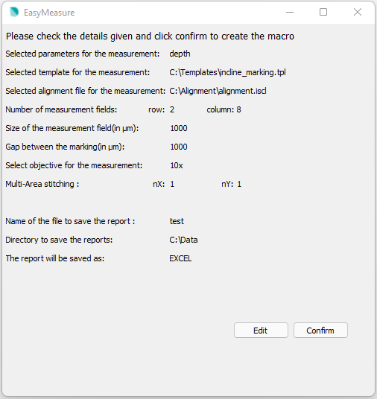

*Figure4*

Click on confirm to move to macro saving window. Here the “demo.mcr” will be created in user selected directory . Use this macro file in LSM software to automatically measure the pattern.

# **Before running macro on OLUMPUS OLS5000 software**

1. Enable “start analysis application after saving the data” in the OLUMPUS OLS5000 software.
2. Open data acquisition and analysis application for Laser Scanning Microscope.
3. Check to “disable” the alignment data in OLUMPUS OLS5000 software.

# **Data acquisition**

The excel report generated by the *microscope software* will contain multiple pages according to the selected parameters to measure. Figure 5 shows a report page showing profile depth measurement for a rectangular pattern. To see more excel reports refer to \sciebo\Aswin Nath\10_LSM Automation\Data_Excel\07.07.2021_data_excel .

*Figure 5*

This part of the application is useful when the pattern contains thousands of data points and generating same number of reports. It becomes difficult to manually retrieve the required parameter value from the excel report.

Selecting “LSM data analysis” from main window and clicking continue will take you to this window(Figure 6).

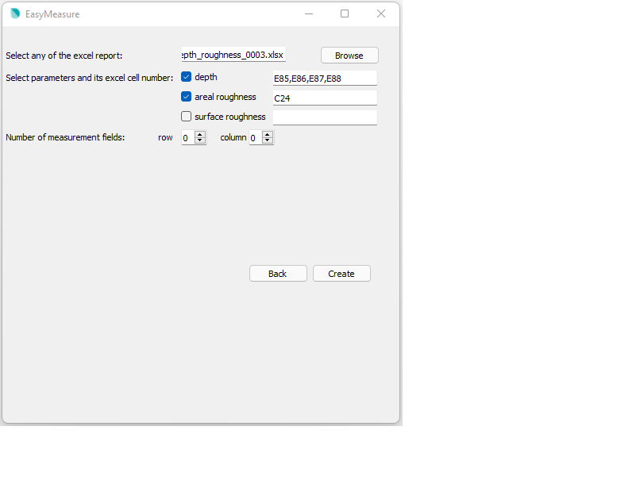

*Figure 6*

## Form fields

1. **Select one of the excel report**: Excel file name and path of the files are obtained using this field. This can be entered manually (mention the entire directory path with file name while entering manually) or selected using browse button.
2. **Select parameters and its excel cell number**: Required parameters and its corresponding cell number is entered in this field. If there are more than one cell number for the parameter, then mean value of those value will be the output. Currently the available parameters are depth, areal roughness and surface roughness. This can be extended in future.
3. **Number of the measurement fields:** This field helps to generate the parameter values according to the pattern. Each parameter will be represented as the rows and columns in separate sheets in the same workbook output. Entering zeros will not generate any extra sheets.

Click on ‘create’ button to create another excel file with required data in the same directory where all reports are saved.