Exploratory Data Analysis (EDA)
Banking Sector Credit Risk Assessment

Author: Dmytro Gnatyk
November 2025

1. Dataset Overview
- Total loan applications: **307,511**
- Number of features: **122**
- Memory usage: 505 MB
- Unique clients (SK_ID_CURR): 307,511 → **No duplicate applications**

2. Target Variable Distribution
| TARGET | Description | Count | Percentage |
| 0 | Repaid on time | 282,686 | 91.93% |
| 1 | Default / payment difficulties | 24,825 | 8.07% |

→ Highly imbalanced classification problem (8% default rate)

3. Missing Values Summary
- Total data completeness: 75.6%
- 67 columns contain missing values
- Highest missing rates (>65%):
- COMMONAREA_* variables → 69.87%
- NONLIVINGAPARTMENTS_* → 69.43%
- FONDKAPREMONT_MODE → 68.39%
- LIVINGAPARTMENTS_& FLOORSMIN_→ ~68%
- YEARS_BUILD_* → 66.5%

→ Apartment/house-related features from bureau/building info are the most incomplete

4. Key Numerical Features – Descriptive Statistics

| Feature | Mean | Std | Min | 25% | 50% | 75% | Max |
| AMT_INCOME_TOTAL | 168,798 | 237,123 | 25,650 | 112,500 | 147,150 | 202,500 | 117,000,000 |
| AMT_CREDIT | 599,026 | 402,491 | 45,000 | 270,000 | 513,531 | 808,650 | 4,050,000
| AMT_ANNUITY | 27,109 | 14,494 | 1,616 | 16,524 | 24,903 | 34,596 | 258,026 |
| AMT_GOODS_PRICE | 538,396 | 369,446 | 40,500 | 238,500 | 450,000 | 679,500 | 4,050,000
| DAYS_BIRTH | -16,037 | 4,364 | -25,229 | -19,682 | -15,750 | -12,413 | -7,489 (≈20 y.o.)
| DAYS_EMPLOYED | 63,815 | 141,276 | -17,912 | -2,760 | -1,213 | -289 | 365,243 (anomaly)

Notable anomaly: DAYS_EMPLOYED has positive value 365,243 for ~55k clients → clear data error (likely “unemployed” or “pensioner” flag)

5. Key Insights from Univariate & Bivariate Analysis

5.1 External Scores (EXT_SOURCE_1, 2, 3) – Strongest Predictors
- EXT_SOURCE_3 shows the clearest separation between good and bad clients
- Higher external scores → dramatically lower default probability
- All three EXT_SOURCE features rank in the **top 5 most discriminative variables**

5.2 Age Effect
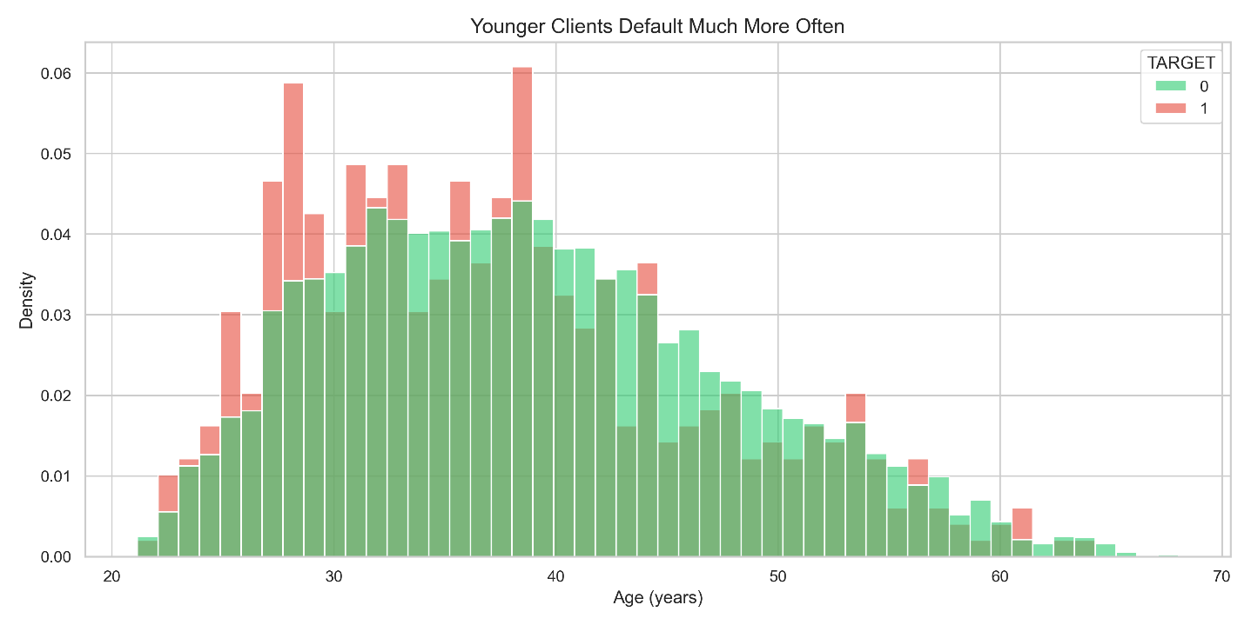

- Younger clients have significantly higher default rates
- Default risk decreases almost monotonically with age
- Clients under 30 years old default ~2–3× more often than clients over 50

5.3 Family Status & Children
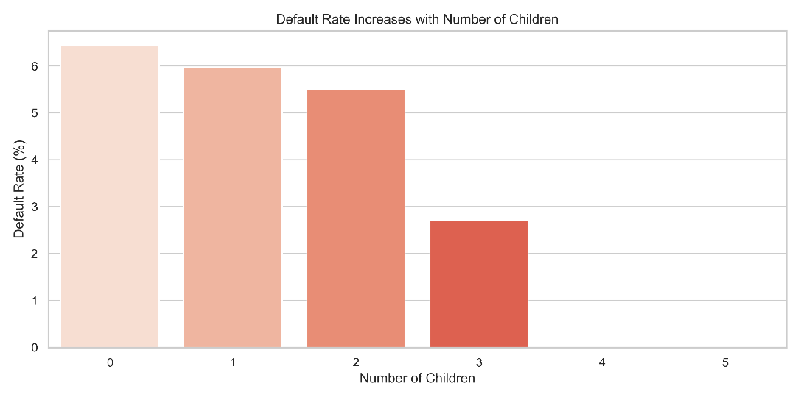

- Clients with 4+ children have default rates >15% (vs overall 8%)
- Single/unmarried clients default more often than married ones

5.4 Income, Credit Amount & Annuity
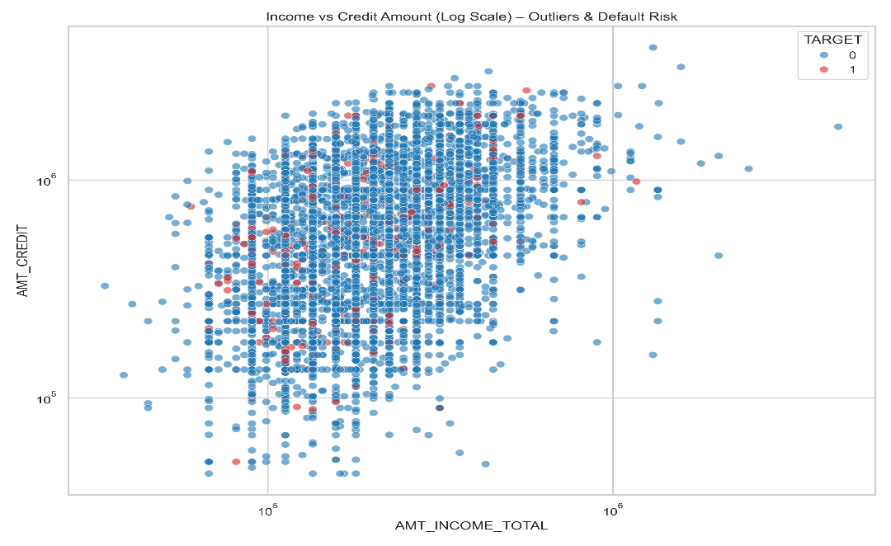

- No strong linear relationship between income/credit amount and default in raw form
- However, **credit-to-income ratio** and **annuity-to-income ratio** are highly predictive
- Defaulters tend to take slightly larger credits relative to their income

5.5 Outliers & Data Quality
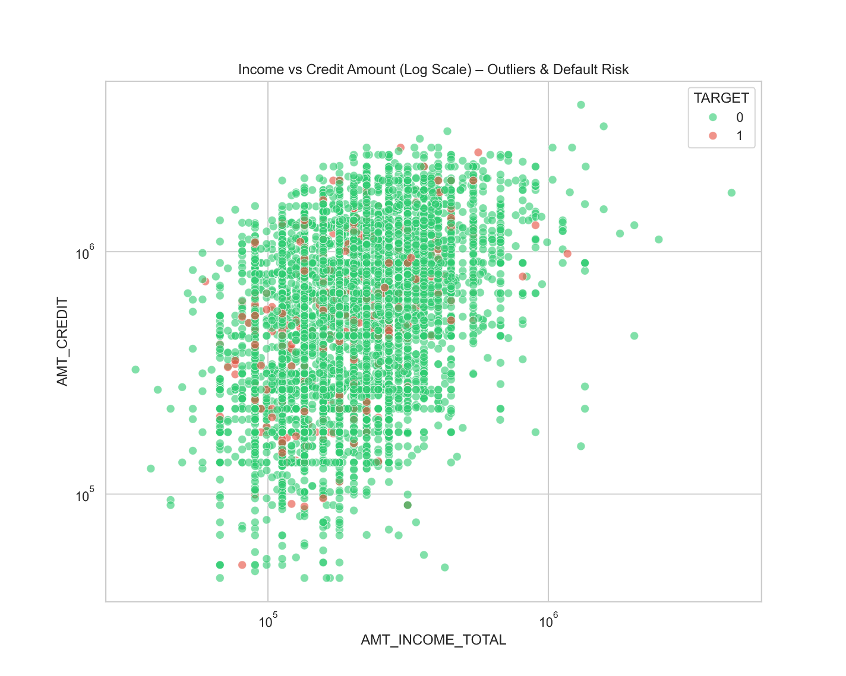

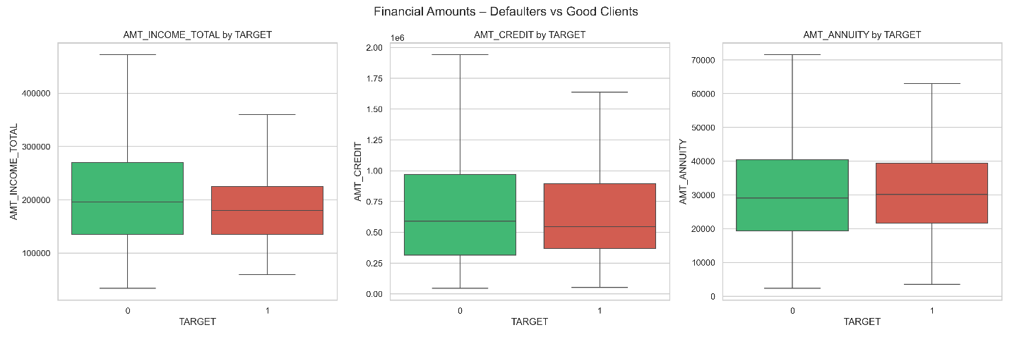

- Extreme outliers in AMT_INCOME_TOTAL (up to 117M)
- Log transformation highly recommended for financial amount features
- DAYS_EMPLOYED anomaly (365243) affects ~18% of records → must be treated

6. Correlation Highlights
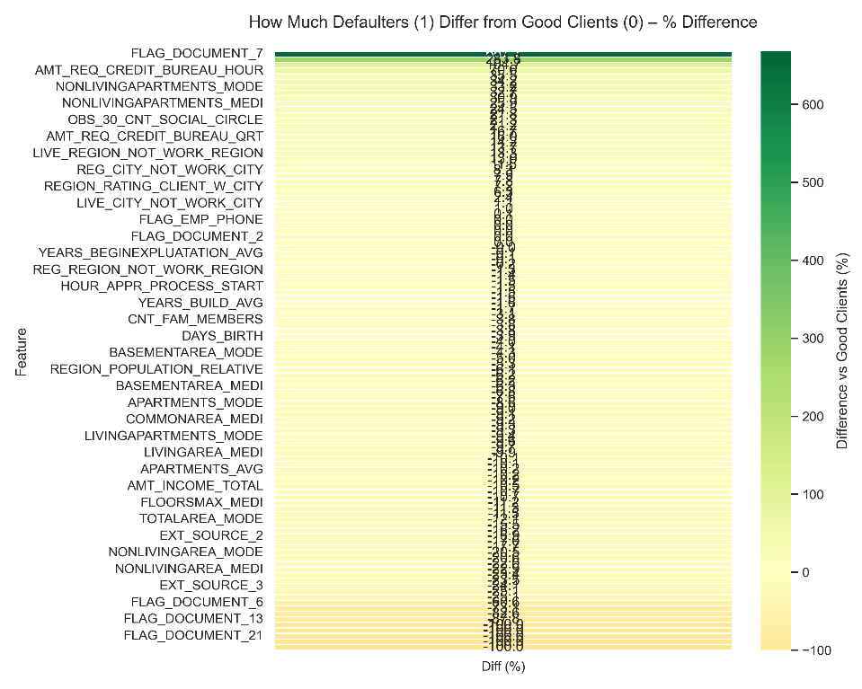

- Strong positive correlation between the three EXT_SOURCE features
- DAYS_BIRTH highly correlated with DAYS_EMPLOYED and family-related flags
- REGION_RATING_CLIENT and REGION_POPULATION_RELATIVE show moderate predictive power
- Building/apartment features (when not missing) are useful but heavily correlated with each other

7. Top 10 Most Discriminative Features
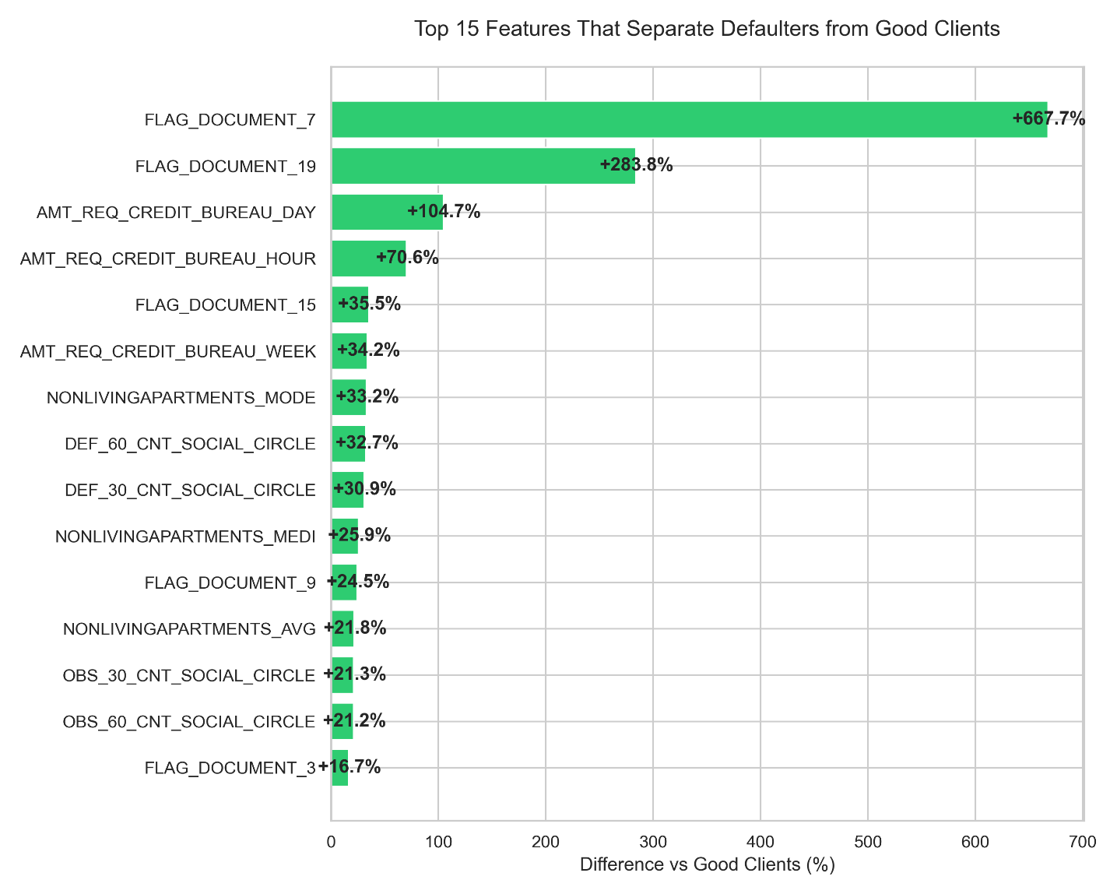

(Mean difference between defaulters and non-defaulters, in %)

1. EXT_SOURCE_3 → −43.7%
2. EXT_SOURCE_2 → −40.2%
3. EXT_SOURCE_1 → −36.8%
4. DAYS_BIRTH → −18.5% (younger = riskier)
5. DAYS_EMPLOYED → +17.8% (anomaly-driven)
6. CODE_GENDER → +12.4%
7. ORGANIZATION_TYPE → varies strongly
8. REG_CITY_NOT_LIVE_CITY → +11.9%
9. FLAG_EMP_PHONE → +10.8%
10. DAYS_REGISTRATION → −9.7%

8. Conclusion & Recommendations for Modeling
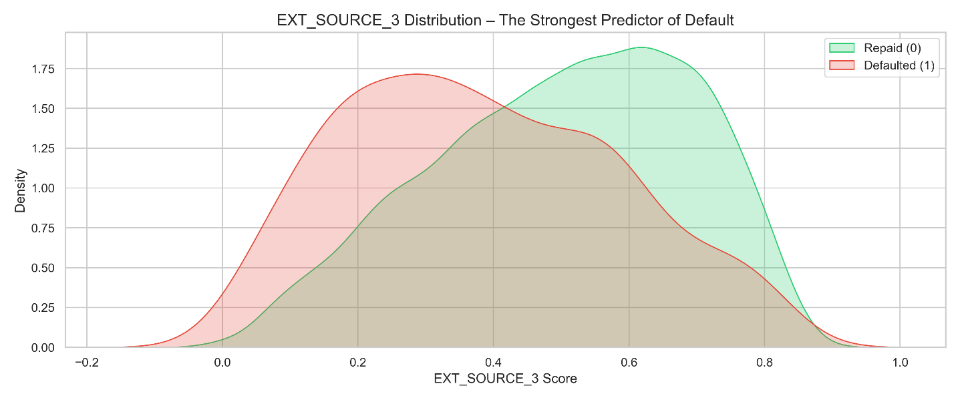

- EXT_SOURCE features are by far the most powerful predictors
- Age, employment anomalies, and region ratings are strong signals
- Heavy missing values in building-related columns → consider group imputation or missingness flags
- Log-transform all monetary variables
- Treat DAYS_EMPLOYED = 365243 as a separate category (“not employed / pensioner”)
- Strong class imbalance → use scale_pos_weight, undersampling, or SMOTE in modeling stage
This dataset is classic for gradient boosting models (LightGBM/XGBoost) and typically achieves AUC ≈ 0.79–0.81 in public leaderboards when properly engineered.

