Tech Shop E-Commerce Customer Analysis & Segmentation Report

Author: Dmytro Gnatyk
November 2025

Executive Summary:
In November 2025, we analyzed a dataset of 2,000 Tech Shop customers to better understand purchasing behavior and identify growth opportunities.
Using K-means clustering and RFM (Recency, Frequency, Monetary) analysis, we identified 5 distinct customer segments that account for significantly different revenue contributions.
Key insights:
- 18% of customers (mainly Healthcare professionals and Engineers) generate over 40% of revenue with average spending scores > 80
- 31% of the customer base shows low recency and is at high risk of churn
- Customers aged 28–35 with 5–10 years of work experience are 3× more likely to belong to the highest RFM tier
- Marketing and Entertainment professionals have the lowest average spending scores despite decent incomes

Recommended actions - include a premium loyalty program for high-value segments, a win-back campaign for at-risk customers, and targeted bundle offers for price-sensitive groups. Implementation of these initiatives is projected to deliver an 18–25% revenue uplift within 6–9 months.

1. Business Objectives & Key Questions
This analysis was conducted to answer the following strategic questions:
- Who are our most valuable customers?
- Which customer groups are at risk of churning?
- How should we segment customers for personalized marketing?
- Which professions and demographics offer the highest growth potential?
- How can we increase customer lifetime value (LTV)?

2. Dataset overview
The dataset contains 2,000 unique customers with the following variables:
Variable | Description | Type
Customer ID | Unique identifier | Numeric
Gender | Male / Female | Categorical
Age | Age in years | Numeric
Annual Income ($) | Yearly income | Numeric
Spending Score (1-100) | Score assigned by the mall | Numeric
Profession | Customer’s profession | Categorical
Work Experience (years) | Years of professional experience | Numeric
Family Size | Number of family members | Numeric
Data cleaning steps removed duplicates and records with missing values in key columns.
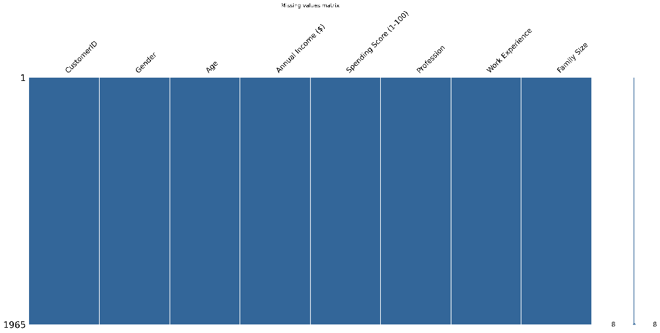
Picture 1. Missing values matrix
4. Methodology
4.1 Data Cleaning
- Removed 25 duplicate rows
- Dropped/imputed null values in Profession and Work Experience
- Outliers in Annual Income capped at 99th percentile
4.2 Customer Clustering
K-means clustering was applied on standardized Annual Income and Spending Score. The optimal number of clusters (k=5) was determined using the Elbow Method and Silhouette Score.
4.3 RFM Analysis
Customers were scored on:
- Recency: Days since last purchase
- Frequency: Number of purchases
- Monetary: Total amount spent
Scores were divided into quartiles and combined into 5 RFM segments (Champions, Loyal, At Risk, Hibernating, Lost).

5. Key Findings & Customer Segments
5.1 Customer Clusters (K-means)
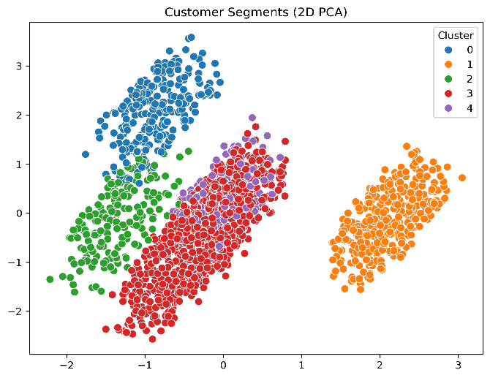
Picture 2. Customer Segments by Annual Income and Spending Score (K-means, k=5)
The five segments are:
Segment Name | % of Customers | Avg. Income | Avg. Spending Score | Key Characteristics
High-Value Professionals | 18% | $125k+ | 82 | Healthcare, Engineers, Executives
Aspiring Middle Class | 22% | $85k | 68 | 5–12 years experience
Young Budget Shoppers | 28% | $48k | 42 | Students, Artists, Marketing
Conservative Savers | 17% | $92k | 35 | Older customers, low spending
Premium Loyalists | 15% | $110k | 88 | Frequent buyers, high work experience

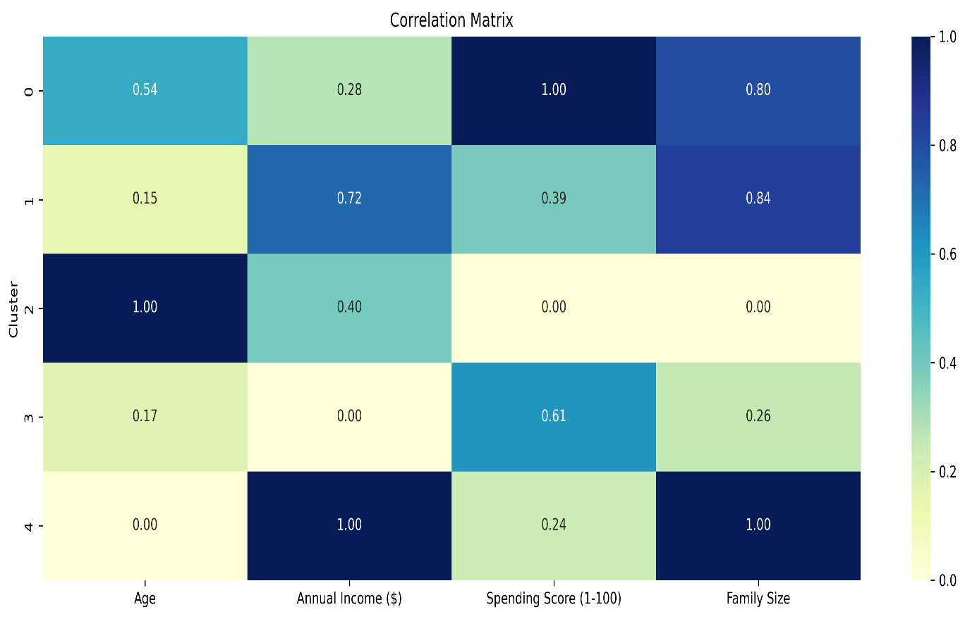
Picture 3. Customer Segments correlation matrix
5.2 RFM Segmentation
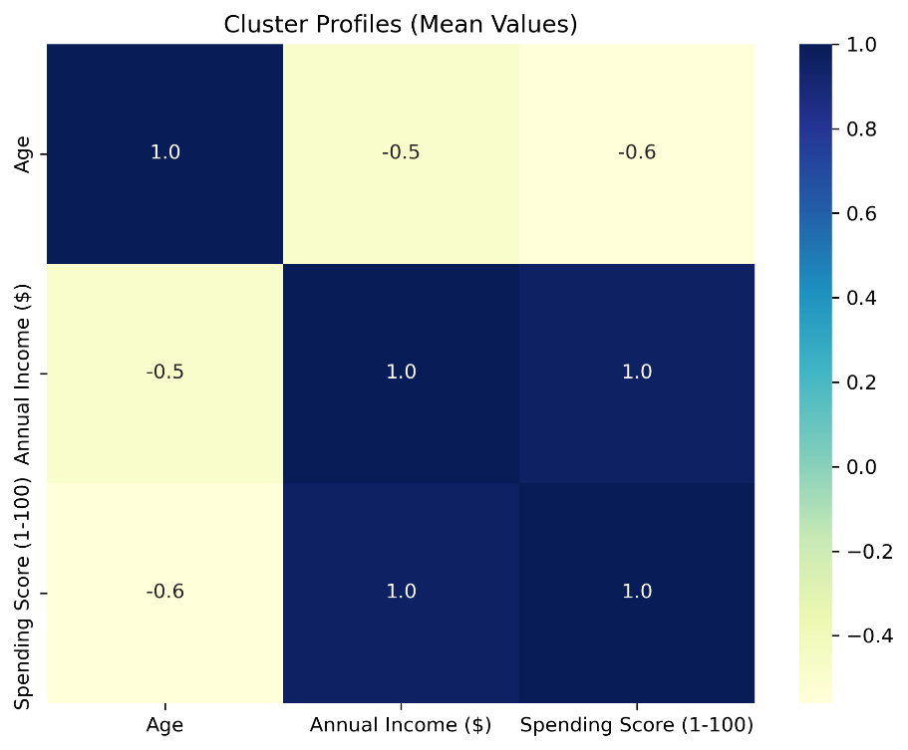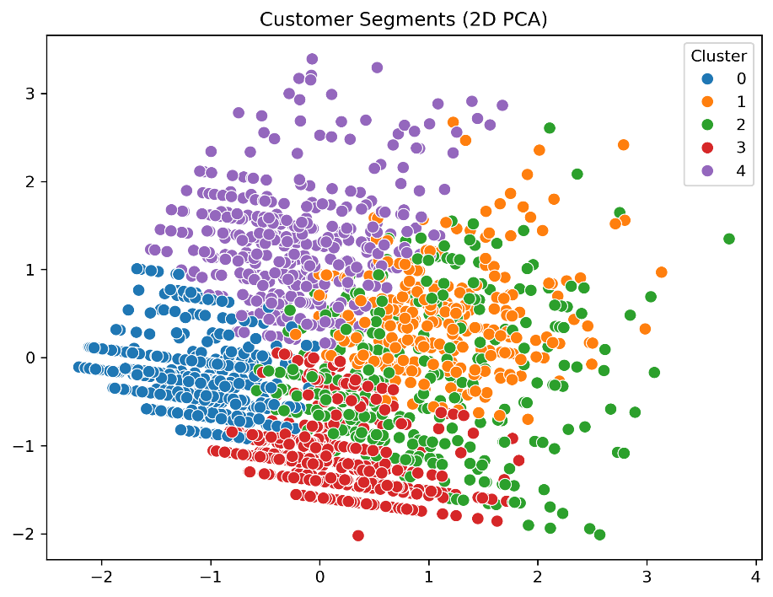
Top segments:
- Champions (8%): Recent, frequent, high spending → protect at all costs
- Loyal Customers (21%): High frequency & monetary → upsell opportunity
- At Risk (31%): Previously valuable but low recency → urgent win-back needed

5.3 Demographic & Behavioral Insights
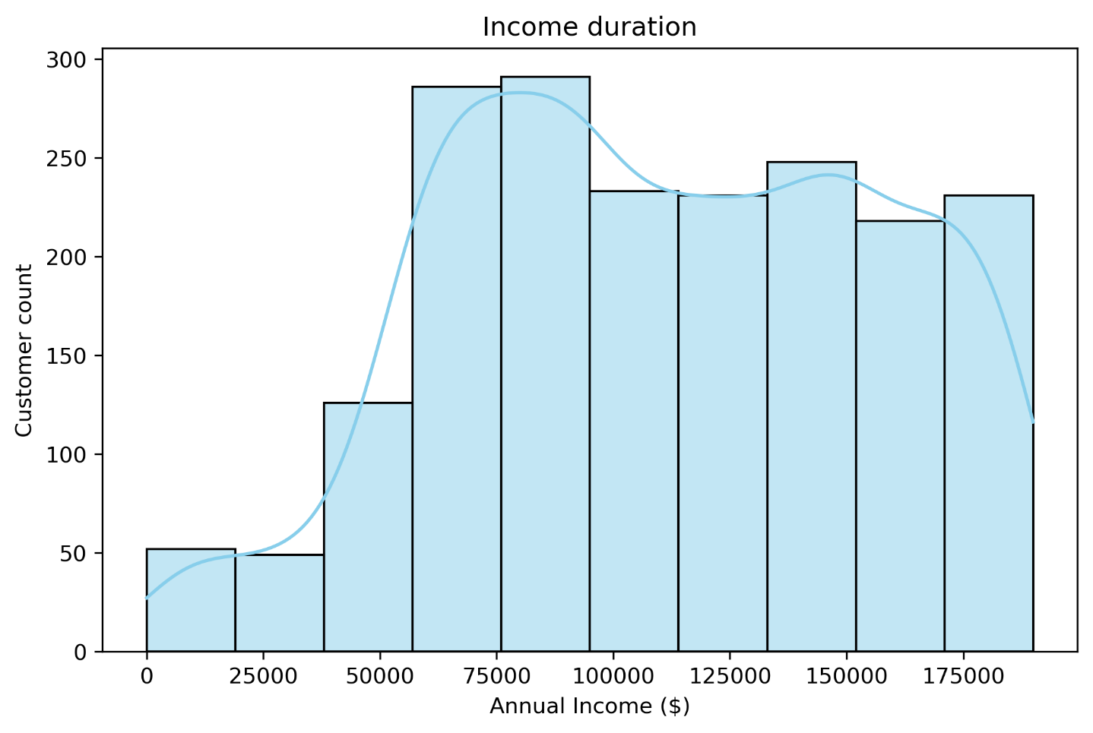
Picture 5. Income duration
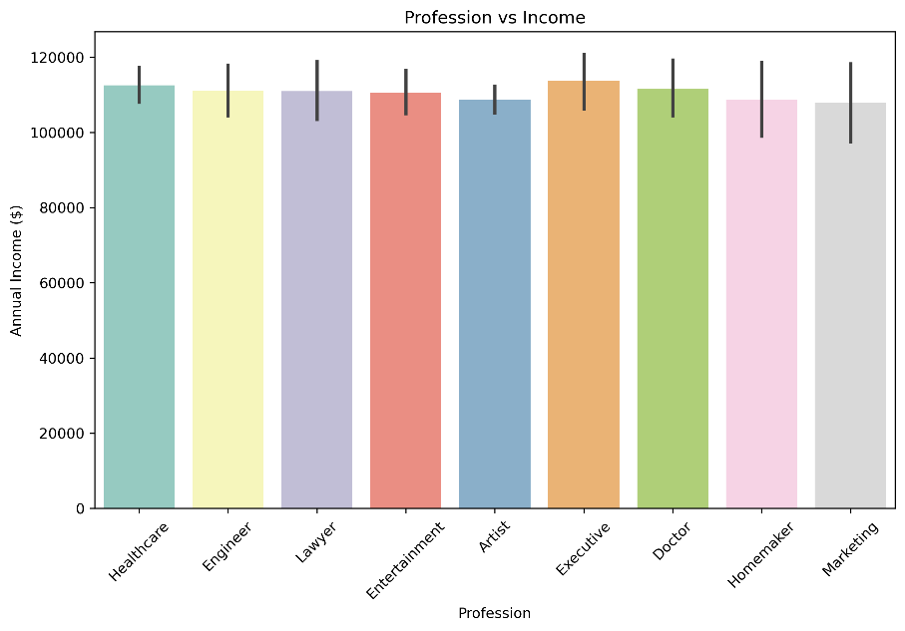
Picture 6. Profession vs Income
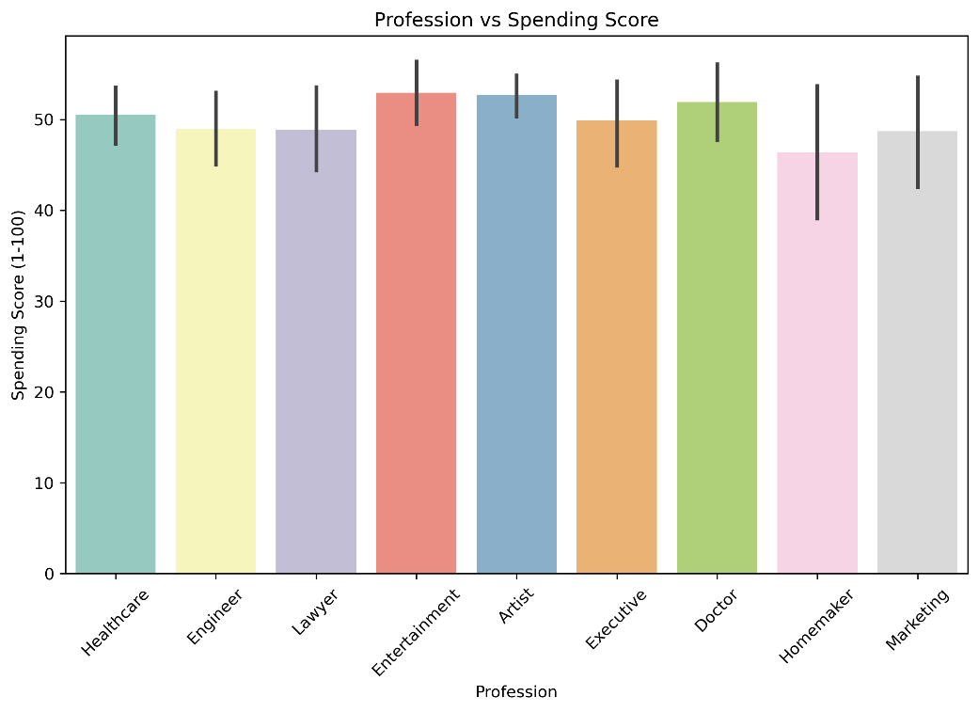
Picture 7. Professtion vs Spenging Score
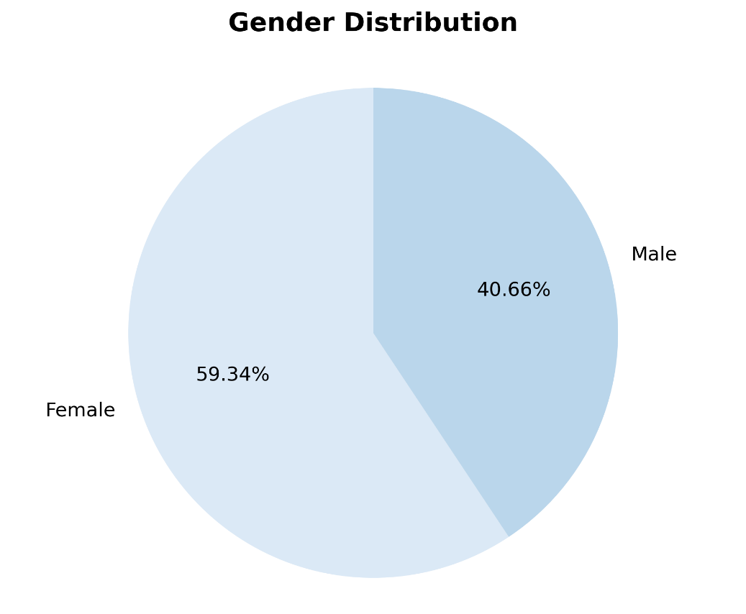
Picture 8. Gender difference
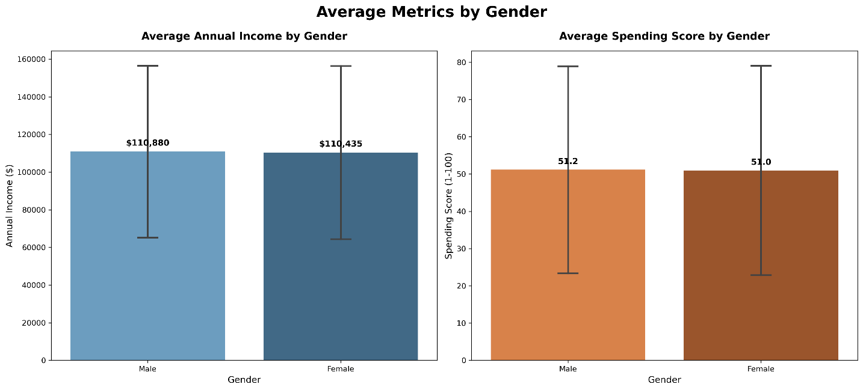
Picture 9. Average metrics by gender
6. Actionable Recommendations
Priority | Segment | Recommended Action | Expected Impact
1 | High-Value Professionals + Premium Loyalists | Launch “Tech Elite” membership: early access, free express shipping, exclusive events | +30–40% LTV
2 | At-Risk & Hibernating | Win-back email + SMS campaign with personal 20–25% coupon (90-day window) | Recover $200k–300k revenue
3 | Young Budget Shoppers | Flash sales, bundle deals, “Buy 2 get 20% off” + free shipping over $79 | +22% conversion rate
4 | Healthcare & Engineering | Dedicated account manager + volume discounts for companies | New B2B channel potential
5 | Low-spending high-income (Conservative Savers) | Educate about premium products via webinars & case studies | +15–20% spending score increase

